An Overview of Sales and Use Tax for Business Owners – Part 1

1. Introduction

1.1 Welcome
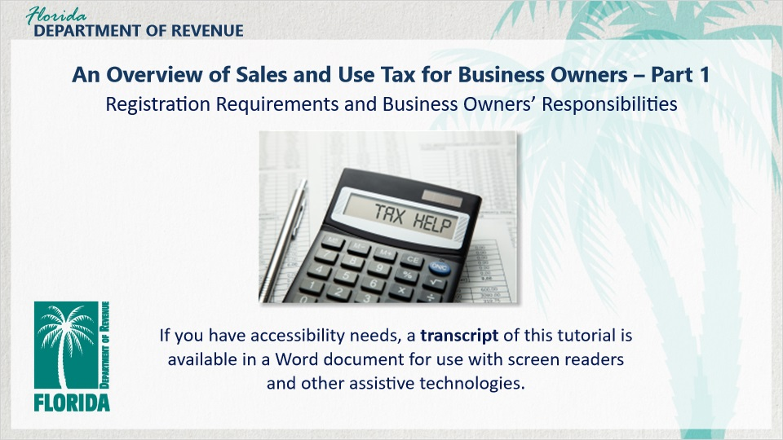
Transcript:
Welcome to An Overview of Sales and Use Tax for Business Owners: Registration Requirements and Business Owners’ Responsibilities.

In this tutorial, we discuss the registration requirements for a new business in Florida and the responsibilities of business owners concerning the collection and remittance of sales and use tax.

1.2 Navigating This Tutorial
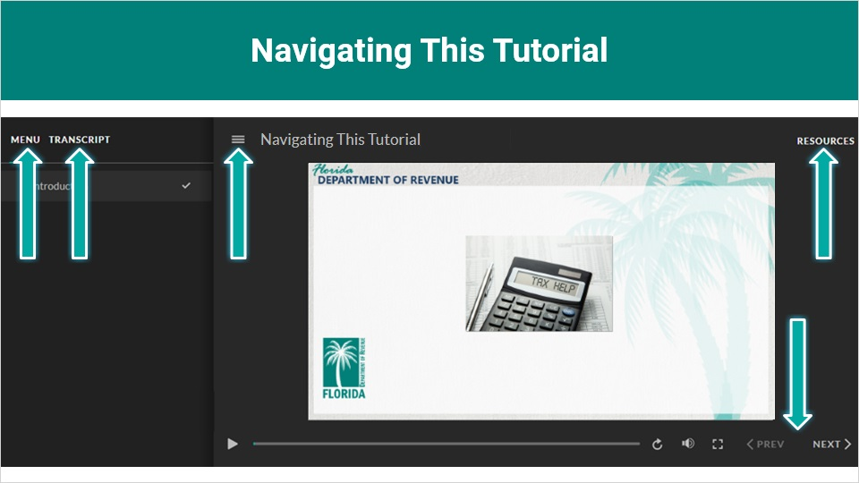
Transcript:
This overview will take approximately 20 minutes to complete. A transcript of the audio is available by clicking on the transcript tab in the top-left corner of your screen. The following tabs and buttons are available to help you navigate throughout this overview.

The menu tab displays by default when the overview is viewed on a computer. It allows you to navigate through the overview by clicking on the topic name on the menu. When viewing this overview on a tablet or smartphone, the menu does not display by default and must be accessed using the menu symbol.

The resources tab is found on the right side of the top bar. When clicked, it displays the list of links to useful forms, documents, and webpages.

The previous and next buttons are located at the bottom-right corner of your screen. These buttons allow you to move either back or forward.

1.3 Topics
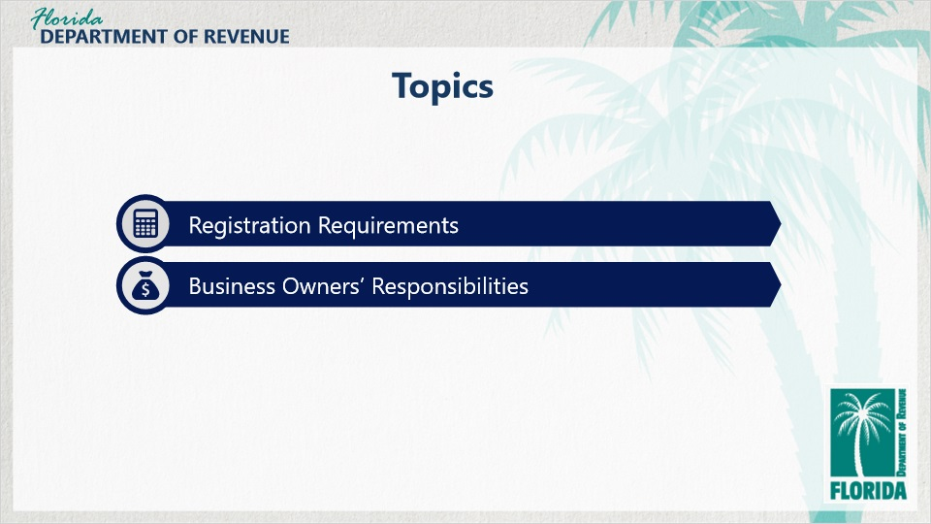
Transcript:
Topics for this tutorial include: Registration Requirements and Business Owners’ Responsibilities.

2. Registration Requirements

2.1 Let's Meet Meredith

Transcript:
In this tutorial, we’ll be following Meredith. She’s decided to open Meredith’s Old-Fashioned Pharmacy. Her business will operate as a fully-functioning pharmacy, with a twist. Customers can enjoy treats such as milkshakes and ice cream sundaes, as well as other frozen novelties while they wait for their prescriptions.

Her business will also sell pint-sized containers of her special homemade ice cream to take home, in addition to other convenience items, like candy and bottled soft drinks at the front counter.

We’ll also present scenarios featuring some of the other business owners located in her building.

How are things going, Meredith?

[Meredith]: Things are going well! I’m quite excited to be starting my very own pharmacy. It’s been a dream of mine for a long time.

That’s great to hear. Do you need help with anything?

[Meredith]: Well, I heard you say this tutorial is going to go over registration and other responsibilities I have as a business owner. It’ll be nice to make sure I’m doing everything I should be.

We can definitely help you with that.

[Meredith]: Thanks. I would really appreciate it!

2.2 Do I Need to Register?
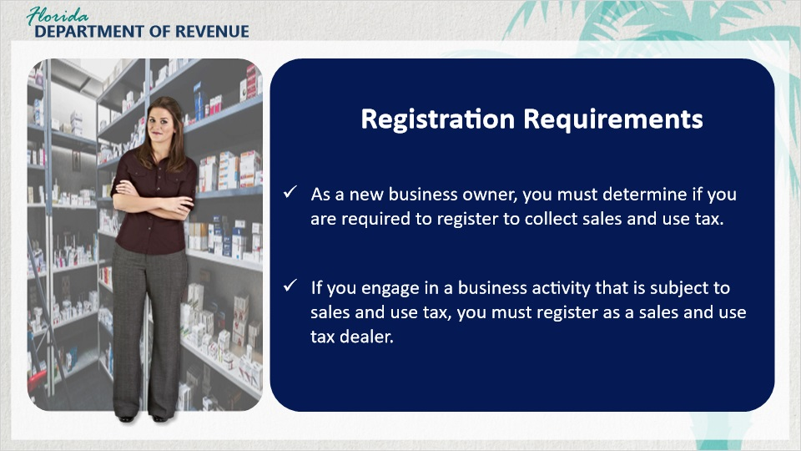
Transcript:
Let’s start with registration requirements, as this is a crucial step for most new business owners.

As a new business owner, you must determine if you are required to register to collect sales and use tax.

If you engage in a business activity that is subject to sales and use tax, you must register as a sales and use tax dealer to collect, report, and remit Florida sales and use tax before you begin conducting business in Florida.

2.3 Taxable Activity
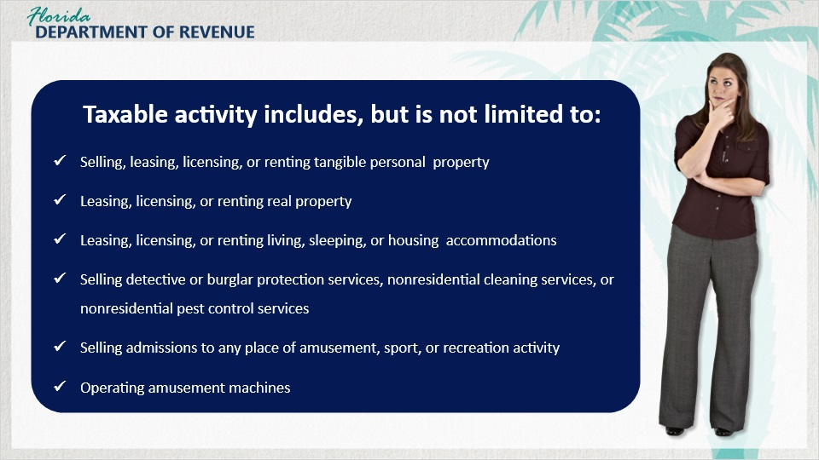
Transcript:
[Meredith]: My colleague who is a pharmacist told me I wouldn’t need to register because medicine and medical supplies are tax-exempt.

Well, that’s true, but what about the other items you are going to sell, like your milkshakes and candy at the front counter? These items are taxable. Therefore, you do need to register to collect and remit sales and use tax to Florida.

[Meredith]: I hadn’t thought about it that way. I’m glad you told me.

Just so you know, taxable business activity includes, but is not limited to selling, leasing, licensing, or renting tangible personal property such as electronics, motor vehicles, certain food and meals and other goods; leasing, licensing, or renting real property; leasing, licensing, or renting living, sleeping, or housing accommodations; selling detective or burglar protection services, nonresidential cleaning services, or nonresidential pest control services; selling admissions to any place of amusement, sport, or recreation activity; and operating amusement machines.

2.4 Exemptions
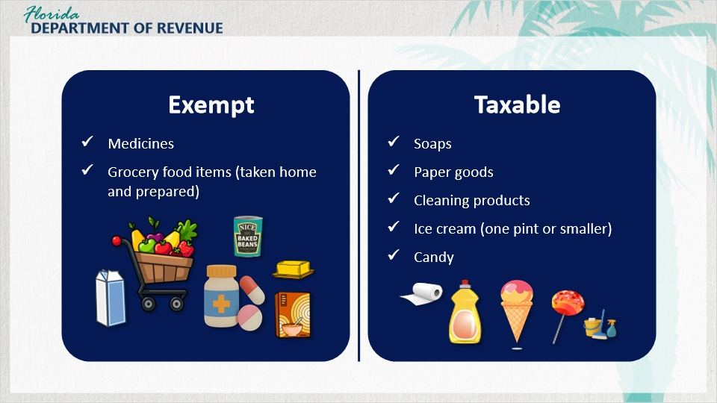
Transcript:
[Meredith]: What about tax-exempt items?

In Florida, sales tax is not applied to items that are considered exempt. For example, medicine and most grocery food items that are typically taken home and prepared are tax-exempt. Milk, butter, cereal, and frozen and canned goods are exempt. Other items, such as soaps, paper goods, cleaning products, ice cream sold in pints or smaller containers, and candy are taxable.

2.5 Information Needed
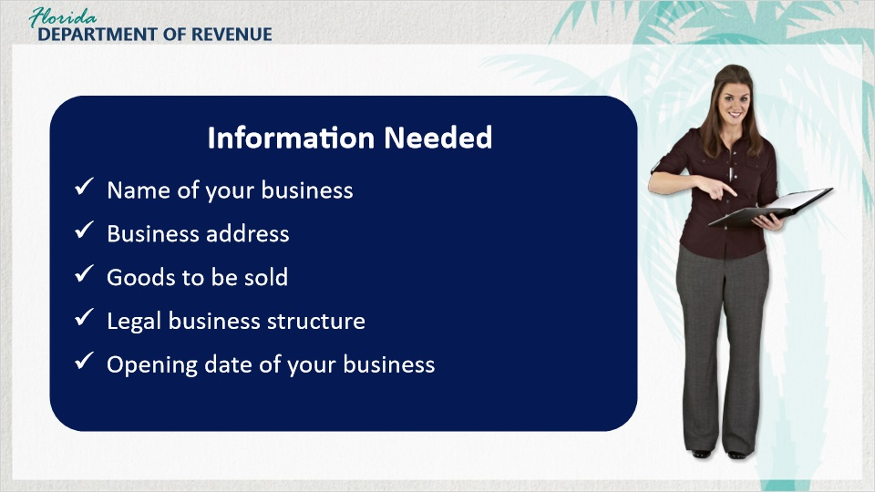
Transcript:
To register to collect and remit sales and use tax, you are required to provide the Florida Department of Revenue information pertaining to your business. This includes the name of your business, business address, the goods to be sold, your legal business structure, and the opening date of your business.

Keep in mind that if your opening date changes from when you submitted your Florida Business Tax Application (Form DR-1), you must notify the Department.

2.6 Knowledge Check #1
(Multiple Choice, 10 points, 2 attempts permitted)
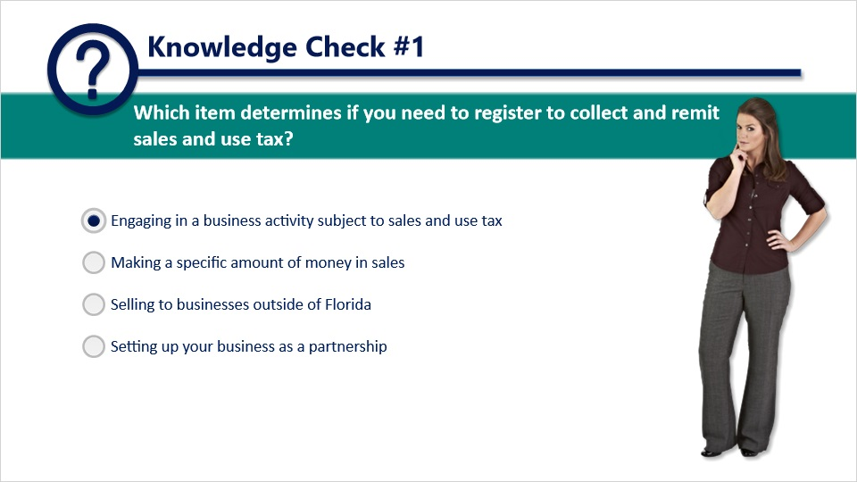
Question:
Which item determines if you need to register to collect and remit sales and use tax?

Answer choices:
One. Engaging in a business activity subject to sales and use tax.
Two. Making a specific amount of money in sales.
Three. Selling to businesses outside of Florida.
Four. Setting up your business as a partnership.
The correct answer is:
One. Engaging in a business activity subject to sales and use tax.

Feedback when correct:
That's right! You selected the correct response.
Feedback when incorrect:
If you engage in a business activity subject to sales and use tax, you need to register.

2.7 Registration Basics
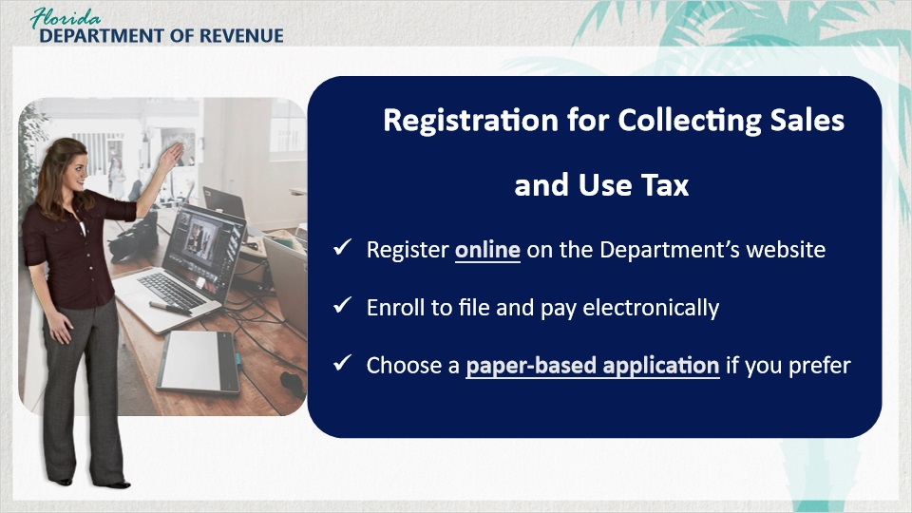
Transcript:
[Meredith]: Do you mind explaining more about the registration process?

Sure, I can do that. Before doing any business, you must register to collect sales and use tax by completing a Florida Business Tax Application (Form DR-1). You may register online on the Department’s website to obtain a Certificate of Registration (Form DR-11).

You may enroll to file and pay electronically at the same time or after registering.

You may also choose instead to file a paper Form DR-1. However, you should know that there are several benefits to registering online.

[Meredith]: I will probably register online since that sounds easier. Do you mind explaining the benefits?

Of course. Benefits of registering online include the ability to revisit a previously submitted application and your registration certificate number is easy to retrieve.

2.8 Documents Received
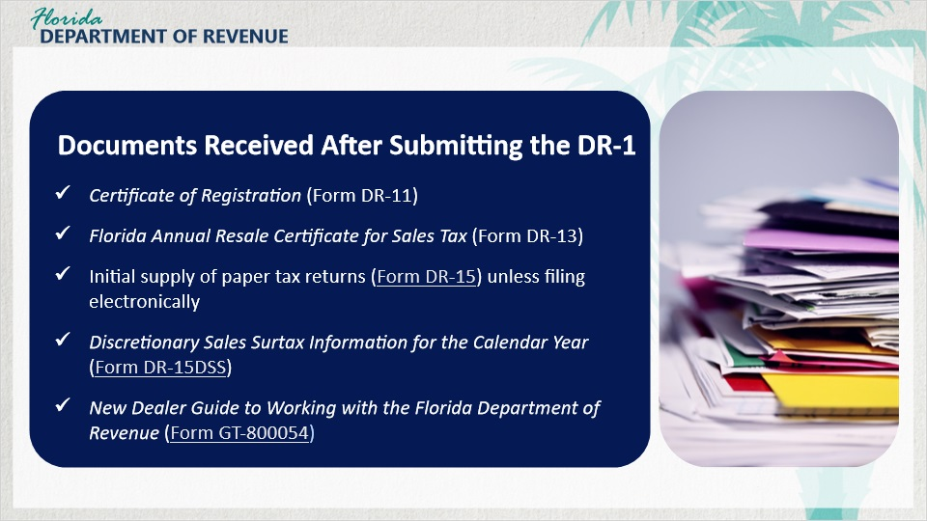
Transcript:
Once your registration is complete, you will receive several documents. The first document will be a Certificate of Registration (Form DR-11), which authorizes you to conduct business at the address shown on the certificate.

The certificate contains your business name and location. The certificate must be displayed in a visible place at your business. If your business is conducted at a temporary location such as a flea market, you must have the certificate in your possession.

The second document you will receive is a Florida Annual Resale Certificate for Sales Tax (Form DR-13), used for tax-exempt purchases or rentals of property or services you intend to resell or re-rent as part of your business.

You will also receive an initial supply of paper tax returns (Form DR-15) unless filing electronically. Additionally, you will receive a document pertaining to discretionary surtax information (Form DR-15DSS).

Lastly, you will be mailed the New Dealer Guide to Working with the Florida Department of Revenue (Form GT-800054).

2.9 Scenario #1
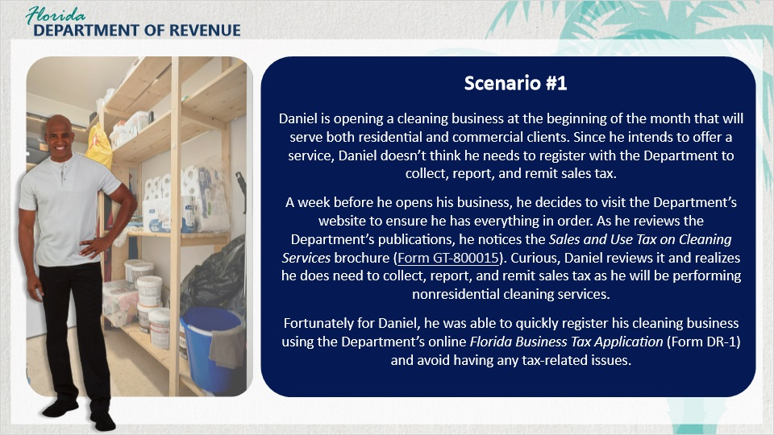
Transcript:
Let’s take a look at Daniel and his situation.

Daniel is opening a cleaning business at the beginning of the month that will serve both commercial and residential clients. Since he intends to offer a service, Daniel doesn’t think he needs to register with the Department to collect, report, and remit sales tax.

A week before he opens his business, he decides to visit the Department’s website to ensure he has everything in order. As he reviews the Department’s publications, he notices the Sales and Use Tax on Cleaning Services brochure (Form GT-800015). Curious, Daniel reviews it and realizes that he does need to collect, report, and remit sales tax as he will be performing nonresidential cleaning services.

Fortunately for Daniel, he was able to quickly register his cleaning business using the Department’s online Florida Business Tax Application (Form DR-1) and avoid having any tax-related issues.

2.10 Knowledge Check #2
(Multiple Response, 10 points, 2 attempts permitted)
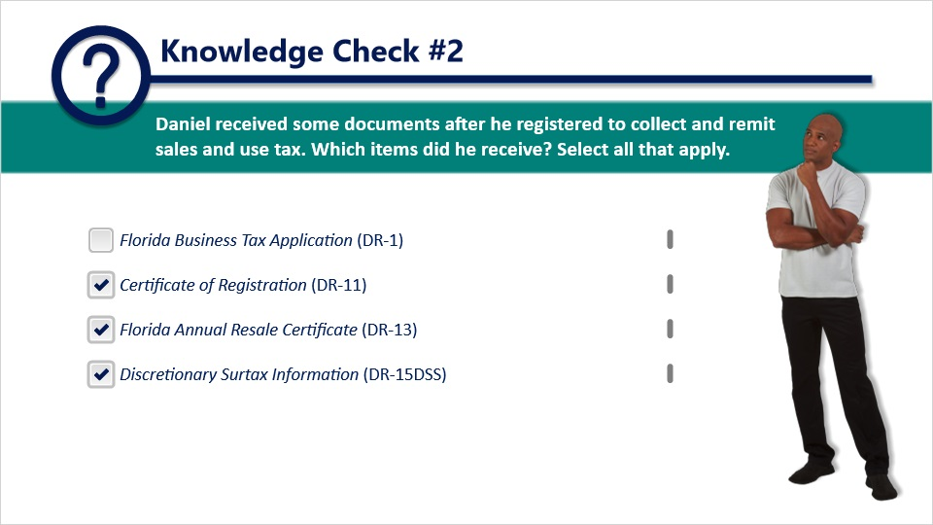
Question:
Daniel received some documents after he registered to collect and remit sales and use tax. Which items did he receive? Select all that apply.

Answer choices:
One. Florida Business Tax Application (DR-1).
Two. Certificate of Registration (DR-11).
Three. Florida Annual Resale Certificate (DR-13).
Four. Discretionary Surtax Information (DR-15DSS).
The correct answers are:
Two, three, and four.
Certificate of Registration (DR-11).
Florida Annual Resale Certificate (DR-13).
Discretionary Surtax Information (DR-15DSS).

Feedback when correct:
That's right! You selected the correct response.
Feedback when incorrect:
Taxpayers receive the DR-11, DR-13, and DR-15DSS after registering.

3. Business Owners' Responsibilities

3.1 Business Owners' Responsibilities
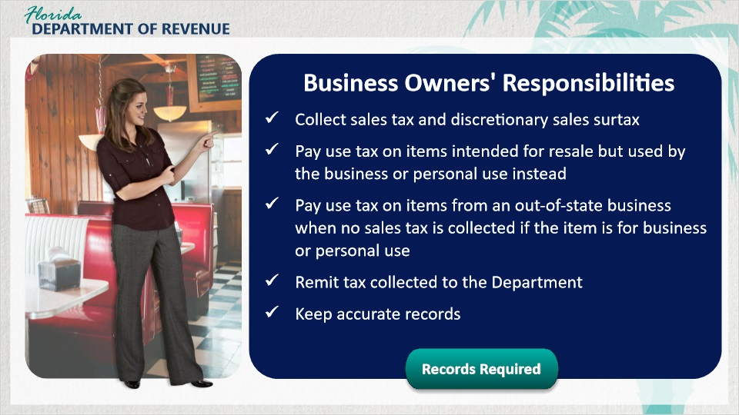
Transcript:
As a business owner in Florida, you have certain responsibilities you must fulfill in order to do business.

[Meredith]: Can you explain more about these responsibilities?

Of course. First, you must collect sales tax and discretionary sales surtax on all taxable items. For example, you would need to collect sales tax on your milkshakes and convenience items such as candy bars and bottles of soda.

[Meredith]: Discretionary sales surtax, what is that?

Discretionary sales surtax is tax paid to Florida counties to pay for items such as emergency services and school improvement. This tax is paid in addition to state sales tax. We will discuss this tax further in Part 2 of this series.

Getting back to the topic of business owner responsibilities, you must pay use tax on items originally intended for resale but then used for the business or for personal use instead.

[Meredith]: I’m a little unclear about what you mean. Can you give me an example?

I certainly can. For example, if you stocked seasonal candy at the front of the pharmacy and then decided to take home some to your family, you would owe use tax.

You are also required to pay use tax on items purchased for your own use from an out-of-state business if no state sales tax was collected at the time of sale.

For instance, if you bought a freezer in another state and then bring it into Florida, or have it delivered into Florida, and no sales tax was collected when you purchased it, you would owe use tax.

You are also required to remit all sales and use tax collected to the Department. Keep in mind that when you collect tax, that money then belongs to the state of Florida. You serve as a steward of those funds until they are remitted to the Department.

Remember, the State of Florida requires that you keep complete and accurate records for all business transactions and tax collected as well as your tax returns, including proof of payment, and documentation of sales and purchases for at least three years.

[Meredith]: What other records do I need to keep?

A comprehensive list of records you will need to retain is available by clicking on the Records Required button on your screen.

-------------------------------------
Here is a list of records you are required to maintain.

Documentation includes sales and purchase invoices, receipts, statements, register tapes, and other evidence of sales and purchases; sales tax exemption certificates and direct pay permits; Florida Annual Resale Certificates for Sales Tax accepted from other dealers; resale verification and authorization numbers; purchase and sales journals, cash receipt and disbursement journals, other journals, and general ledgers; and copies of sales and use tax returns and payments, including electronic payment and return filing confirmation numbers.

3.2 Scenario #2
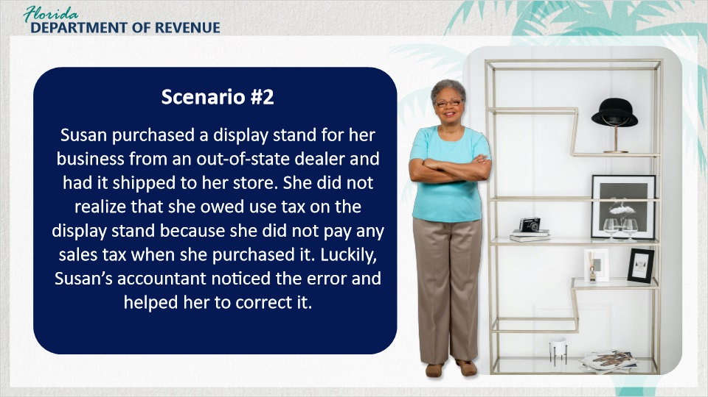
Transcript:
Let’s learn about Susan and her business.

Susan purchased a display stand for her business from an out-of-state dealer and had it shipped to her store. She did not realize that she owed use tax on the display stand because she did not pay any sales tax when she purchased it.

Luckily, Susan’s accountant noticed the error and helped her to correct it.

3.3 Knowledge Check #3
(Multiple Response, 10 points, 2 attempts permitted)
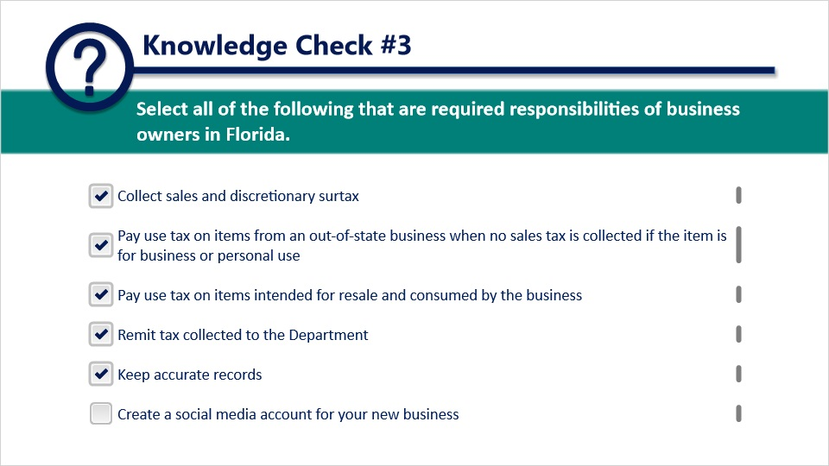
Question:
Select all of the following that are required responsibilities of business owners in Florida.

Answer choices:
One. Collect sales and discretionary surtax.
Two. Pay use tax on items from an out-of-state business when no sales tax is collected if the item is for business or personal use.
Three. Pay use tax on items intended for resale and consumed by the business.
Four. Remit tax collected to the Department.
Five. Keep accurate records.
Six. Create a social media account for your new business.
The correct answers are:
One, two, three, four, and five.
Collect sales and discretionary surtax.
Pay use tax on items from an out-of-state business when no sales tax is collected if the item is for business or personal use.
Pay use tax on items intended for resale and consumed by the business.
Remit tax collected to the Department.
Keep accurate records.

Feedback when correct:
That's right! You selected the correct response.
Feedback when incorrect:
Business owners in Florida have many responsibilities, but creating a social media account is not one of them.

Transcript:

4. Conclusion Survey

4.1 Summary
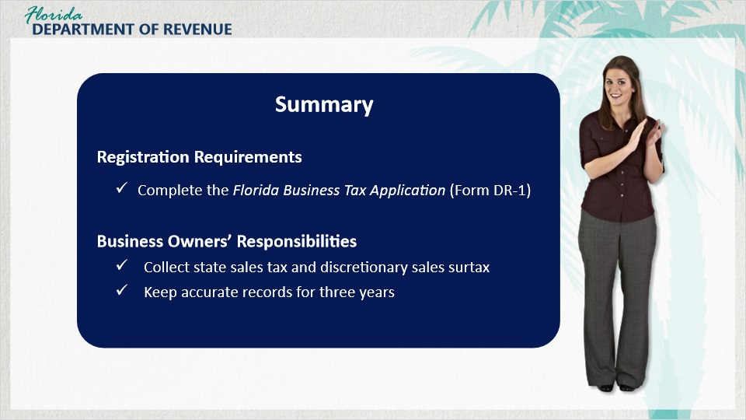
Transcript:
[Meredith]: You’ve given me some really great information. I really appreciate it. Let me see if I can do a recap to make sure I’ve got everything.

That sounds like a great idea.

[Meredith]: In this tutorial, we discussed registration requirements for a new business. For instance, you are required to complete a Florida Business Tax Application (Form DR-1) to collect and remit sales and use tax if you engage in any taxable business activity in Florida.

We also reviewed business owners’ responsibilities for collecting state sales and use tax in Florida. Responsibilities include collecting state sales tax and discretionary sales surtax and keeping accurate records for at least three years.

4.2 Survey
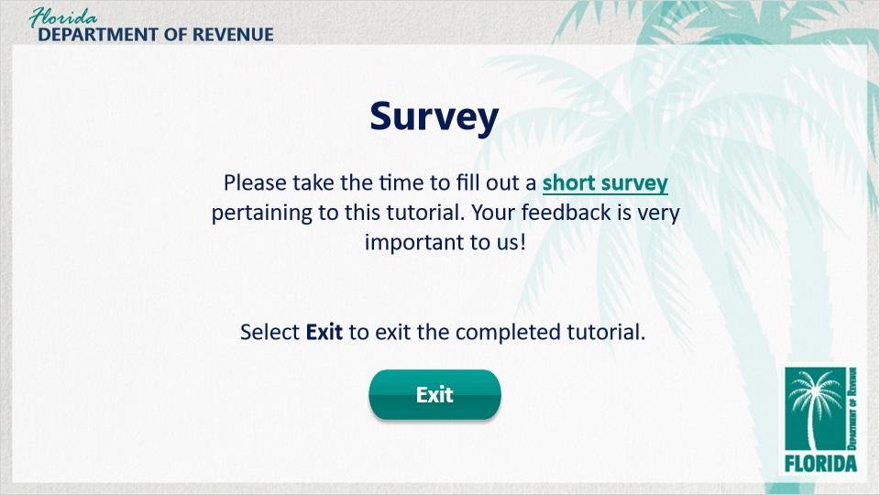
Transcript:
This concludes An Overview of Sales and Use Tax for Business Owners: Registration Requirements and Business Owners’ Responsibilities.

For more information, check out the resources available within this tutorial by clicking on the Resources tab in the upper-right corner of your screen.

In addition, there are several helpful guides and tutorials available on a variety of tax-related topics on the Department’s website at floridarevenue.com.

Please take the time to fill out a brief survey pertaining to this tutorial. Your feedback is very important to us.

To exit this tutorial, click on the Exit button. Thank you.

