Reemployment Tax Part 5: Filing a Quarterly Corrected Return (RT-8A) Online

1. Introduction

1.1 Welcome
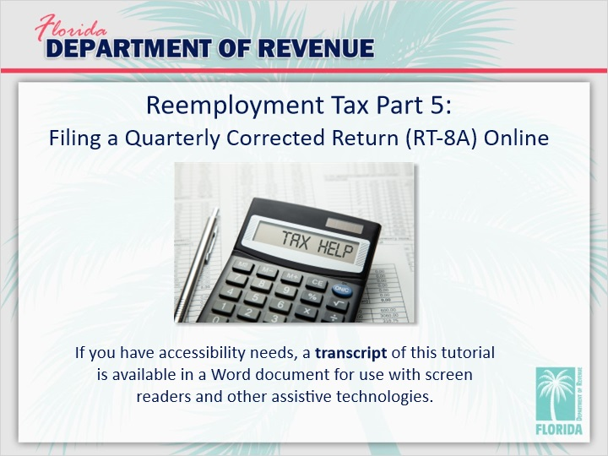
Transcript:
Welcome to Reemployment Tax: Filing a Quarterly Corrected Return (RT-8A) Online. In this tutorial, we will be taking you step-by-step through the process of filing an RT-8A online.

1.2 Navigation
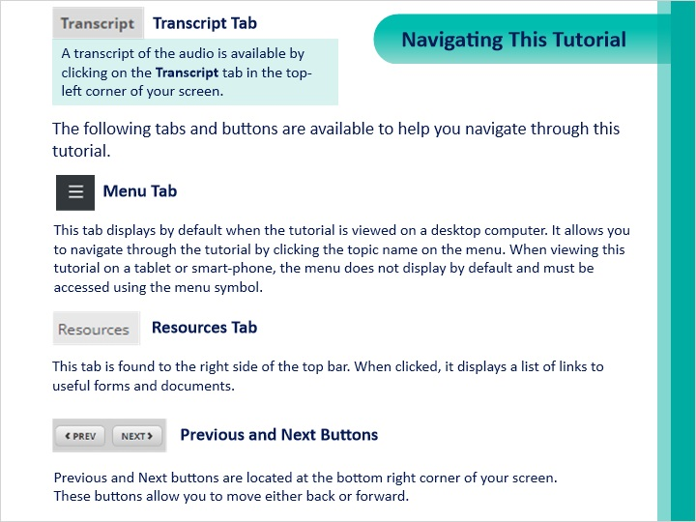
Transcript:
This tutorial will take approximately 15 minutes to complete. A transcript of the audio is available by clicking on the Transcript tab in the top-left corner of your screen.

The following tabs and buttons are available to help you navigate through this tutorial.

Menu Tab
This tab displays by default when the tutorial is viewed on a desktop computer. It allows you to navigate through the tutorial by clicking the topic name on the menu. When viewing this tutorial on a tablet or smart-phone, the menu does not display by default and must be accessed using the menu symbol.

Resources Tab
This tab is found to the right side of the top bar. When clicked, it displays a list of links to useful forms and documents.

Previous and Next Buttons
Previous and Next buttons are located at the bottom right corner of your screen. These buttons allow you to move either back or forward.

1.3 Topics
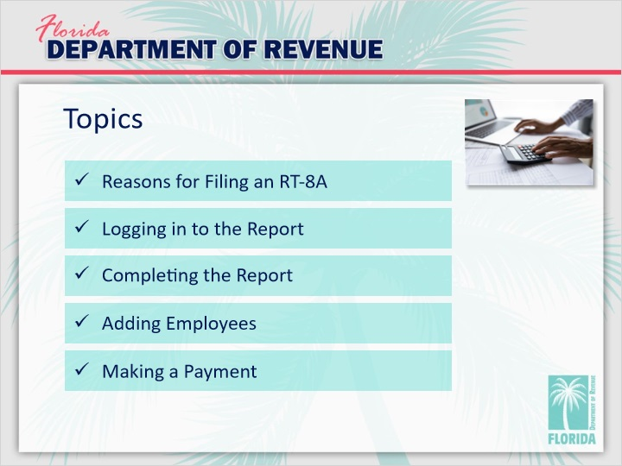
Transcript:
Topics for this tutorial include reasons for filing an RT-8A, logging in to the report, completing the report, adding employees, and making a Payment.

2. Reasons for Filing an RT-8A

2.1 Hello, Olivia!

Transcript:
It’s been a while since we’ve checked in with our friend, Olivia.

Hi, Olivia. How’ve you been doing?

[Olivia]: Hi everyone. Well, I’ve gotten myself into a little bit of a pickle. I just realized that the wages for my assistant, Emily, were not correct in the last quarterly report I submitted. I’m not exactly sure what to do.

We can help you with that. In this tutorial, we’ll show you how to resolve errors in past quarterly reports by filing a Quarterly Corrected Return (RT-8A).

[Olivia]: That’s great. I could really use some help. To be honest, I’m a little embarrassed about my mistake.

It’s okay, Olivia. Mistakes happen. That’s why the Department of Revenue has a way for taxpayers to correct issues when they occur. Don’t beat yourself up.

[Olivia]: OK, I’ll try not to. It’s done now. Let’s focus on getting it fixed.

That’s the spirit!

2.2 Overview of Reasons
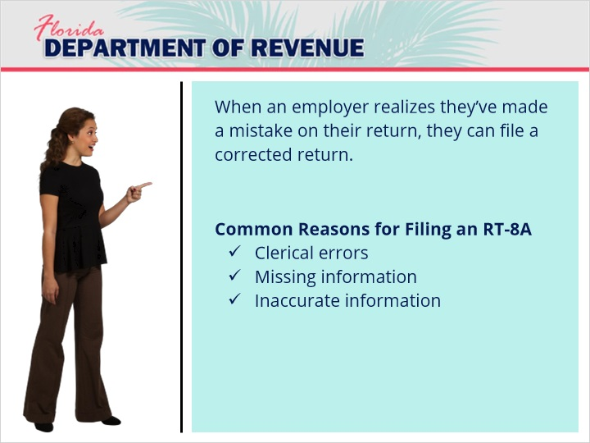
Transcript:
When an employer realizes they’ve made a mistake on their return, they can file a corrected return.

There are many reasons why a taxpayer would need to complete an RT-8A to correct a prior quarterly report. Some of these include clerical errors, missing information, and inaccurate information. Sometimes an erroneous report includes a combination of these. We’ll go through some examples in the next few slides.

[Olivia]: Sounds good.

2.3 Clerical Errors
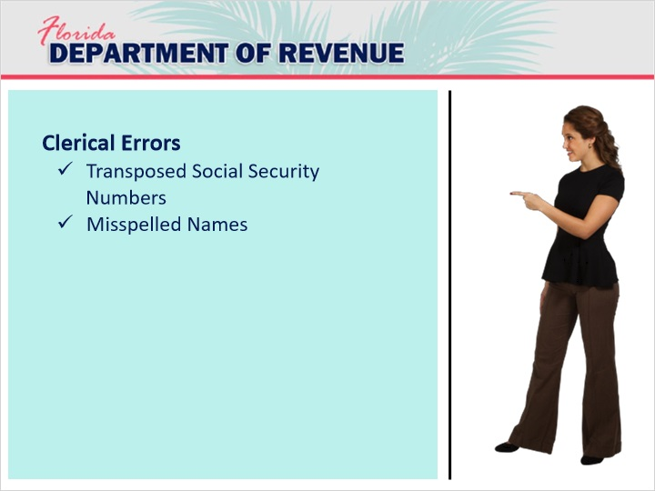
Transcript:
Clerical errors are common. Many people transpose the last numbers of Social Security numbers for one or more employees. Sometimes, names are misspelled. These are little mistakes that can be resolved quickly.

2.4 Missing Information
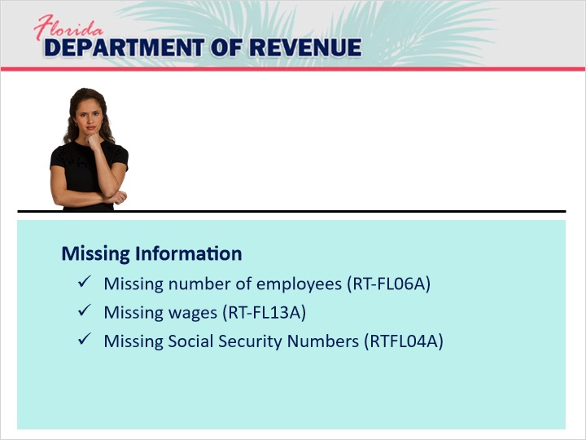
Transcript:
Another common mistake taxpayers make is leaving out important information on their return. The Department will send form letters for certain types of errors associated with not providing the required information. Don’t be alarmed if you receive one of these letters. They are just informing you of mistakes on your past return. If these are corrected, then no harm is done.

One common mistake is leaving out the number of employees working for you during the three months of the reported quarter. In that case, you would receive letter RT-FL06A informing you of this mistake.

Another common mistake is not reporting gross and taxable wages for one or more employees. For this error, you would receive letter RT-FL13A.

Finally, a return missing Social Security numbers is also common. If this happens, letter RT-FL04A will be sent to you.

2.5 Inaccurate Information
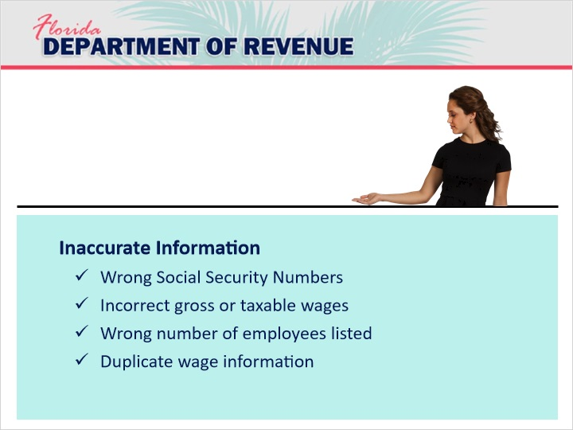
Transcript:
Inaccurate information is often caused by clerical errors or not including all pertinent information.

For example, transposing two numbers of a Social Security Number is a clerical error, and does not include all pertinent information.

Tell me more about your situation, Olivia.

[Olivia]: Well, I realized that the amount that I put for Emily’s gross wages was incorrect. The reason it was wrong was because I switched two of the numbers by mistake. So, I guess my clerical error caused my information to be inaccurate.
Resolving your issue is easy. In the next section of this tutorial, we will go through the process of filing the RT-8A online to send in a corrected return.

2.6 Penalty
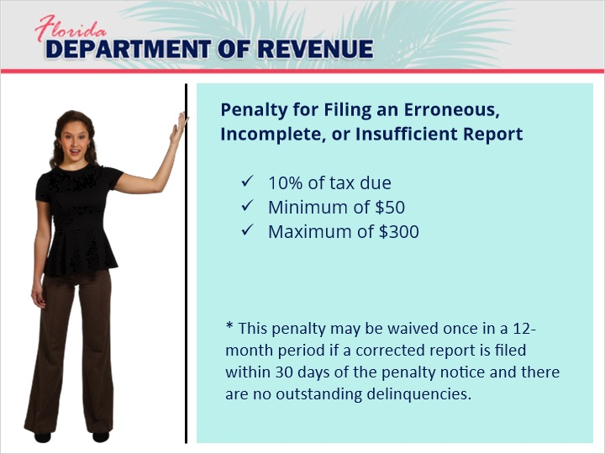
Transcript:
[Olivia]: There must be a penalty for filing an incorrect report, right?

Yes, there is. The penalty for filing an erroneous, incomplete, or insufficient report equals 10% of the tax due. The minimum fee is $50. The maximum is $300.

[Olivia]: So, I guess I’m going to have to pay then.

Not necessarily. This penalty may be waived once in a 12-month period if a corrected report is filed within 30 days of the penalty notice and there are no outstanding delinquencies on your account.

[Olivia]: Well, there’s some good news. Thanks.

3. Logging in to the Report

3.1 From the Homepage

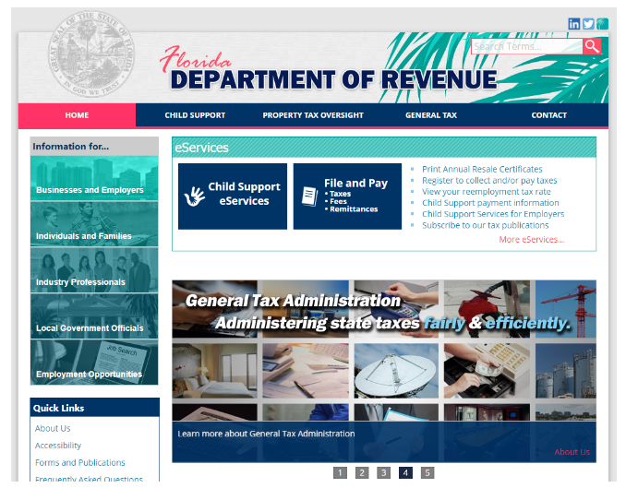
Transcript:
The information on this slide should be familiar to you. You log in using the same method you used to pay other taxes and to complete your RT-6 online.

Start by going to the homepage at floridarevenue.com.

Click on the blue box that says File and Pay.

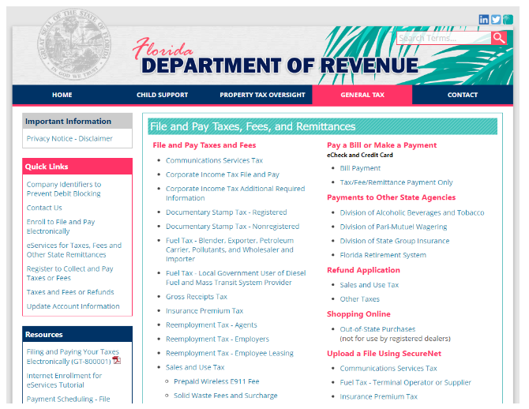

[Olivia]: OK, I remember this.

You will be taken to the page called File and Pay Taxes, Fees, and Remittances. Under the subtitle of File and Pay Taxes and Fees, go down to the appropriate reemployment tax link and select it. For example, if you are not an agent for an employer and are not a representative of an employee leasing company, you would select Reemployment Tax - Employers.

3.2 The Login Page

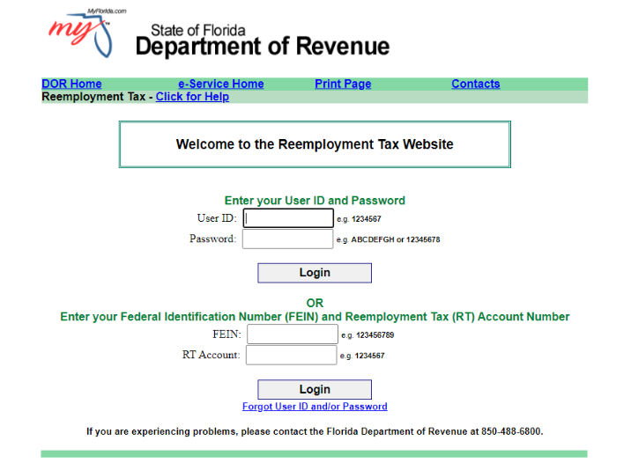
Transcript:
Once you have selected the appropriate link, you will be taken to a login screen for the Reemployment Tax website.

The first option is to log in with the user ID and password you chose when you created your account for the Florida Business Tax Application (Form DR-1).

The second option is to log in with your FEIN and RT Account number. Keep in mind that if you choose this option, you will not be able to use the banking and contact information on file with the Department to autofill pertinent information in your return. Fill out the information for the option you choose and then click the Login button under the option you chose.

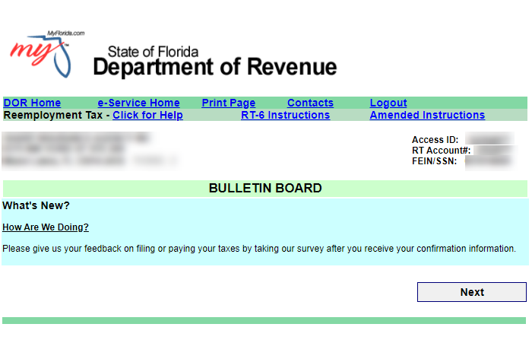
Once you log in, you will be taken to the bulletin board, which features relevant information about reemployment tax. Read through this information and then select Next to move on.4.

Completing the Online Form

4.1 Selecting the Return

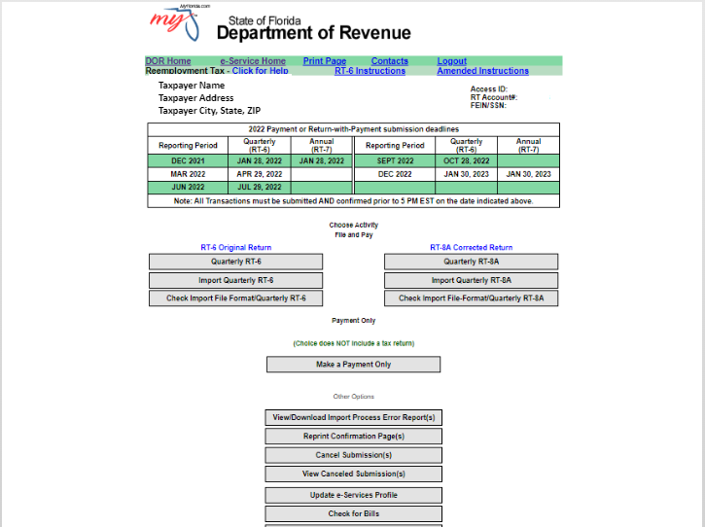
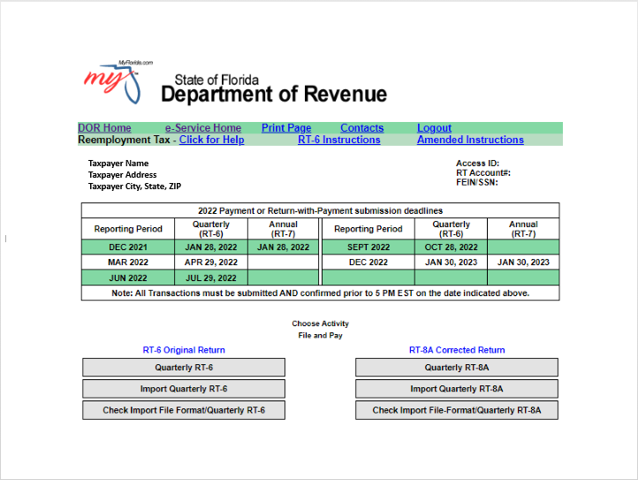
Transcript:
Here, you have the option either to import corrected data or to manually key in the data. In this example, we are going to enter the data manually.

On the menu, click Quarterly RT-8A.

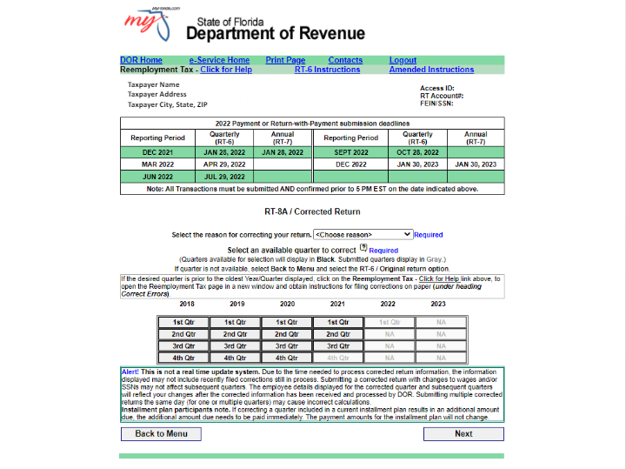

Before completing the RT-8A, you must enter the reason you are filing a corrected return.

As discussed previously, there are many reasons you may need to complete a corrected return. One example is when you receive letter RTFL06A.

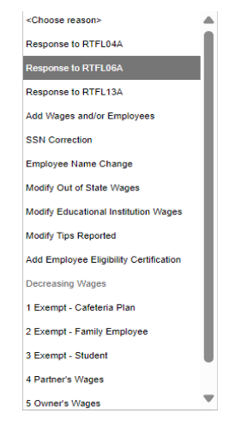
You will receive this letter if you fail to enter the number of employees you have for each month of the reported quarter.

Let’s see what happens when you select this reason.

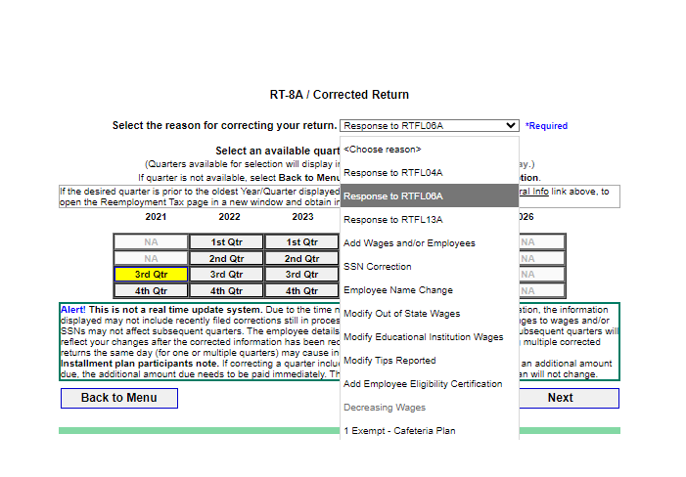
Go to the dropdown box that says, Choose Reason and select Response to RT-FL06A.

From the table, select the quarter that you are filing for. You must select one that is highlighted in black. Click Next to continue.

4.2 E-Verify Certification

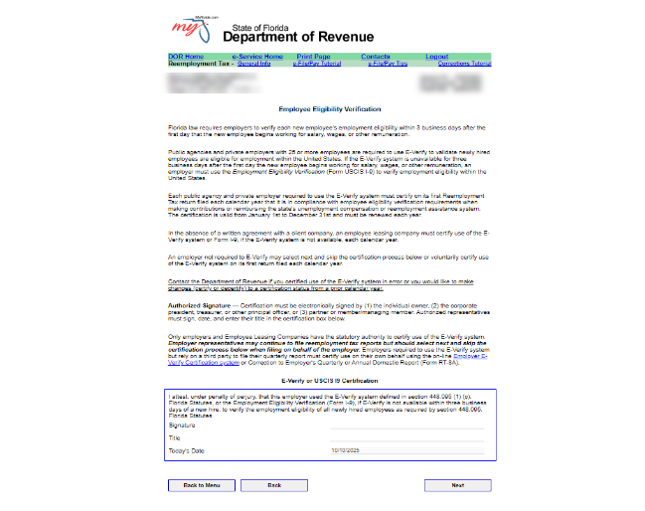
Transcript:
You will be taken to the Employee Eligibility Verification page.
Section 448095, Florida Statutes (F.S.), requires employers to verify each new employee’s employment eligibility within three business days after the first day that the new employee begins working for salary, wages, or other remuneration.

Public agencies, private employers with 25 or more employees, or employee leasing companies that do not defer certification through a written agreement or understanding with the client company are required to use E-Verify to validate that newly hired employees are eligible for employment within the United States.

If you are required to use the E-Verify system, you must certify on your first reemployment tax return or report filed each calendar year that you used E-Verify or the federal form USCIS I-9 to confirm employment eligibility of each new employee.

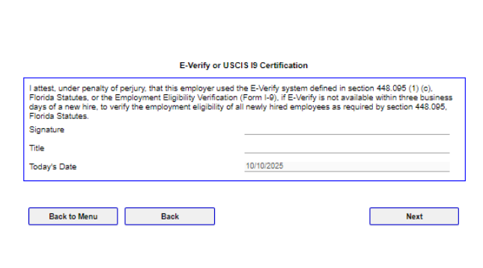
You must attest on the bottom of the page that your business used the E-Verify system. Complete the form with your signature, title, and the date, and select the Next button.

4.3 Responding to the RTFL06A

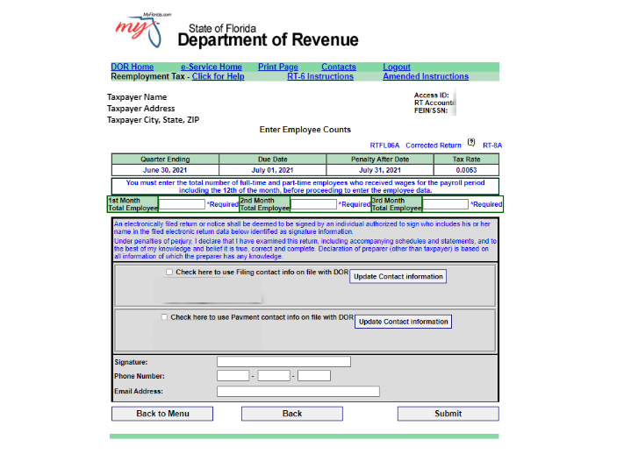
Transcript:
Once you have signed the Employee Eligibility Verification page and selected Next, you will enter employee counts for each month. Once you have done so, indicate whether you want the contact information the Department has on file for you to be used. If so, click on the first checkbox.

If you want the payment contact information the Department has on file for you to be used, click on the second checkbox.

If you choose not to use the information on file, you will need to enter your name in the signature box along with your phone number and email address.

Then click Submit at the bottom of the page.
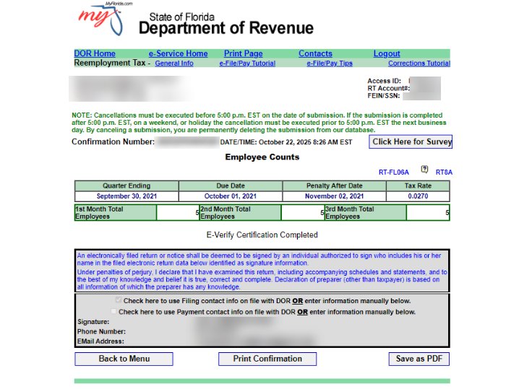

Once you have done so, you will be taken to a page displaying the employee counts you entered along with a message stating that E-Verify Certification has been completed.

You have options to print the confirmation or save it as a pdf for your records. When you are finished viewing the confirmation page, select the “Back to Menu” button.
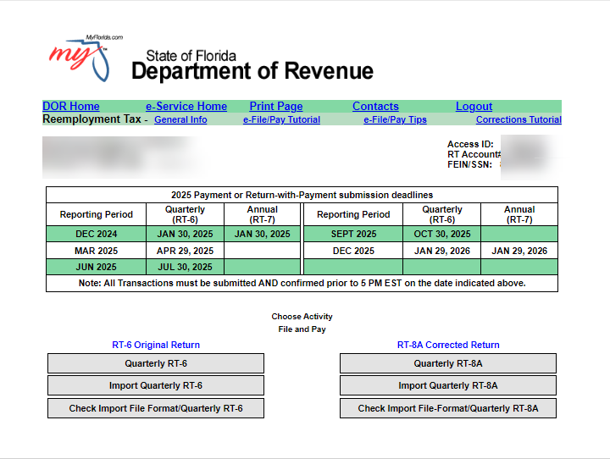

[Olivia]: Do I need to fill out a separate corrected return for each reason I have for correcting my return?

No. All other reasons listed for correcting a return take you to a form with the same interface. The only one that looks different is the interface for the reason of Response to RTFL06A. That’s why I showed it to you first.

Why don’t we go through the process of choosing another reason for correcting a return and see what happens?

4.4 Add Wages and Employees
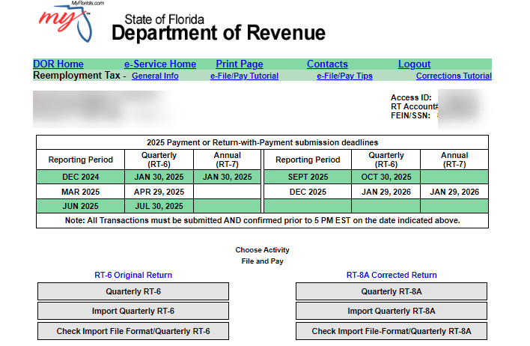

Transcript:
Begin again at the main menu. Select Quarterly RT-8A.

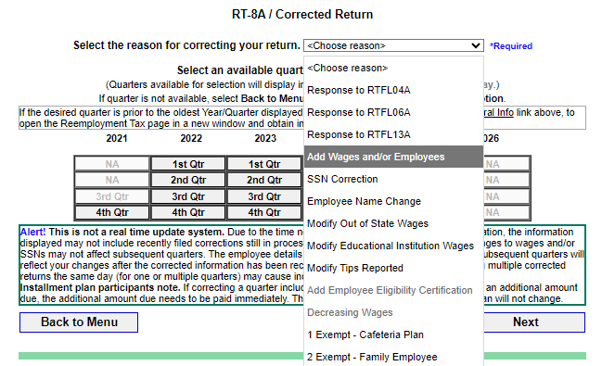

This time we will select a different reason: adding employees or editing their information. Select the Add Wages and/or Employees option from the dropdown menu. Then, select the quarter for the return you are correcting. Click the Next button.

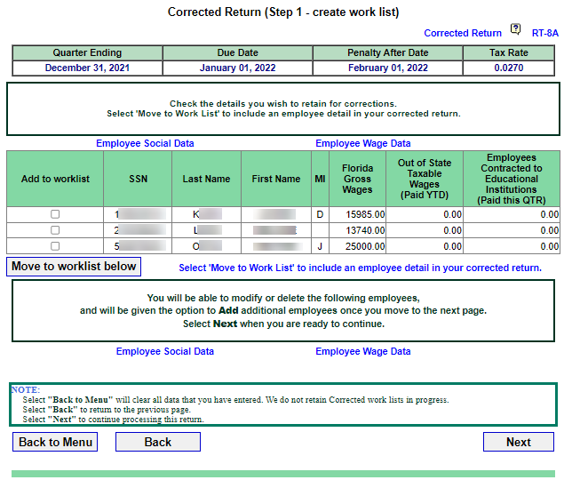

From the list of employees, select the checkmark next to the employees’ names you want to move, and then select the Move to worklist below button.

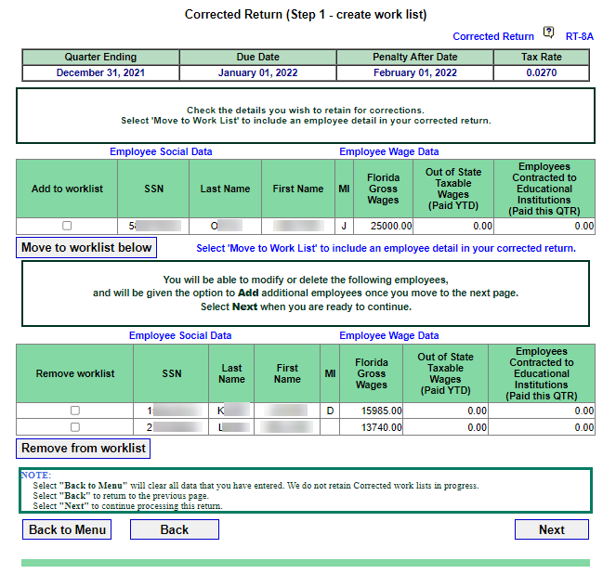

The new worklist will appear. If you want to remove any of the employees you selected from the worklist, select the checkmark next to their names and then select the Remove from worklist button.

To continue, click Next.

4.5 Update the Worklist
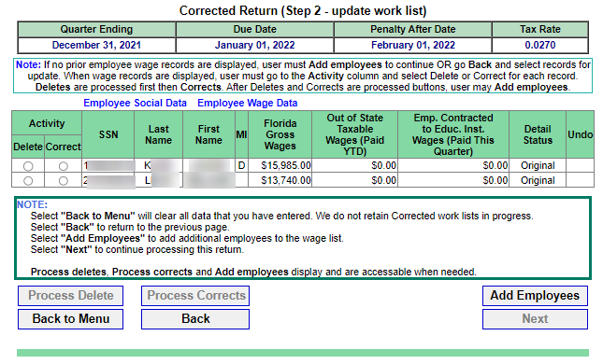

Transcript:
To edit the worklist, select the radio buttons under the Activity column for each employee whose information you want to change.

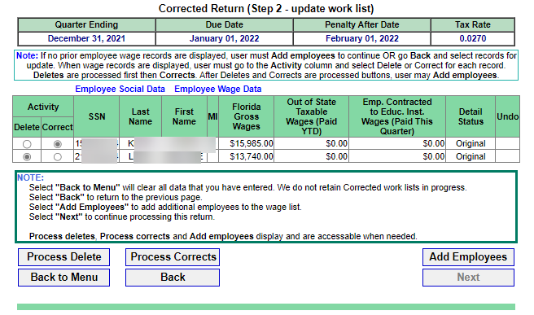

In this case, we are going to change an employee’s wages. We are also going to delete an employee.
To correct an employee’s record, select the correct radio button. To delete an employee, select the delete radio button.

Then, select the Process Corrects button.
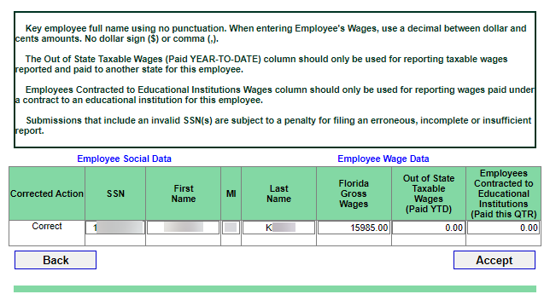

On the next screen, verify the information for the employee you are editing is correct and select Accept.

4.6 Update the Worklist Continued
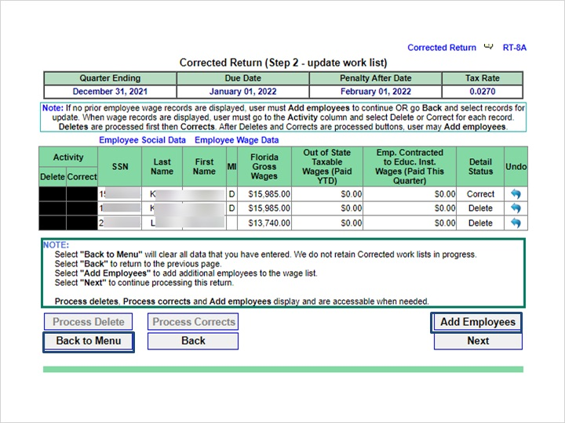
Transcript:
You will return to the worklist.

[Olivia]: Why is the same person listed twice in the list? Is that supposed to happen?

Yes. In this example, notice that the person with the last name starting with “K” displays twice in the list. Under the “Detail Status” column in the table, the first entry says “Correct.” This entry is the new, corrected entry for employee “K.”

The second entry for employee “K” has the status of “Delete.” This is the original entry which will be deleted.

To delete an employee completely, make sure that the “delete” radio button is selected for their entry under the “Activity” column.

Then, select the “Process” delete button.
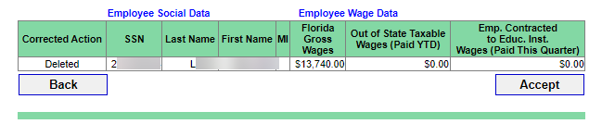

Verify that the correct employees are being deleted. Select the “Accept” button to delete them.

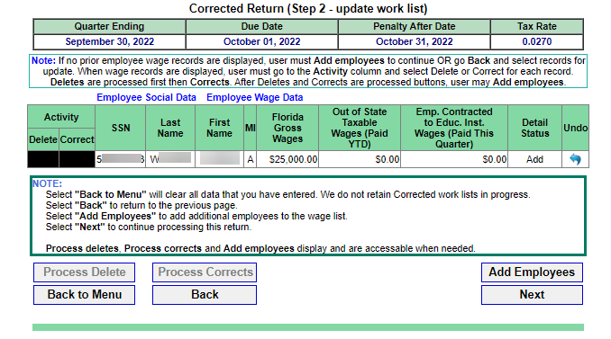
From here, you can return to the main menu by clicking on “Back to Menu.” If you need to Add Employees, click on the “Add Employees” button.

4.7 Adding Employees
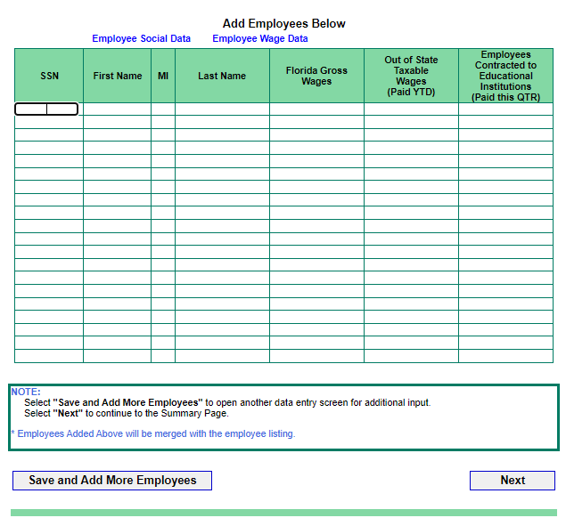
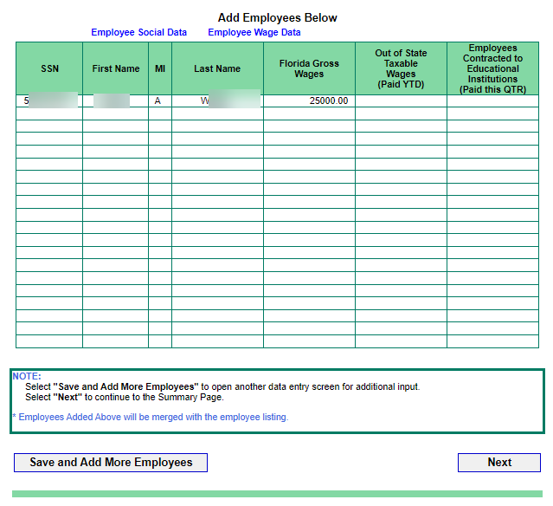
Transcript:
To add an employee, fill out the information for the employee in the table. If you wish to save these entries and add more, click the button labeled “Save and Add More Employees.” If you have finished, click the “Next” button.

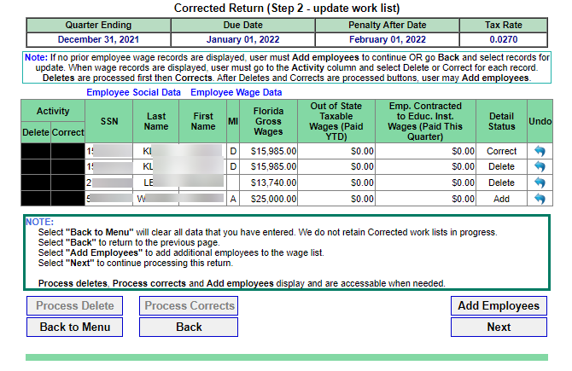
You will be returned to the worklist. If you are ready to continue, click the “Next” button.

4.8 Review and Summary
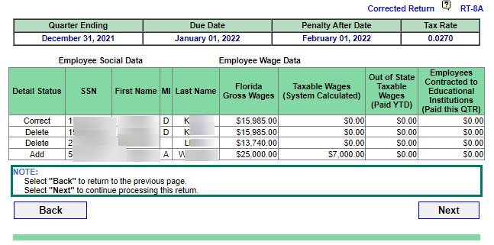
Transcript:
The next step is to review the changes that you’ve made.

Here, you can see where the first employee with the last initial of “K” was edited. On the third line in the table, you can see that an employee with the last initial of “L” was deleted. Finally, a new employee with the last initial of “W” was added.

If you need to revise anything on the worklist, click the Back button to go to the previous page. Once you’ve reviewed the worklist and are ready to move forward, click the Next button.

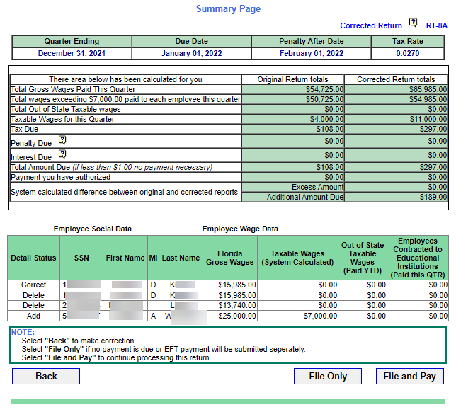

The Summary Page for the corrected return is now visible.

You should see two columns in green: one shows the original return totals and the other shows the corrected return totals. Review these totals to see if they reflect the changes as shown in the Employee Wage Data at the bottom of the page.

If you want to submit your corrected return without making a payment, click on the File Only button. To file your return and pay, click on the File and Pay button. Please note that if you don’t owe any money, the File and Pay button will not be active.

4.9 Making a Payment
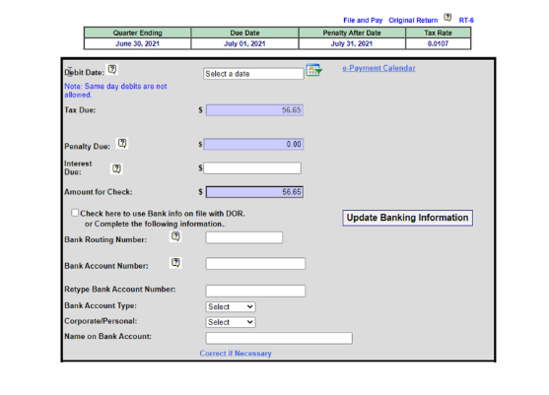
Transcript:
Once you select File and Pay, the banking information section will appear.

The Debit Date field is displayed on the top half of the screen above your banking information. This indicates the date the funds will be taken out of your bank account. To select a date, type it in manually into the Debit Date field, or click on the calendar icon. Please note, you can only select dates in black. The blue and gray dates are unavailable.

Your banking information will pre-populate based on the data you have on file with the Department. Check the box that says, “Check here to use Bank info on file with DOR.” Your banking information will appear in the fields below the checkbox.

Scroll down to the bottom of the page.
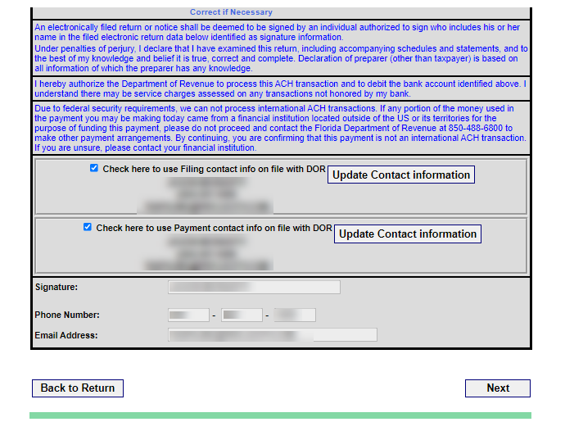

There are two more checkboxes. Select the first checkbox if you want to use the filing contact information already on file with the Department.

Select the second checkbox if you want the system to use the payment contact information on file.

[Olivia]: Didn’t you say something earlier about information that wouldn’t be available if you logged in a certain way?

Yes, I did. Keep in mind that if you chose your FEIN and RT Account number as your method of logging in, these options will not be available to you. You will have to enter all information manually.

Once all the information is displayed or has been entered, click the Next button on the lower right-hand corner of the screen.

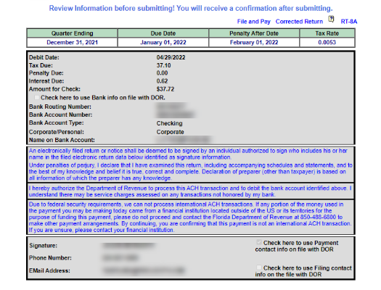

Here, you will review pertinent information before submitting your corrected return.

Your banking information will be displayed at the top of the page.

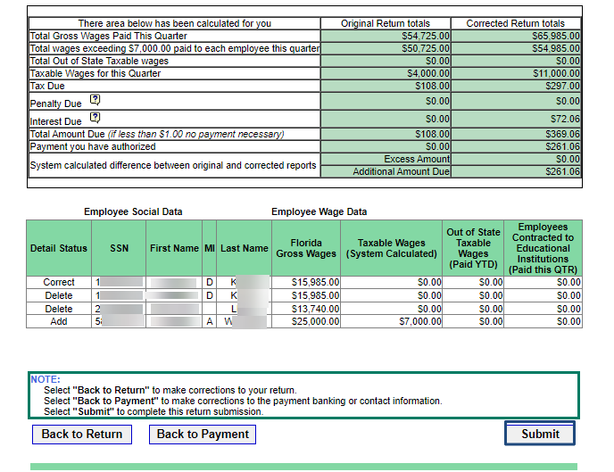
Below, you will see a comparison of your original return and your corrected return. Your employee wage data will also be displayed.

If you wish to go back to your return to make adjustments, select Back to Return. If you wish to revisit the banking section, select Back to Payment. Finally, to submit your amended return, select Submit.

4.10 Confirmation
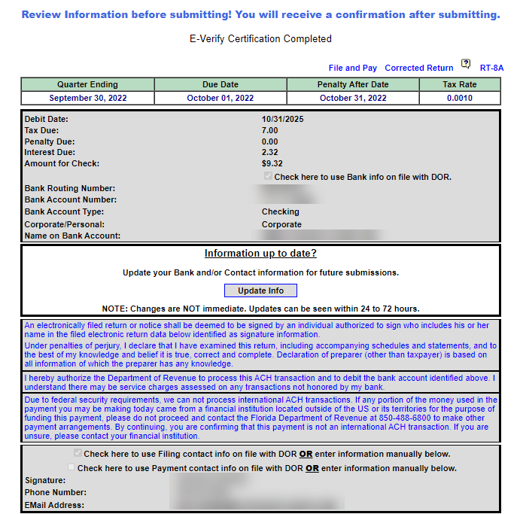

Transcript:
You will review your information before officially submitting your return.

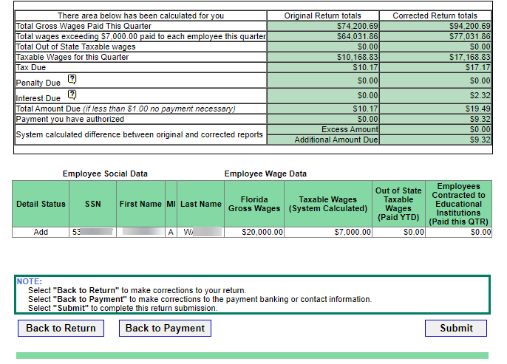

Be sure to review all the information including your banking information and the comparison of your original return verses your corrected return. When you have done so, click Submit.

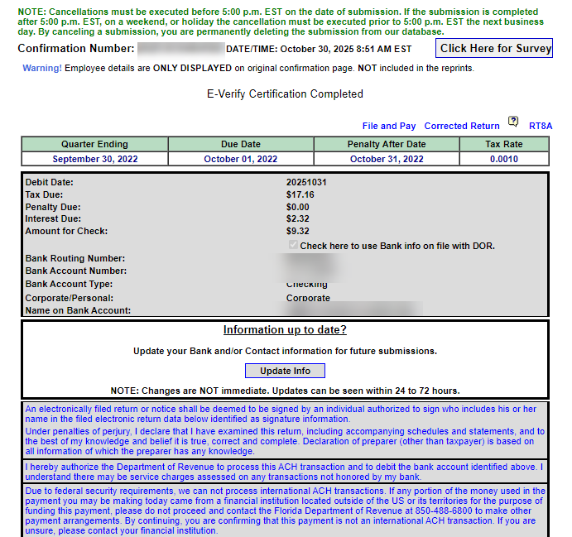

The Confirmation Page will display. You will see your confirmation number for your corrected return at the top of the page.
Your payment information will be displayed in the middle of the page.

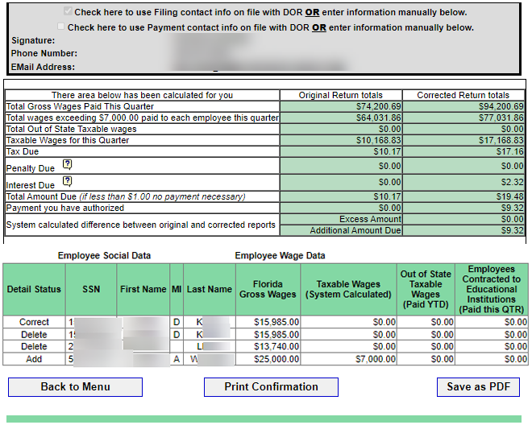

Next, you will see a table with a comparison of the amounts on your original return and your corrected return.
At the bottom of the screen, you will have the option to go back to the main menu by selecting Back to Menu. You may also print the confirmation of the return by selecting Print Confirmation. To save the document as a PDF, select Save as PDF.

5. Conclusion

5.1 Summary
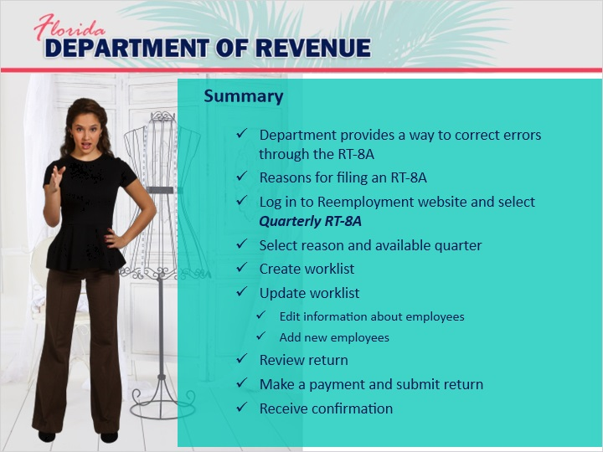
Transcript:
So, Olivia. Are you feeling more confident about amending your return by submitting an RT-8A?

[Olivia]: I think so.

Do you think you could walk us through the process?

[Olivia]: I would be happy to.

First of all, making a mistake on your original RT-6 return is not a big deal. It happens. That’s why the Department provides employers with a way to make corrections through filing a corrected return.

There are several reasons someone might need to file an RT-8A. These include clerical errors, missing information, or inaccurate information on the original return.

Logging in to complete an RT-8A is very similar to what you did to complete your original RT-6 return. Go to the Department’s homepage and click on the blue File and Pay button. Log in to the Reemployment website and select the button that says Quarterly RT-8A to file your corrected return. Choose a reason for filing a corrected return and select the available quarter you wish to correct.

You will begin by creating a worklist consisting of all the employees whose information needs to be updated. These updates include editing information about established employees such as correcting their Social Security numbers or adjusting their wages. If needed, you will add employees not originally submitted on the original return.

Once you have updated your worklist, you will have a chance to review your corrected return. You can either file the return only or choose to file and pay your return at the same time.

If you choose to file and pay, be sure all payment information is entered correctly and then submit the return. You will receive a confirmation message that your return has been accepted.

Did I miss anything?

No, I think that covers everything. Thanks, Olivia.

[Olivia]: No, thank you for helping me.

My pleasure.

5.2 Survey
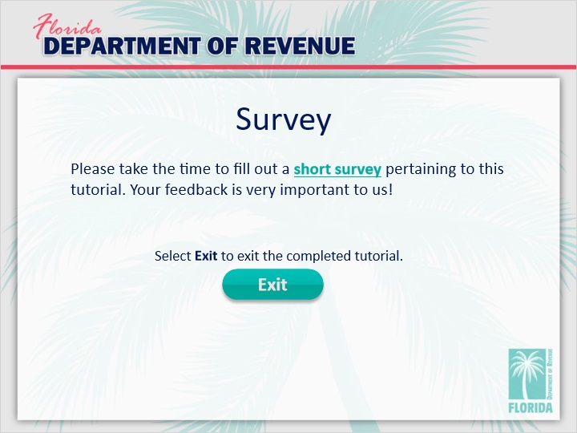
Transcript:
This concludes the tutorial for Reemployment Tax Part 5: Filing a Quarterly Corrected Return (RT-8A) Online.

For more information, check out the resources available within this overview by clicking on the Resources tab in the upper-right corner of your screen.

Please take a moment to fill out a brief survey pertaining to this tutorial. Your feedback is very important to us.

To exit this tutorial, click on the Exit button.

Thank you.

