How to Complete Sales and Use Tax (Form DR-15EZ) - Accessibility Outline

1. Introduction

1.1 Title Slide
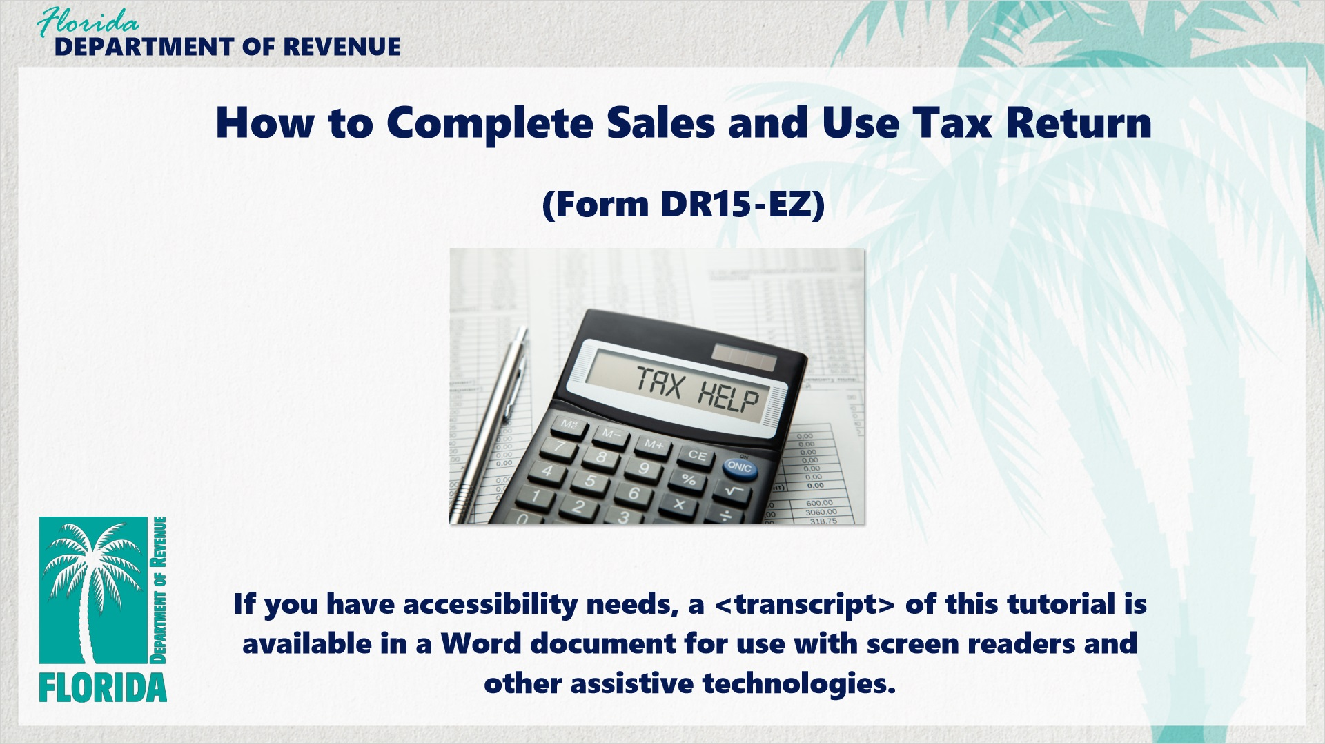
Transcript:
Welcome. This tutorial helps businesses understand how to complete the Sales and Use Tax Return (Form DR-15EZ).
If you have accessibility needs, a transcript of this tutorial is available in a Word document for use with screen readers and other assistive technologies.

1.2 Navigating This Tutorial
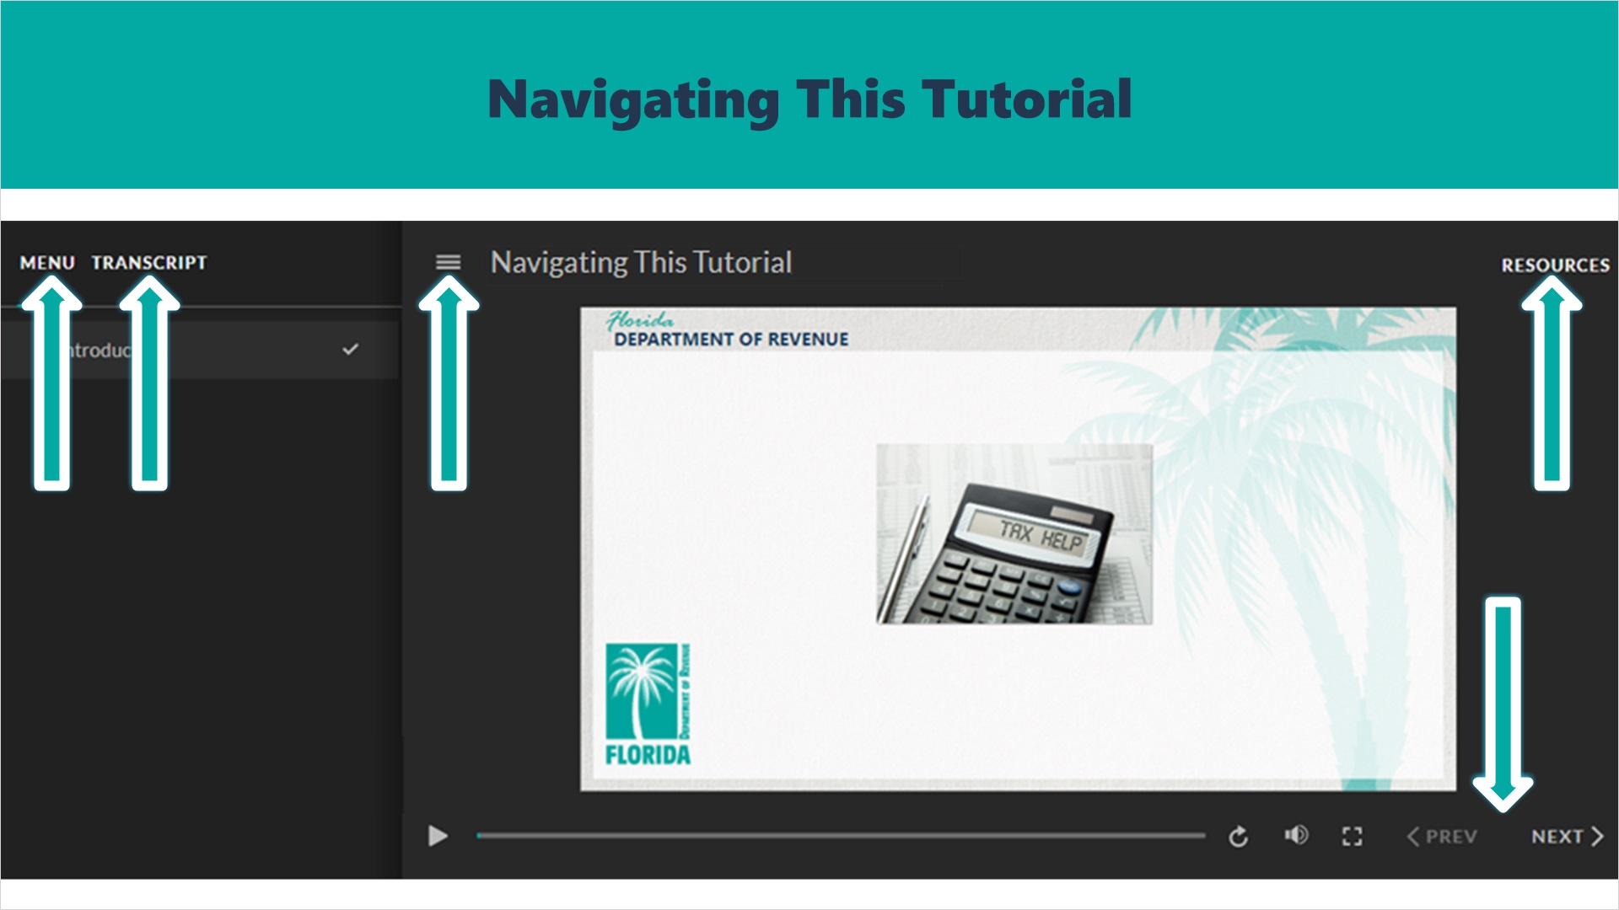
Transcript:
This tutorial will take approximately 15 minutes to complete. A transcript of the audio is available by clicking on the transcript tab in the top-left corner of your screen.
The following tabs and buttons are available to help you navigate throughout this tutorial.
Menu Tab
The menu tab displays by default when the tutorial is viewed on a computer. It allows you to navigate through the tutorial by clicking on the topic name on the menu. When viewing this tutorial on a tablet or smartphone, the menu does not display by default and must be accessed using the menu symbol.
Resources Tab
The resources tab is found on the right side of the top bar. When clicked, it displays the list of links to useful forms, documents, and webpages.
Previous and Next Buttons
The previous and next buttons are located at the bottom-right corner of your screen. These buttons allow you to move either back or forward.

1.3 Topics Slide
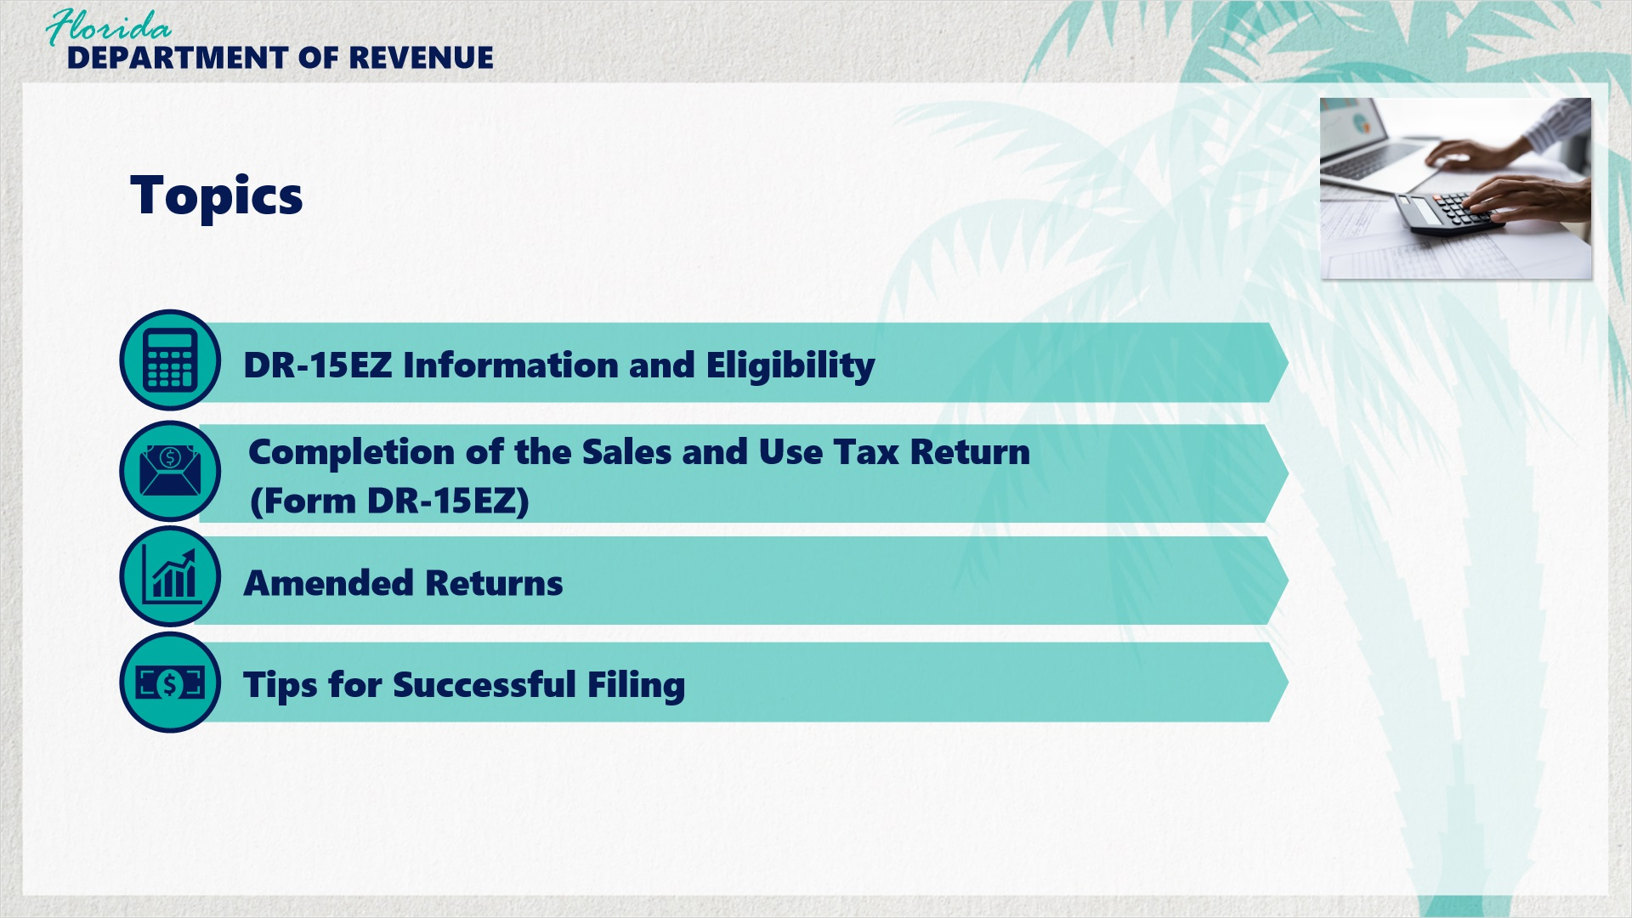
Transcript:
The topics covered in this tutorial include DR-15EZ Information and Eligibility, Completion of the Sales and Use Tax Return (Form DR-15EZ), Amended Returns, and Tips for Successful Filing.

2. Tax Return Overview

2.1 What is the DR-15EZ?
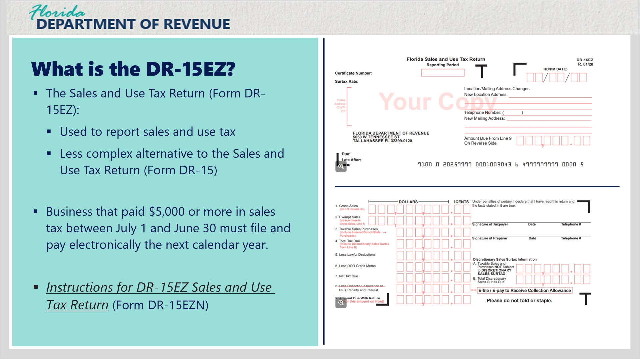
Transcript:
The Sales and Use Tax Return (Form DR-15EZ) is used to report sales and use tax and is a less complex alternative to the Sales and Use Tax Return (Form DR-15).
You may voluntarily file and pay taxes electronically; however, Florida law requires businesses that paid $5,000 or more in sales tax between July 1 and June 30 to file and pay electronically the next calendar year.
Refer to the Instructions for DR-15EZ Sales and Use Tax Return (Form DR-15EZN) on the Department’s Forms and Publications page for additional guidance when completing the form.
Click on the images to view larger versions of the front and back of Form DR-15EZ.

Front Large Layer (Slide Layer)
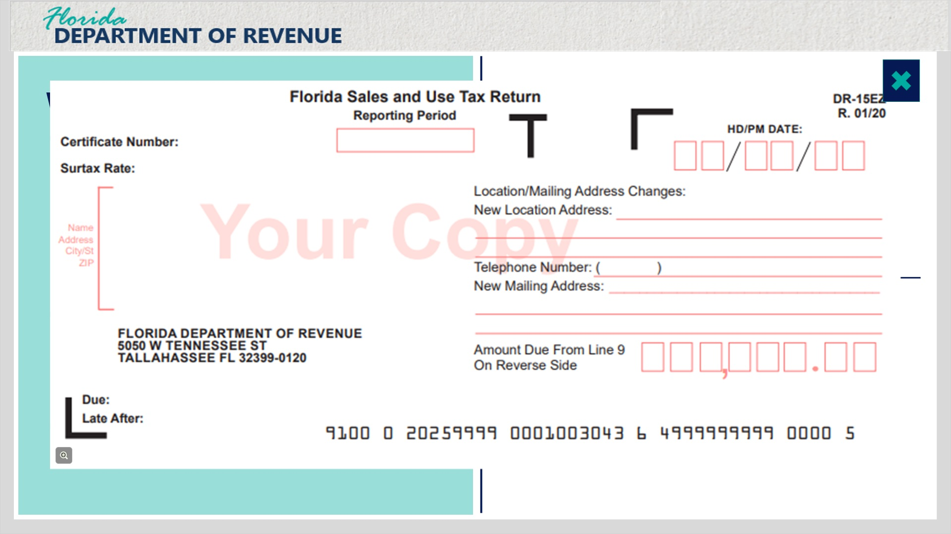

Back Large Layer (Slide Layer)
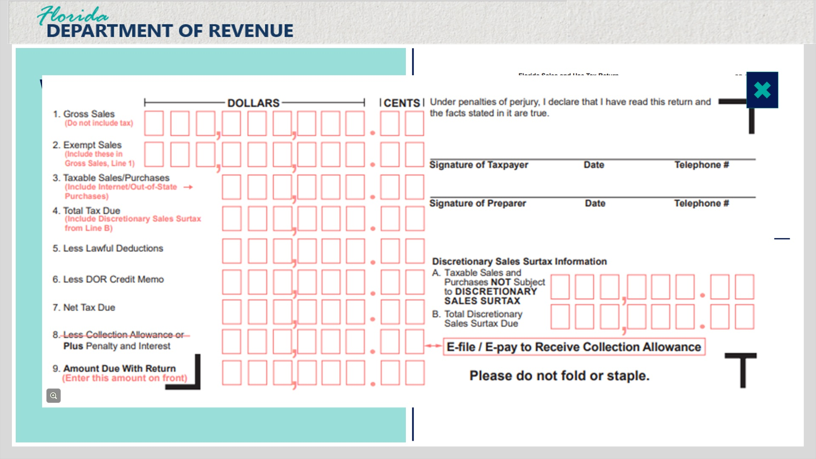

2.2 DR-15EZ Eligibility
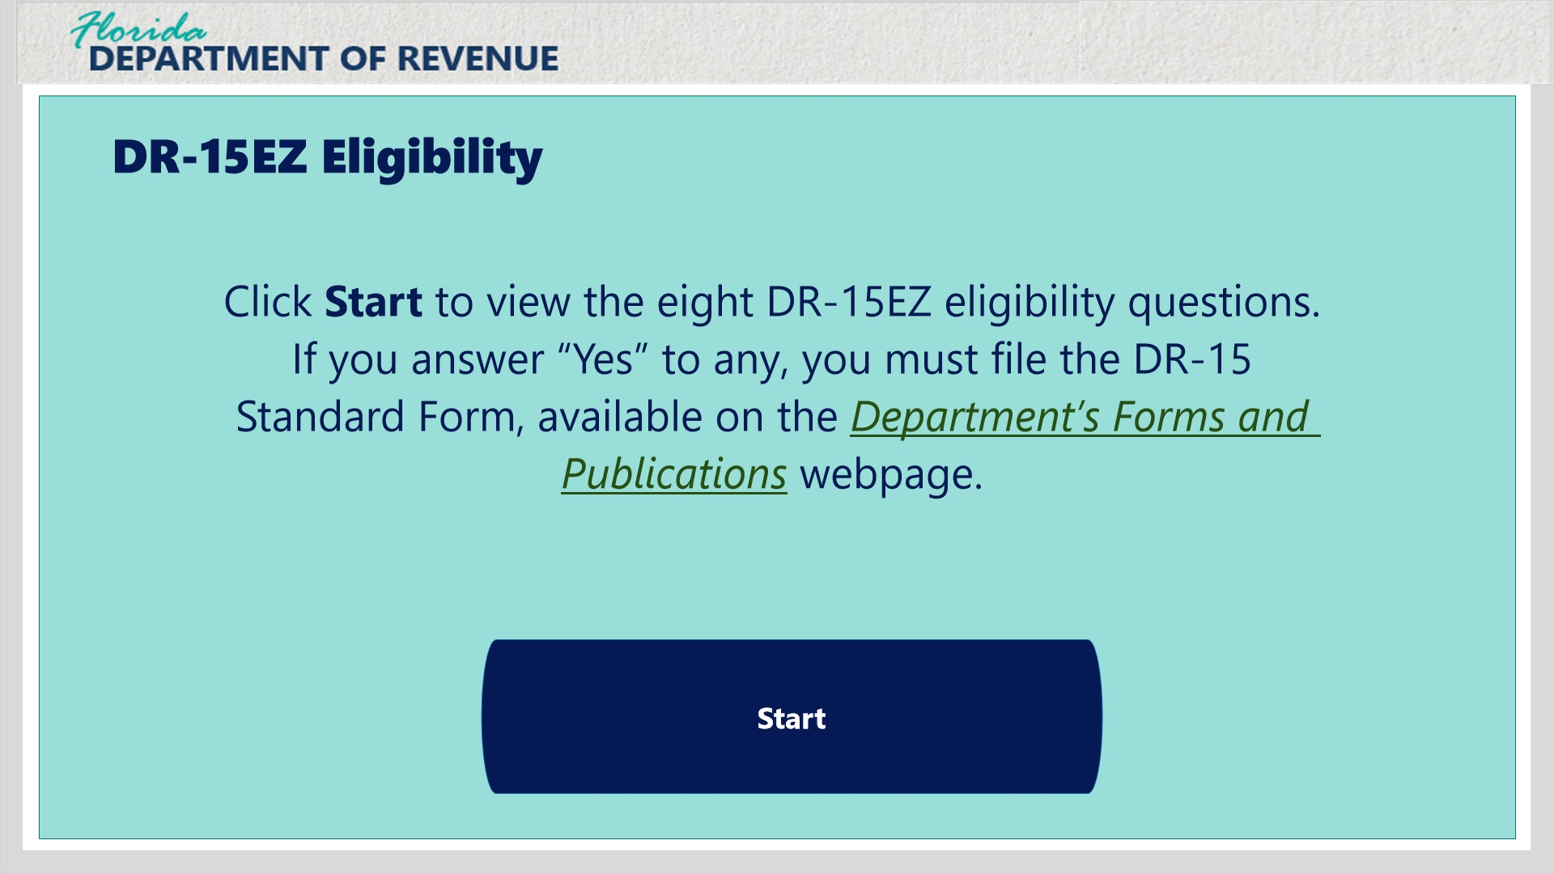
Transcript:
Not all businesses are eligible to file using Form DR-15EZ. To verify your eligibility, click the Start button and answer each question.
If you answer yes to any of these questions, you are required to use the DR-15 Standard Form. You can access the form using the Department’s Forms and Publications webpage.

Remitted over $200k (Slide Layer)
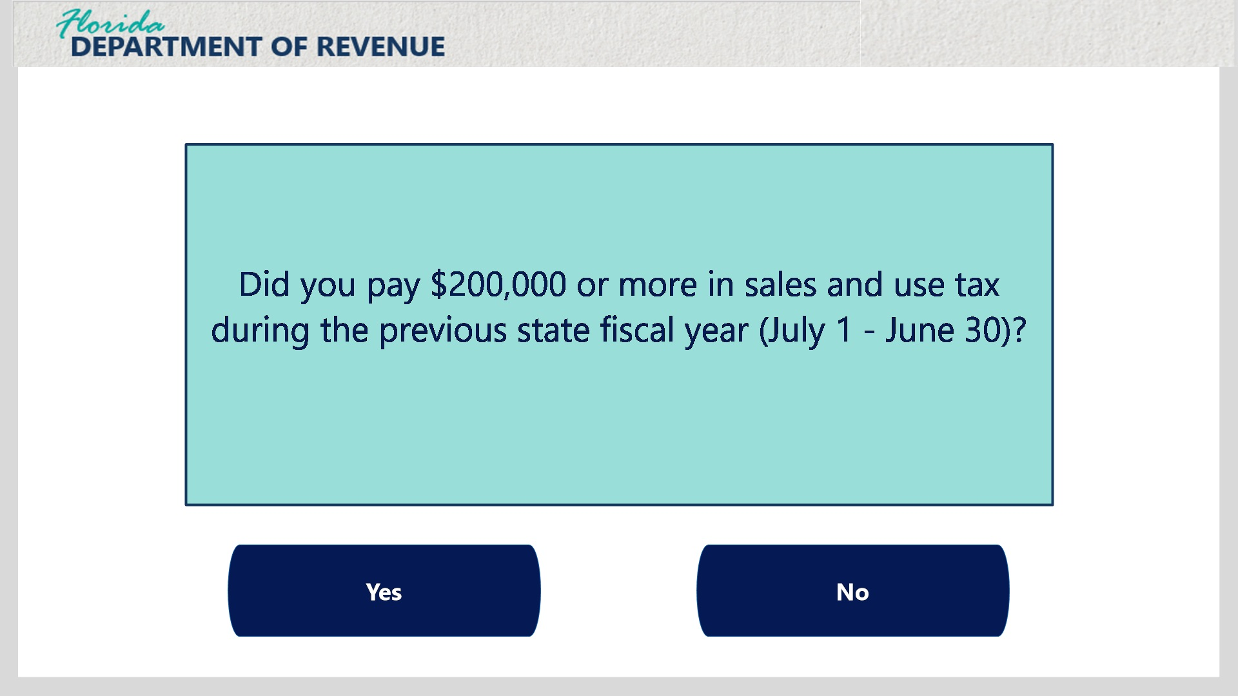
Transcript:
Did you pay $200,000 or more in sales and use tax during the previous state fiscal year (July 1 - June 30)?

Deliver to other counties (Slide Layer)
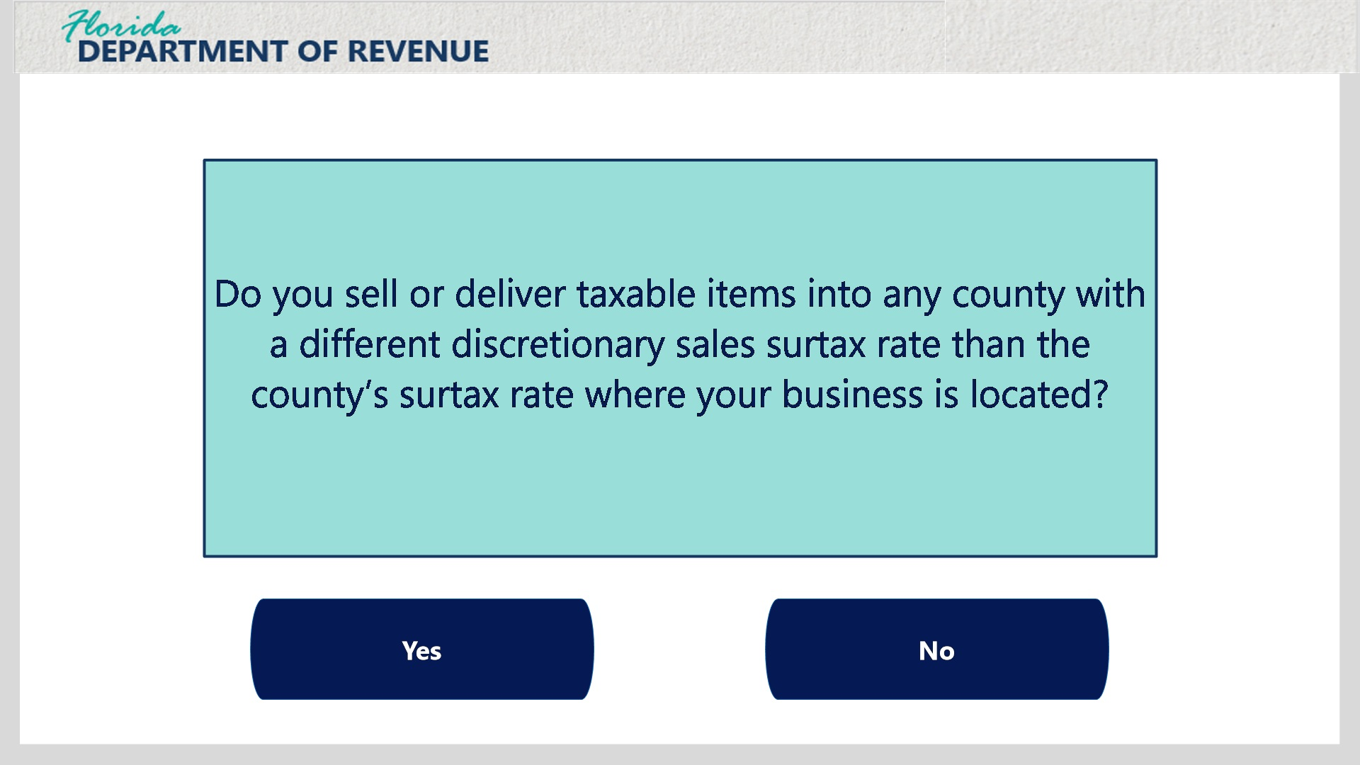
Transcript:
Do you sell or deliver taxable items into any county with a different discretionary sales surtax rate than the county’s surtax rate where your business is located?

Rentals (Slide Layer)
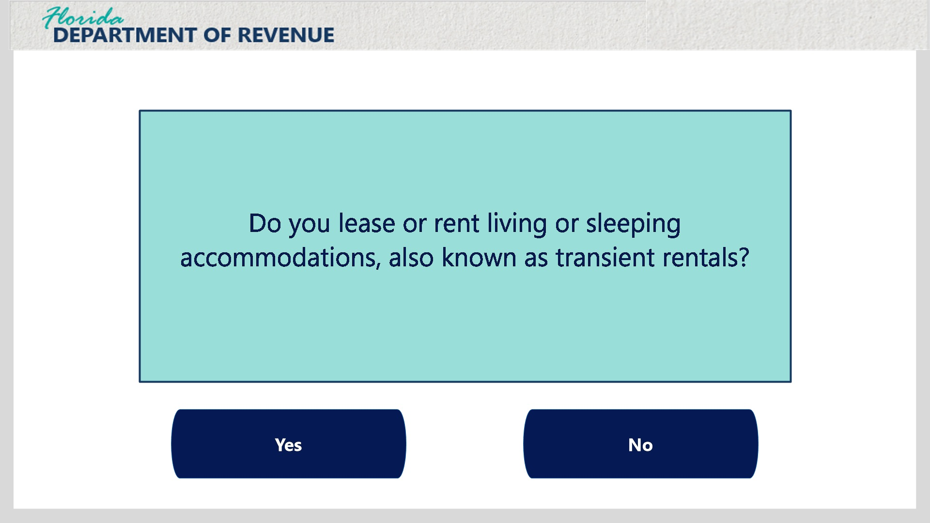
Transcript:
Do you lease or rent living or sleeping accommodations, also known as transient rentals?

Commercial Property (Slide Layer)
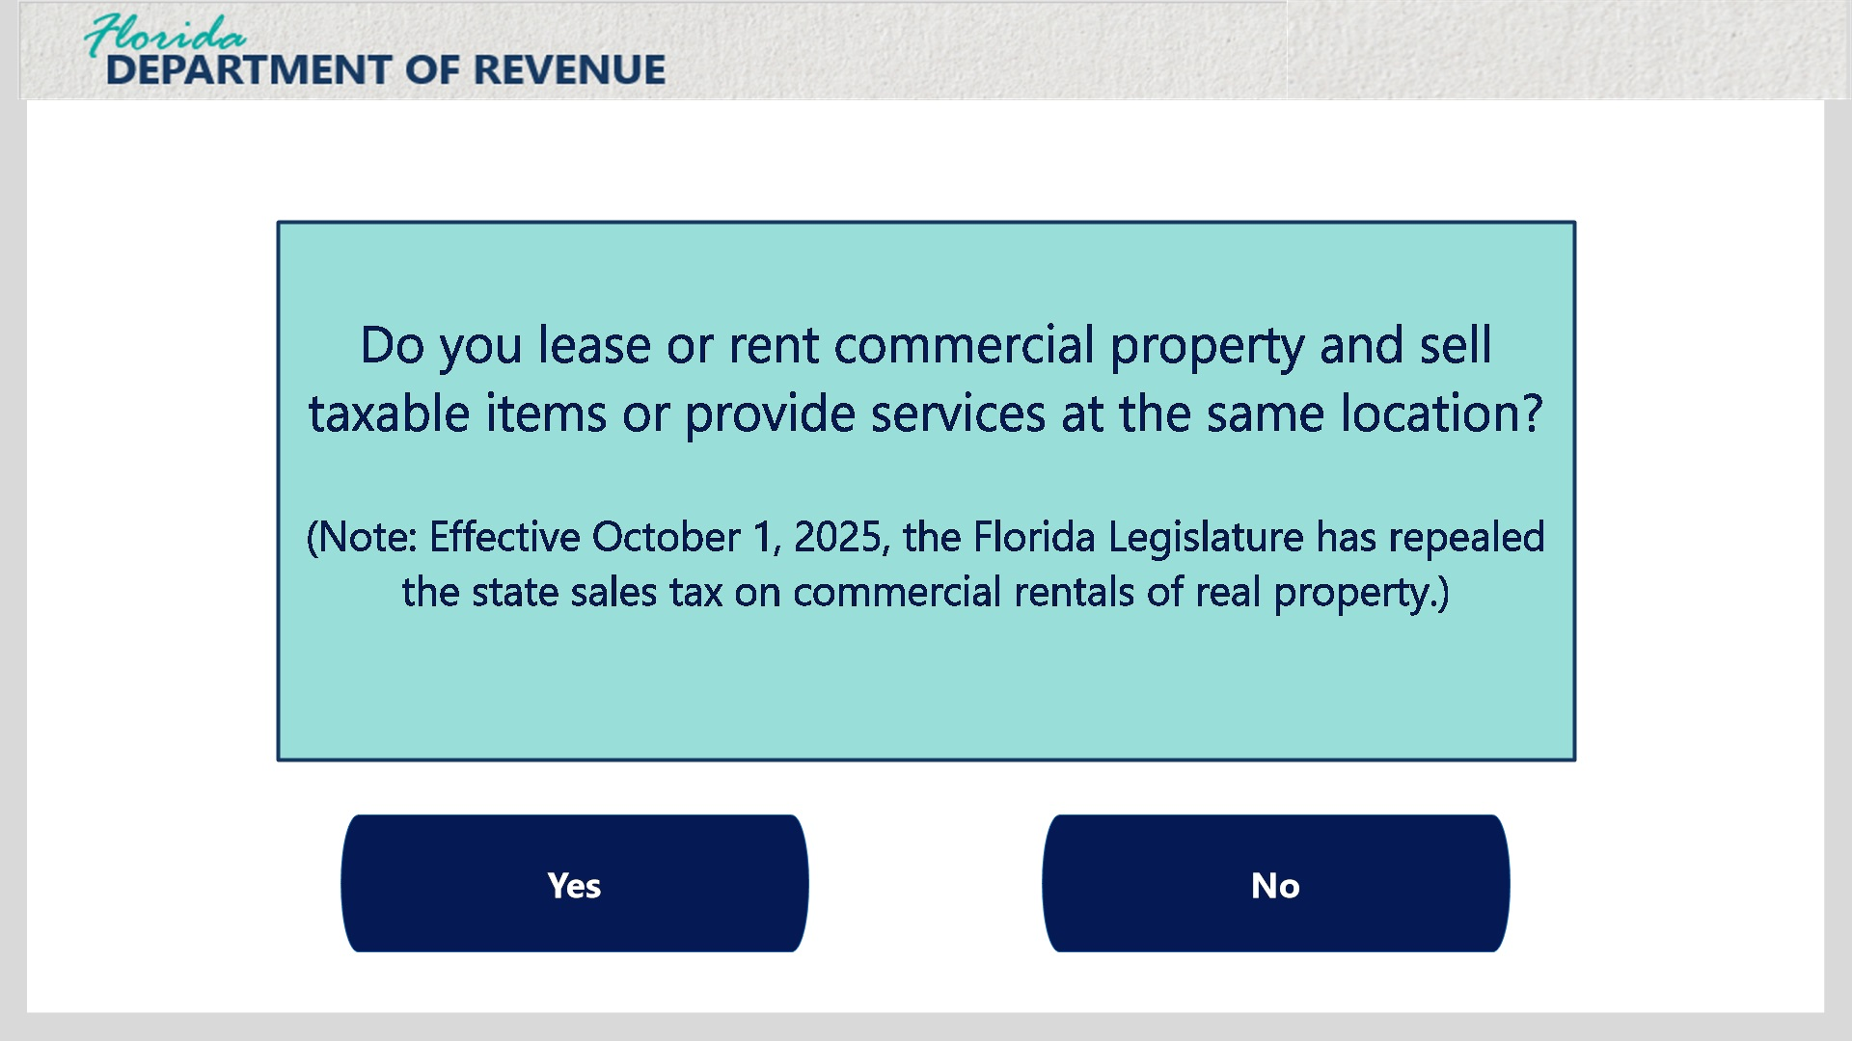
Transcript:
Do you lease or rent commercial property and sell taxable items or provide services at the same location? Note that effective October 1, 2025, the Florida Legislature has repealed the state sales tax on commercial rentals of real property.

Planes, Boats, and Cars (Slide Layer)
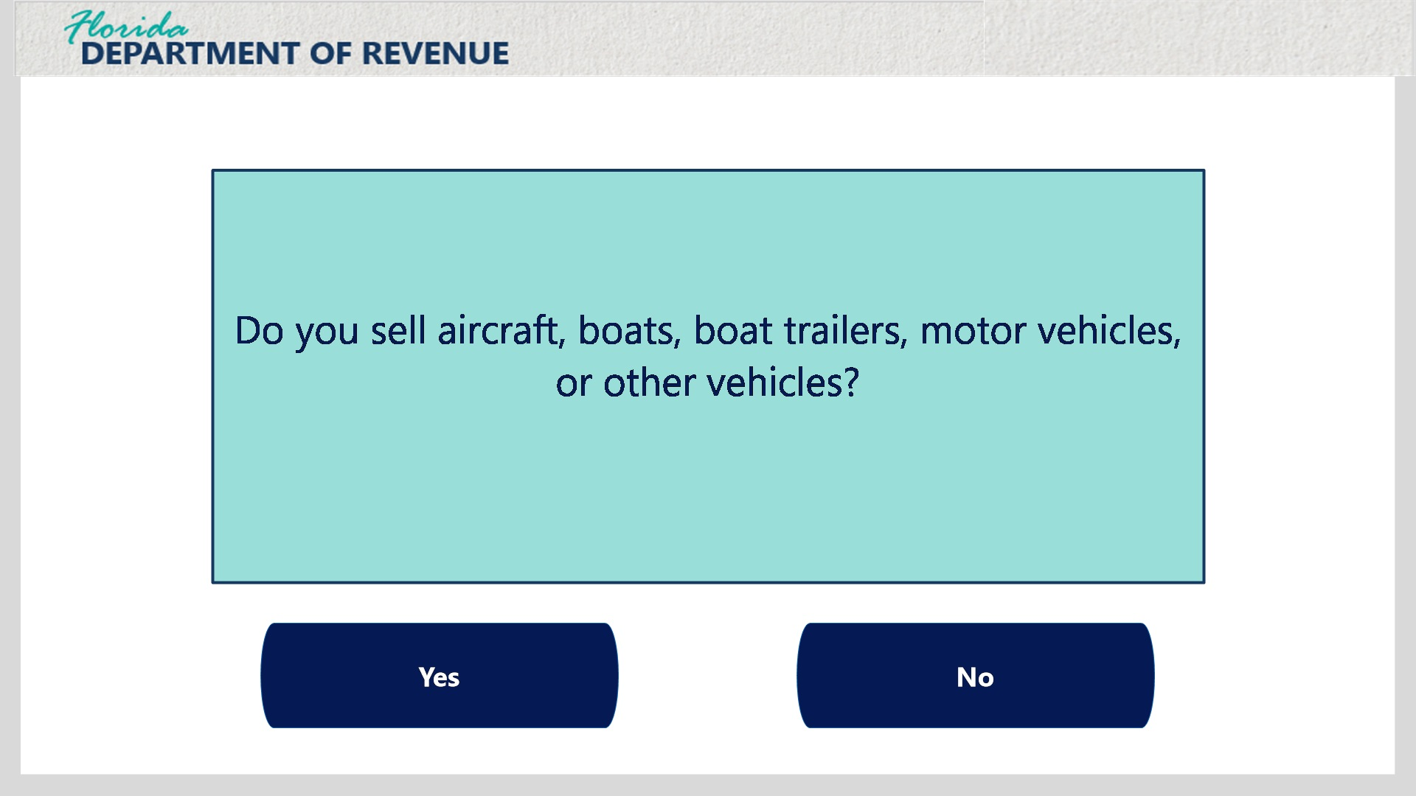
Transcript:
Do you sell aircraft, boats, boat trailers, motor vehicles, or other vehicles?

Vending and Amusement Machines (Slide Layer)
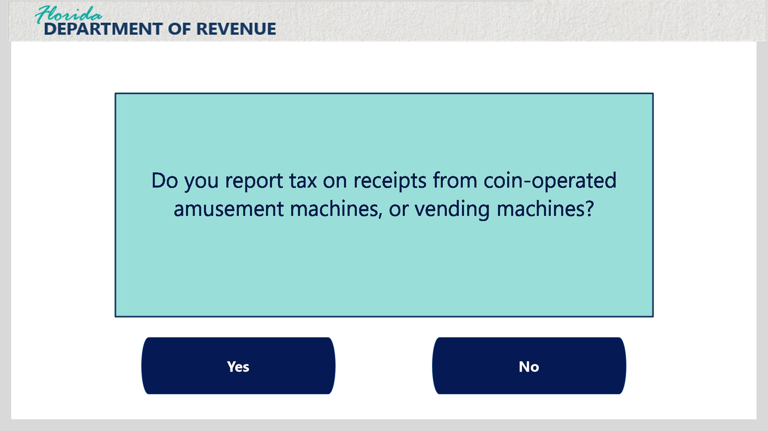
Transcript:
Do you report tax on receipts from coin-operated amusement machines, or vending machines?

Tractors and Undyed Diesel (Slide Layer)
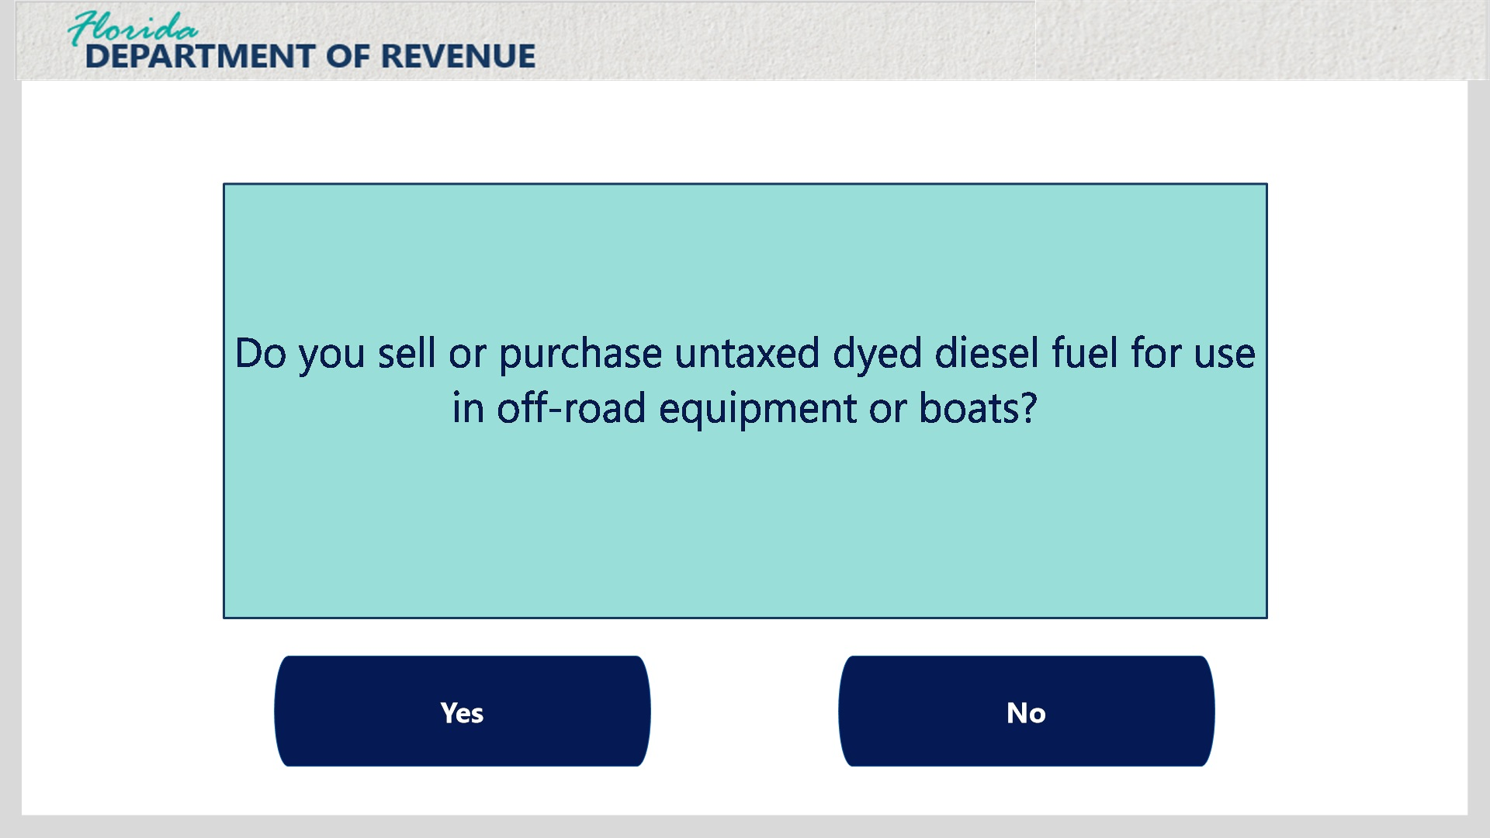
Transcript:
Do you sell or purchase untaxed dyed diesel fuel for use in off-road equipment or boats?

Jobs and Scholarships (Slide Layer)
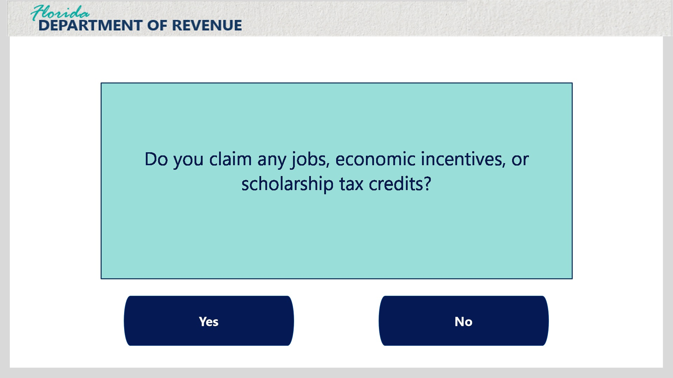 Transcript:
Do you claim any jobs, economic incentives, or scholarship tax credits?

Proceed with DR-15EZ course (Slide Layer)
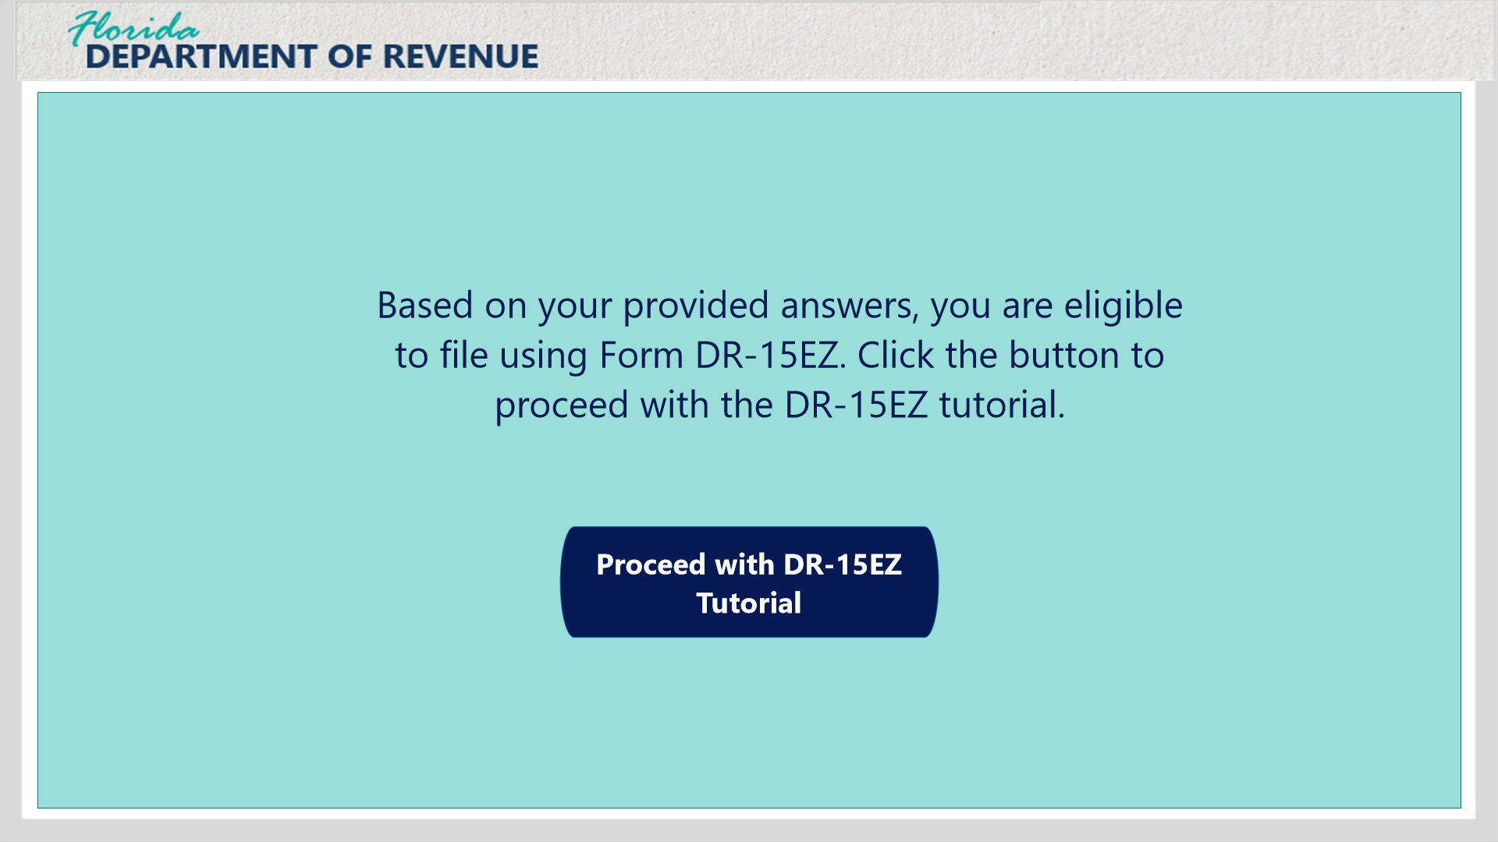
Transcript:
Based on your provided answers to the previous questions, you are eligible to file using Form DR-15EZ. Click the button to proceed with the DR-15EZ tutorial.

Go to DR-15 course or form (Slide Layer)
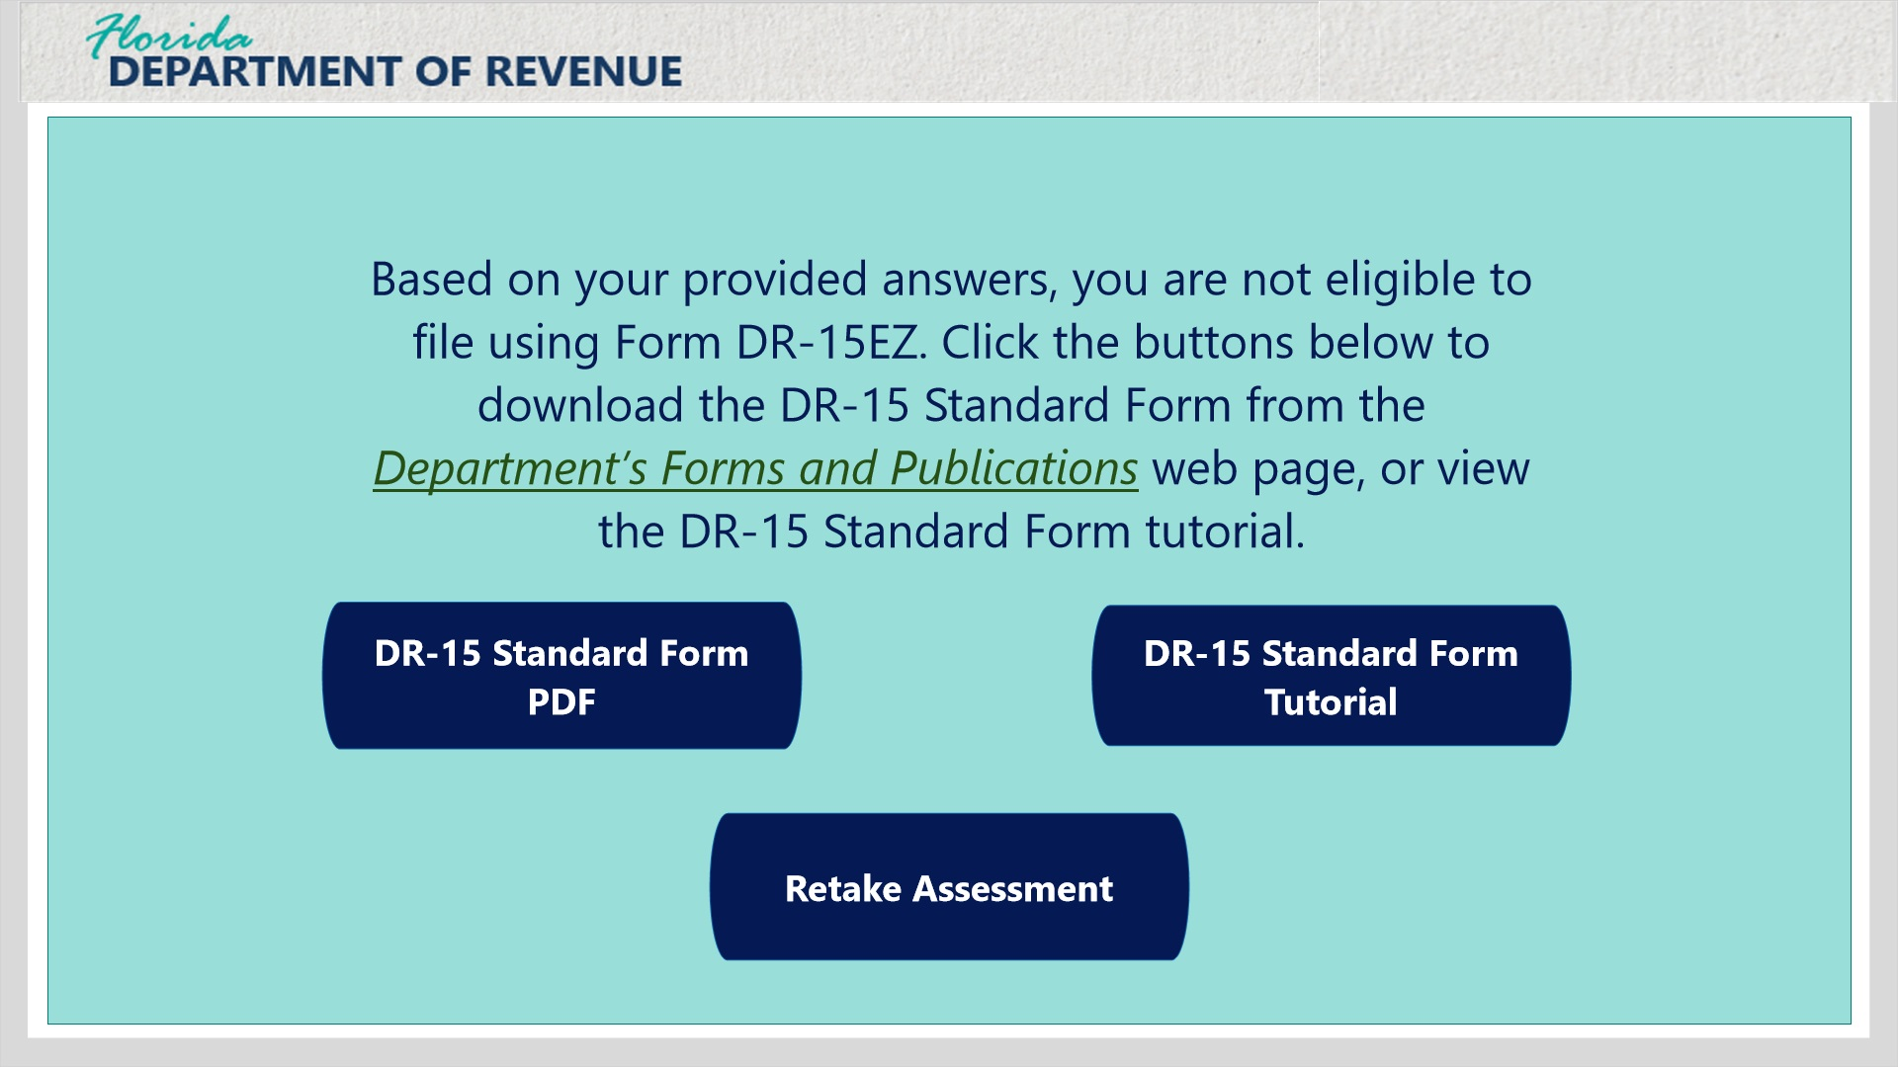
Transcript:
Based on your provided answers to the previous questions, you are not eligible to file using Form DR-15EZ. Click the buttons to download the DR-15 Standard Form from the Department’s Forms and Publications webpage, view the DR-15 Standard Form tutorial, or retake this assessment.

2.3 Due Dates
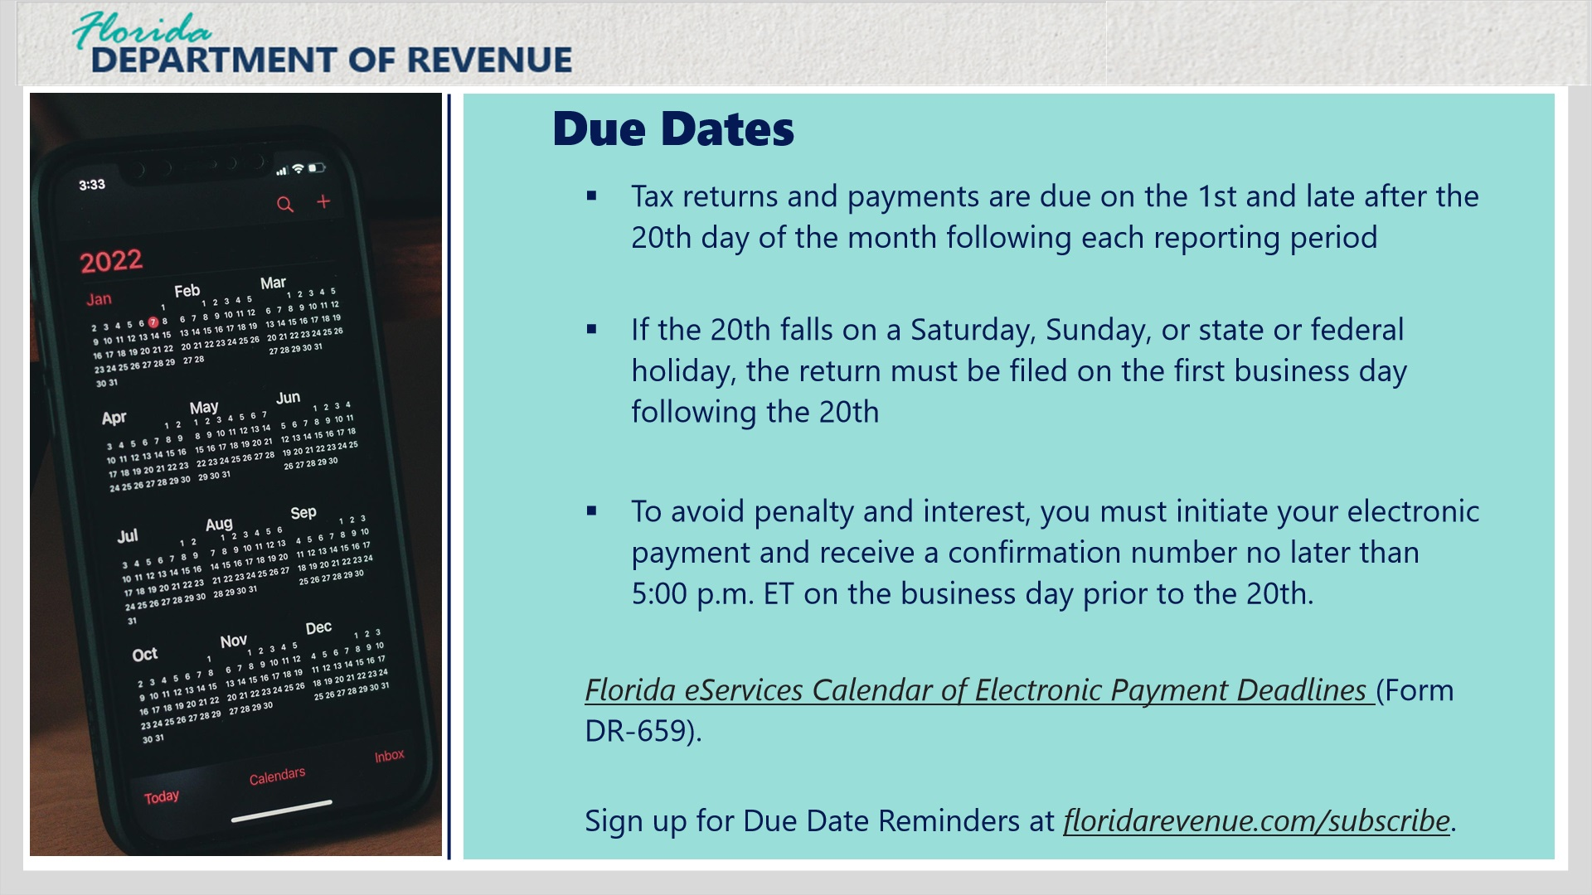
Transcript:
Tax returns and payments are due on the 1st and late after the 20th day of the month following each reporting period. If the 20th falls on a Saturday, Sunday, or a state or federal holiday, your tax return must be received electronically, postmarked, or hand-delivered on the first business day following the 20th.
To avoid penalty and interest, you must initiate your electronic payment and receive a confirmation number no later than 5 p.m. ET on the business day prior to the 20th. Keep the confirmation number in your records. A list of deadlines for initiating electronic payments on time is located at: Florida eServices Calendar of Electronic Payment Deadlines (Form DR-659).
If you file your paper returns monthly or quarterly, you can sign up to receive an email every reporting period, reminding you of the due date, by visiting floridarevenue.com/subscribe.

2.4 State Sales Tax Rates
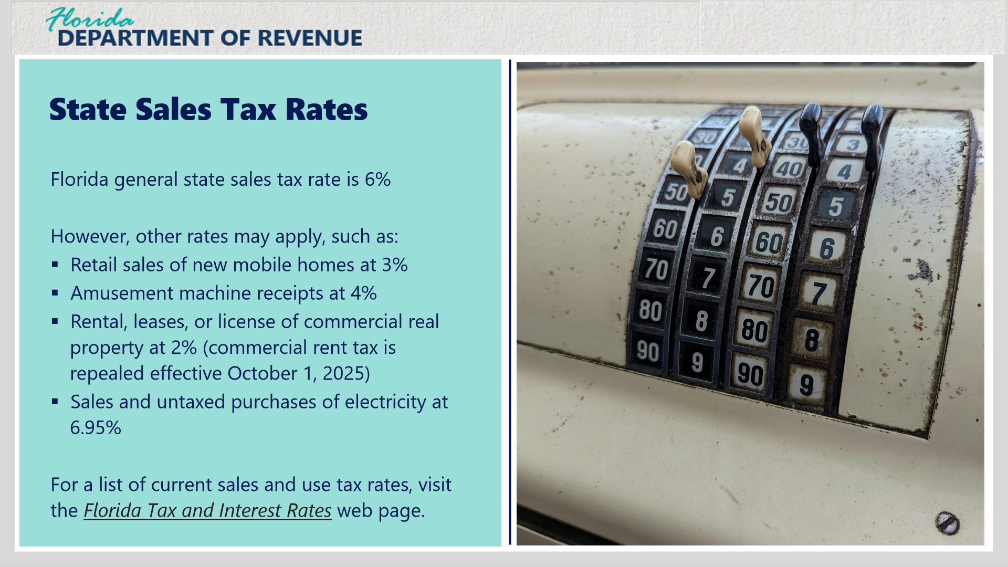
Transcript:
Florida imposes a general state sales tax rate of 6% on sales and purchases of items, services, and transient rentals.
However, other rates may apply for items, such as retail sales of new mobile homes at 3%, amusement machine receipts at 4%, rental, leases, or license of commercial real property at 2% (state sales tax of commercial rentals of real property is repealed effective October 1, 2025), sales and untaxed purchases of electricity at 6.95%.
For a list of current sales and use tax rate, visit the Florida Tax and Interest Rates webpage.

2.5 Discretionary Sales Surtax
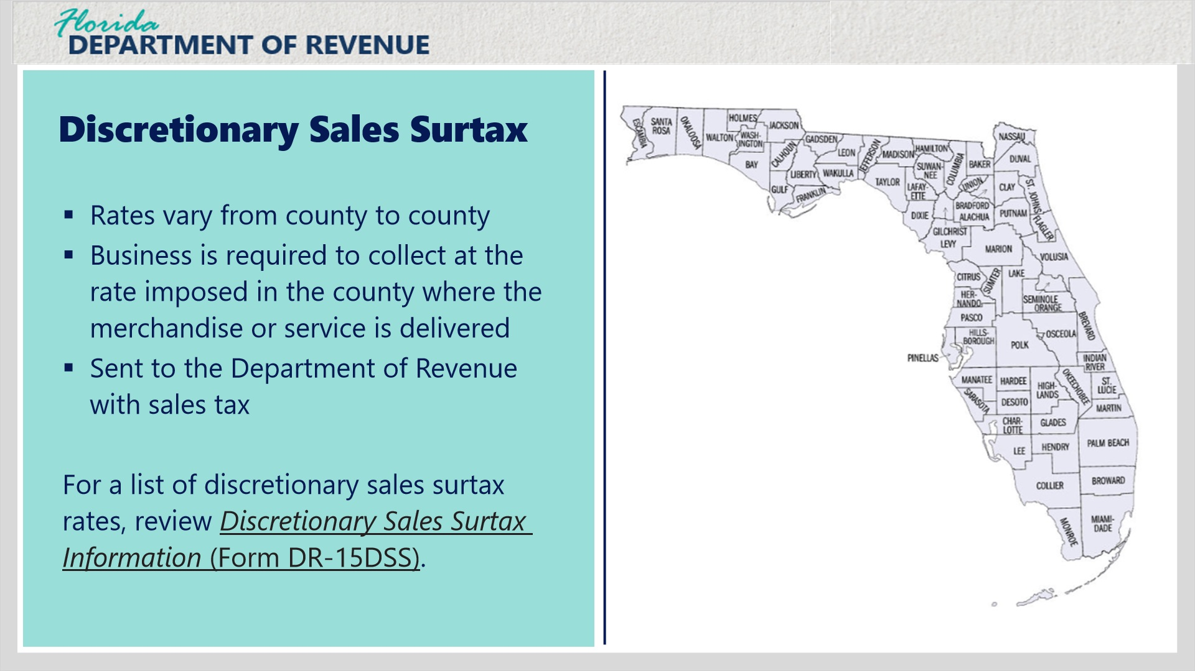
Transcript:
In addition to the state sales and use tax rate, Florida counties may impose a discretionary sales surtax. Rates vary from county to county, the surtax is collected along with the state sales tax, and the surtax is sent to the Department of Revenue along with sales tax.
If you rent, deliver, or receive taxable merchandise or services in or at a location within a county imposing discretionary sales surtax, you are required to collect surtax at the rate imposed in the county where the merchandise or service is delivered.
For a list of discretionary sales surtax rates, please review Discretionary Sales Surtax Information (Form DR-15DSS).

2.6 Rounding Algorithm
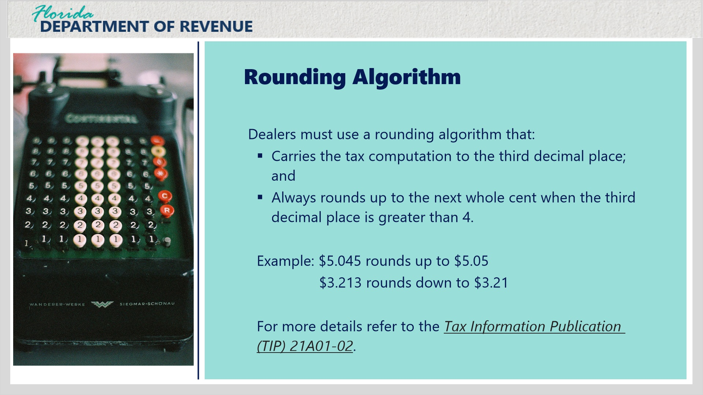
Transcript:
Effective July 1, 2021, all dealers must use a rounding algorithm when calculating sales tax and discretionary surtax.
Dealers must use a rounding algorithm that carries the tax computation to the third decimal place; and always rounds up to the next whole cent when the third decimal place is greater than 4.
For example, if the total is $5.045, you would round up to $5.05. Or, if the total is $3.213, you would round down $3.21.
Dealers may compute the tax by applying the rounding algorithm to the combined taxable amount on an invoice or to individual taxable items on an invoice.
For more details, refer to the Tax Information Publication (TIP) No. 21A01-02.
Click next to complete a knowledge check for the rounding algorithm.

2.7 Knowledge Check 1
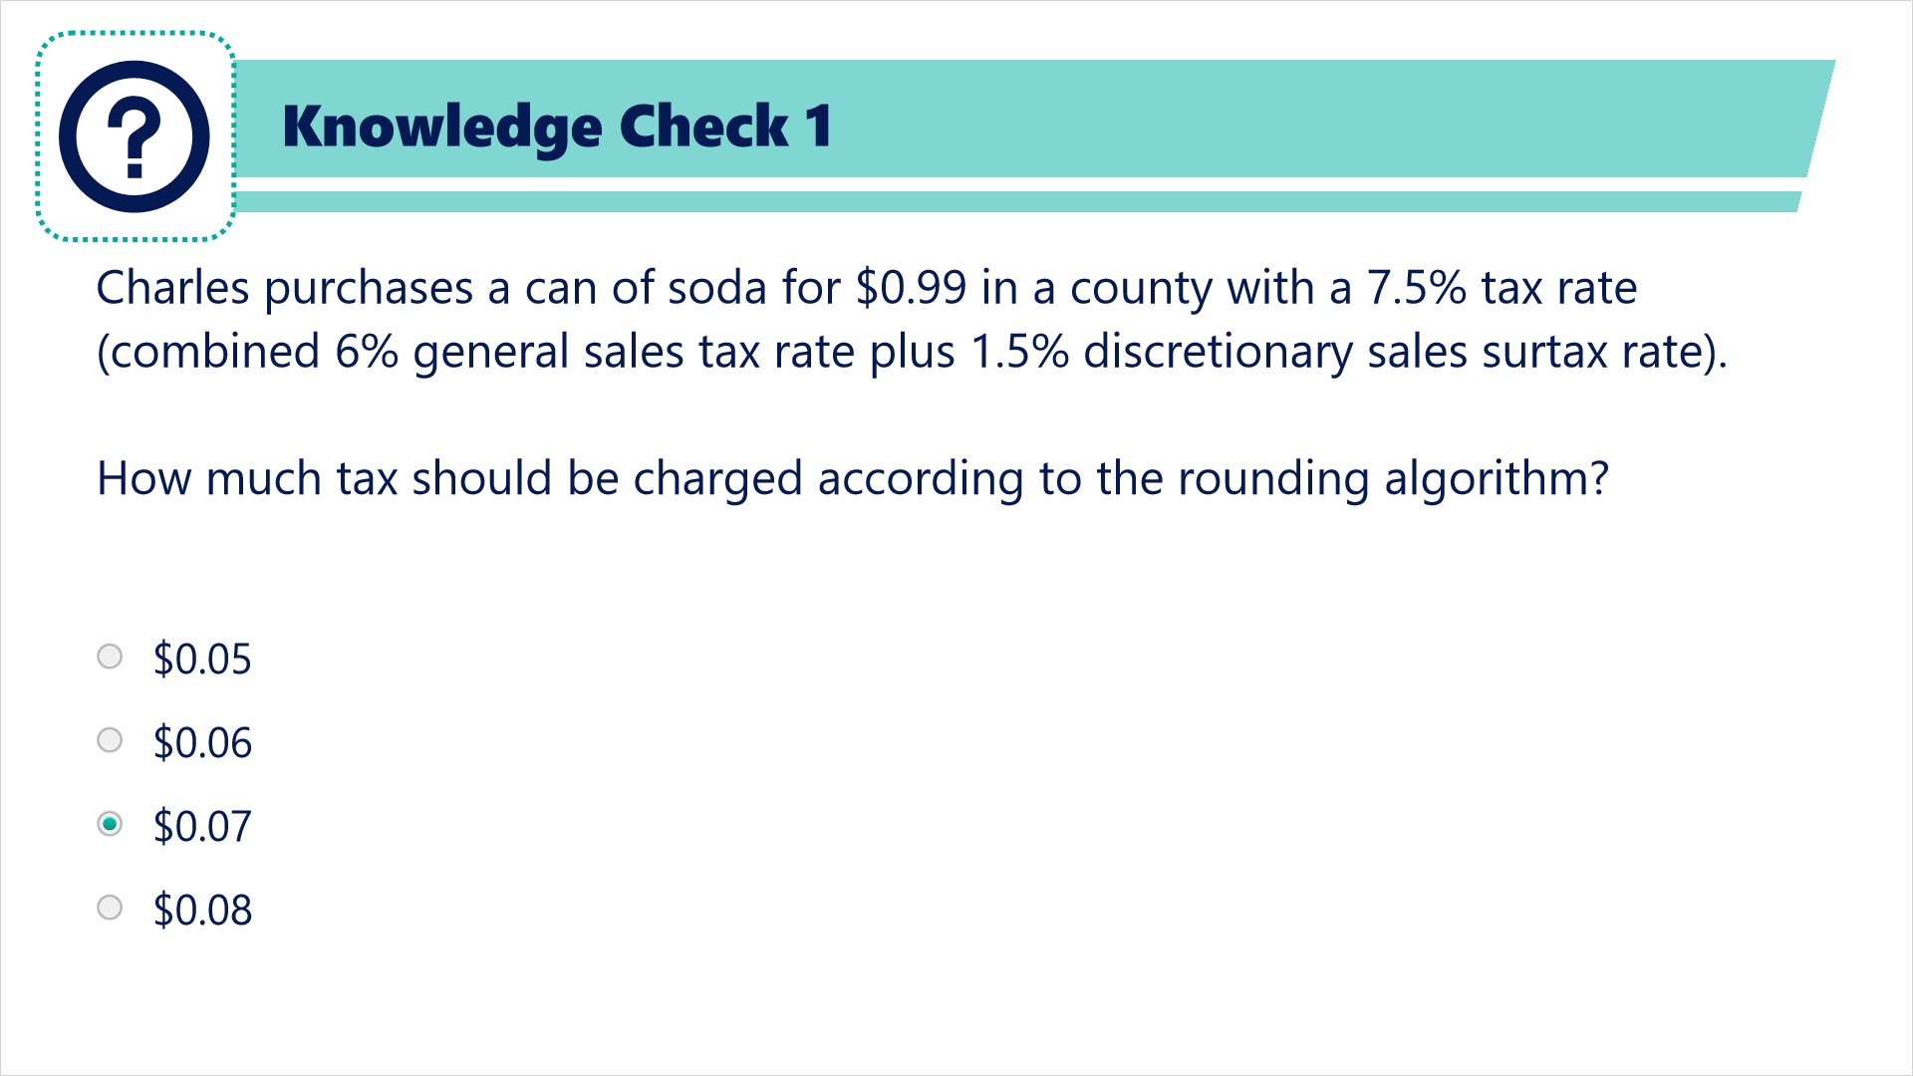
Transcript:
Charles purchases a can of soda for $.99 in a county with a 7.5% tax rate (combined 6% general sales tax rate plus 1.5% discretionary sales surtax rate).
How much tax should be charged according to the rounding algorithm?
$0.05
$0.06
$0.07
$0.08

Correct (Slide Layer)
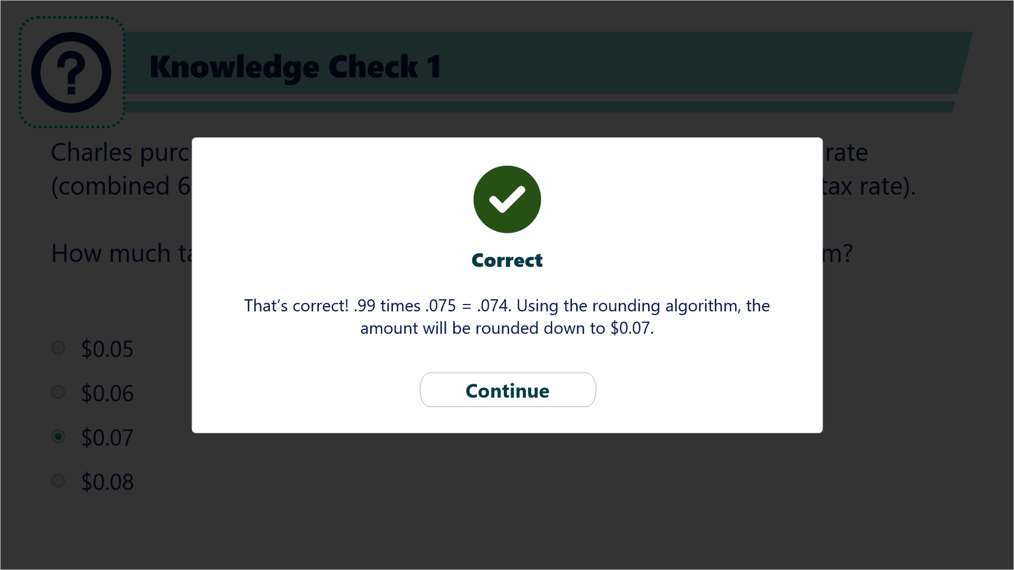

Try Again (Slide Layer)
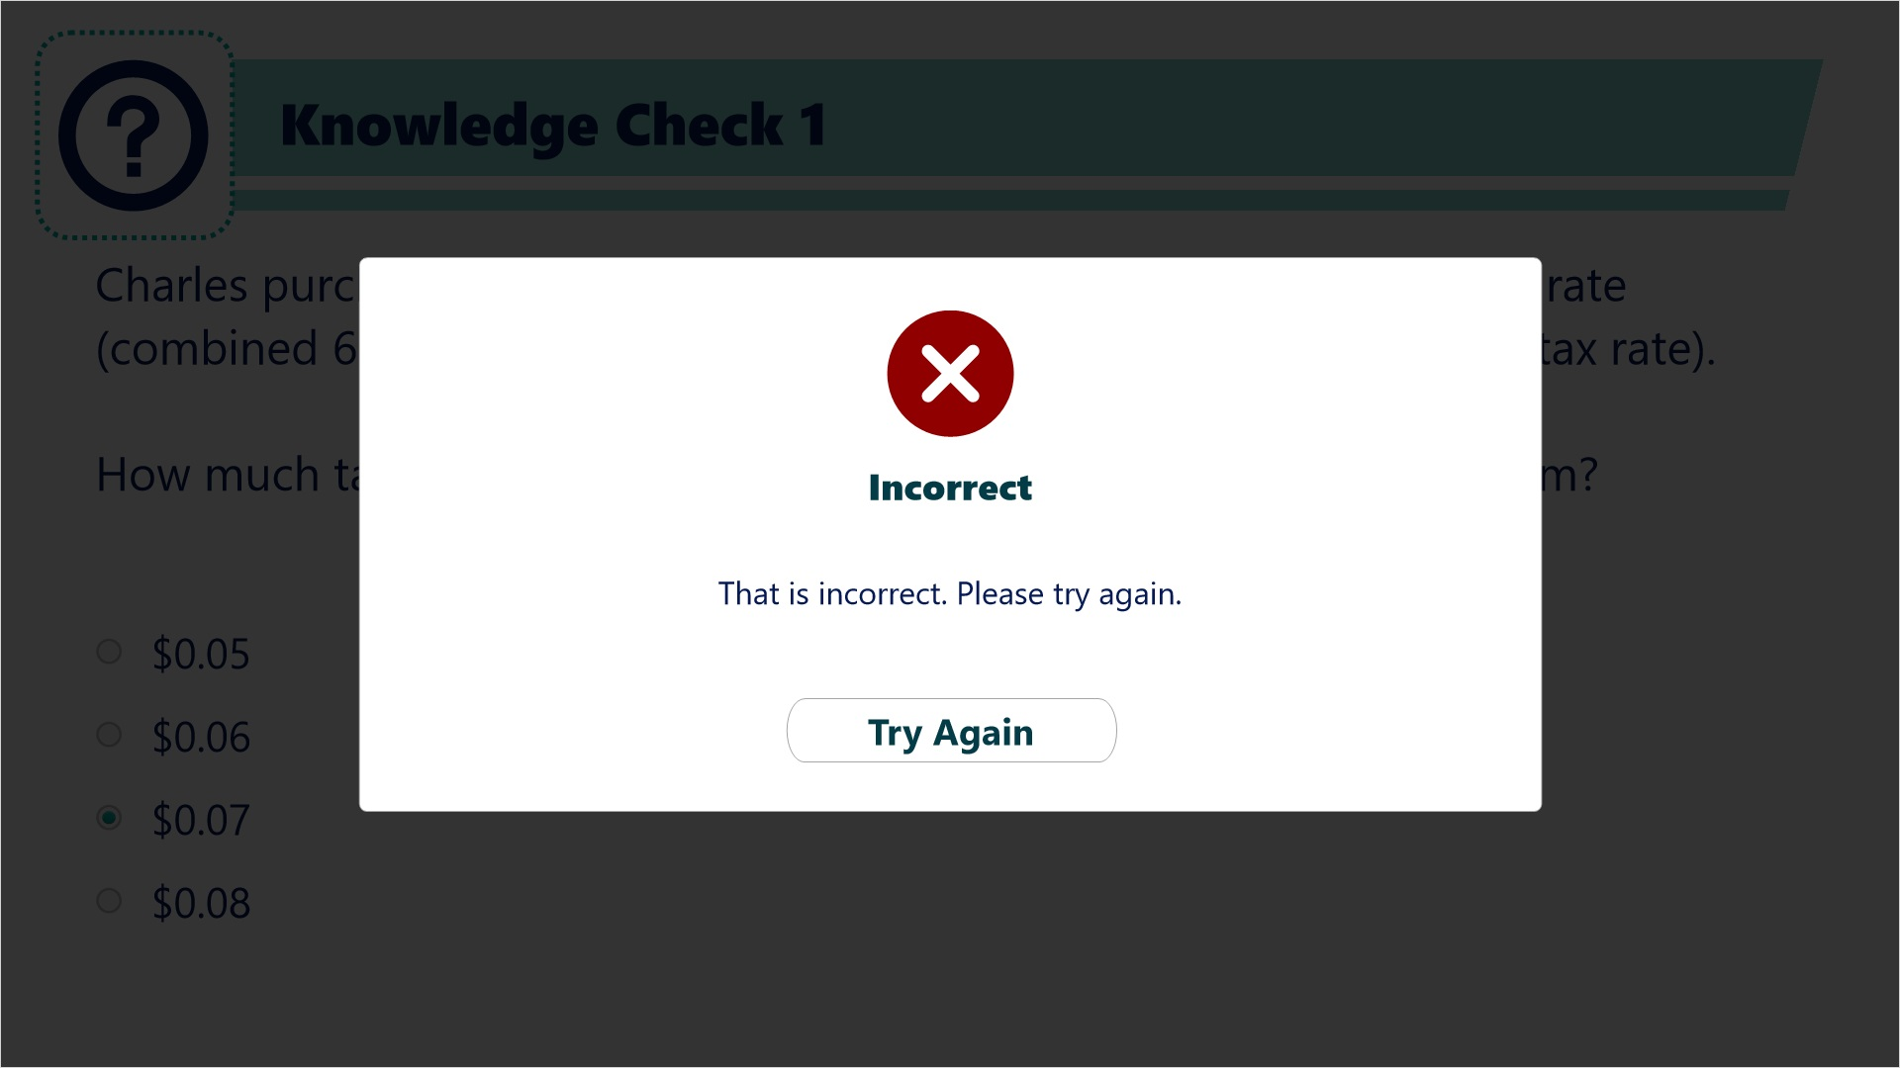

Incorrect (Slide Layer)
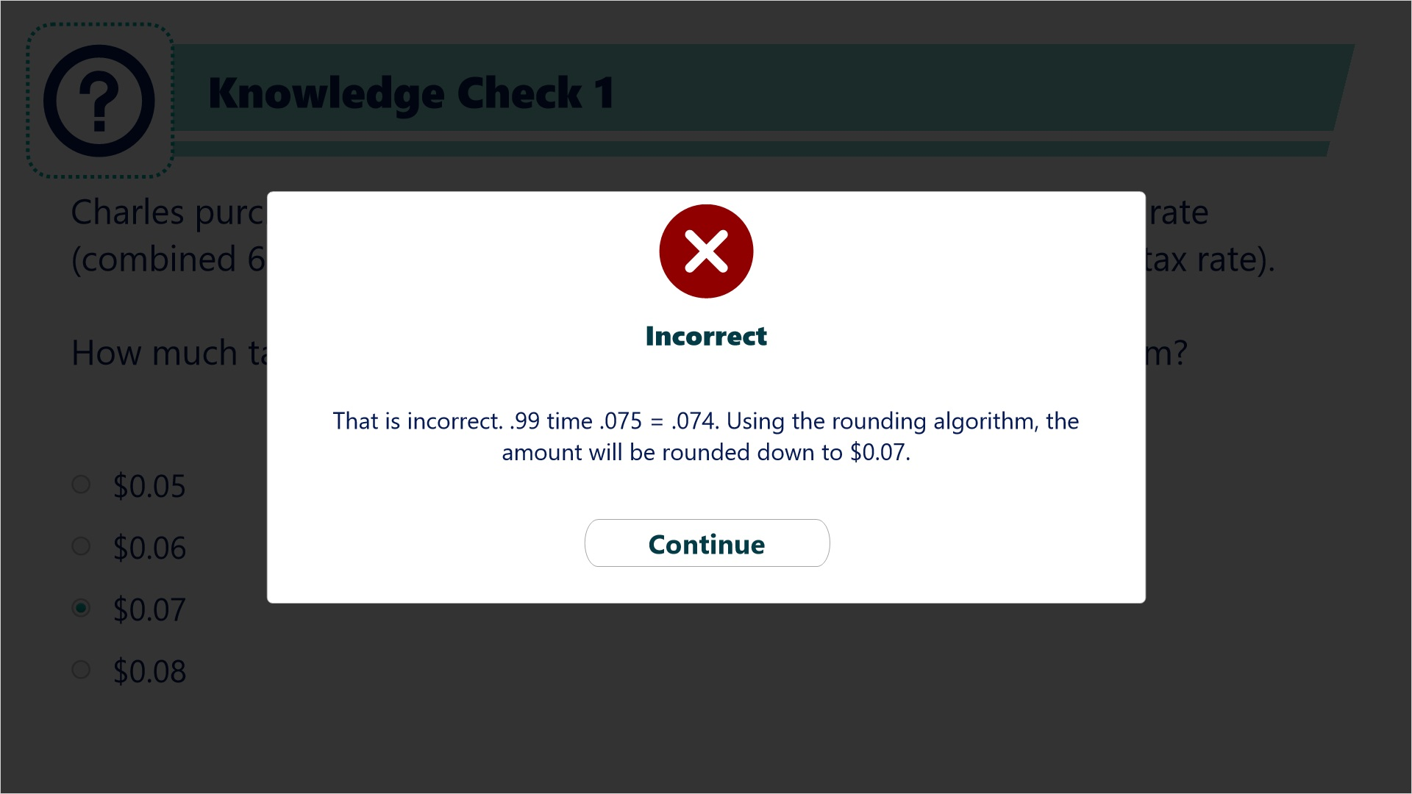

3. Lines 1-3

3.1 Lines 1-3
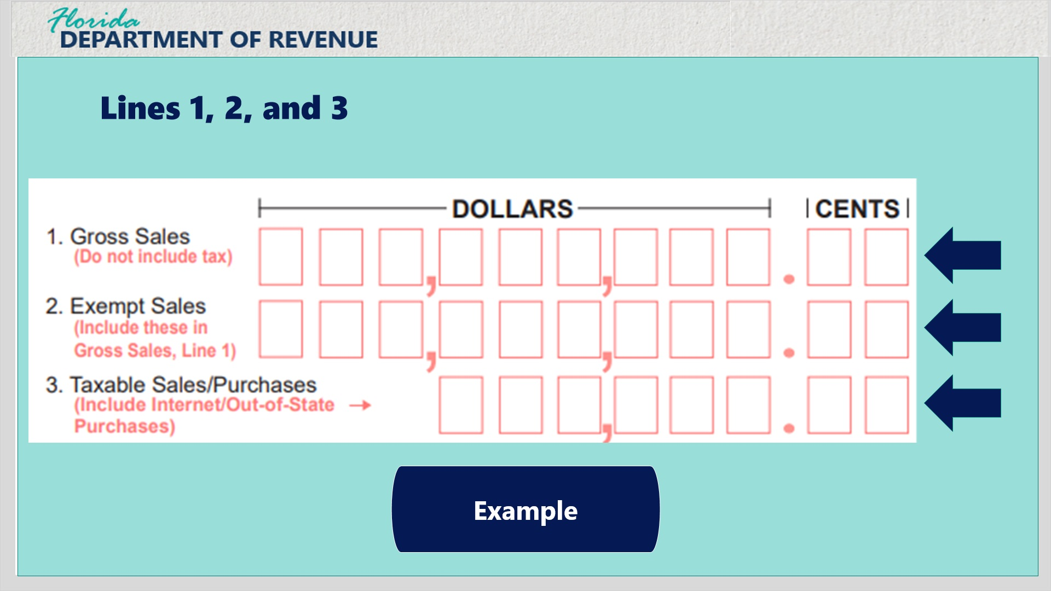
Transcript:
Next, let’s take a look at Lines 1-3 on the back of Form DR-15EZ.
To calculate Line 3, Taxable Sales/Purchases, users will first determine and populate Line 1, Gross Sales. Next, determine and populate Line 2, Exempt Sales. Subtract Line 2 from Line 1 and add any Taxable Purchases to determine and populate Line 3, Taxable Sales/Purchases.
Click the button to view an example.

Lines 1-3 Example (Slide Layer)
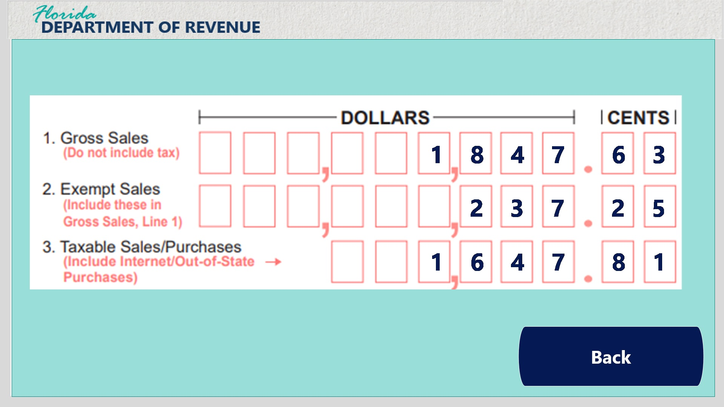
Transcript:
For the filing period, Gross Sales totaled $1,847.63, and Exempt Sales totaled $237.25. The business reported a Taxable Purchase of $37.43.
First, populate Line 1, Gross Sales with $1,847.63.
Next, populate Line 2, Exempt Sales with $237.25.
Now, subtract Line 2 from Line 1, for a total of $1,610.38.
Finally, add the Taxable Purchase of $37.43 for a Line 3, Taxable Sales/Purchases total of $1,647.81.
Click the next button to view more information about Gross Sales and Commercial Rentals.

3.2 Gross Sales Information
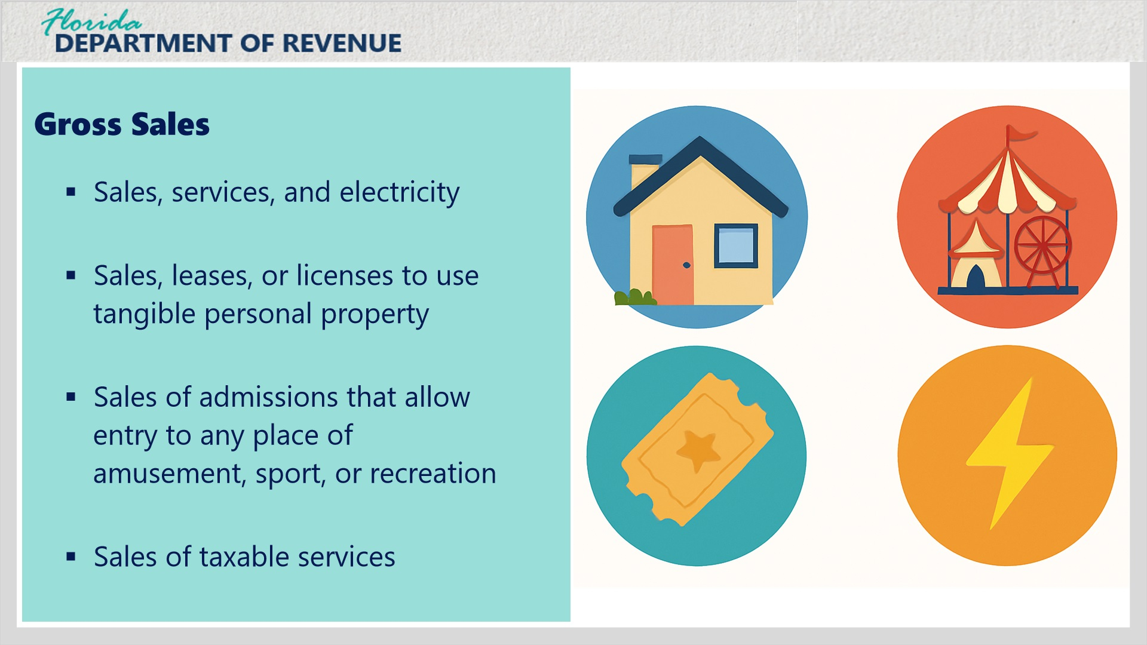
Transcript:
Gross sales include sales, services, electricity, sales, leases, or licenses to use tangible personal property, sales of admissions that allow entry to any place of amusement, sport, or recreation, and sales of taxable services.

3.3 Commercial Rentals
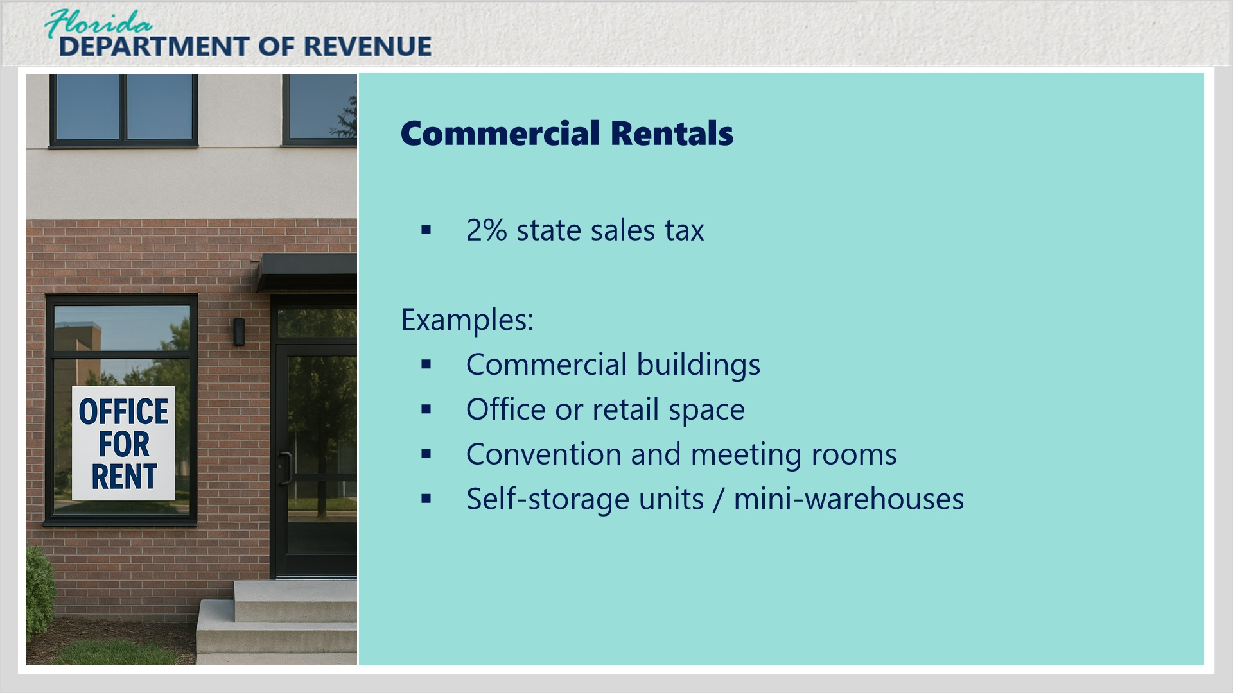
Transcript:
In Florida, rentals, leases, and licenses to use real property are generally subject to a two percent state sales tax under section 212.031 of the Florida Statutes.
In addition, the county where the property is located may impose a discretionary sales surtax, which is added to the state rate.
This tax applies unless a specific exemption or exception is available.
Common examples of taxable commercial rentals include commercial buildings, office or retail space, convention and meeting rooms, and self-storage units or mini-warehouses.

Transition Layer with Links and Commercial Rent Repeal (Slide Layer)
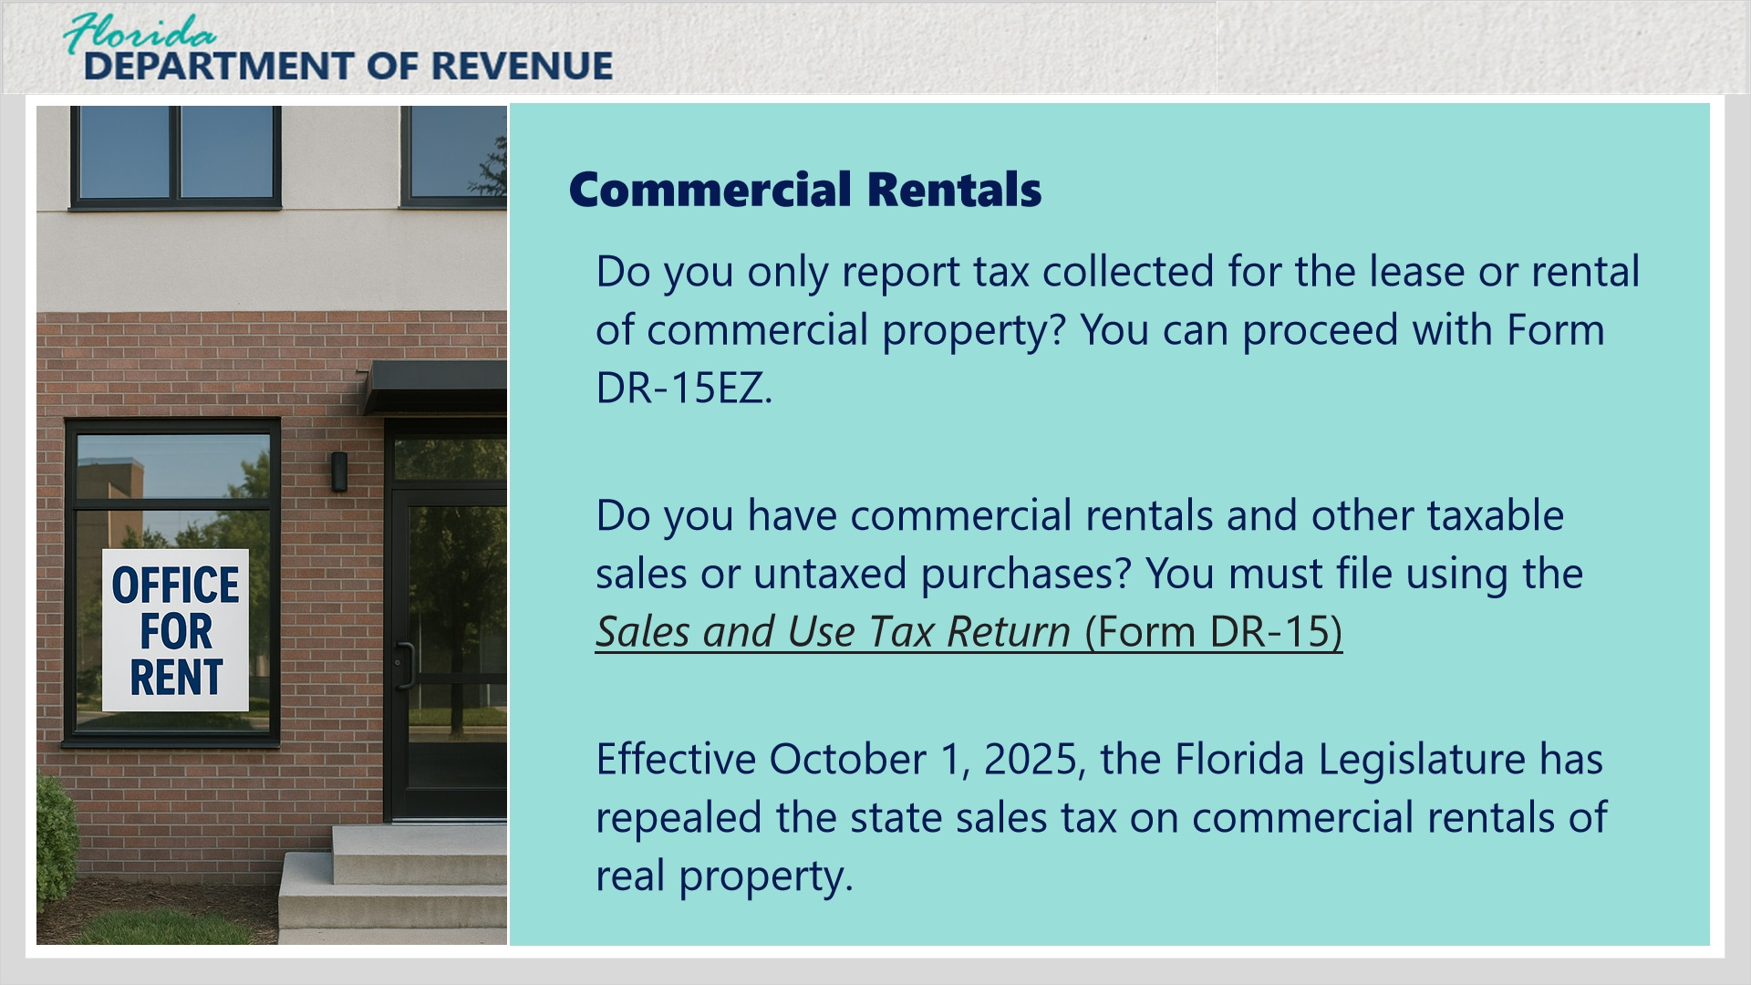
Transcript:
If you only report tax collected for the lease or rental of commercial property (you have no other sales or untaxed purchases to report), you may use Form DR-15EZ.
If you have commercial rentals and other taxable sales or untaxed purchases, you must use Form DR-15.
Please note that effective October 1, 2025, tax is no longer due on commercial rentals.

3.4 More Information on Taxable Purchases
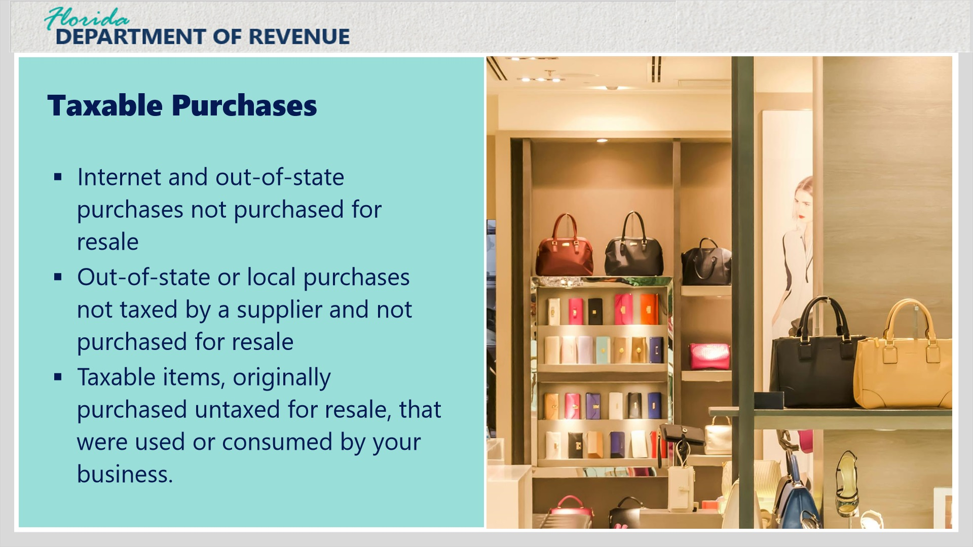
Transcript:
You owe use tax on taxable purchases of goods or services you have used or consumed that were internet and out-of-state purchases not purchased for resale, out-of-state or local purchases not taxed by a supplier and not purchased for resale, taxable items, originally purchased untaxed for resale, that were used or consumed by your business, include use tax and discretionary sales surtax on the return for the reporting period during which you purchased, used, or consumed the item(s).
Click next to complete a knowledge check for Taxable Sales/Purchases.

3.5 Knowledge Check 2
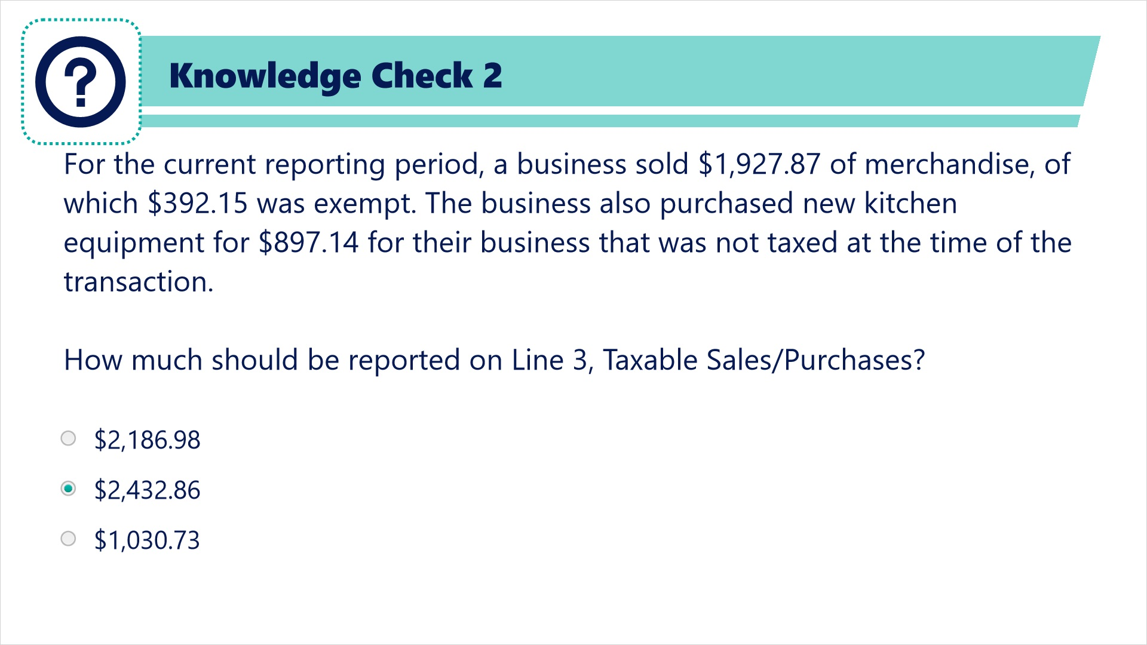
Transcript:
For the current reporting period, a business sold $1,927.87 of merchandise, of which $392.15 was exempt. The business also purchased new kitchen equipment for $897.14 for their business that was not taxed at the time of the transaction.
How much should be reported on Line 3, Taxable Sales/Purchases?
$2,186.98
$2,432.86
$1,030.73

Correct (Slide Layer)
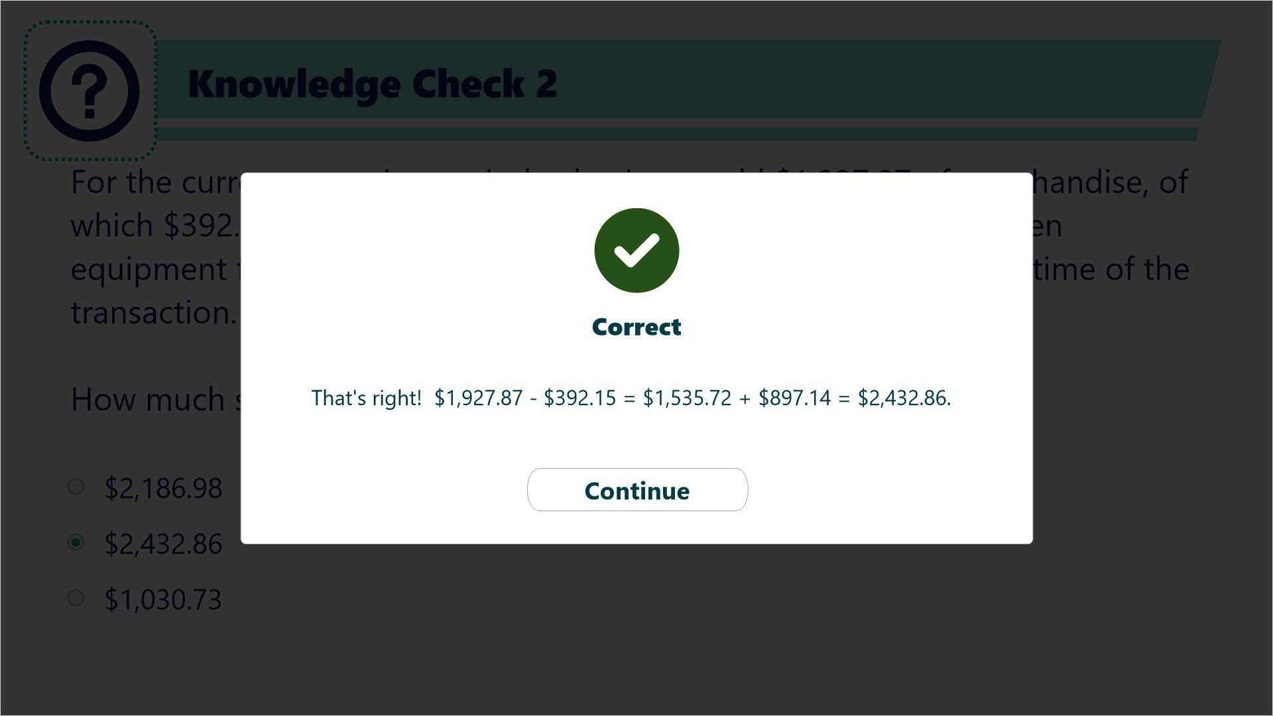

Incorrect (Slide Layer)
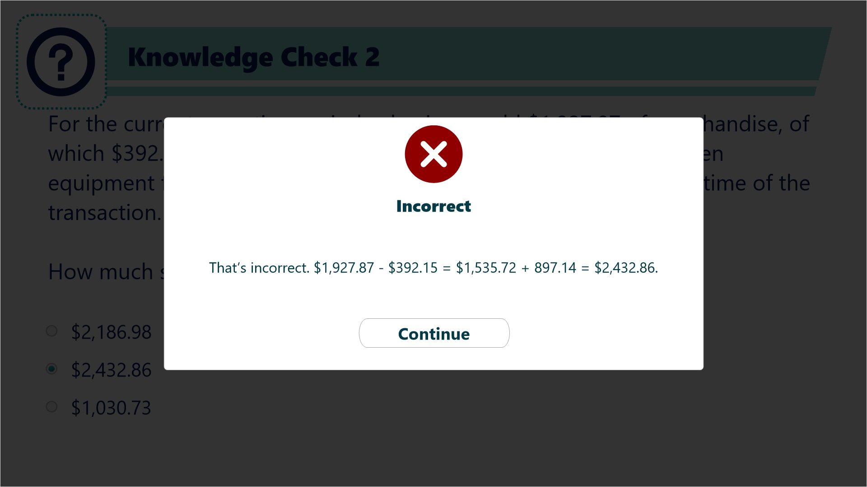

Try Again (Slide Layer)
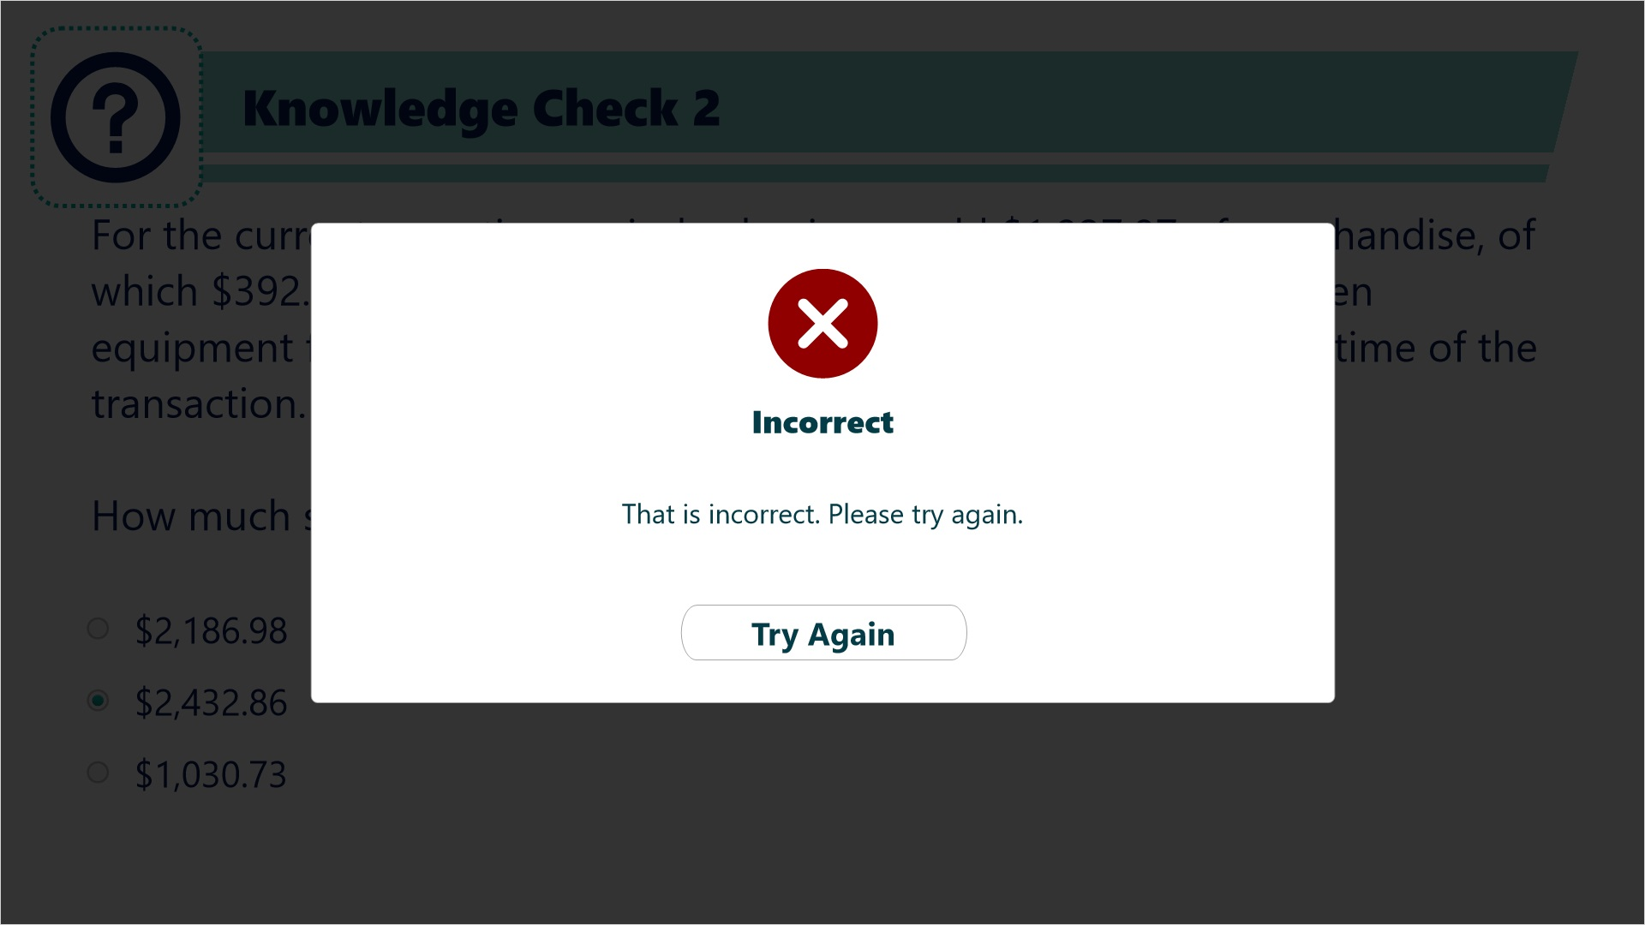

4. Lines 4-9

4.1 Lines 4-5
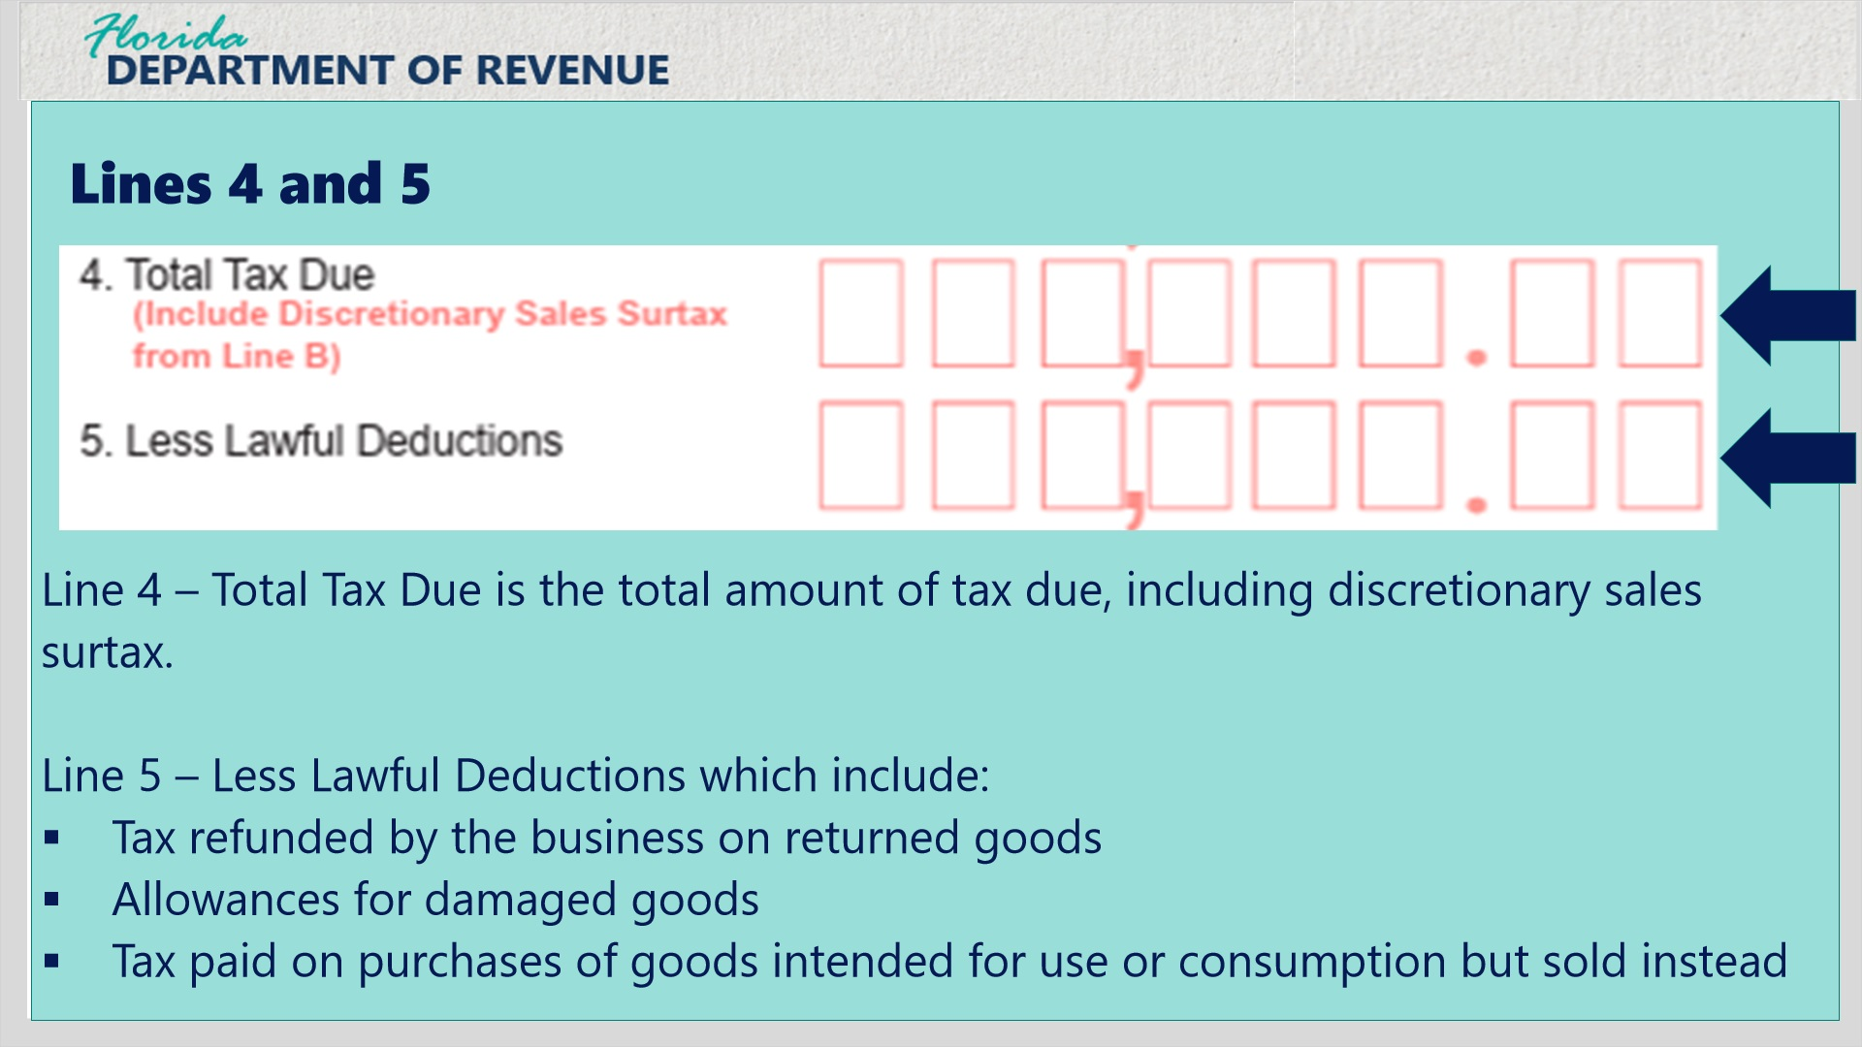
Transcript:
Line 4 is the Total Tax Due, which includes discretionary sales surtax due from each taxable sale and the use tax due on taxable purchases.
Line 5 is Less Lawful Deductions. On occasion customers will return goods resulting in a refund of tax by the business.
Other examples of lawful deductions include allowances for damaged goods, tax paid on the purchases of goods intended for use or consumption but sold instead, any other deductions.
Click next to complete a Knowledge Check for Line 5, Less Lawful Deductions.

4.2 Knowledge Check 3
(Multiple Choice, 10 points, 2 attempts permitted)
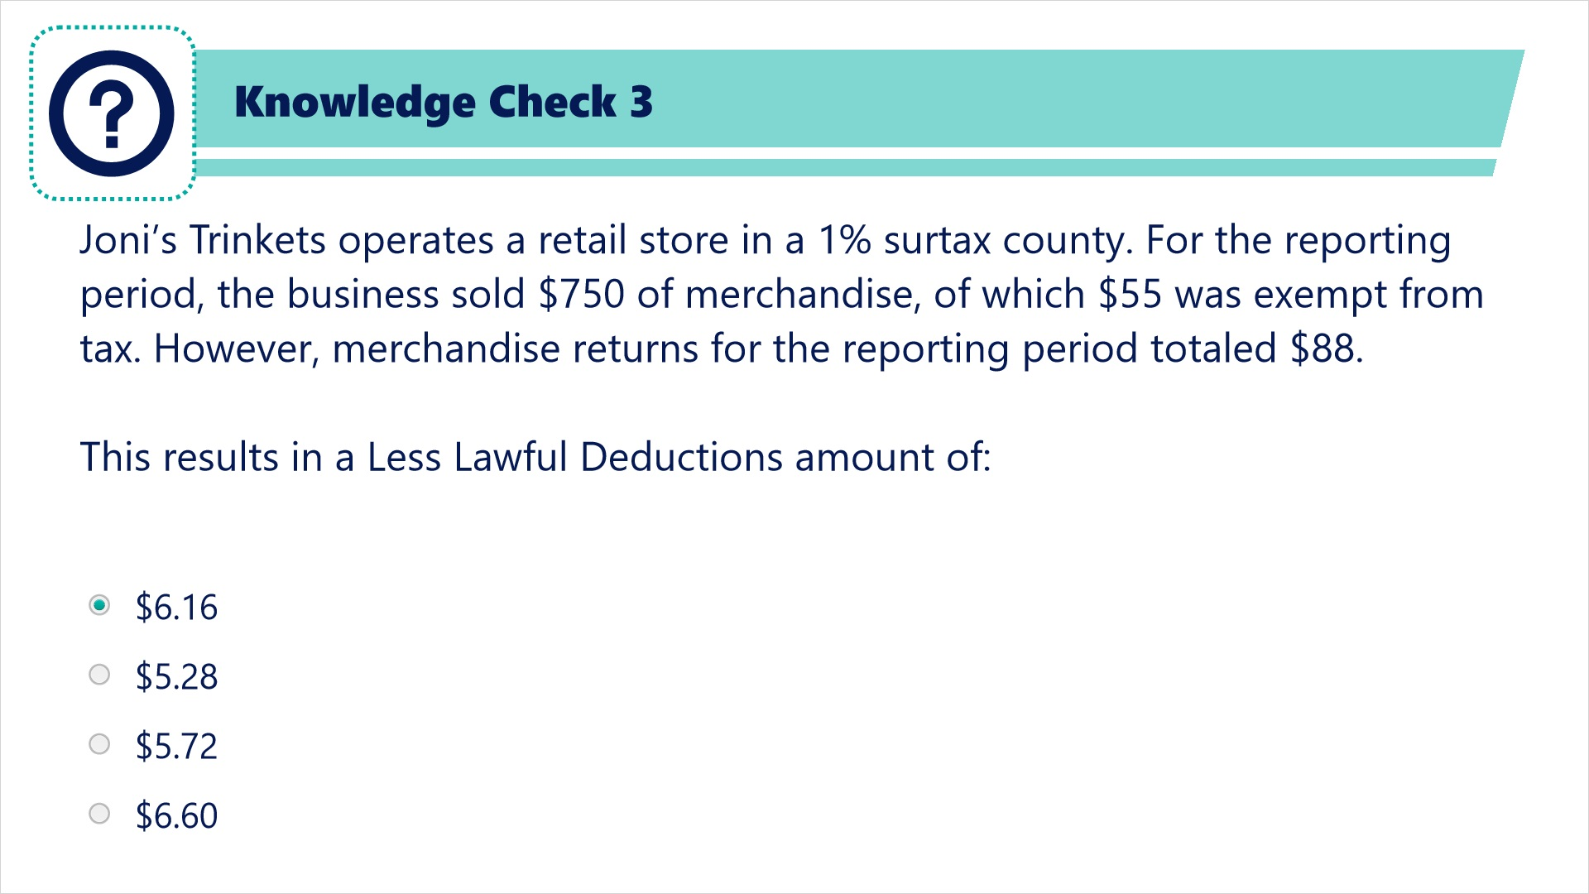
Transcript:
Joni’s Trinkets operates a retail store in a 1% surtax county. For the reporting period, the business sold $750 of merchandise, of which $55 was exempt from tax. However, merchandise returns for the reporting period totaled $88.
This results in a Less Lawful Deductions amount of:
$6.16
$5.28
$5.72
$6.60

Correct (Slide Layer)
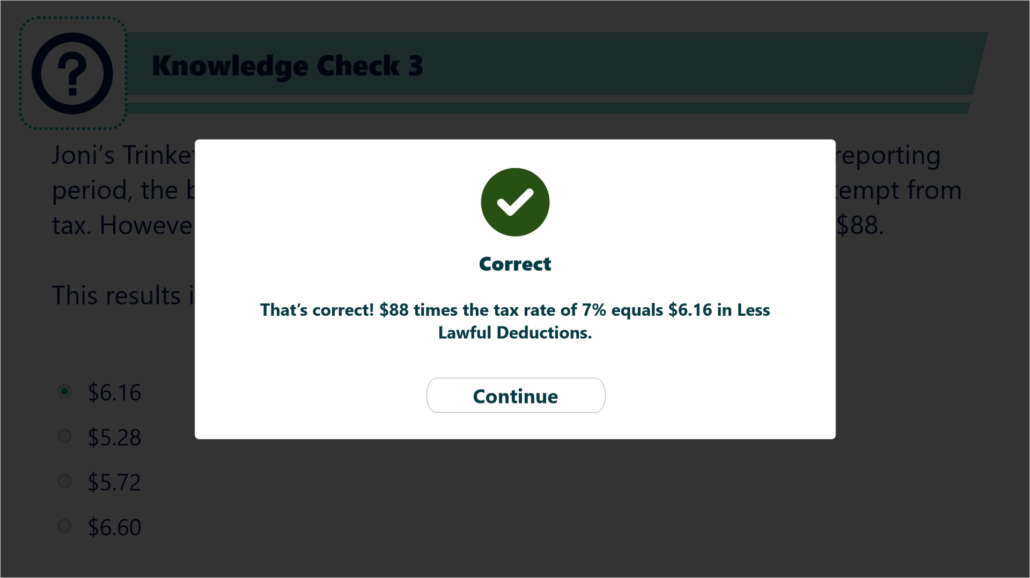

Try Again (Slide Layer)
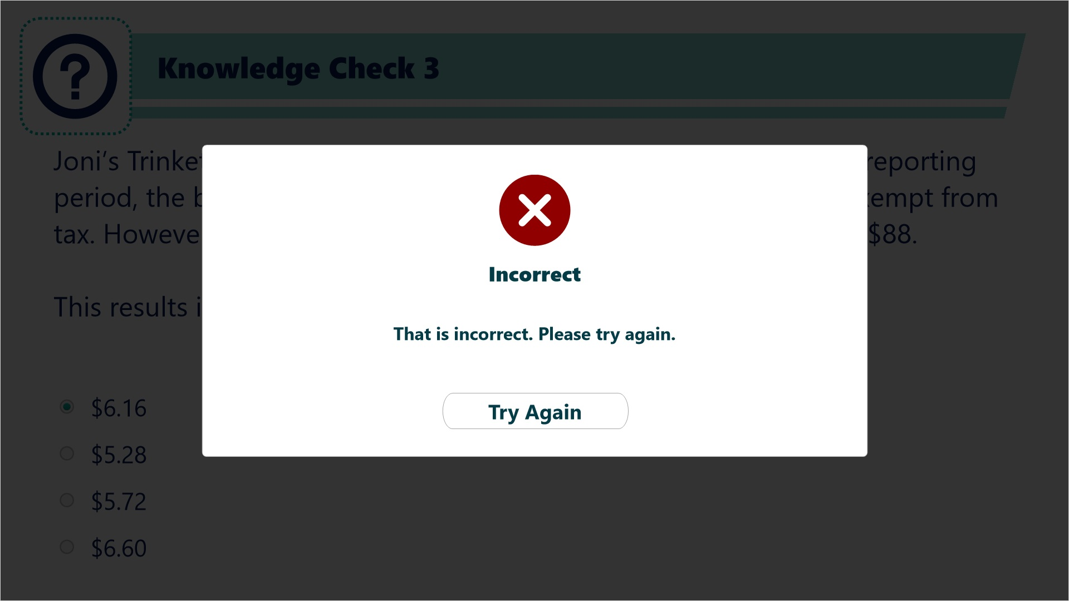

Incorrect (Slide Layer)
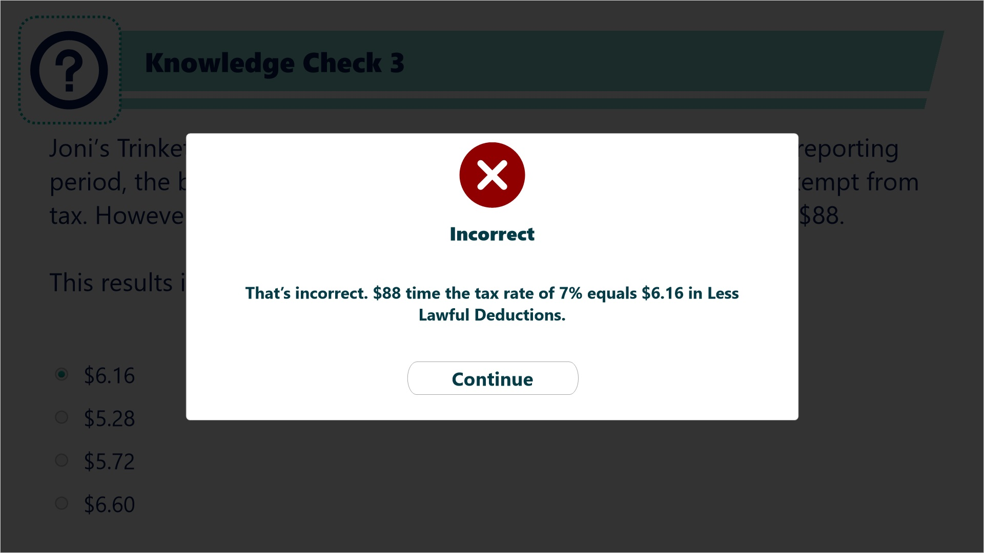

4.3 Lines 6, 7, and 8
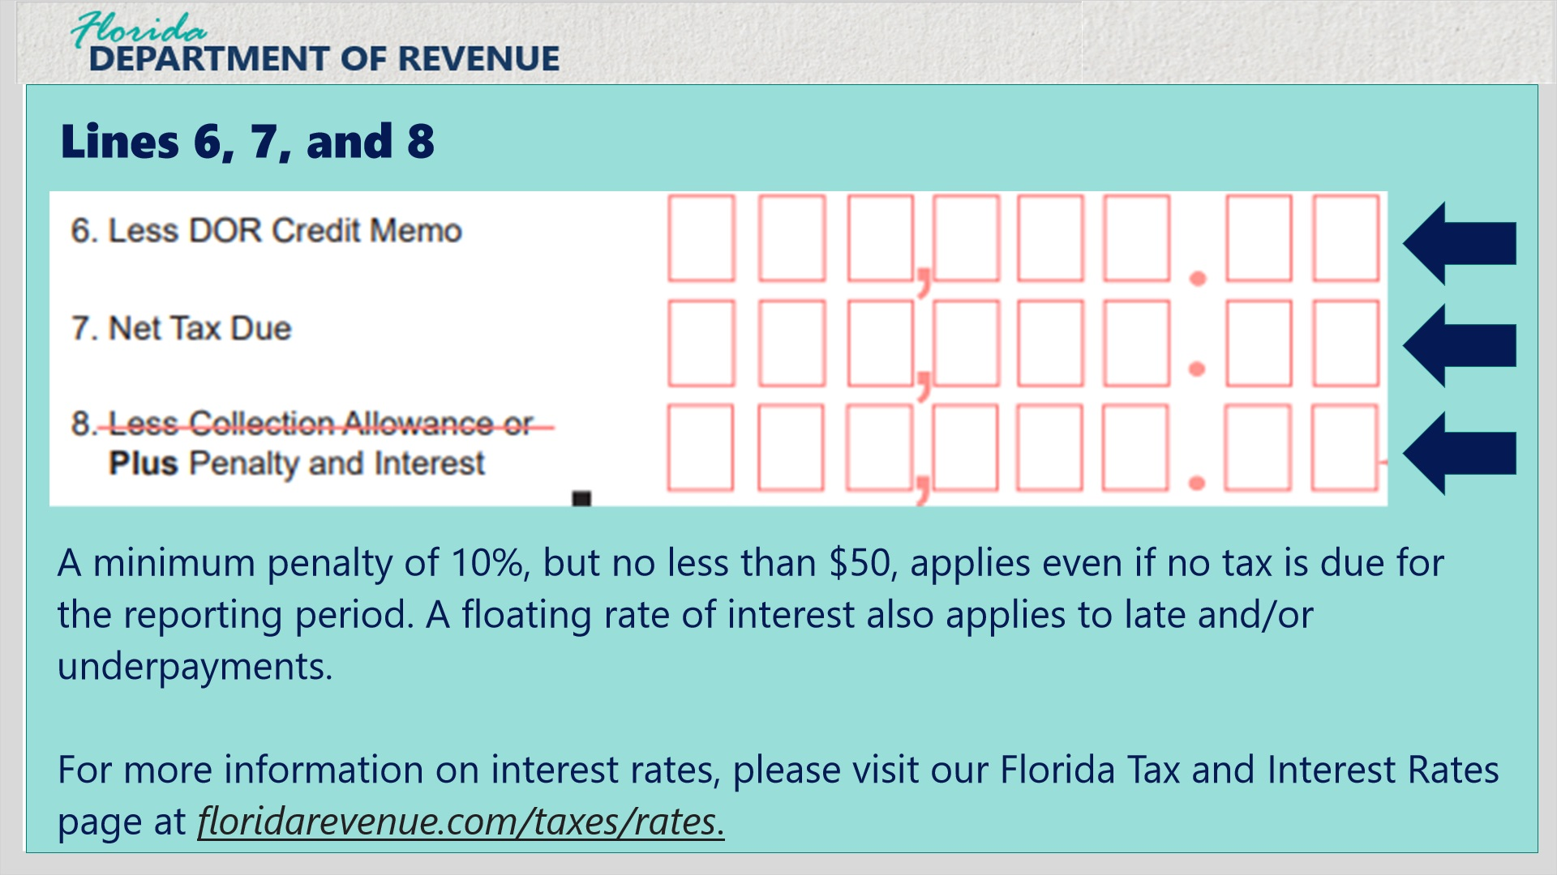
Transcript:
Line 6, Less DOR Credit Memo is used when the Department has issued a sales tax credit memo to the business.
Line 7, Net Tax Due is the result of Line 4 minus Lines 5 and 6. If the total for Line 7 is negative, enter zero.
Line 8, Plus Penalty and Interest is used when you are filing the return and/or payment late. If you file your return or pay tax late, a late penalty of 10% of the amount of tax owed, but no less than $50, may be charged.
Please note that the $50 minimum penalty applies even if no tax is due for the reporting period. A floating rate of interest also applies to late payments and underpayments of tax.
Businesses that file and pay electronically and on time are entitled to deduct a collection allowance. The online Form DR-15EZ will feature two Line 8 options: Less Collection Allowance, or if late, Plus Penalty and Interest.
For more information regarding interest, please see the link to our Florida Tax and Interest Rates page at floridarevenue.com/taxes/rates.

4.4 Line 9
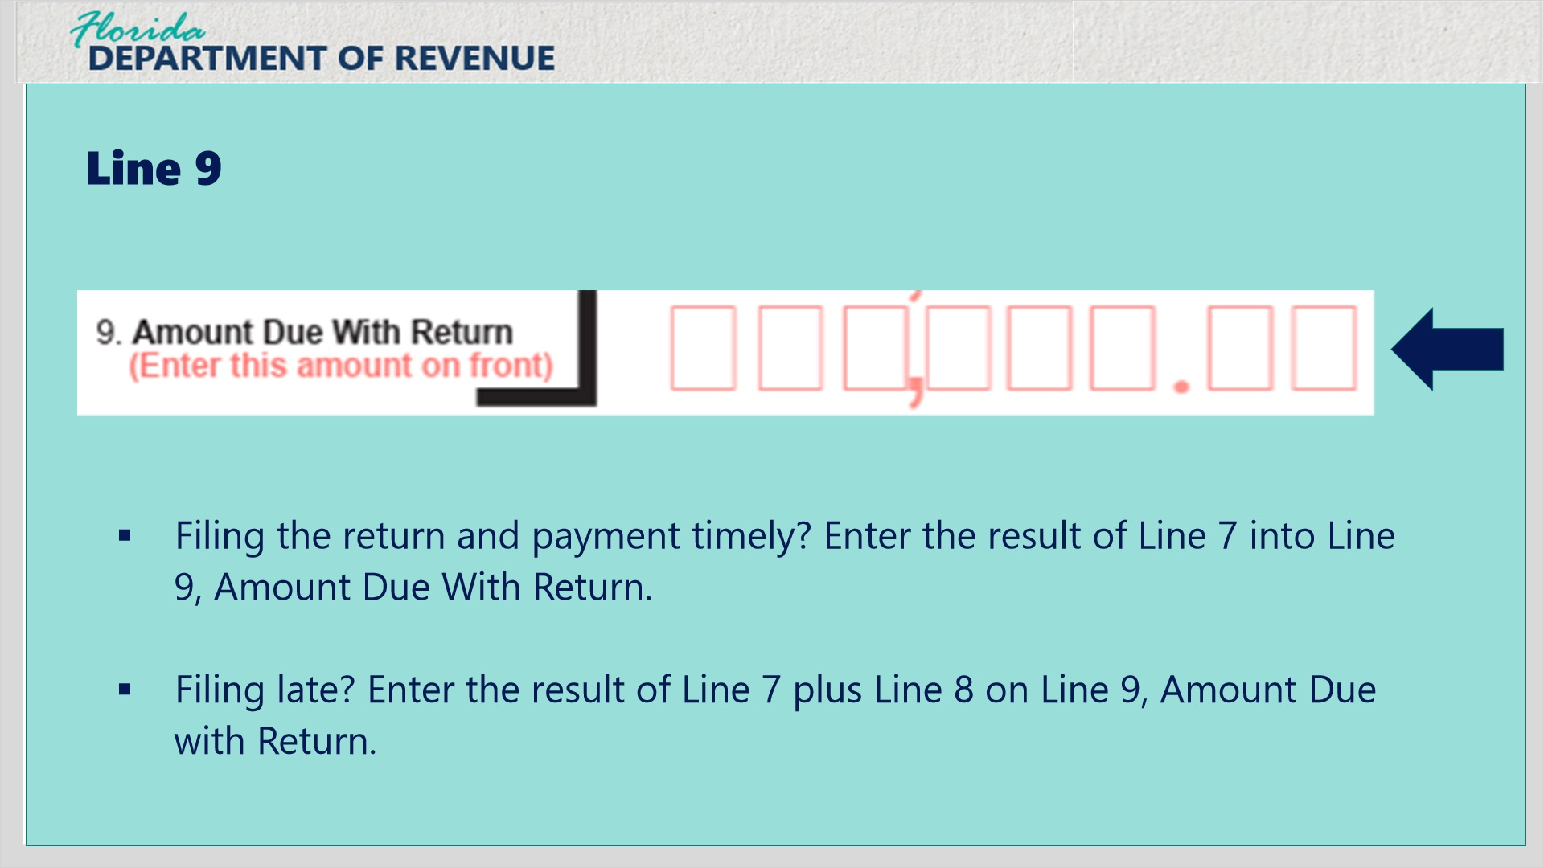
Transcript:
Line 9 is the Amount Due With Return line of the form.
If you are filing the return and payment timely, enter the result of Line 7 into Line 9. If you are filing late, enter the result of Line 7 plus Line 8 on Line 9.

5. Lines A-B

5.1 Lines A-B
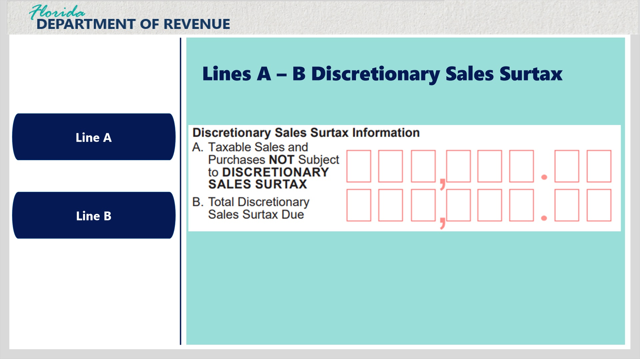
Transcript:
The right side of the back of Form DR-15EZ is used for Discretionary Sales Surtax Information. Click the Line A and Line B example buttons to view more information for each line.

Line A Taxable Sales and Purchases NOT Subject to Discretionary Sales Surtax (Slide Layer)
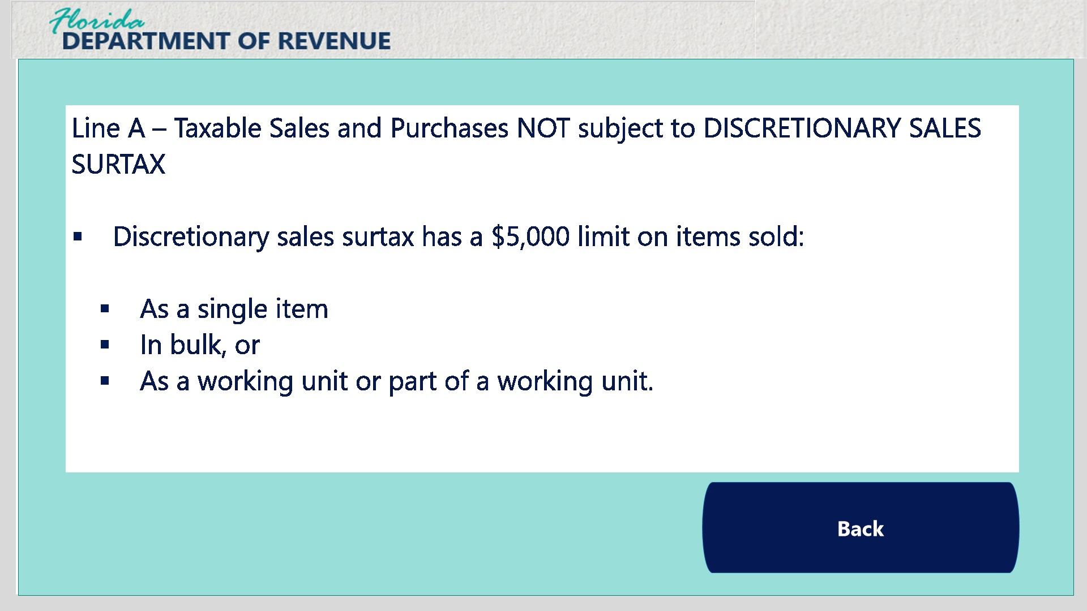
Transcript:
Line A is used to report taxable sales and purchases not subject to discretionary sales surtax.
Discretionary sales surtax has a $5,000 limit on sales when sold as a single item, in bulk, or as a working unit or part of a working unit.

Line B Total Discretionary Sales Surtax Due (Slide Layer)
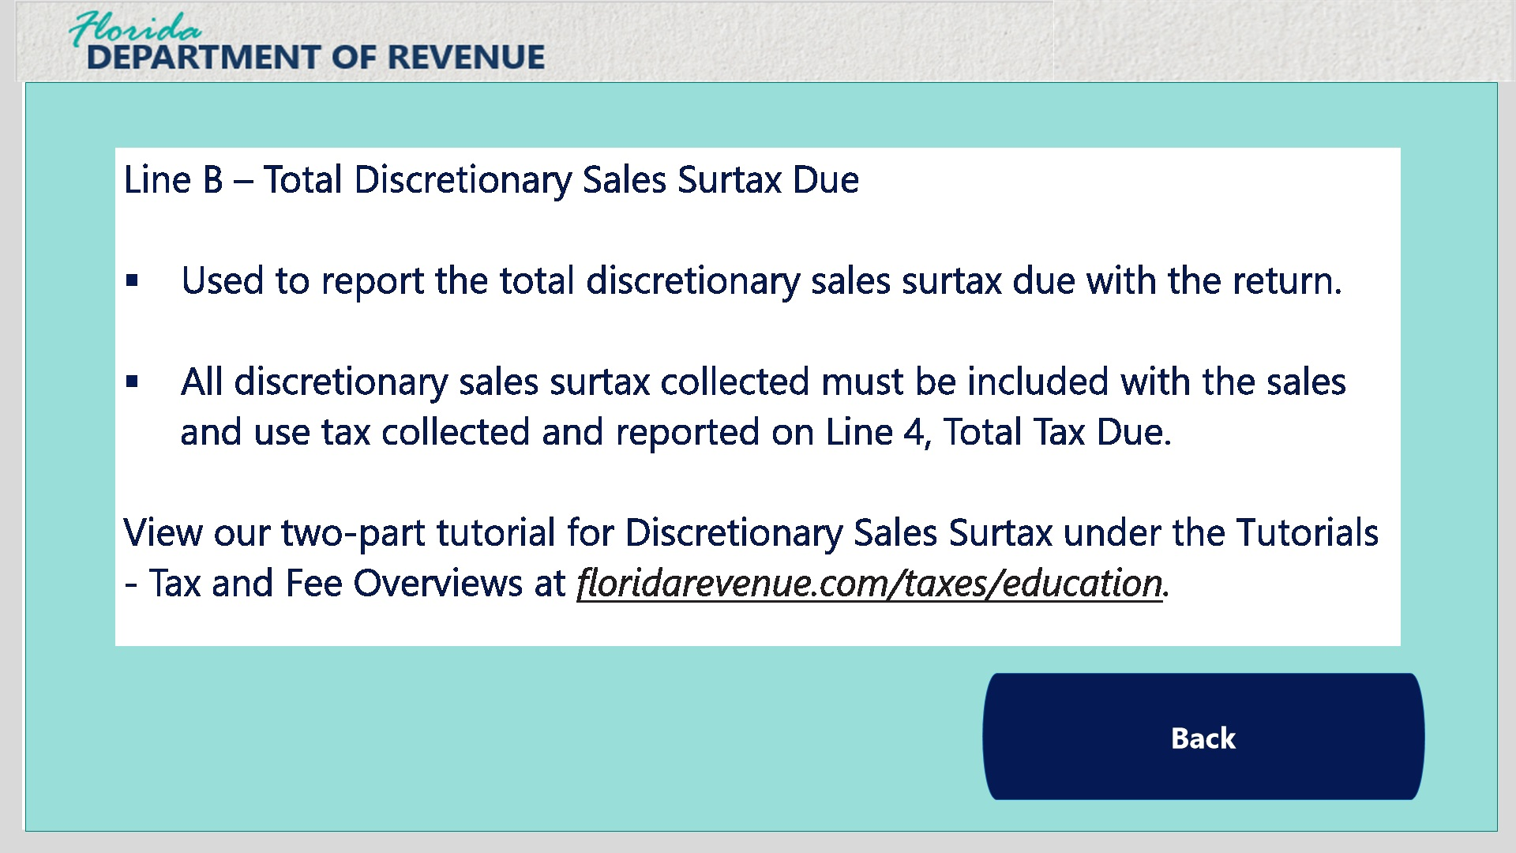
Transcript:
Line B is used to report the total discretionary sales surtax due with the return, and the amount entered in Line B must also be included in Line 4 – Total Tax Due.
For more information regarding discretionary sales surtax, visit our Taxpayer Education page at floridarevenue.com/taxes/education. You can locate the two-part tutorial for discretionary sales surtax under the Tutorials – Tax and Fee Overviews.

6. Front of the Return

6.1 DR-15EZ Front of Form
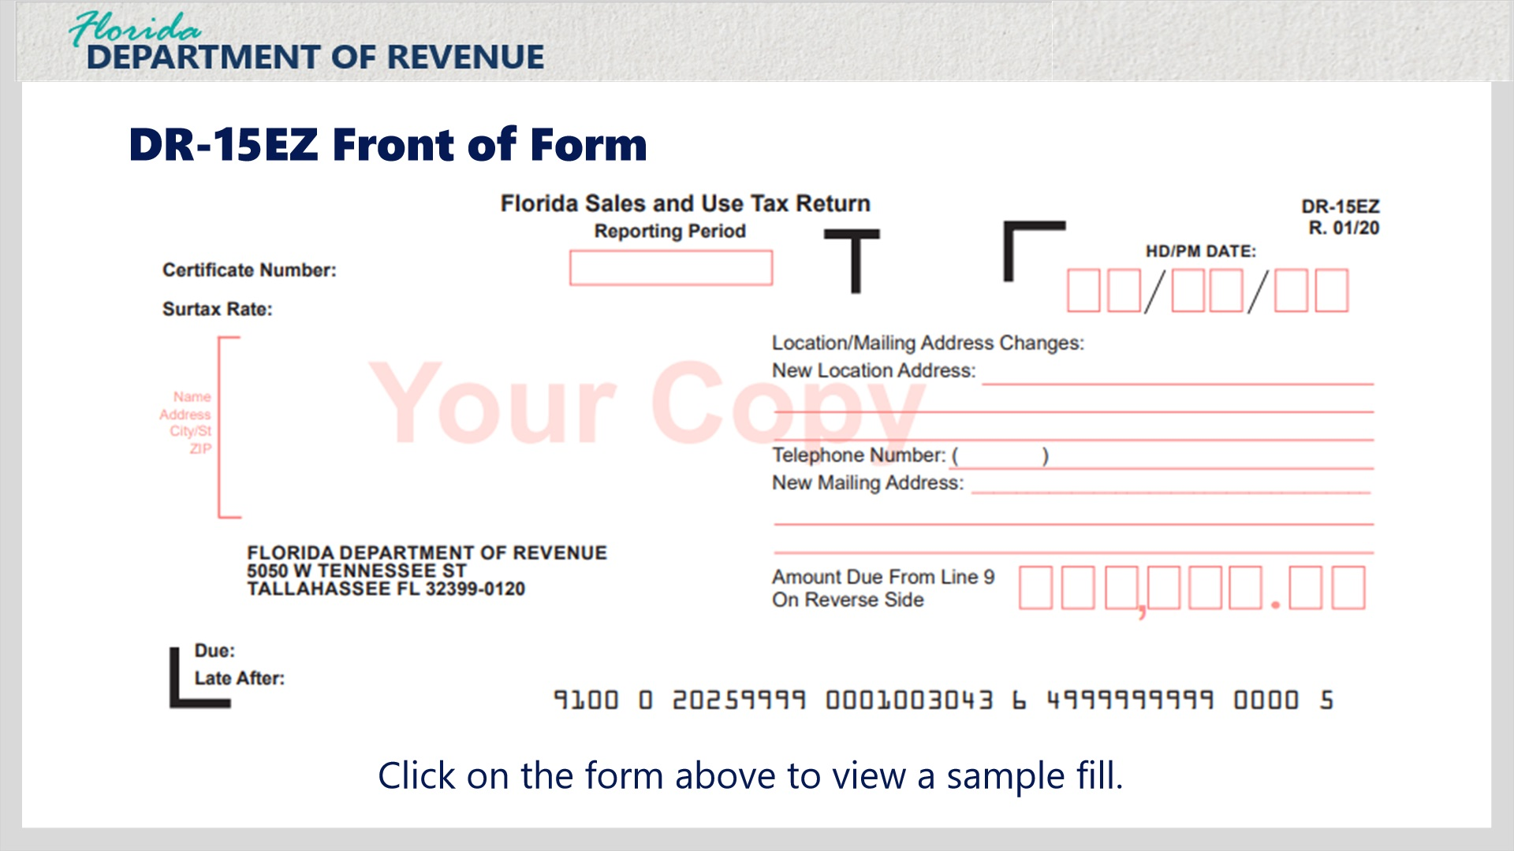
Transcript:
Let’s take a moment to complete the front of Form DR-15EZ. Click on the form image on the screen to view an example.

Example Fill Layer (Slide Layer)
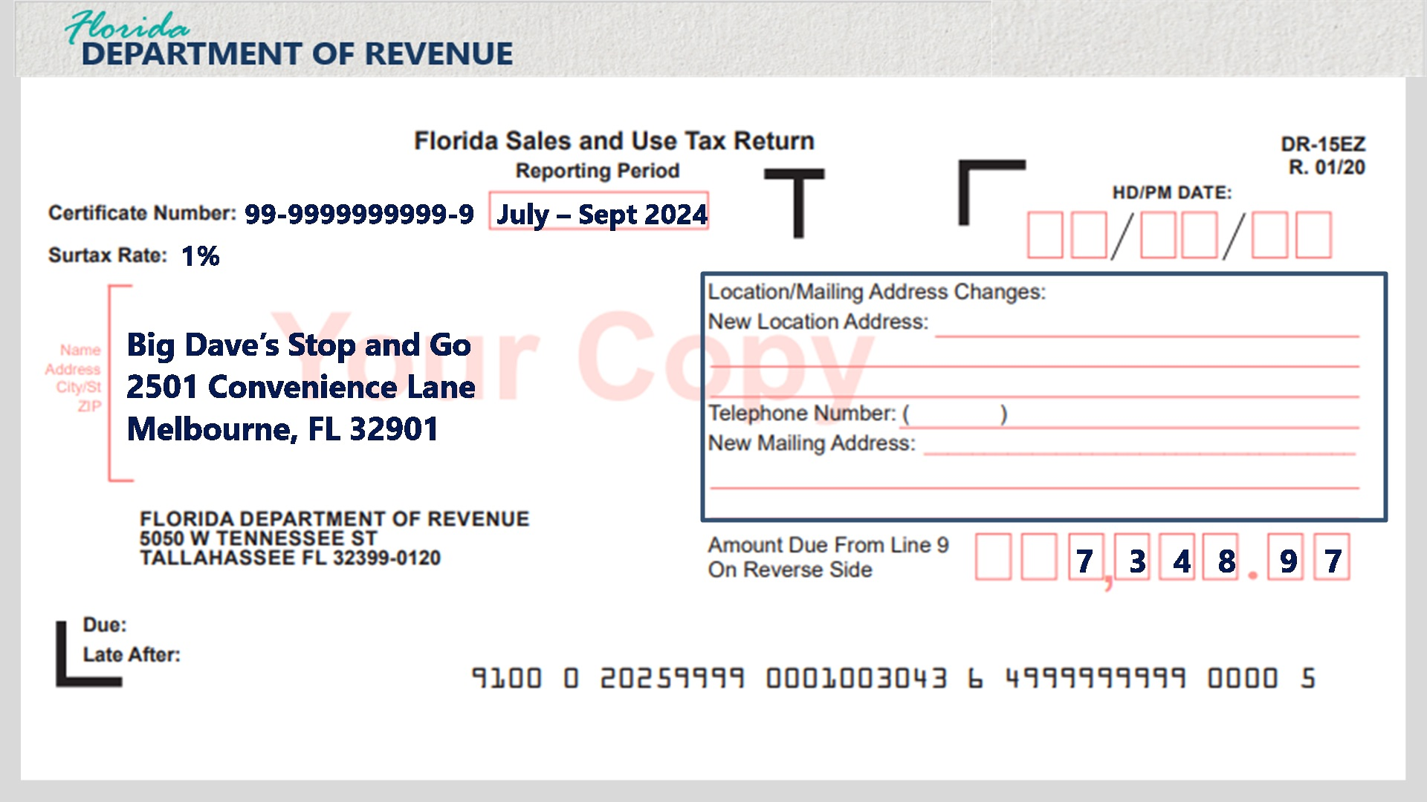
Transcript:
First, enter the certificate number for the business at the top of the return. Then enter the tax reporting period in the Reporting Period box. Next, enter the surtax rate for the county where the business is located. Finally, enter the name, address, city/state, and ZIP code under the surtax rate space.
If the location or mailing address for the business has changed, enter the new information on the right side of the form, and the Department will update its records when the return is processed.
Now, transfer the Line 9 – Amount Due on the back of the form to the Amount Due From Line 9 On Reverse Side box on the front of the form.
Click the next button to view tips for successful filing and helpful links.

7. Tips and Conclusion

7.1 Successful Filing Tips
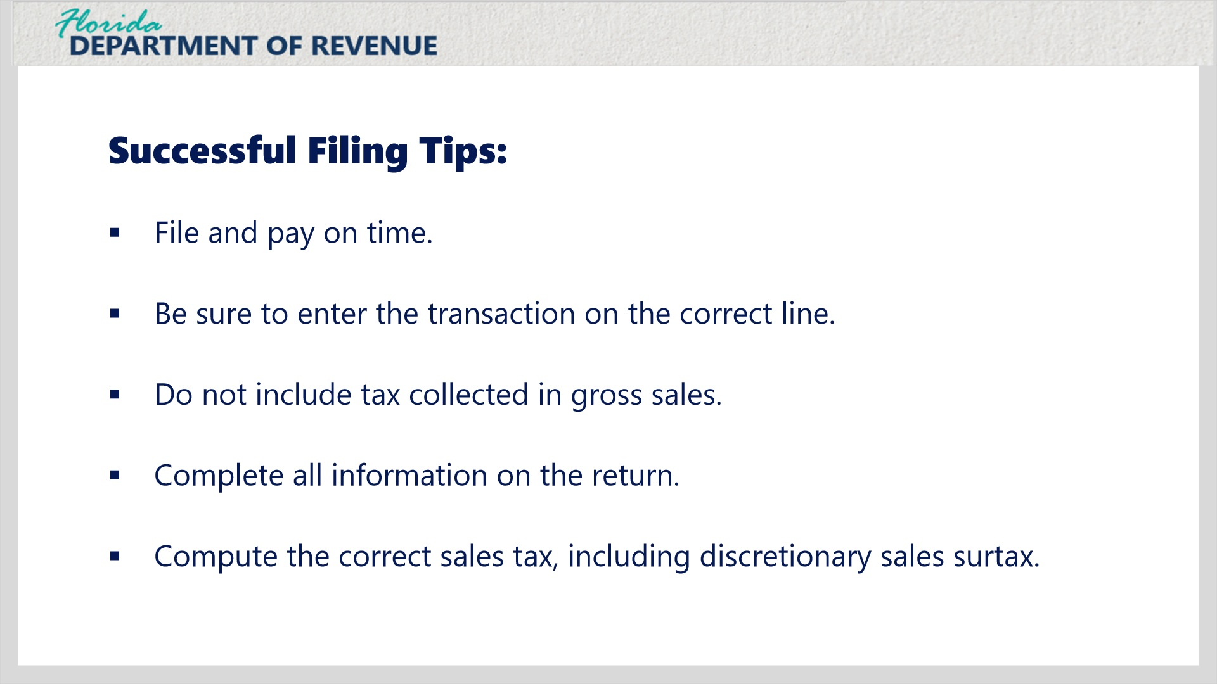
Transcript:
The following tips will assist you with successful tax filing: file and pay on time, be sure to enter the transaction on the correct line, do not include tax collected in gross sales, complete all information on the return, compute the correct sales tax, including discretionary sales surtax.

Transition layer (Slide Layer)
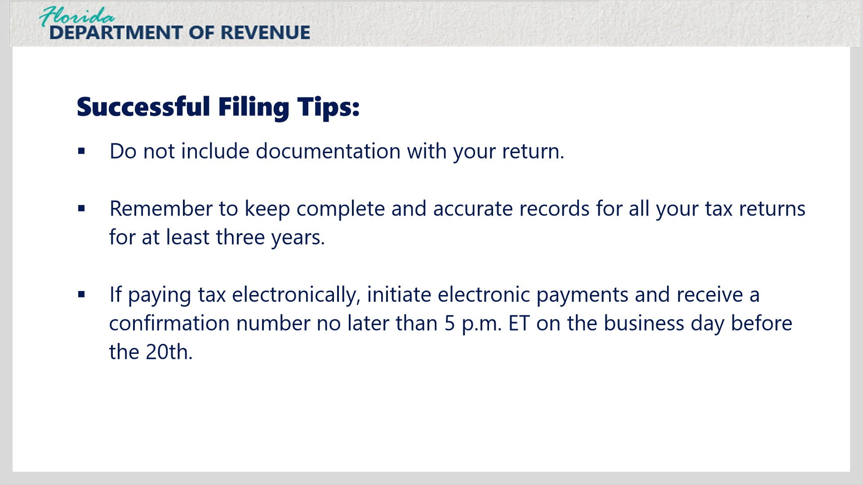
Transcript:
Do not include documentation with your return, remember to keep complete and accurate records for all your tax returns for at least three years, if paying tax electronically, initiate electronic payments and receive a confirmation number no later than 5 p.m. ET on the business day before the 20th.

7.2 Amended Returns
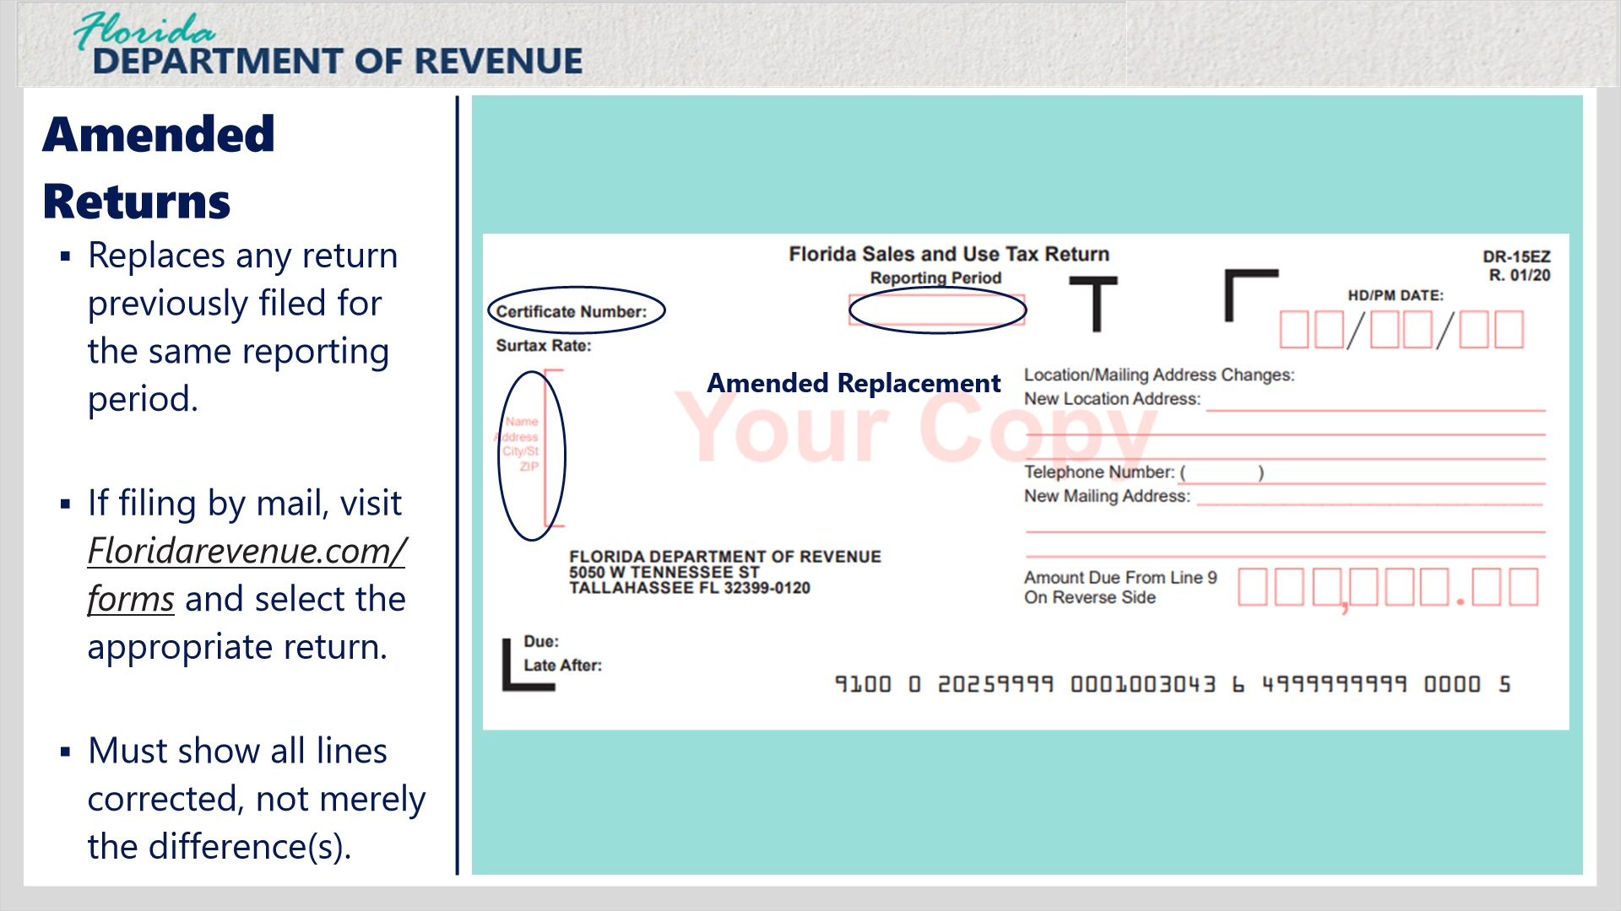
Transcript:
An amended return will replace any return previously filed for the same reporting period. It can be completed and submitted by mail or electronically. Please note that the quickest way to amend a return is online.
If filing by mail, visit floridarevenue.com/forms and select the appropriate return from the list. For our example, we will use Form DR-15EZ.
Write on the return the certificate number, the reporting period, the business name and address, and amended replacement
The amended return must show all lines as corrected, not merely the differences. The amended return will replace the original return in its entirety.

7.3 Taxpayer Education Page and Social Media
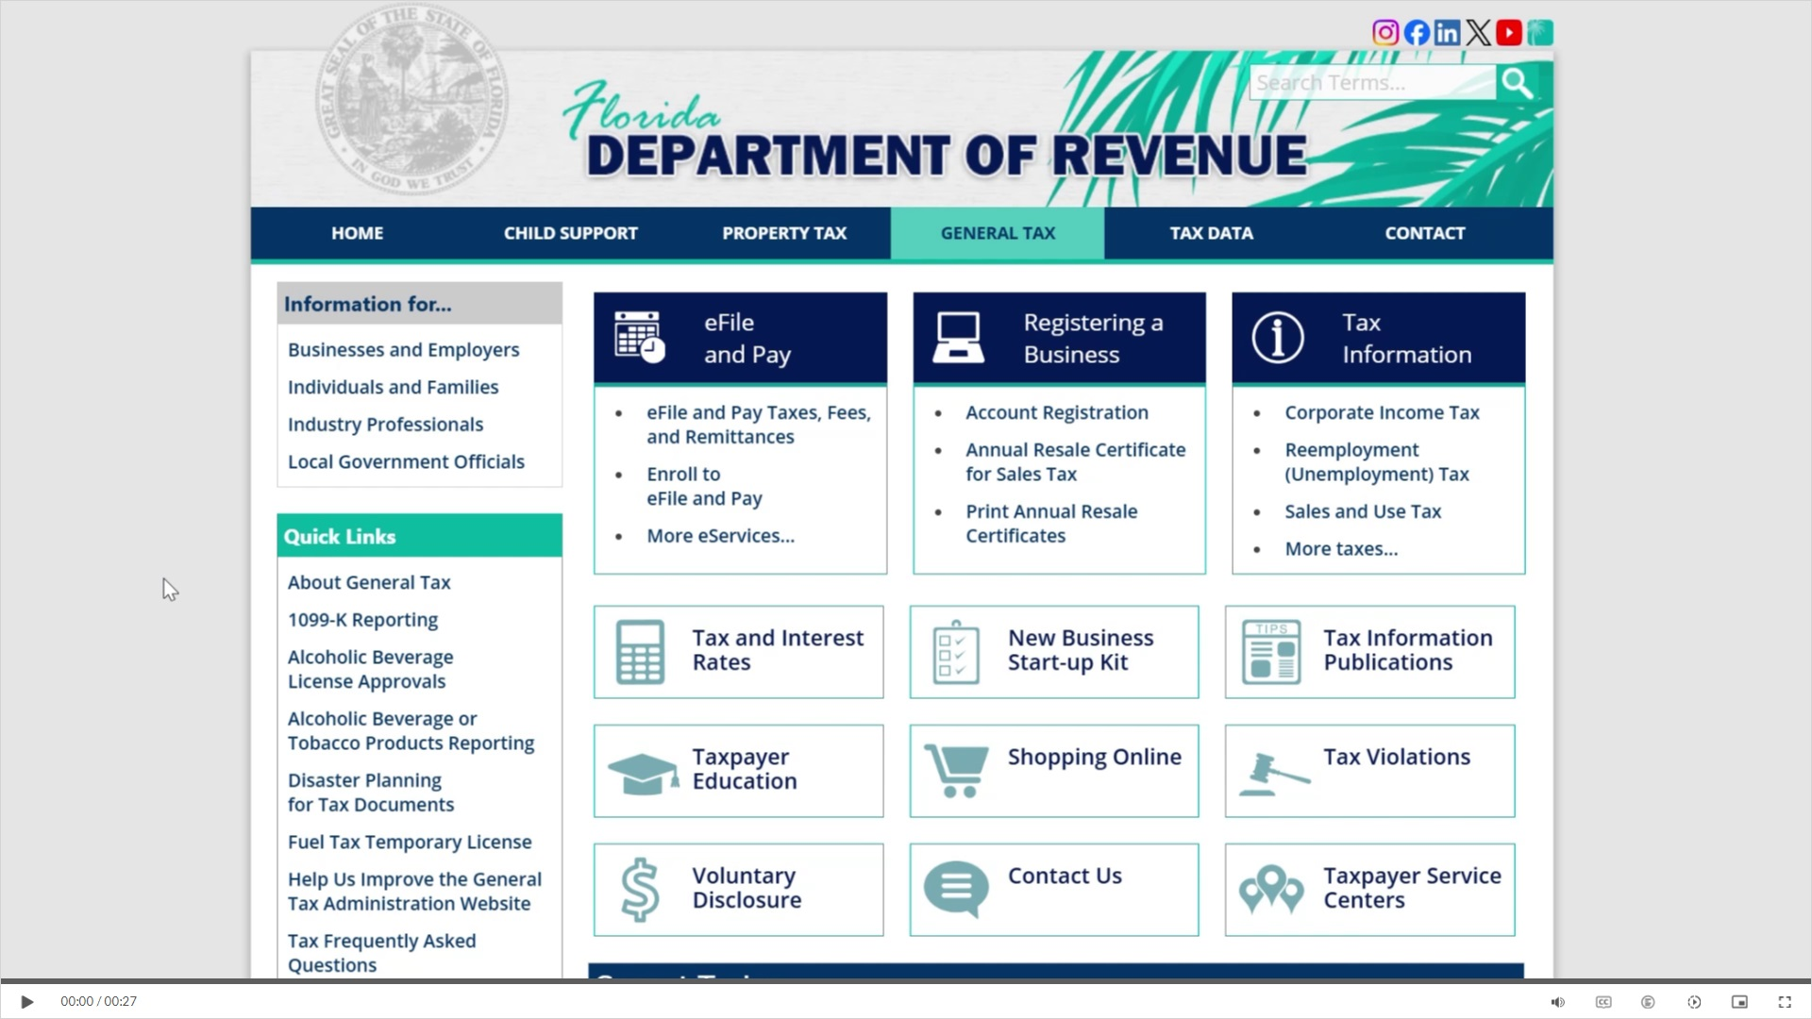
Transcript:
Visit floridarevenue.com/taxes for business resources such as forms, publications, and information on all tax types. Check out our Taxpayer Education webpage for new business guides, tutorials, and other helpful tools. And follow us on YouTube, Facebook, X, Instagram, and LinkedIn using the icons at the top of our website to stay up to date on tax topics, alerts, and more.

7.4 Survey
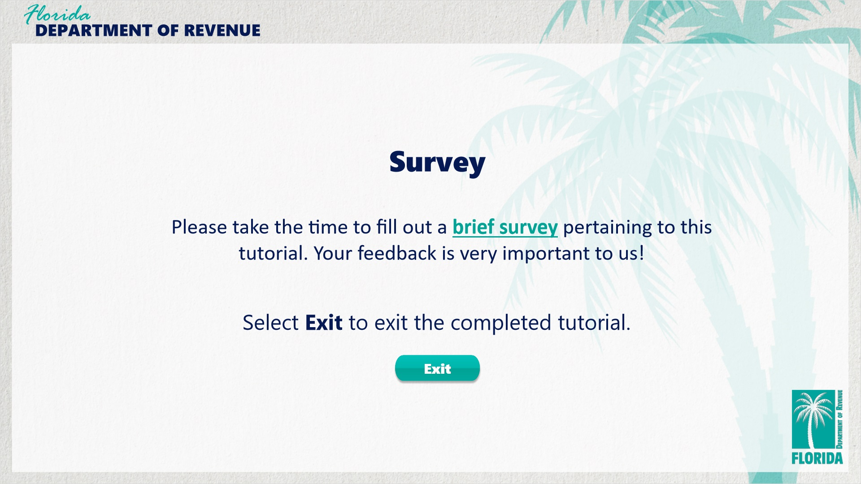
Transcript:
This concludes the How to Complete the Sales and Use Tax Return (Form DR-15EZ) tutorial.
For more information, check out the resources available within this overview by clicking on the Resources tab in the upper-right corner of your screen.
Please take a moment to fill out a brief survey pertaining to this overview. Your feedback is very important to us.
To exit this tutorial, click on the Exit button.
Thank you.

