Discretionary Sales Surtax Part 2: How to Calculate and Report

1. Introduction

1.1 Introduction
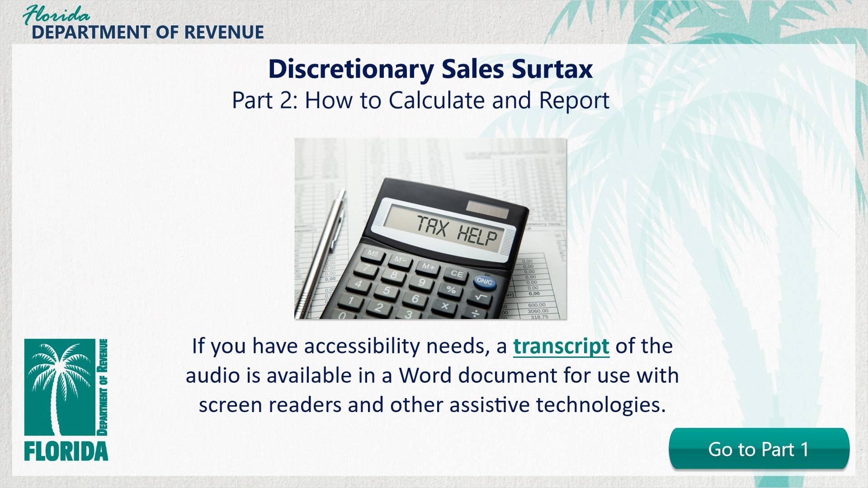
Transcript:
Welcome to “Discretionary Sales Surtax Part 2: How to Calculate and Report. This is the second of a two-part series on discretionary sales surtax.
In this tutorial, we will discuss how to calculate and report discretionary sales surtax on both the DR-15 and the DR-15EZ sales and use tax forms.
If you would like a review of the basic concepts of discretionary sales surtax before completing this advanced tutorial, you may choose to go to Part 1 by clicking on the button labeled Go to Part 1.
If you have accessibility needs, a transcript of the audio is available in a Word document for use with screen readers and other assistive technologies.

1.2 Navigating This Tutorial
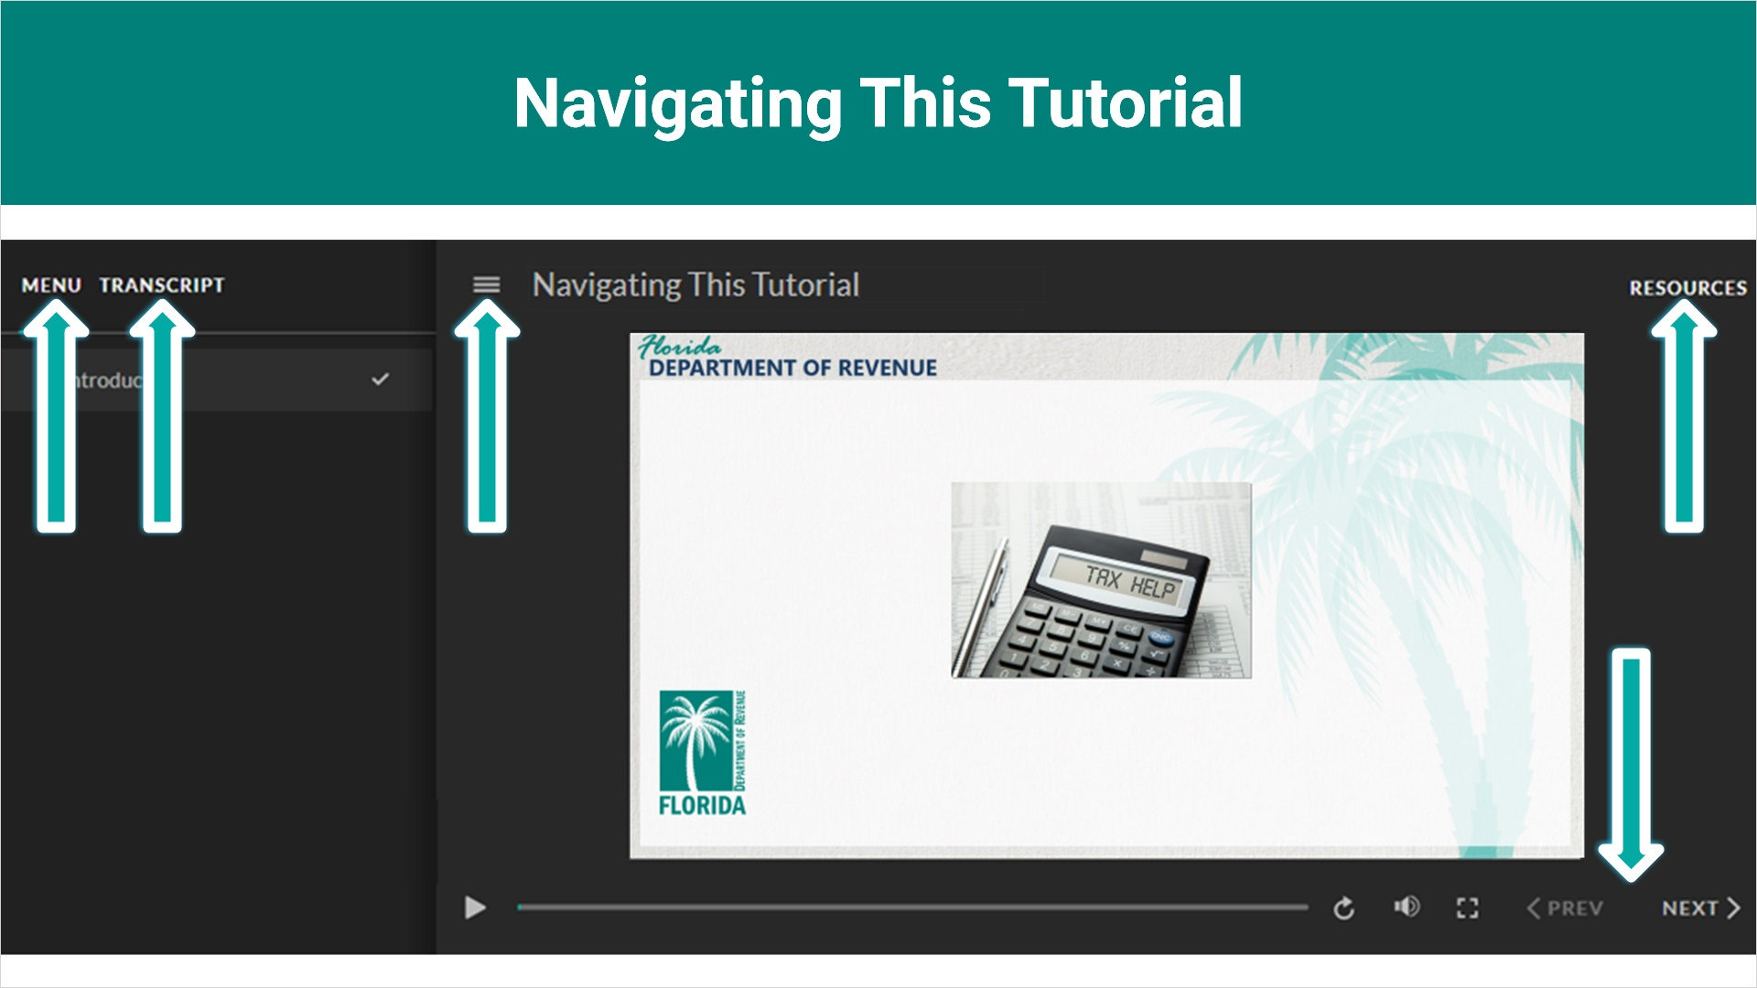
Transcript:
This overview will take approximately 20 minutes to complete. A transcript of the audio is available by clicking on the transcript tab in the top-left corner of your screen.
The following tabs and buttons are available to help you navigate throughout this overview.
Menu Tab
The menu tab displays by default when the overview is viewed on a computer. It allows you to navigate through the overview by clicking on the topic name on the menu. When viewing this overview on a tablet or smartphone, the menu does not display by default and must be accessed using the menu symbol.
Resources Tab
The resources tab is found on the right side of the top bar. When clicked, it displays the list of links to useful forms, documents, and webpages.
Previous and Next Buttons
The previous and next buttons are located at the bottom-right corner of your screen. These buttons allow you to move either back or forward.

1.3 Topics Slide
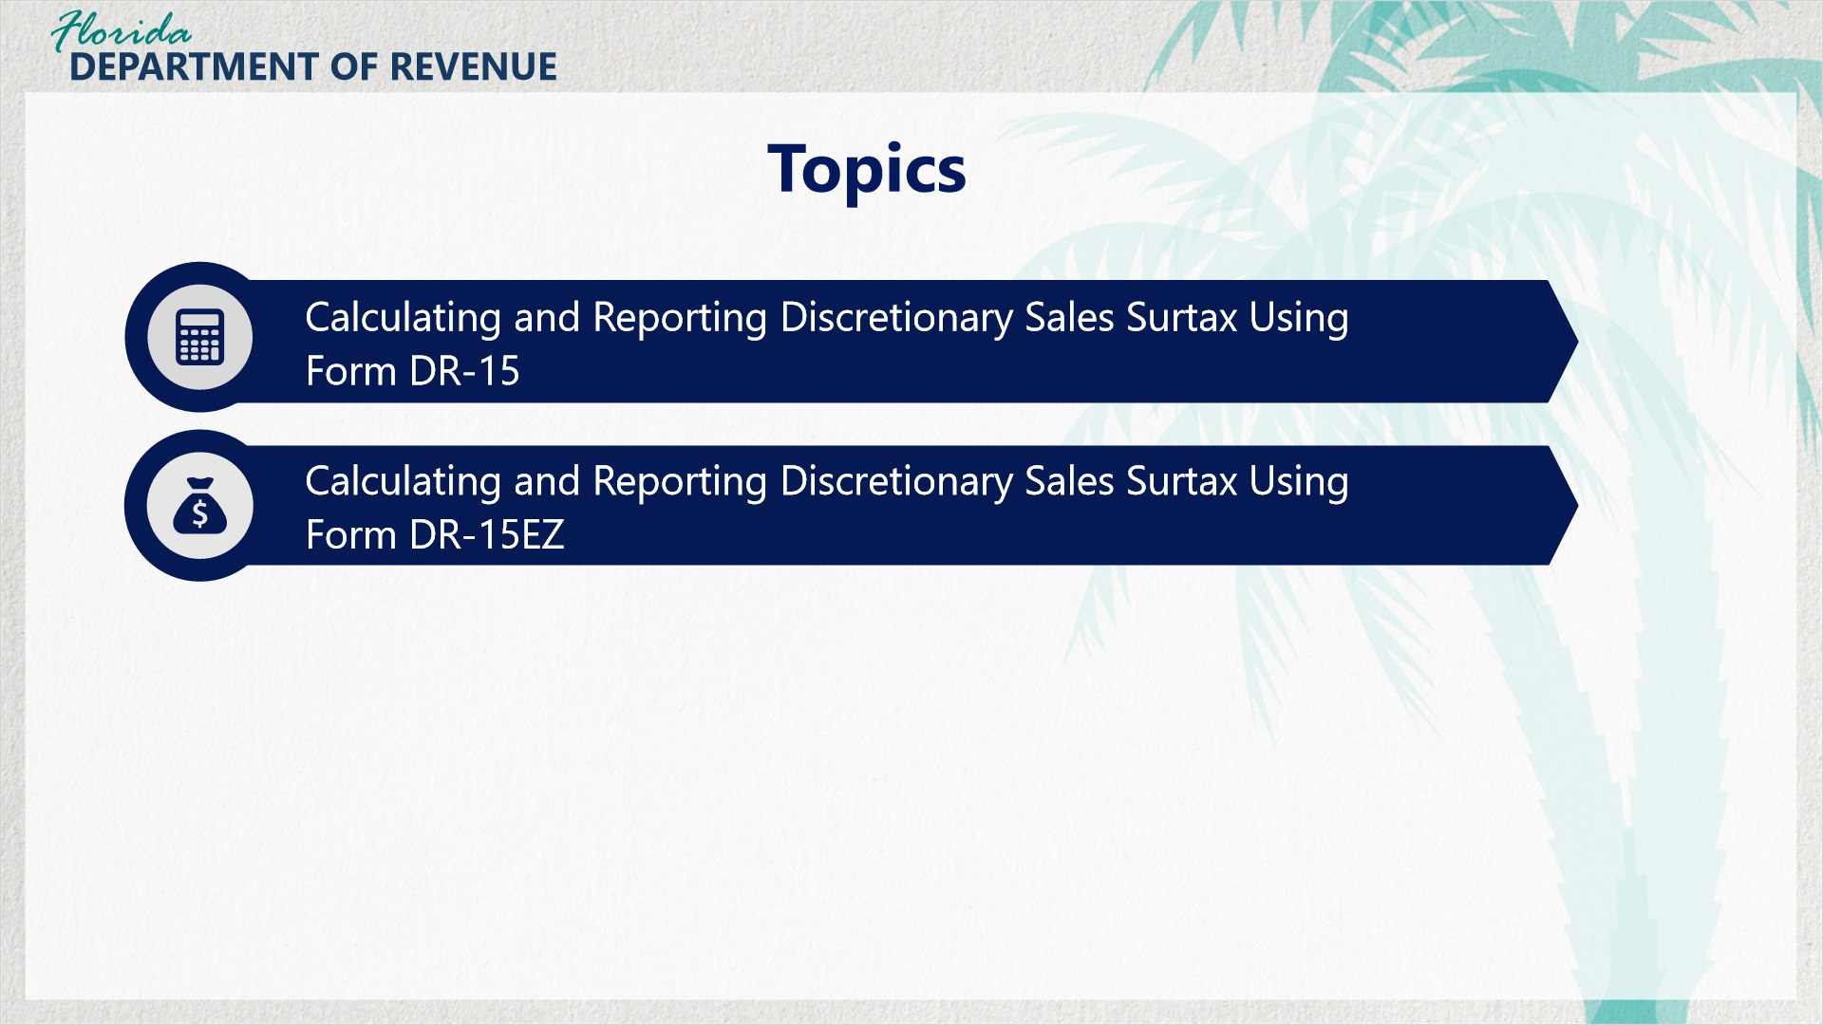
Transcript:
Topics for this tutorial include information about the Sales and Use Tax Return (Form DR-15), the process for completing the return, the process for submitting an amended return, and tips for filing your return successfully.

1.4 Assessment Information
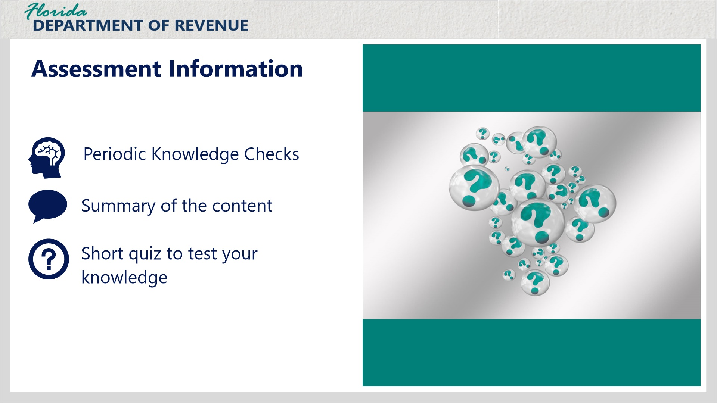
Transcript:
There will be periodic Knowledge Checks throughout this tutorial for you to practice what you’re learning.
At the end of this tutorial, there will be a summary of the content followed by a short quiz to test your knowledge.
Keep in mind that there is no audio for Knowledge Checks or quiz slides.

1.5 Review of Part 1
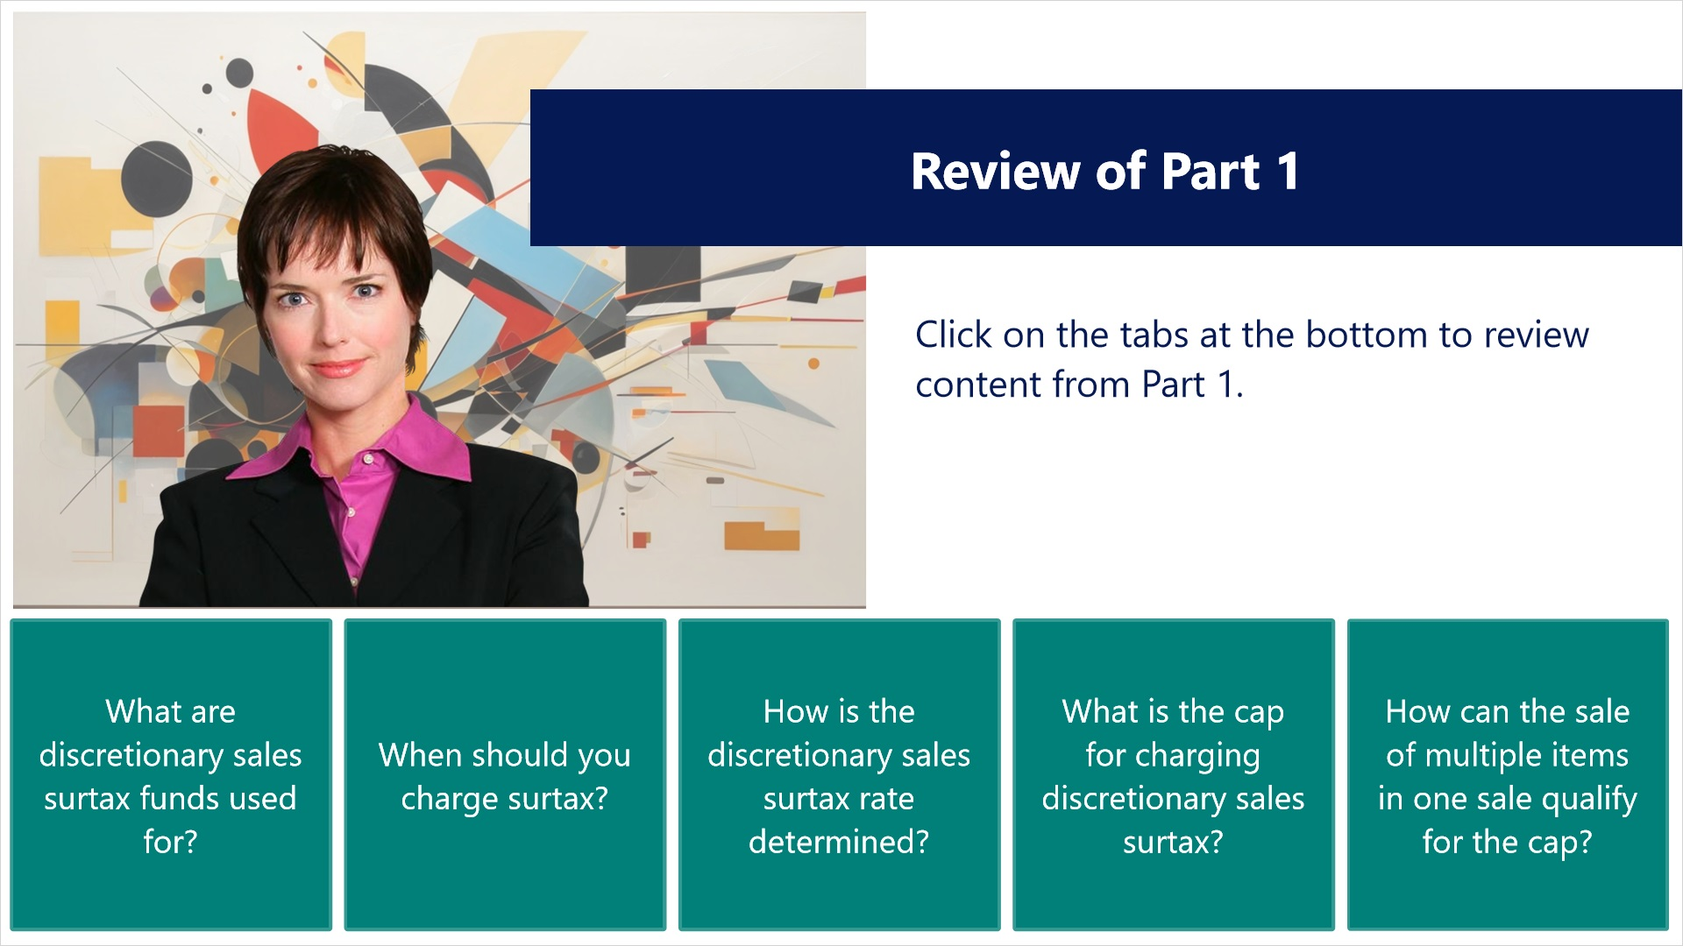
Transcript:
Click on the tabs below to review content from Part 1.
---------------------------------------
Tab 1
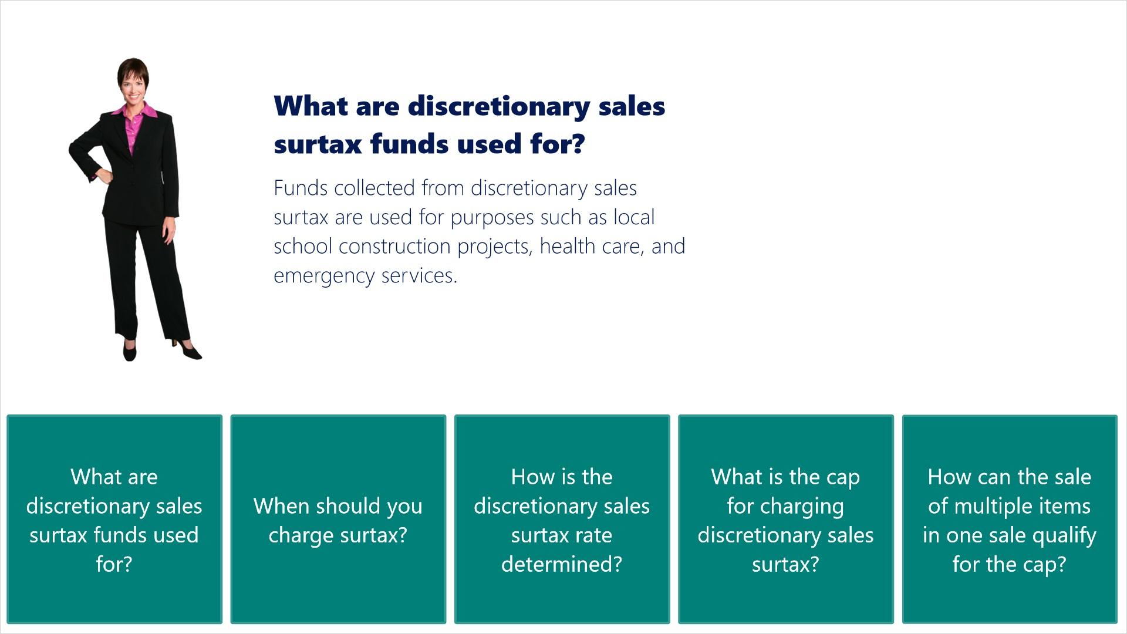
Transcript:
What are discretionary sales surtax funds used for?
[Janet]: Funds collected from discretionary sales surtax are used for purposes such as local school construction projects, health care, and emergency services.
----------------------------------------
Tab 2
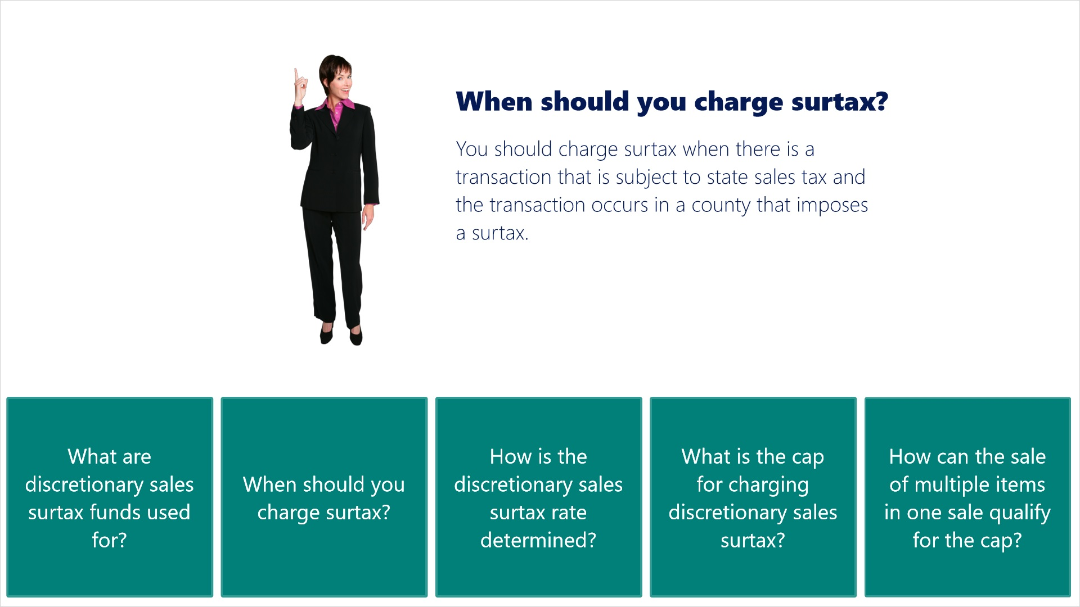
Transcript:
When should you charge surtax?
[Janet]: You should charge surtax when there is a transaction that is subject to state sales tax and the transaction occurs in a county that imposes a surtax.
-----------------------------------------
Tab 3
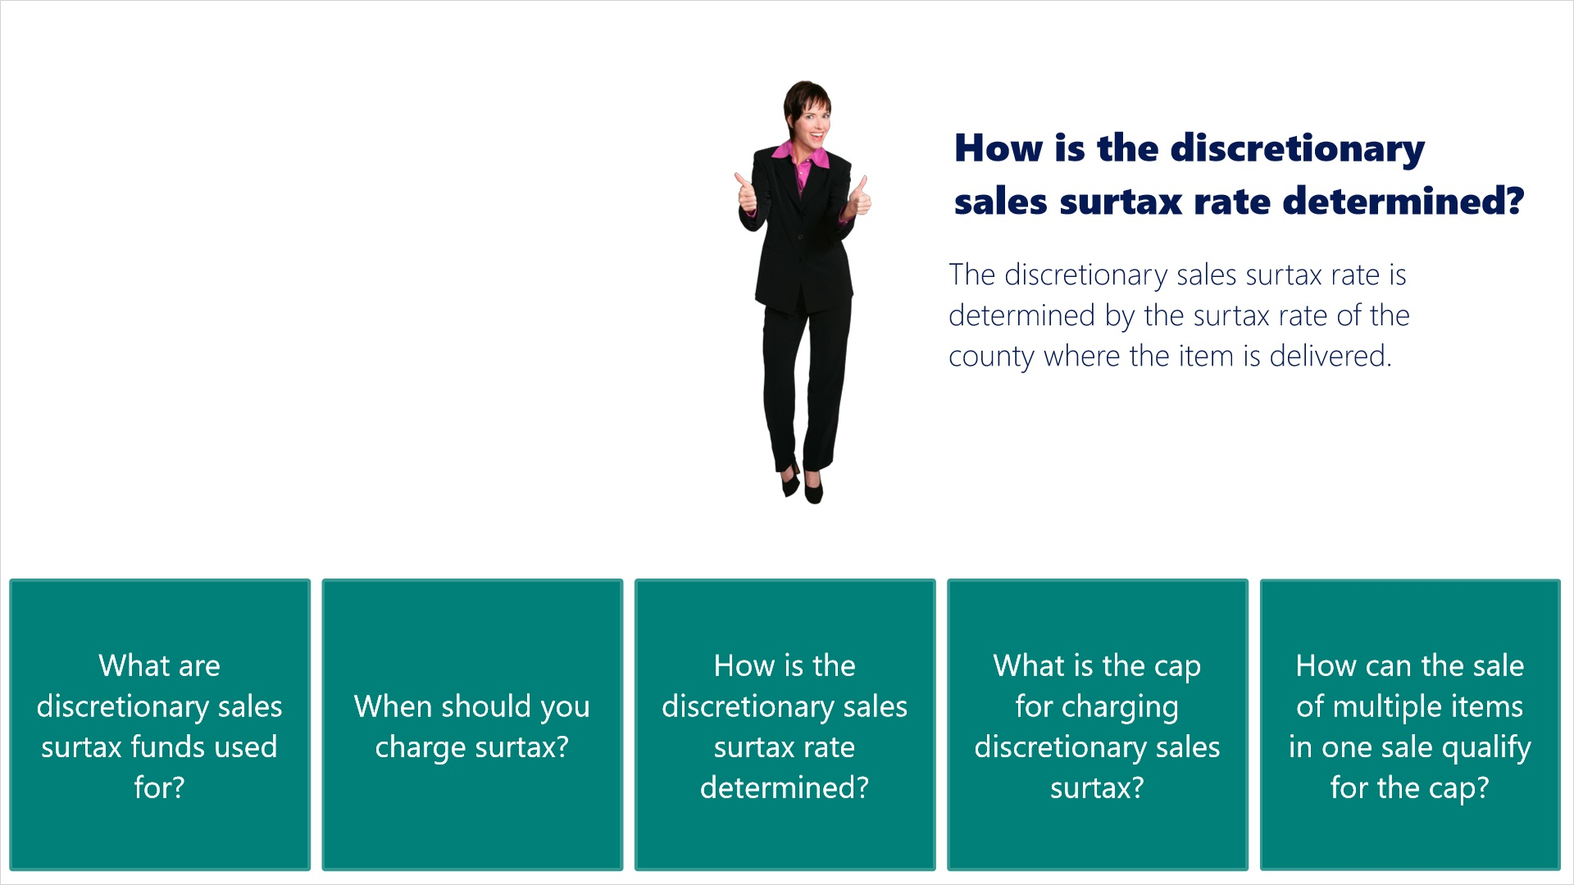
Transcript:
How is the discretionary sales surtax rate determined?
[Janet]: The discretionary sales surtax rate is determined by the surtax rate of the county where the item is delivered.
-----------------------------------------
Tab 4
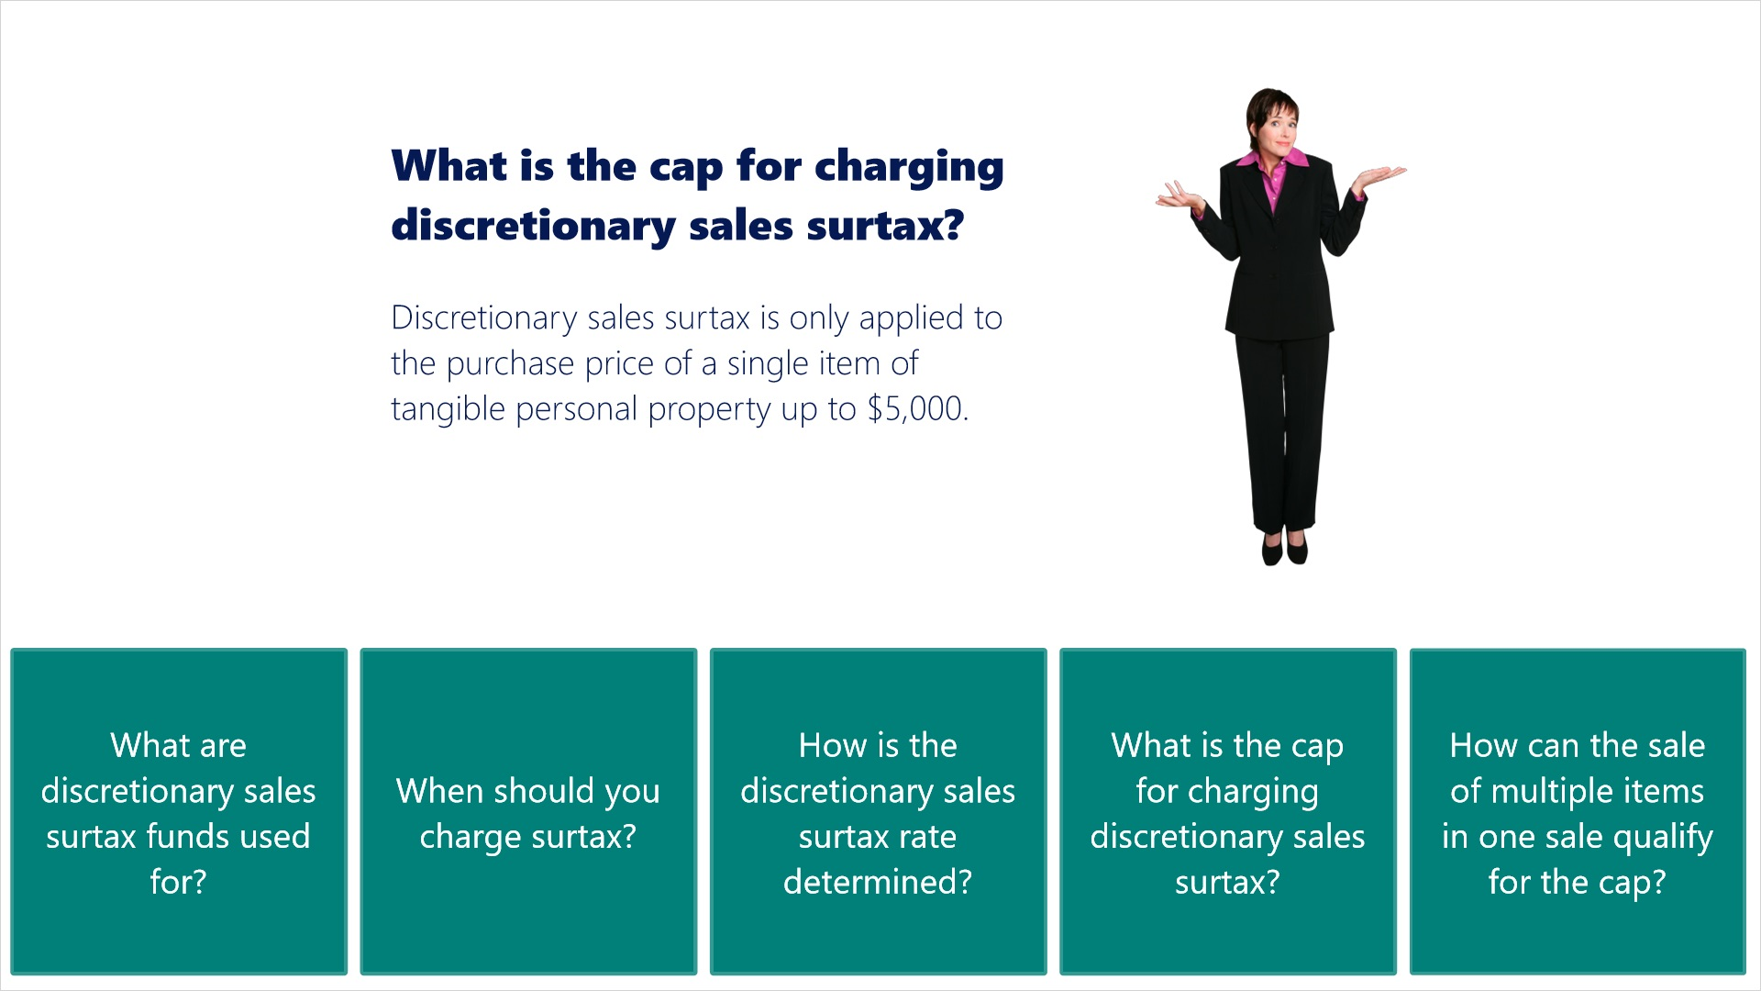
Transcript:
What is the cap for charging discretionary sales surtax?

[Janet]: Discretionary sales surtax is only applied to the purchase price of a single item of tangible personal property up to $5,000.
-----------------------------------------
Tab 5
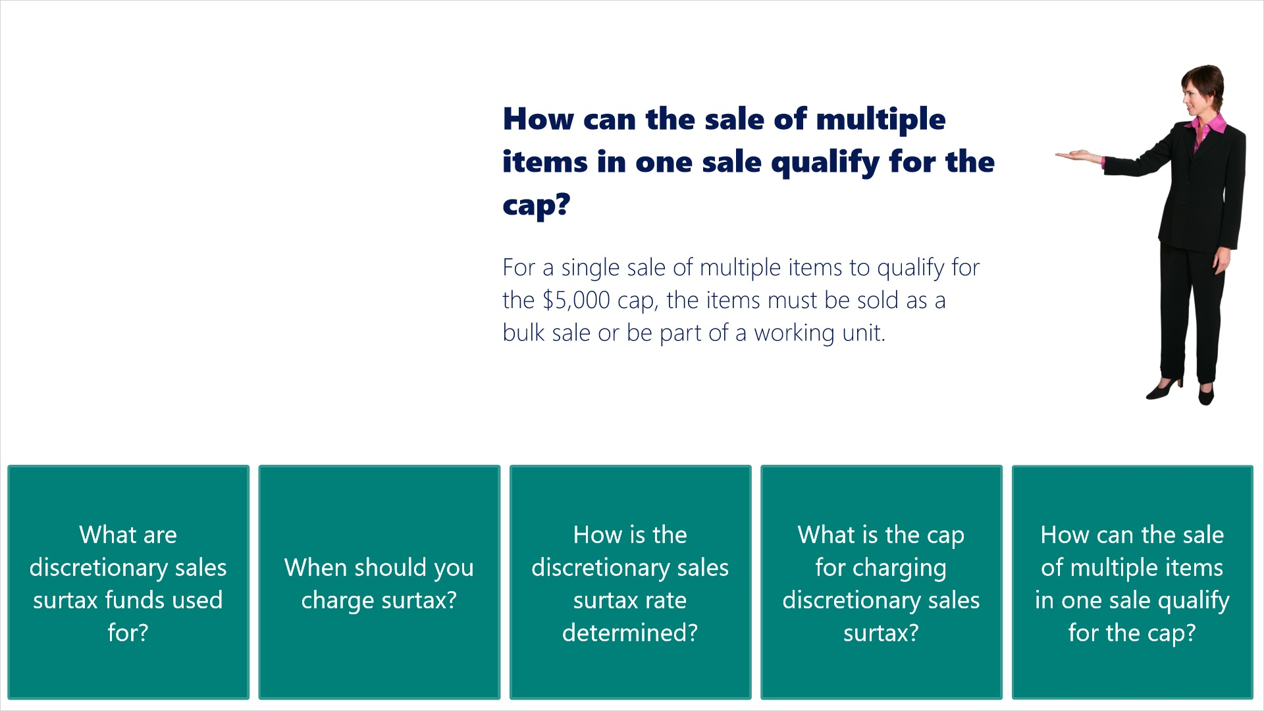
Transcript:
How can the sale of multiple items in one sale qualify for the cap?
[Janet]: For a single sale of multiple items to qualify for the $5,000 cap, the items must be sold as a bulk sale or be part of a working unit.

2. Forms For Reporting

2.1 Sales and Use Tax Forms
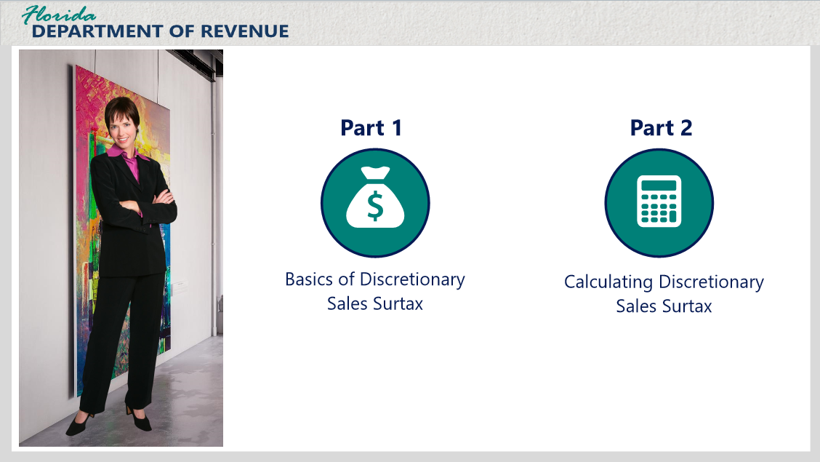
Transcript:
In Part 1 of this tutorial series, we met Janet, owner of Janet’s Gallery - a high-end art gallery and boutique. In that tutorial, we discussed the basics of discretionary sales surtax, and I answered some of her questions.
It’s good to see you again, Janet.
[Janet]: Thanks. It’s good to see you too. Our last talk was helpful, but I still have some questions for you.
I will be happy to answer them for you. I thought you might have some questions regarding how to properly calculate and report discretionary sales surtax on your sales and use tax return.
[Janet]: You read my mind. What calculations are required?
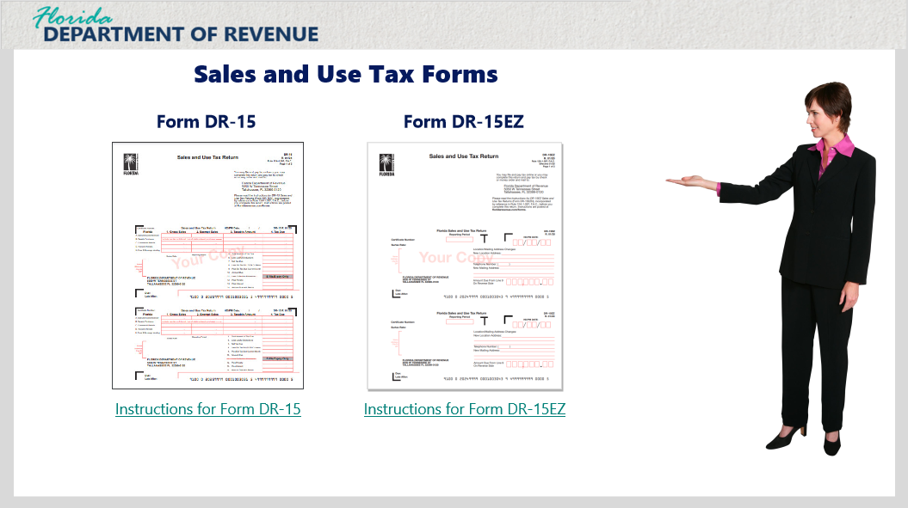
It really depends on which sales and use tax return you complete.
[Janet]: There’s more than one?
Yes. In fact, there are two. Both are available through eFiling or by completing a paper-based return.
The first one is the traditional Sales and Use Tax Return (Form DR-15). This is the most commonly used version.
[Janet]: Yes, that is the version I have been using. I didn’t know there was another.
Many people don’t. The second version, the DR-15EZ, is less complex than the original DR-15 form; however, your business must meet certain requirements to use it.
Those requirements can be found by clicking on the link for the DR-15EZ instructions. You should know that if you sell or deliver taxable items into any Florida county with a different discretionary sales surtax rate than the county’s surtax rate where your business is located, you are required to use Form DR-15.
[Janet]: I understand. Since I deliver to many counties with different surtax rates from my own, I would be ineligible to use the DR-15EZ.
That’s right. Given your specific situation, you are required to file and report your sales and use tax with the DR-15.
[Janet]: Would you mind if we went over how to use both forms? I want to learn about both in the event I change my delivery availability to just my county.
Sure. We can do that.

3. Calculating and Reporting Discretionary Sales Surtax (Form DR-15)

3.1 Overview of Required Calculations
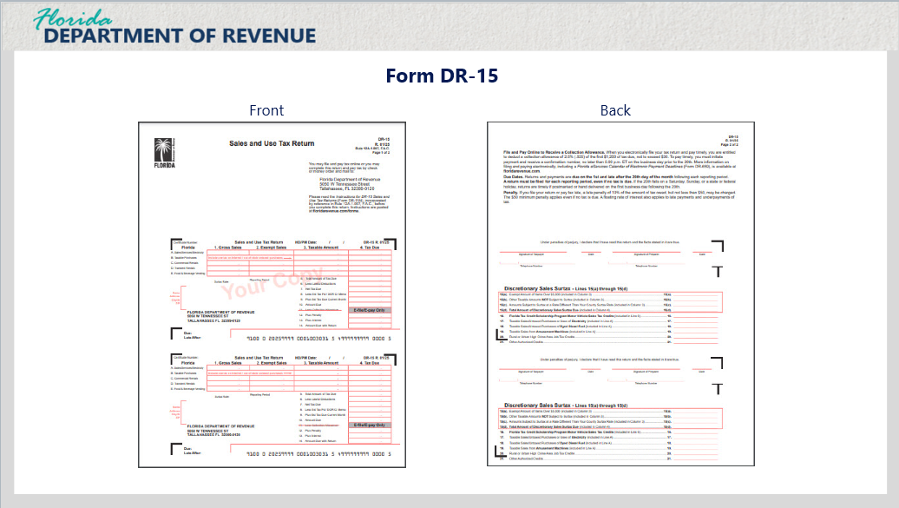
Transcript:
As stated previously, you can file and pay your sales and use taxes and discretionary sales surtax either by eFiling or by using a paper-based form.
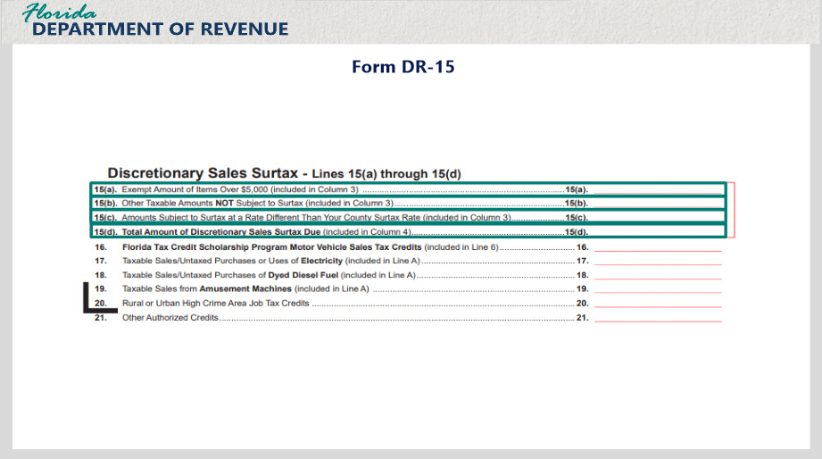
Transcript:
When filing your return, Lines 15(a) through 15(d) will contain the calculations required to report discretionary sales surtax. If you are filing a paper-based return, these lines can be found on the back. We will go into more detail on how to calculate each line in a moment. But first, I’ll explain what is reported on each line.
Line 15(a) is where you enter the exempt amount of items over $5,000 included in Column 3 of your return. You add together all of the amounts above where the discretionary sales surtax cap has been applied and put them on Line 15(a).
Line 15(b) is where you will enter other taxable amounts not subject to surtax included in Column 3. Here, you will total all of the amounts of sales where no surtax was charged.
Line 15(c) is used to enter the amounts subject to surtax at a rate different from your county surtax rate included in Column 3. Any items you sell and deliver to a county with a different surtax rate from your own will be calculated here.
And Line 15(d) is where you will enter the total amount of discretionary sales surtax due included in Column 4.
Now that you know what is entered on each line, let’s go into more detail about how each one is calculated and reported.

3.2 Line 15(a)
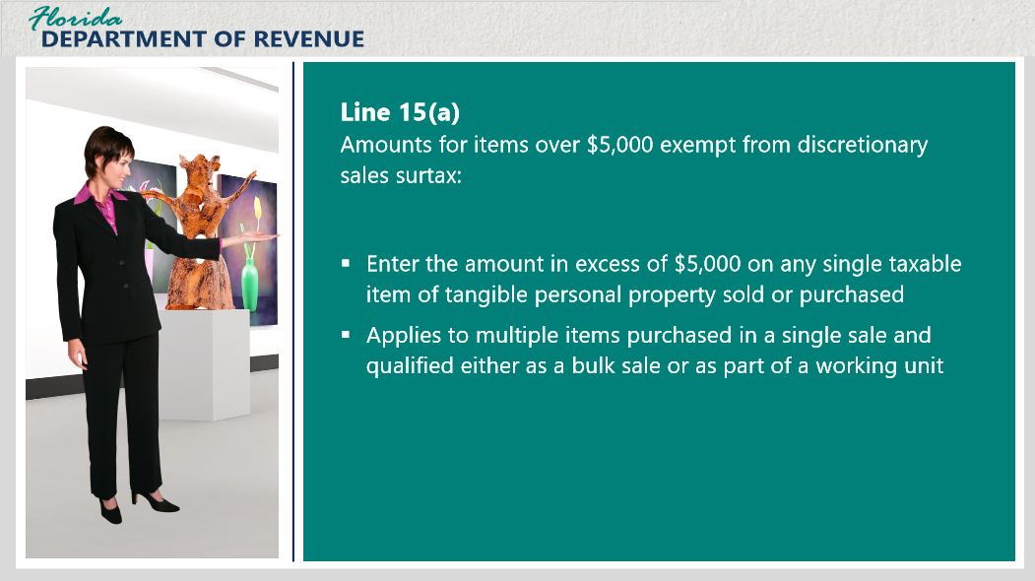
Transcript:
On Line 15(a), you will enter the amounts for items sold over $5,000 that were exempt from discretionary sales surtax. In other words, you will enter the amount in excess of $5,000 on any single taxable item of tangible personal property sold or purchased for more than $5,000. This would also apply to multiple items that were purchased in a single sale and qualified for the cap either as a bulk sale or because the items were part of a working unit.
Here is an example:
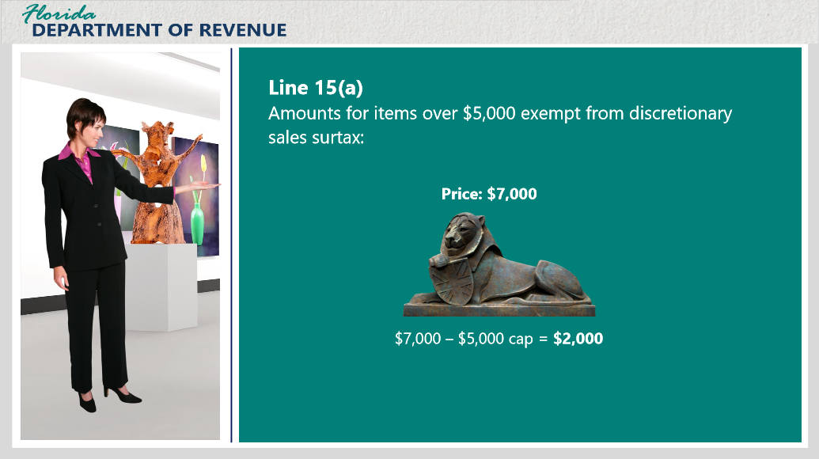
Transcript:
If a single item of tangible personal property is sold for $7,000, enter $2,000, the amount over the $5,000 cap, on Line 15(a). Of course, you will probably have multiple sales over $5,000 that meet the cap, especially in your business, Janet. You would add these excess amounts together and put the total on Line 15(a).
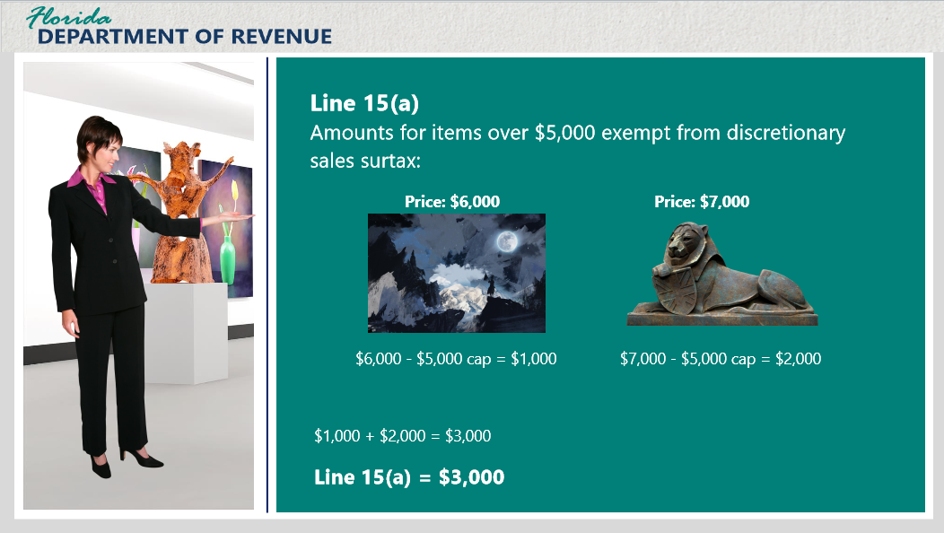

Transcript:
For instance, let’s say you only sell two pieces for a reporting period: one painting for $6,000 and a sculpture for $7,000. The excess amount over the cap is $1,000 for the painting and $2,000 for the sculpture. Adding these two excess amounts gives you a total of $3,000, which you would enter as your exempt amount of items over $5,000 on Line 15(a).
If you had 10 items for a reporting period that exceeded the cap, you would add together the excess for all 10 items and put the total on Line 15(a).
[Janet]: Thank you for simplifying that process for me. I understand it better now.
That’s what I like to hear. To be sure, let’s do a little practice.

3.3 Knowledge Check: Line 15(a)
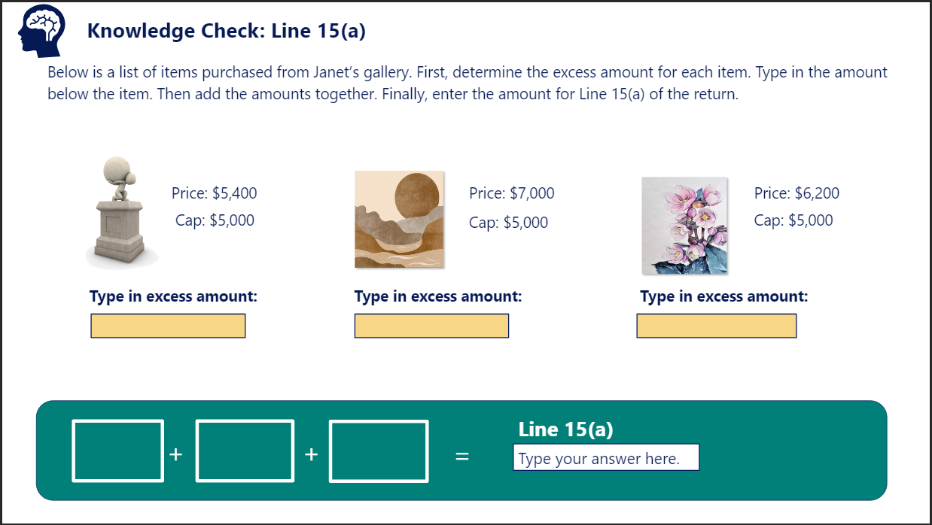
Transcript:
Question: Below is a list of items purchased from Janet’s gallery. First, determine the excess amount for each item. Type in the amount below each item. Then add the amounts together. Finally, enter the amount for Line 15(a) of the return.
Item 1 Price: $5,400
Item 2 Price: $7,000
Item 3 Price: $6,200
Correct Answer: $400 + $2,000 + $1,200 = $3,600 on Line 15(a)

3.4 Line 15(b)
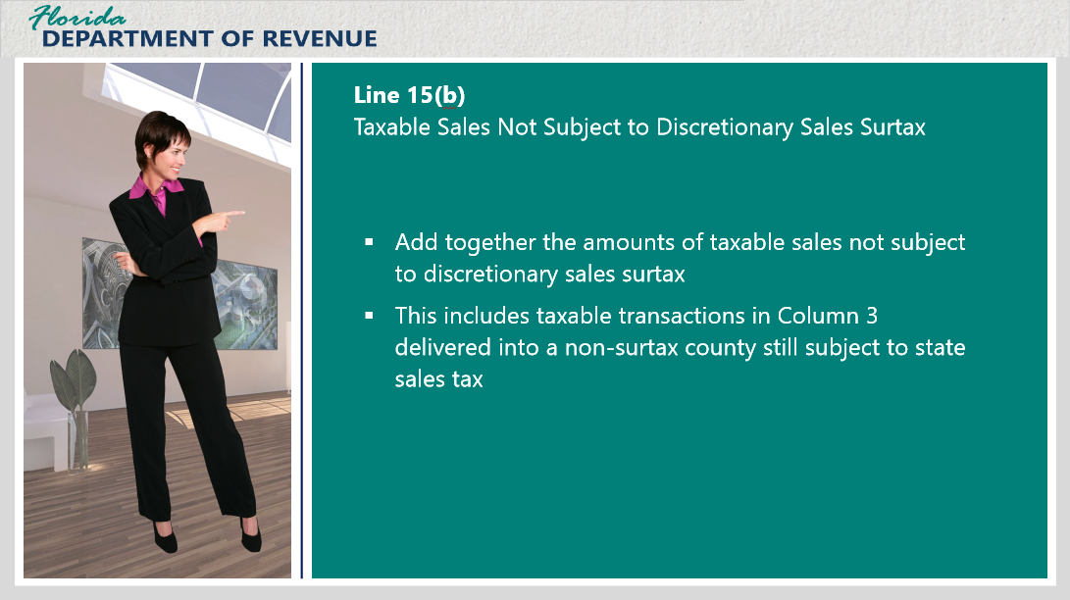
Transcript:
The next item to complete includes taxable sales or purchases included in Column 3 that are not subject to discretionary sales surtax. This includes taxable transactions in Column 3 delivered into a non-surtax county that are subject to state sales tax, but not discretionary sales surtax.
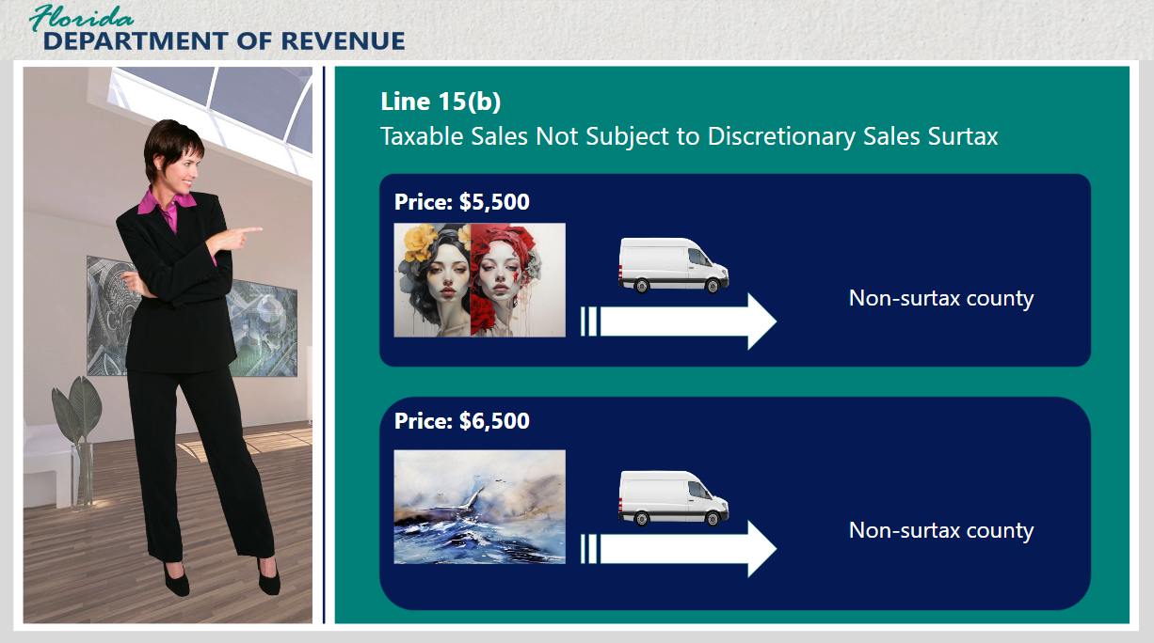
Transcript:
Janet, let’s say your gallery sells two paintings in a reporting period: one for $5,500 and another for $6,500. You deliver both of these items into counties with no discretionary sales surtax.

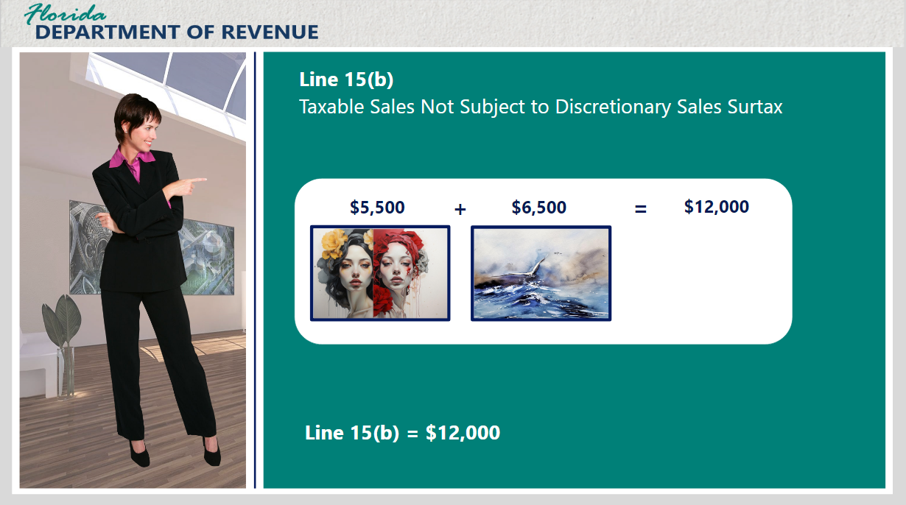
Transcript:
You would add these two amounts together and enter the total of $12,000 on Line 15(b).
Again, however many items fall into this category in a reporting period would be added together and totaled on Line 15(b).
Let’s do some more practice.

3.5 Knowledge Check: Line 15(b)
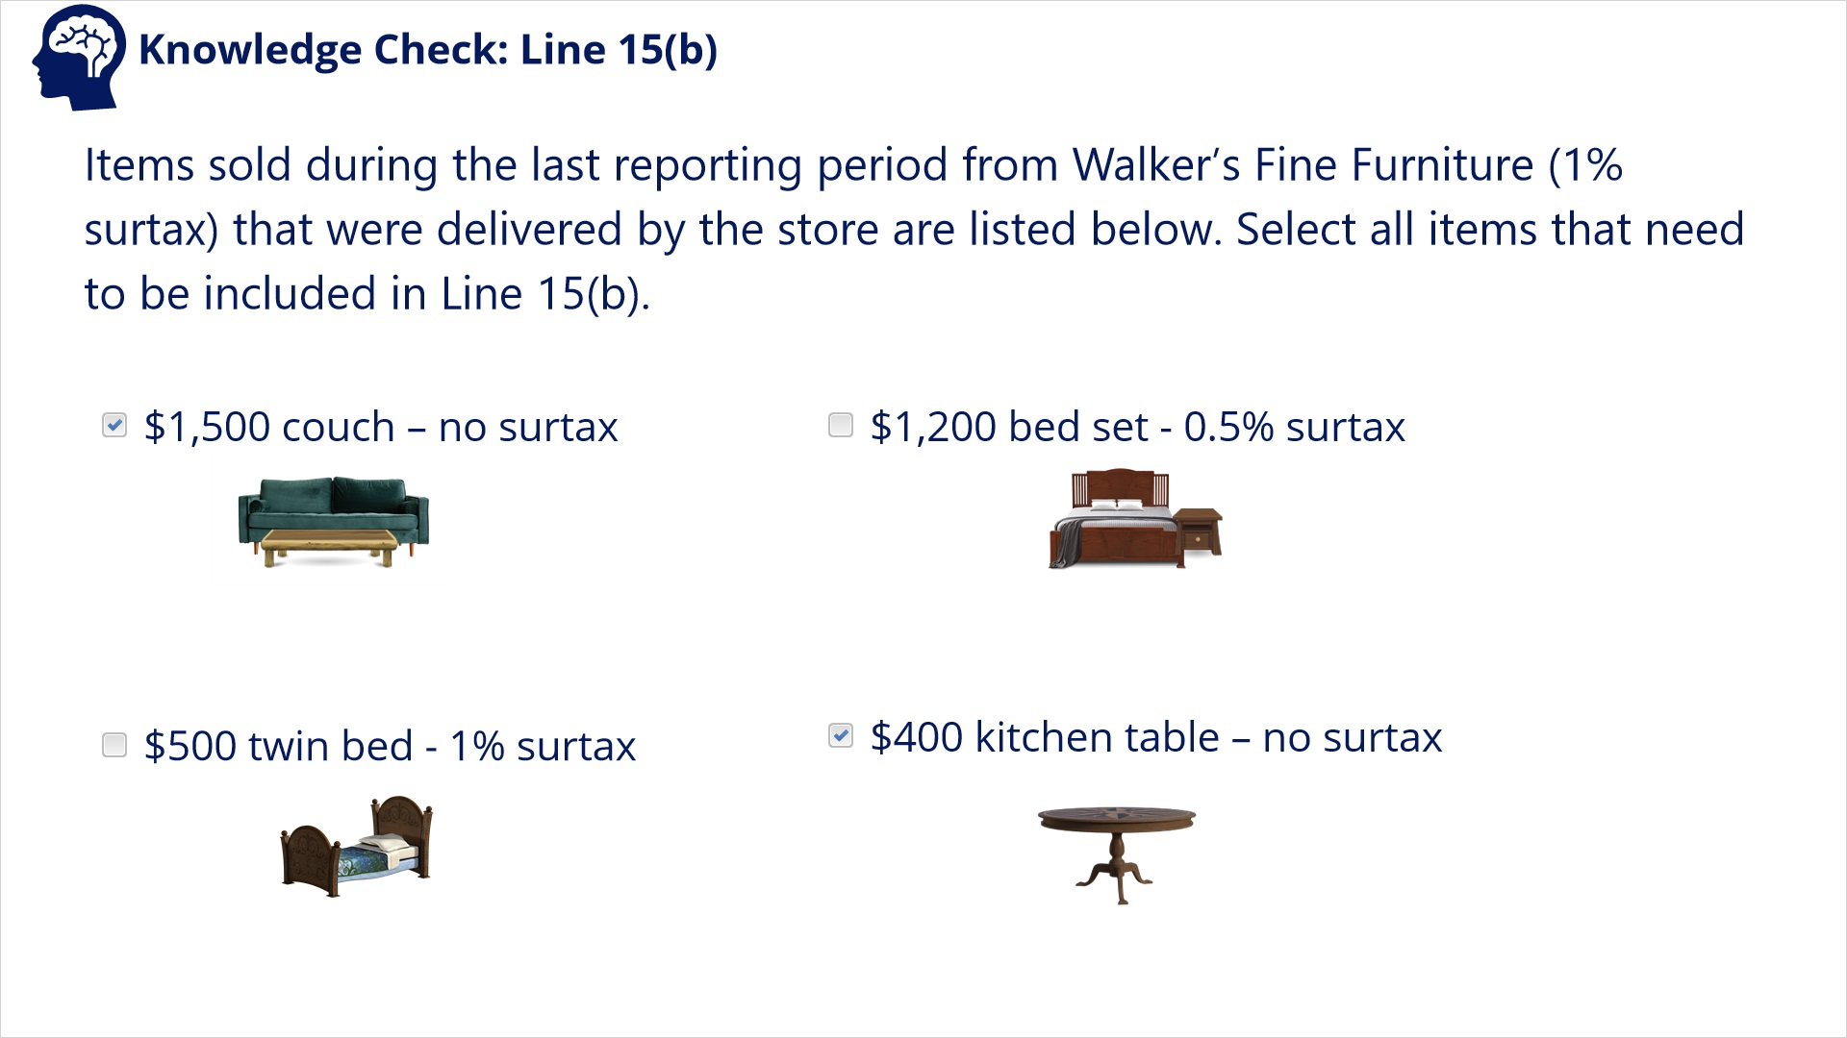
Transcript:
Question: Items sold during the last reporting period from Walker’s Fine Furniture (1% surtax) that were delivered by the store are listed below. Select all the items that need to be included in Line 15(b).
Items to choose from (multiple items accepted)
- Couch - $1,500 – no surtax
- Bed set - $1,200 – 0.5% surtax
- Twin bed - $500 – 1% surtax
- Kitchen table - $400 – no surtax
Correct Answers: Only the items with no surtax belong in Line 15(b). These include the couch and the kitchen table.

3.6 Line 15(c) Part 1
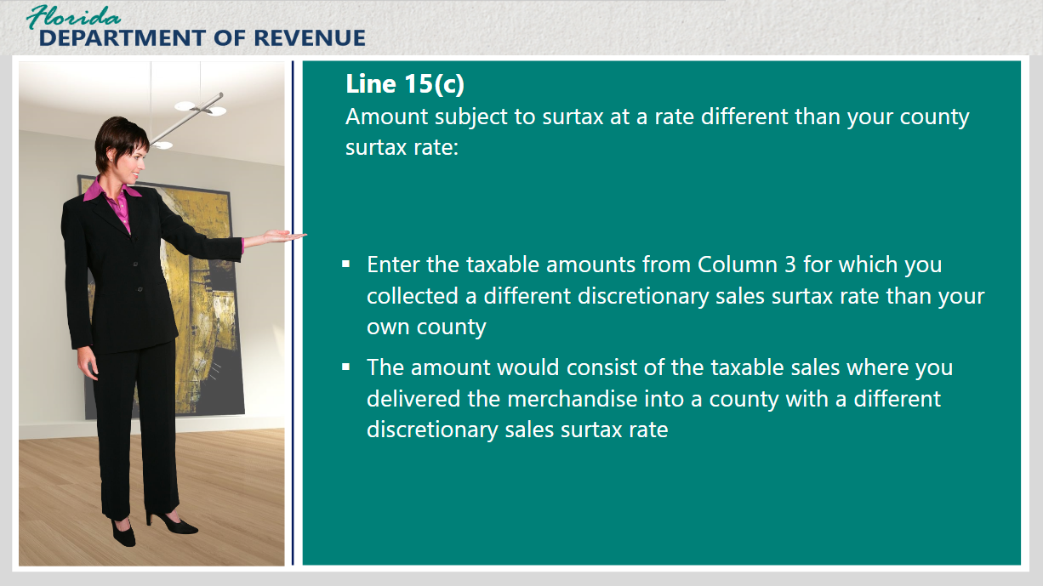
Transcript:
Let’s take a minute and talk about Line 15(c): Amount Subject to Surtax at a Rate Different Than Your County Surtax Rate.
Begin by looking at Column 3, which is the taxable amount of all your sales. Enter the taxable amounts from Column 3 for which you collected a different discretionary sales surtax rate than your own county’s.
The amount would consist of the taxable sales where you delivered the merchandise into a county with a different discretionary sales surtax rate. This information would be provided on Line 15(c).
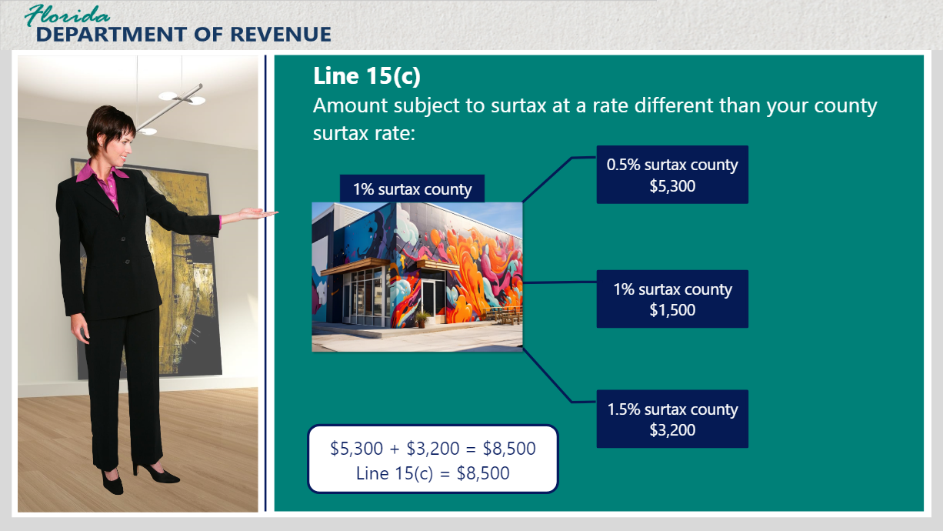
Transcript:
For example, your gallery is in a 1% discretionary sales surtax county. In this instance, assume that no purchases were eligible for the $5,000 cap.
You sell merchandise to three different counties.
Two of these counties have different surtax rates from yours. One of them has the same surtax rate at 1%.
To calculate Line 15(c), you would add together the taxable amounts only from the two counties with different surtax rates from your county’s. In this instance, the total taxable sales for Line 15(c) would be $8,500.
[Janet]: This is where I get confused. I know I add all of the taxable amounts from sales to different discretionary sales surtax rates and enter them into Line 15(c). But how do I let the Department of Revenue know which transactions go to which counties? How does the Department make sure that the painting I sold to a customer in a 0.5% surtax county goes to that county?
That is a great question. As the taxpayer, it is not your responsibility to tell the Department where the funds should be sent. The Department has a method for determining which county gets what funds. However, you do need to keep records of these transactions and where they take place in case of an audit.
[Janet]: That’s a relief. Can you give me an example of how reporting discretionary sales surtax from multiple counties would work? I just want to make sure I understand.
I’d be happy to.

3.7 Line 15(c) Part 2
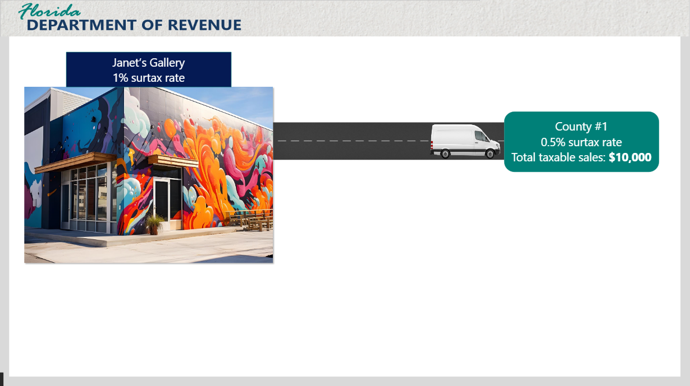
Transcript:
Click on the delivery van to hear about its journey.
-------------------------------------------------
Let’s say your gallery located in a 1% surtax county frequently makes deliveries into two nearby counties. The first county where deliveries are often made has a 0.5% surtax rate. The total sales subject to state sales tax and discretionary sales surtax is $10,000.
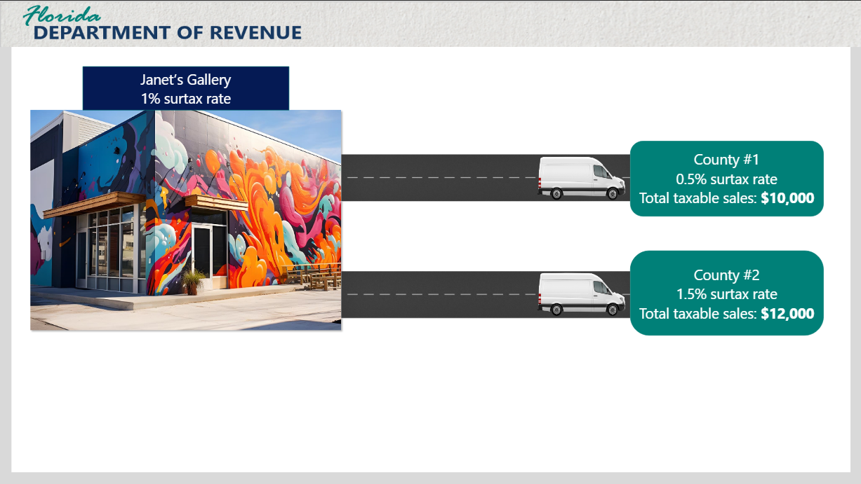
Click on the second delivery van to hear about its journey.
-----------------------------------------------
The total for the second county, a 1.5% surtax county, is $12,000. For the sake of this example, your gallery has not had any sales that qualify for the $5,000 cap.
Since your gallery is located in a 1% surtax county, the taxpayer will have to enter amounts for the other two counties since they must charge a different discretionary sales surtax rate.
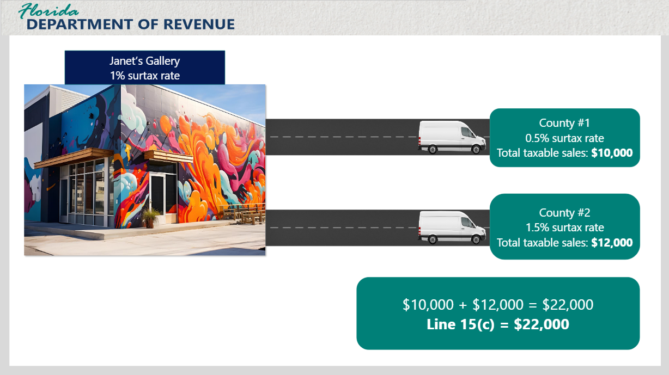
The total entered on Line 15(c) would equal the amounts for both counties added together which would be $22,000.
[Janet]: I appreciate you for making things a bit clearer for me.
You’re welcome.
It gets a bit more interesting when you have to account for the $5,000 cap on each of your transactions.

3.8 Line 15(c) Part 3
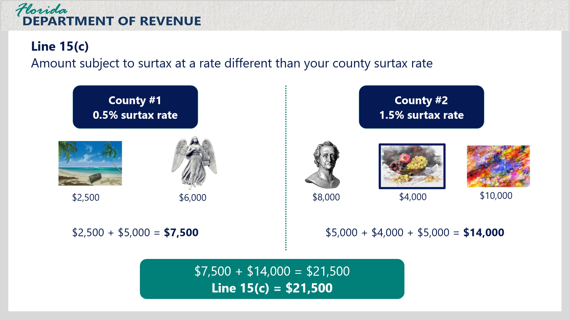
Transcript:
Let’s focus on your gallery again for this next example.
You frequently deliver art from your gallery to one county that has discretionary sales surtax rate of 0.5%, different from your county. The purchases for this county are as follows: one painting of a beach, ($2,500) and one statue ($6,000)
The total from the first county to be included in Line 15(c) would be $7,500. Janet, do you know why the total wouldn’t be $8,500?
[Janet]: Because in a single sale, you can only charge discretionary sales surtax on the first $5,000, so you would add the $2,500 for the beach painting and the $5,000 for the statue to total $7,500. Is this the amount I would enter on Line 15(c)?
Yes, if you were only entering the sales subject to discretionary sales surtax from that one outside county.
To make things more interesting, let’s say there is one more nearby county you often deliver to that has a discretionary sales surtax rate of 1.5%, also different from your county. The purchases from the 1.5% county are as follows: one sculpture ($8,000), one painting of fruit in a bowl ($4,000), and one large abstract painting ($10,000)
Do you know which items would qualify for the $5,000 cap from this county?
[Janet]: The sculpture and the large abstract painting are each over $5,000, so they would qualify.
That’s right. If you add up the remaining amounts, what is your total?
[Janet]: $5,000 + $4,000 + $5,000 = $14,000.
That’s correct. For the 0.5% county, your total was $7,500. For the 1.5% county, the total subject to discretionary sales surtax was $14,000. What do you do next?
[Janet]: I would add those two totals together, and that is what I would enter on Line 15(c). The total amount would be $21,500.
Exactly. It takes a few extra steps to get there, but it really doesn’t have to be too complicated. Just take it step by step.

3.9 Knowledge Check: Line 15(c)
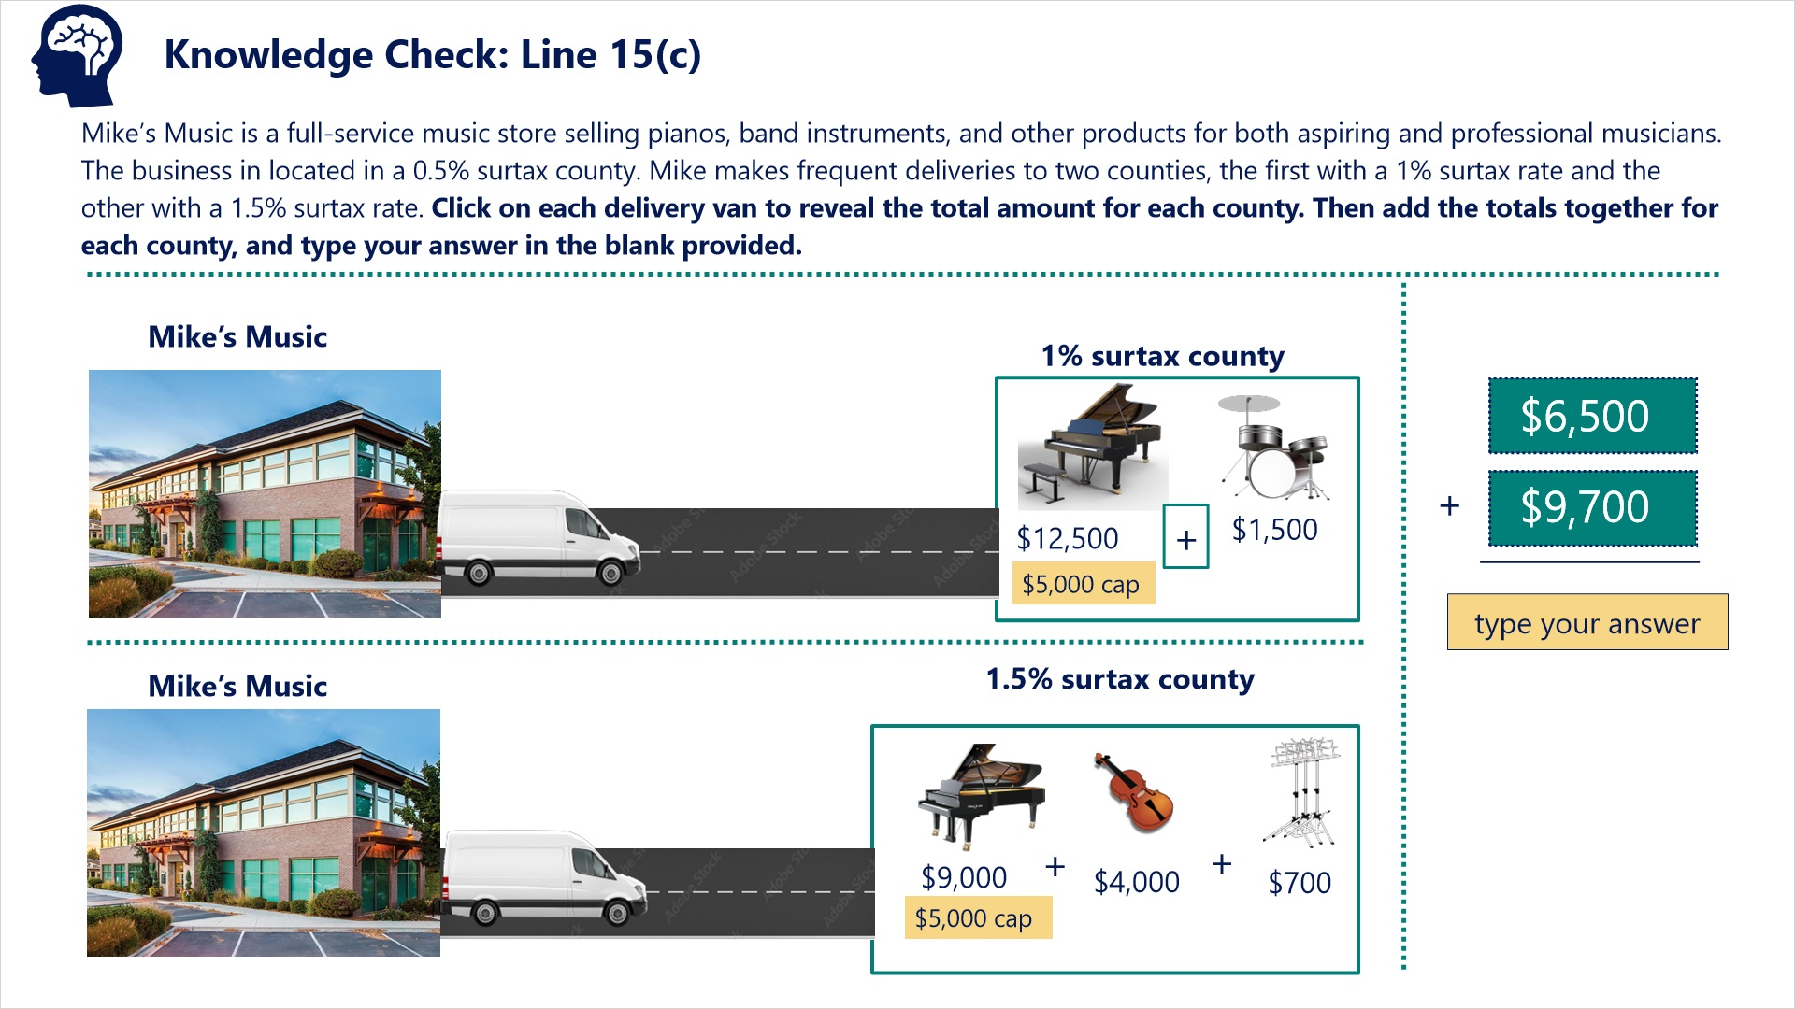
Transcript:
Question: Mike’s Music is a full-service music store selling pianos, band instruments, and other products for both aspiring and professional musicians. The business in located in a 0.5% surtax county. Mike makes frequent deliveries to two counties, the first with a 1% surtax rate and the other with a 1.5% surtax rate.
Click on each delivery van to reveal the total amount for each county. Then add the totals together for each county and type your answer in the blank provided.
Correct Answer: $6,500 (1% surtax county) + $9,700 (1.5% surtax county) = $16,200

3.10 Line 15(d)
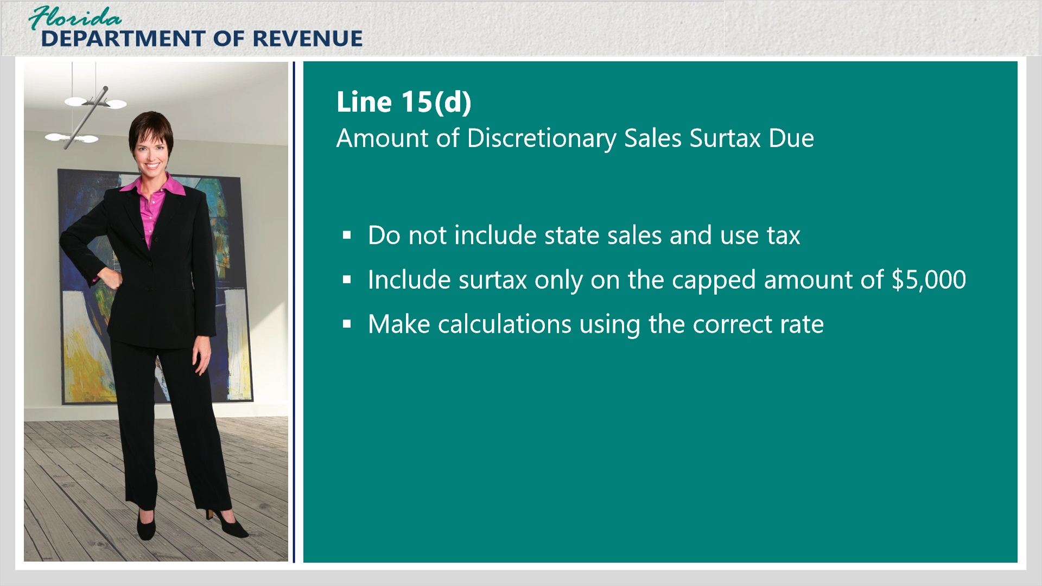
Transcript:
On Line 15(d), you will enter the total amount of discretionary sales surtax due to the Department of Revenue.
There are a few considerations that should be made with these calculations.
First of all, do not include state sales and use tax in this amount. This line is only for discretionary sales surtax owed. If you include sales and use tax, you will end up paying more than you owe.
[Janet]: OK, is there anything else I should be aware of?
The next thing to remember is to include surtax only on the capped amount of $5,000 to any transactions that qualify in this calculation. Remember that you already accounted for the excess amount beyond the cap for items that qualify in Line 15(a), Exempt Amount of Items Over $5,000.
This will be especially important for businesses like yours that commonly sell big-ticket items or those that typically sell items in bulk.
Finally, remember to make your calculations using the correct discretionary surtax rate for items your business delivers to other counties.
[Janet]: OK. Thank you for making me aware of these considerations.
I’m glad that helped.

3.11 Line 15(d) Basic Example
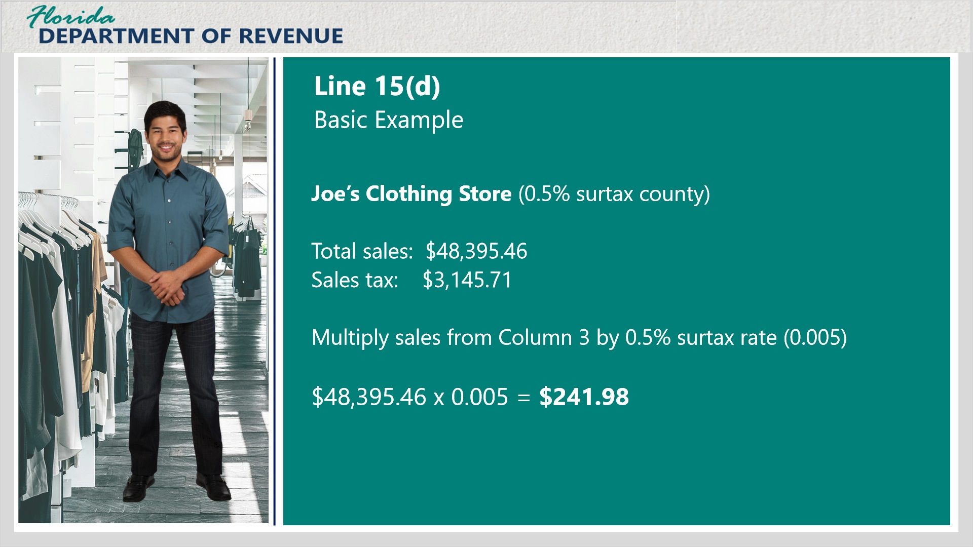
Transcript:
Let’s look at a simple example for Line 15(d).
Joe’s Clothing Store is in a county with a 0.5% discretionary sales surtax rate. Joe does not deliver merchandise. Since his items are not very expensive and he typically sells in smaller quantities, none of the transactions are eligible for the $5,000 cap.
Joe had sales of $48,395.46. Joe’s sales tax for the month was $3,145.71. The amount of discretionary sales surtax collected would be the taxable amount from Column 3 of the return multiplied by the discretionary sales surtax rate being applied.
[Janet]: So would he multiply his sales from column 3 by the 0.5% surtax rate, or by 0.005?
Yes. Very good, Janet. The total discretionary sales surtax owed would be $241.98. This is the amount he would put on Line 15(d).
Now, let’s practice calculating discretionary sales surtax with a similar example.

3.12 Knowledge Check #1: Line 15(d)
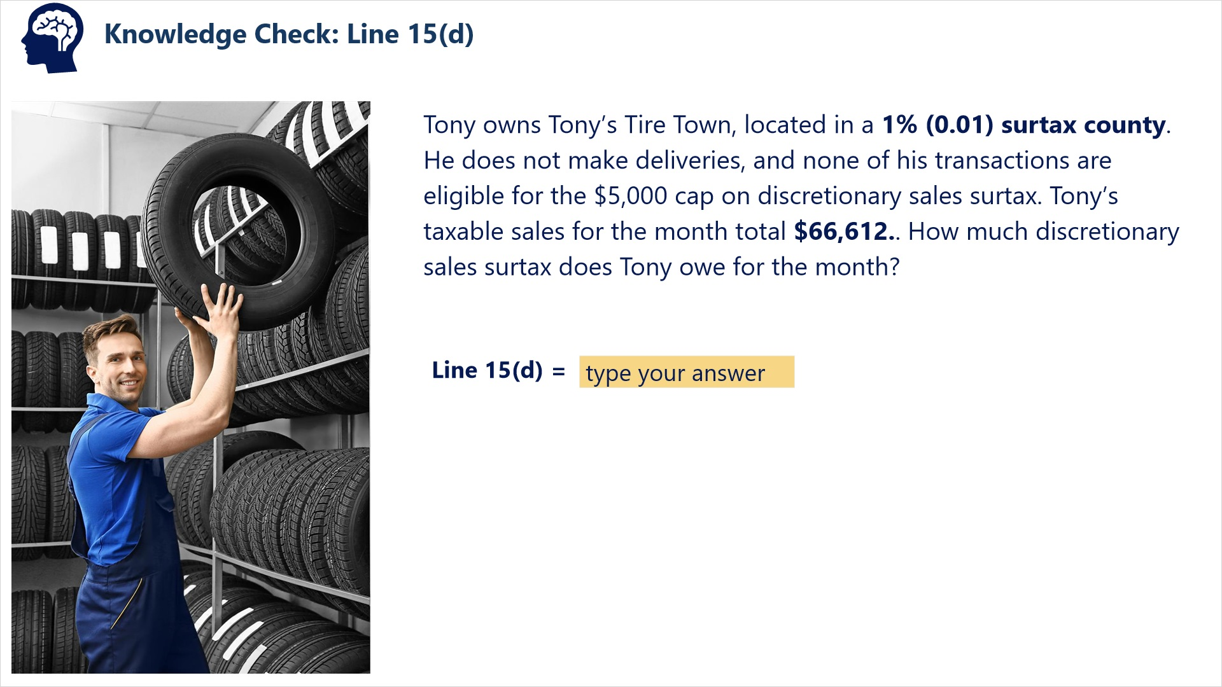
Transcript:
Question: Tony owns Tony’s Tire Town, located in a 1% (0.01) surtax county. He does not make deliveries, and none of his transactions are eligible for the $5,000 cap on discretionary sales surtax. Tony’s taxable sales for the month total $66,612. How much discretionary sales surtax does Tony owe for the month?
Correct Answer: Multiply Tony’s taxable sales for the month by the surtax rate.
$66,612 x 0.01 = $666.12

3.13 Line 15(d): Sales in Multiple Surtax Counties
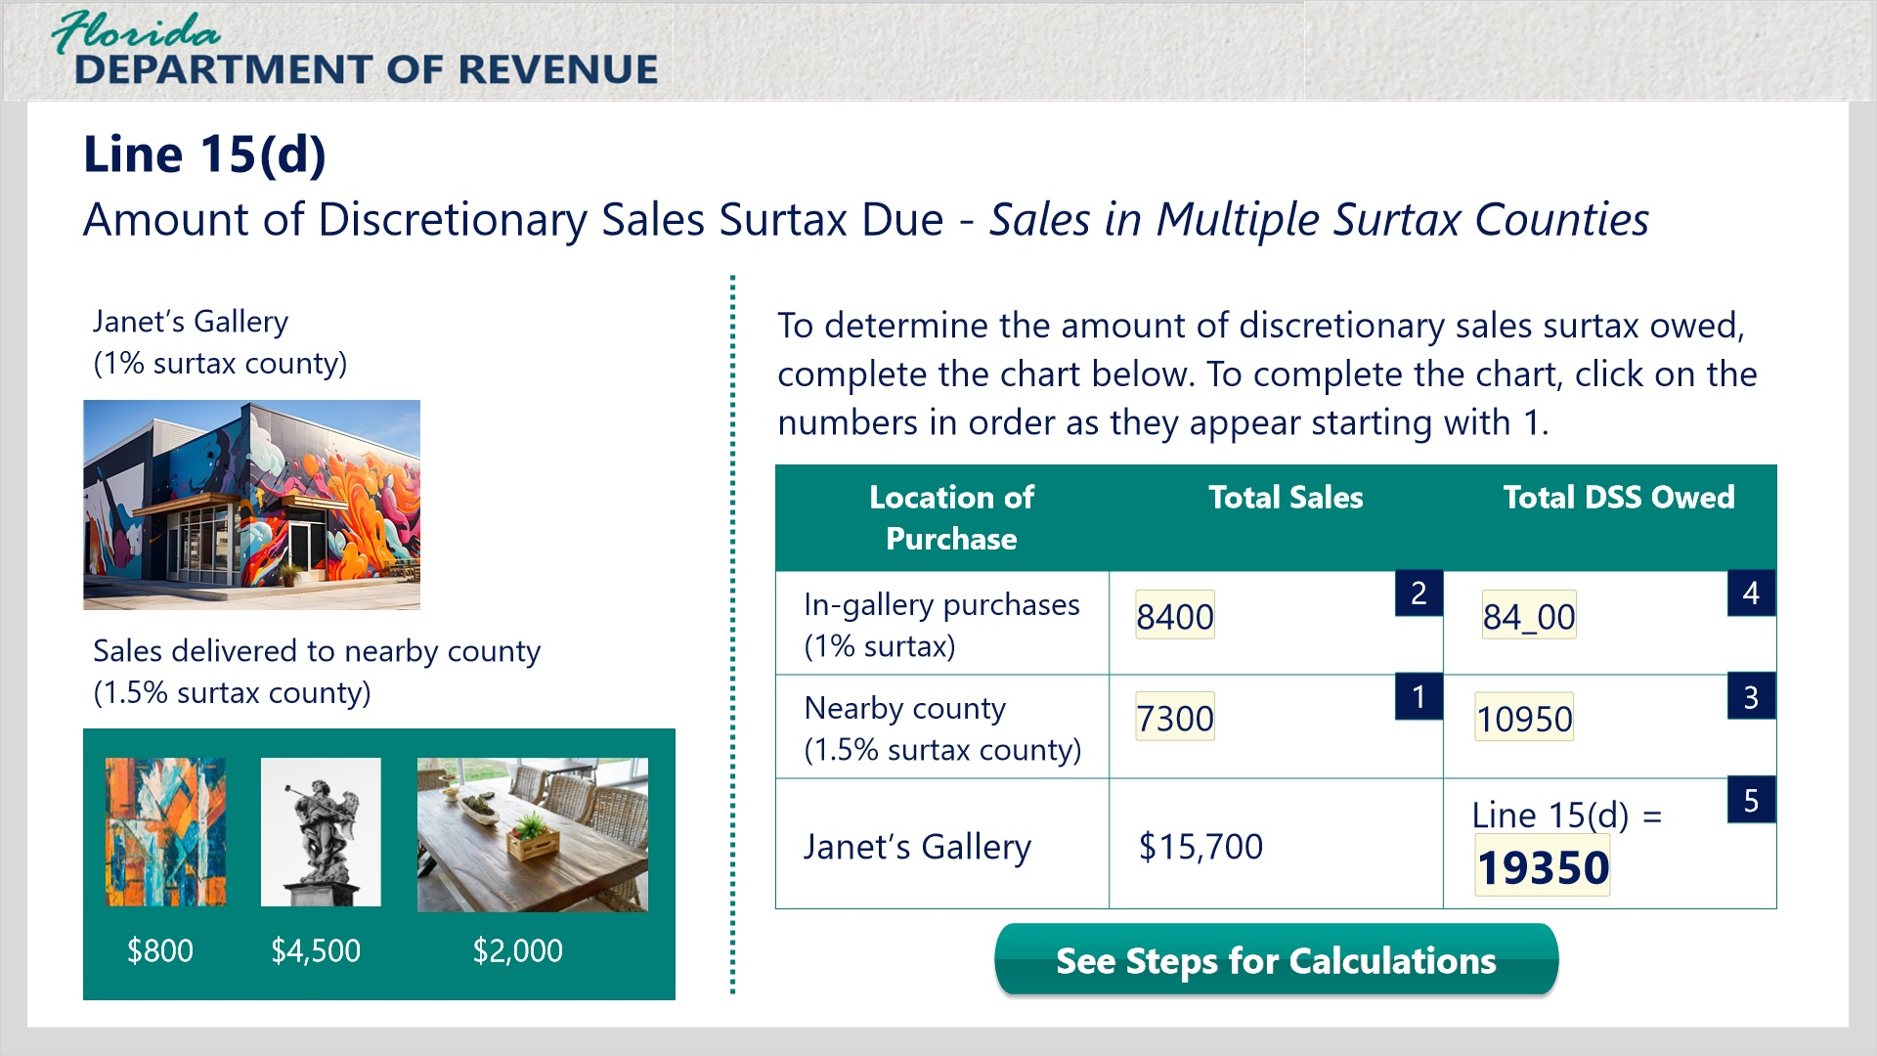
Transcript:
Things get even more interesting when you add in sales and deliveries made into counties with a different surtax. Let’s look at another example for your gallery, Janet.
Your gallery is located in a 1% surtax county. The gallery’s total sales for the reporting period were $15,700. None of your transactions are eligible for the $5,000 cap in this example. You make frequent deliveries to a nearby county with a 1.5% surtax rate.
Your deliveries to the 1.5% surtax county for the reporting period include the following transactions: one small abstract painting ($800), one sculpture ($4,500), and one handmade table ($2,000).
What is the total discretionary sales tax amount for Line 15(d)?
To determine the amount of discretionary sales surtax owed, complete the chart below. To complete the chart, click on the numbers in order as they appear starting with 1.
If you would like to see the steps for the calculations on a single slide, click the button “See Steps for Calculations.”
-------------------------------------
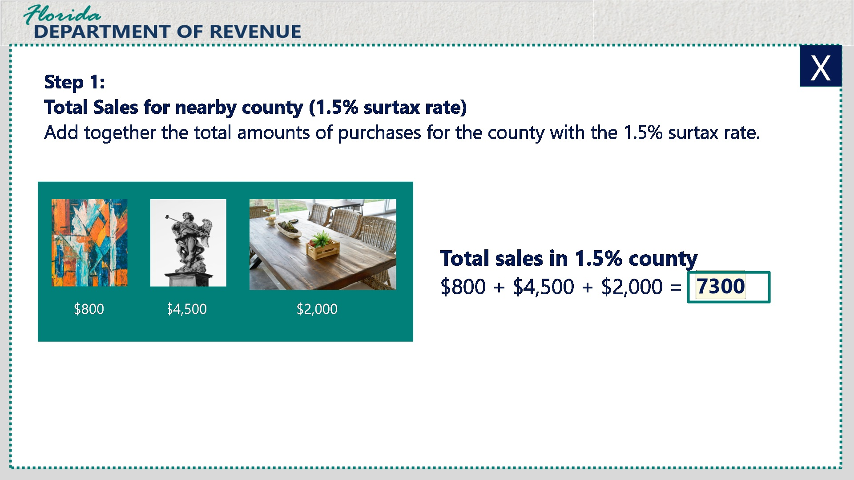
Transcript:
First, add together the total amounts for the county you deliver to, which has a 1.5% surtax rate.
The total amount of the transactions added together for the 1.5% surtax county is $7,300.
----------------------------------------
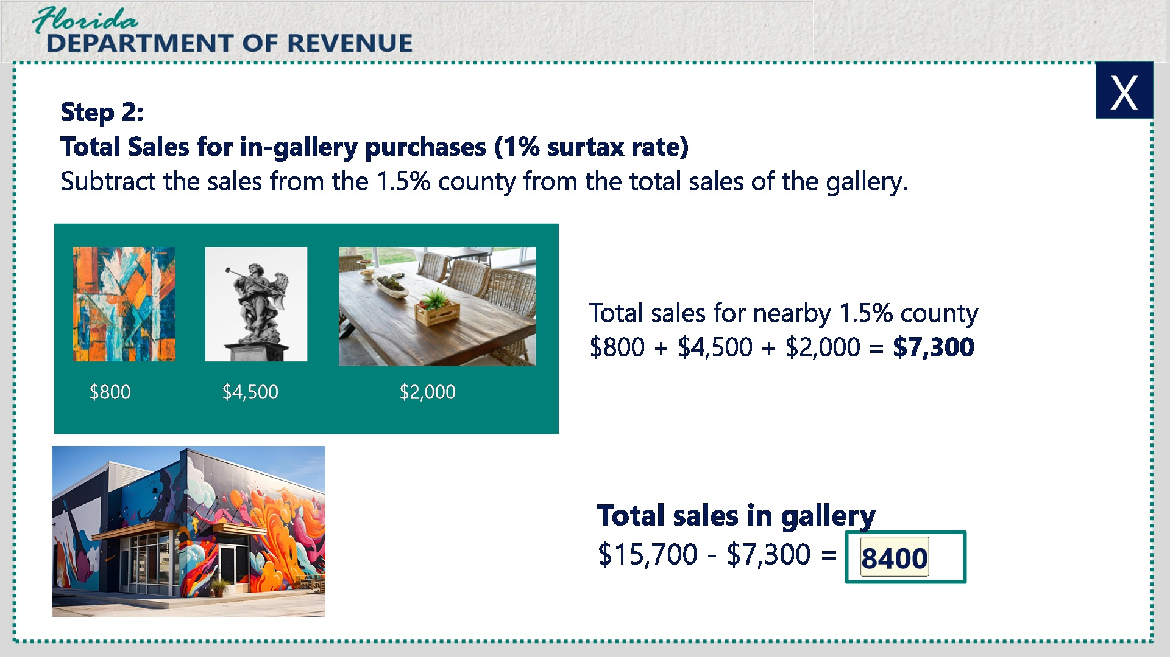

Transcript:
Then subtract the sales from the 1.5% county from the total sales of the gallery. This leaves you with the amount of sales for your county, which has a surtax rate of 1%.
$15,700 - $7,300 = $8,400 for the 1% in-store county.
----------------------------------------
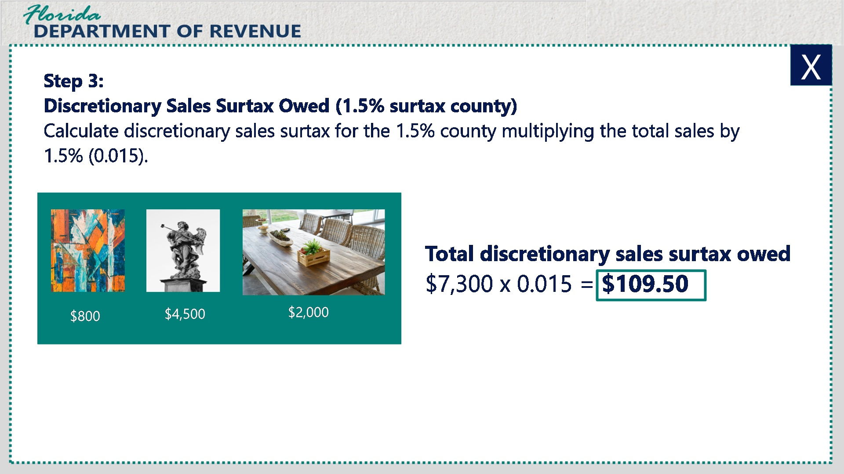

Next, calculate the discretionary sales surtax for the 1.5% surtax county by multiplying the total sales by 1.5% or 0.015.
The total discretionary sales surtax owed due on Line 15(d) is $109.50.
----------------------------------------
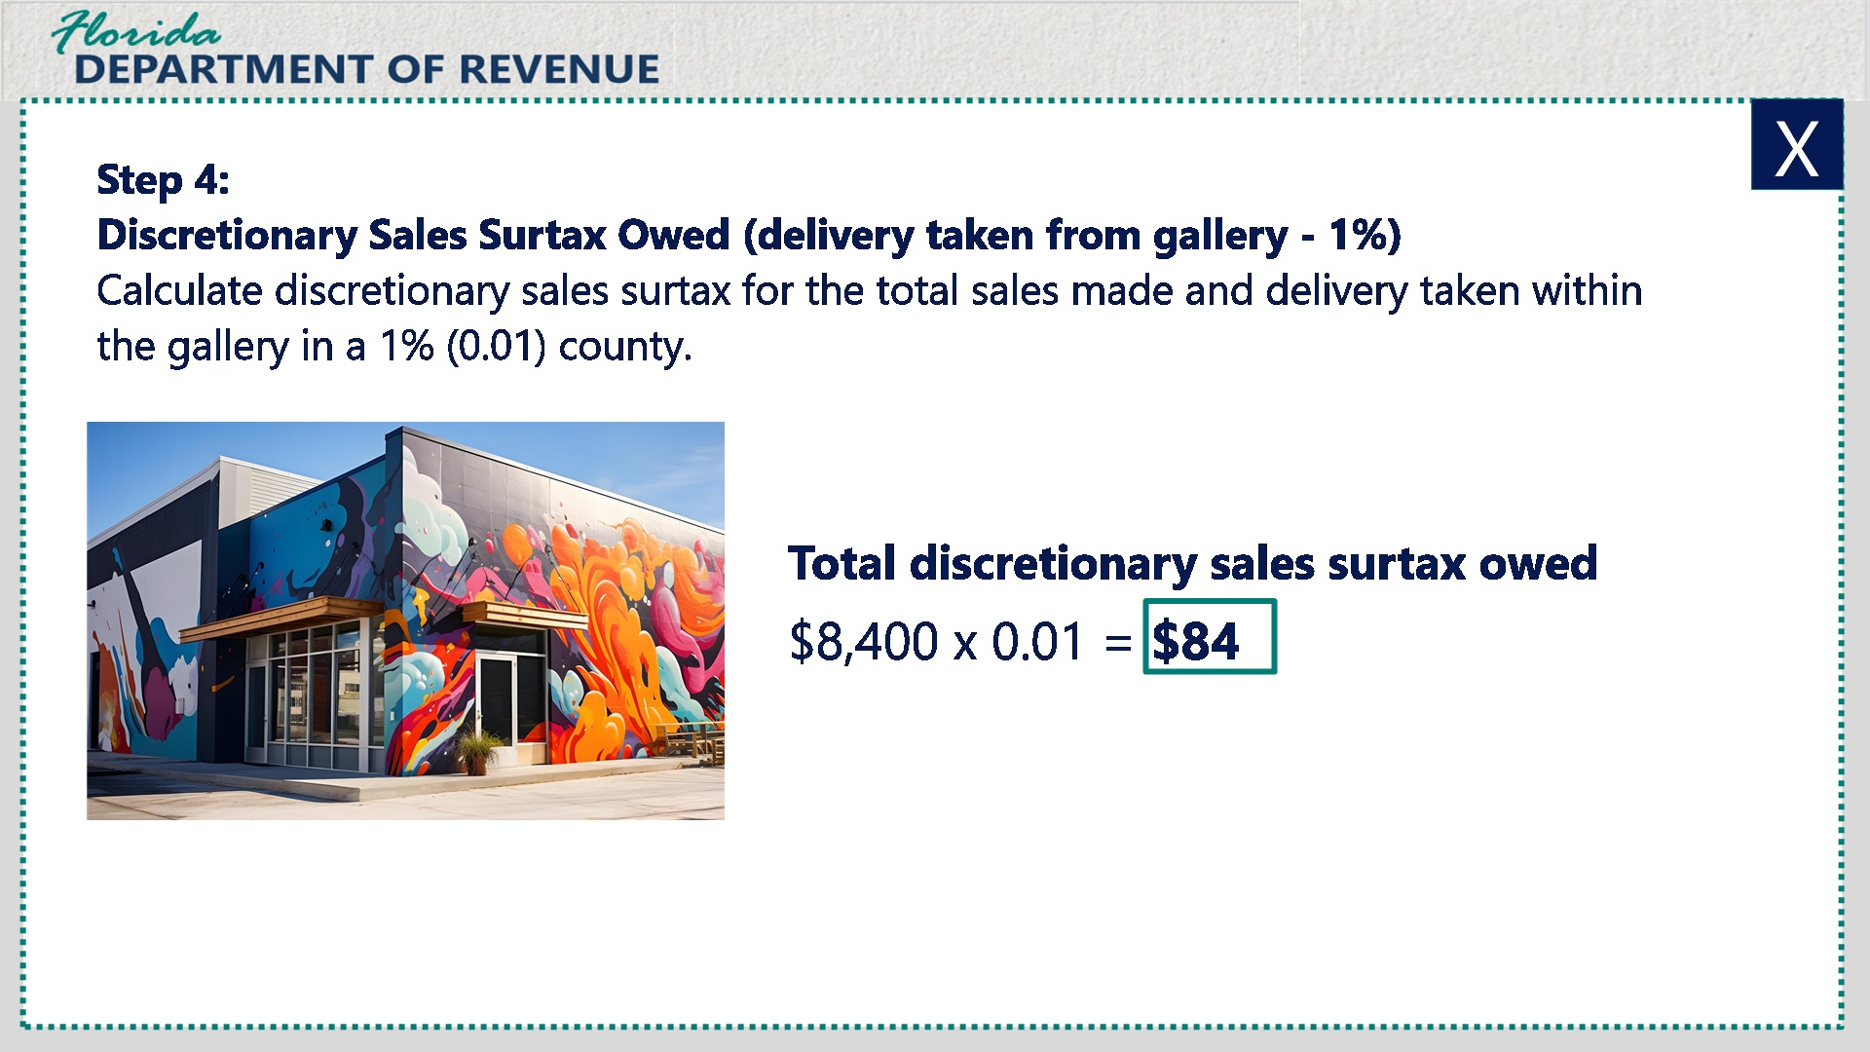

Transcript:
Now calculate the discretionary sales surtax for your county, which has a 1% sales surtax rate, by multiplying the total sales by 1% or 0.01.
The total discretionary Sales surtax owed for purchases taken directly from the gallery is $84.00.
----------------------------------------
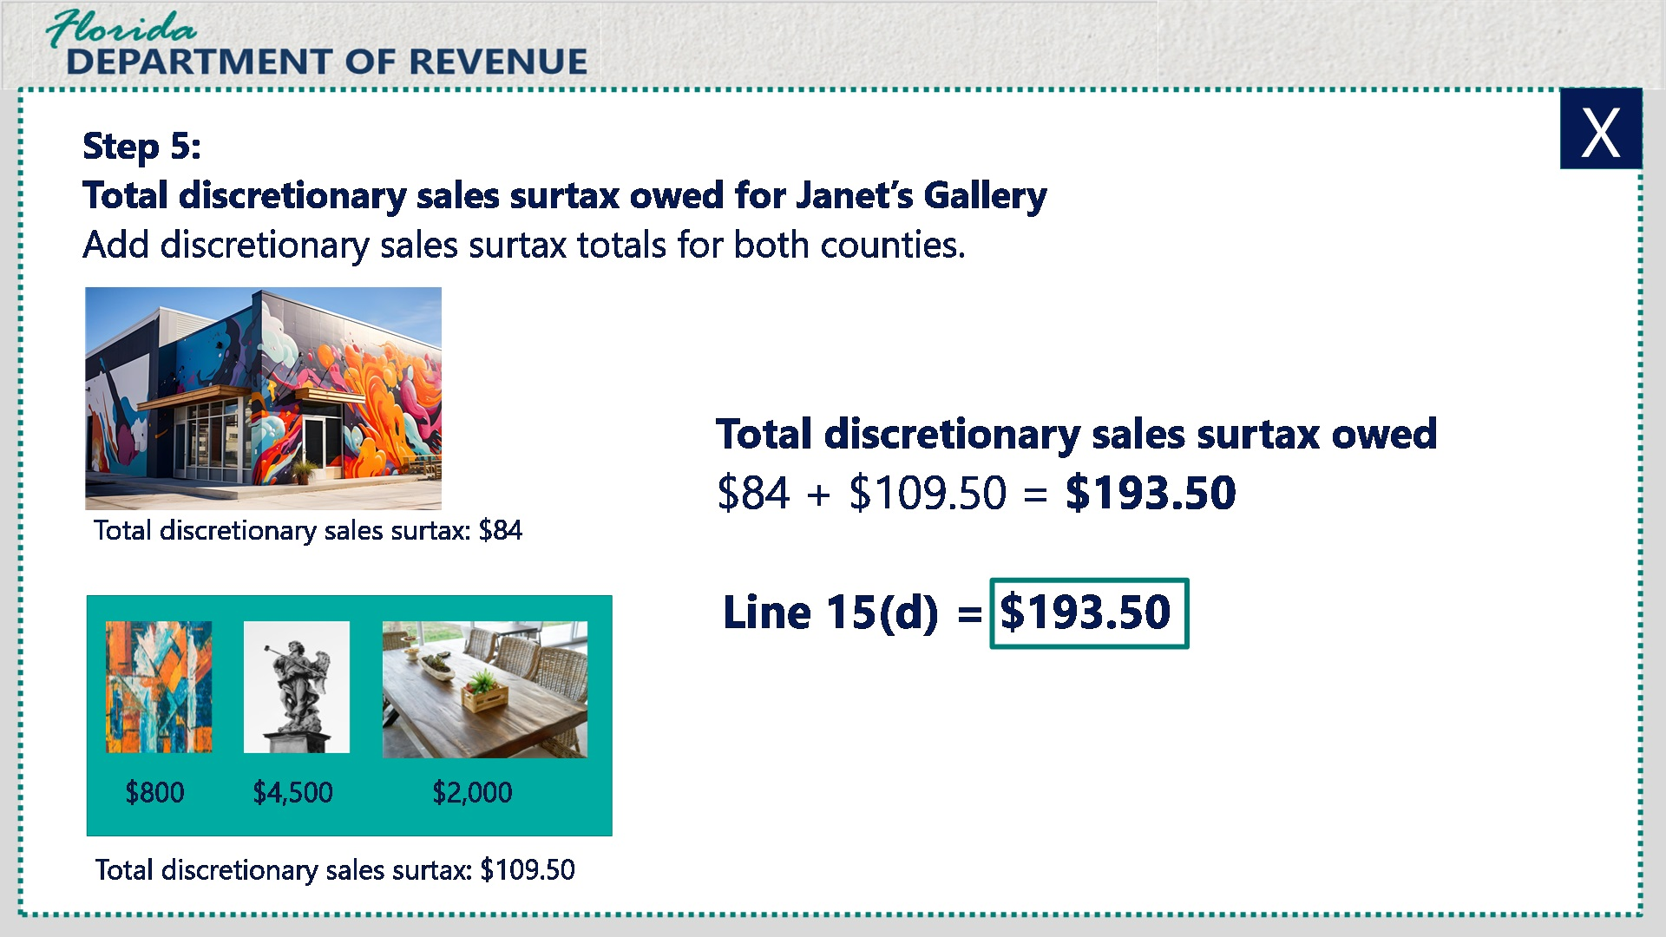

Transcript:
Finally, add the discretionary sales surtax totals for both counties.
$84 + $109.50 = $193.50.
The total discretionary sales surtax owed due on Line 15(d) is $193.50.
---------------------------------------
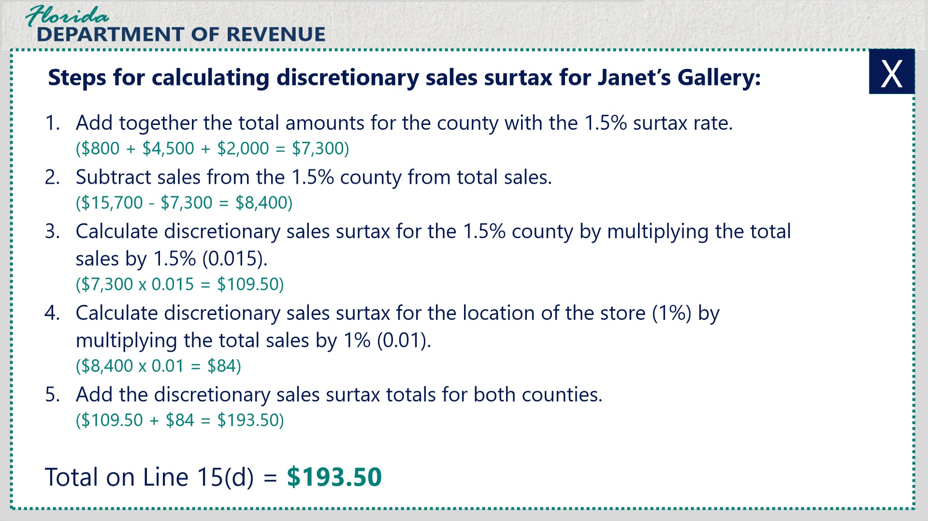

Transcript:
Here are the steps for calculating discretionary sales surtax for Janet’s Gallery.
- Add together the total amounts for the county with the 1.5% surtax rate.
- Subtract sales from the 1.5% county from total sales.
- Calculate discretionary sales surtax for the 1.5% county by multiplying the total sales by 1.5% or 0.015.
- Calculate discretionary sales surtax for the location of the store in a 1% county by multiplying the total sales by 1% or 0.01.
- Add the discretionary sales surtax totals for both counties.
- The total on Line15(d) equals $193.50.

3.14 Knowledge Check #2: Line 15(d)
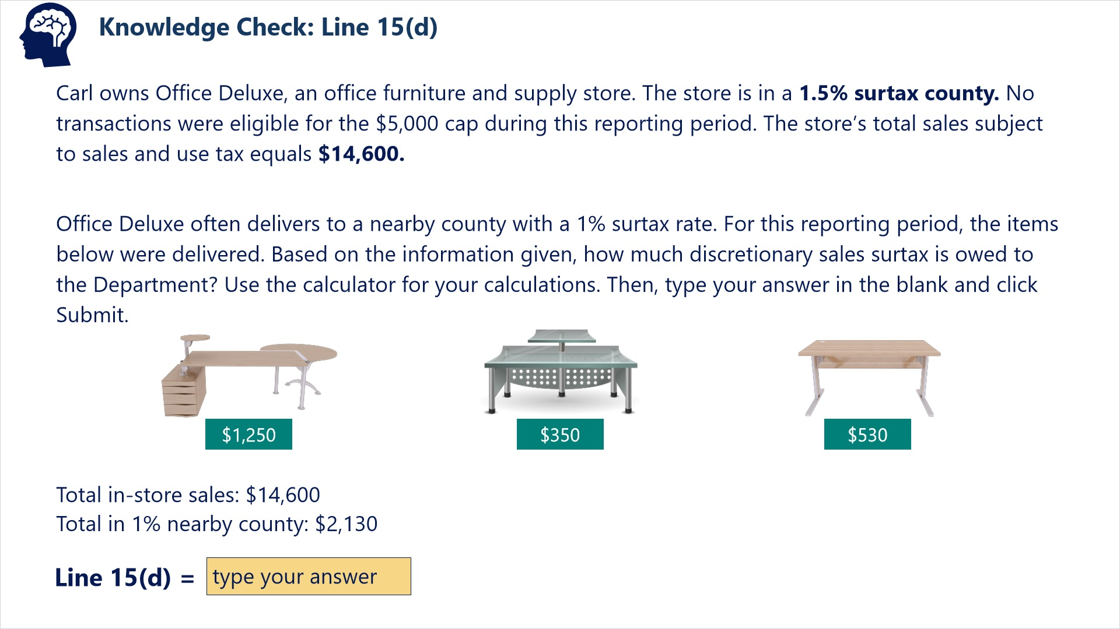
Transcript:
Question: Carl owns Office Deluxe, an office furniture and supply store. The store is in a 1.5% surtax county. No transactions were eligible for the $5,000 cap during this reporting period. The store’s total sales subject to sales and use tax equals $14,600.
Office Deluxe often delivers to a nearby county with a 1% surtax rate. For this reporting period, the items below were delivered. Based on the information given, how much discretionary sales surtax is owed to the Department? Use the calculator for your calculations. Then, type your answer in the blank and click Submit.
Total in-store sales: $14, 600
Total in 1% nearby county: $2,130
Correct Answer: Line 15(d) = $208.35

3.15 Line 15(d): Sales with Caps in Multiple Surtax Counties
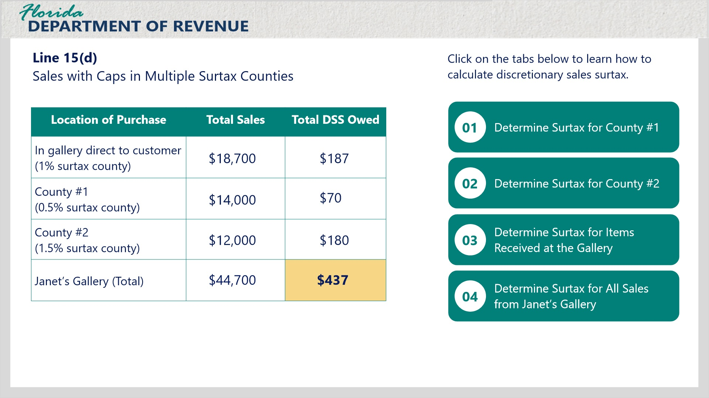
Transcript:
This last one is going to be a bit more difficult. We’ll use your gallery as an example once more. Not only are there multiple counties involved, but there are also items eligible for the $5,000 cap.
Your gallery is in a 1% sales surtax county and makes frequent deliveries to two nearby counties. The total taxable sales subject to surtax is $44,700.
Click the tabs on the screen to learn how to calculate discretionary sales surtax to be entered on Line 15(d) for this example. As you go through the calculations for each step, the calculations will appear on the chart.
---------------------------------
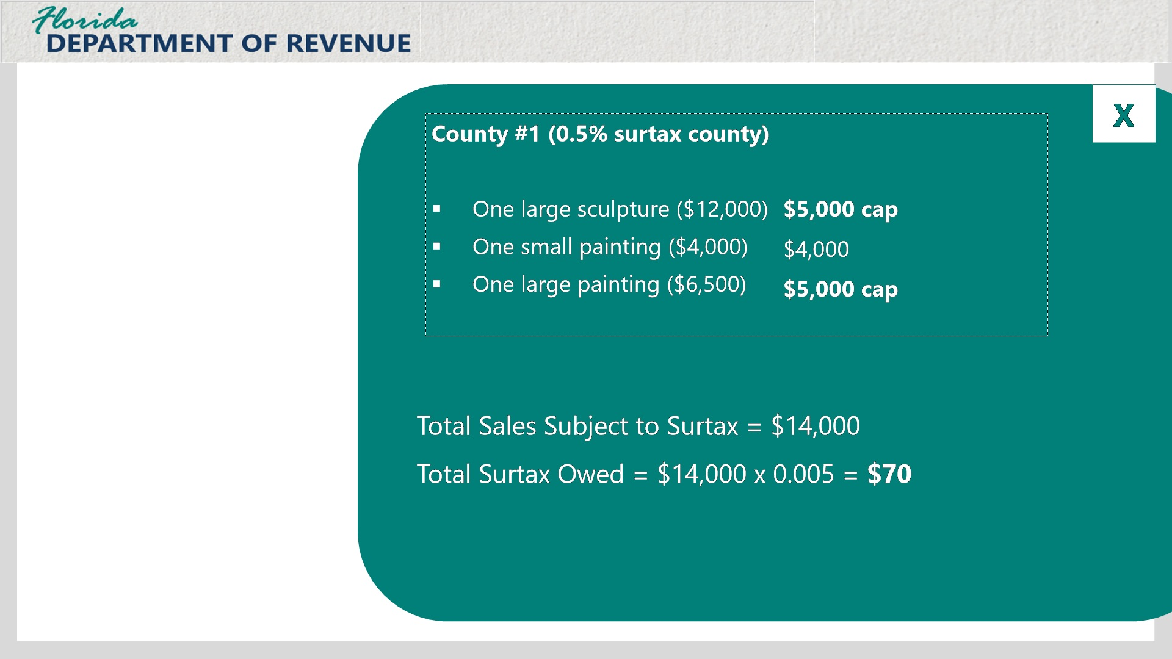

Transcript:
The first set of transactions in a 0.5% surtax county includes: one large sculpture for $12,000, one small painting for $400, and one large painting for $6,500.
[Janet]: What step should I take first to do the calculations?
A good place to begin would be to determine the items that qualify for the cap. That will make it easier for you to determine how much discretionary sales surtax is owed for each county.
[Janet]: That makes sense to me.
Let’s take a look at the 0.5% surtax county. The sculpture and the large painting are both over $5,000. If you add those amounts together, plus the $4,000 for the small painting, you have a total of $14,000 subject to discretionary sales surtax.
Then you would multiply that amount by the surtax rate of 0.5% or 0.005. The total discretionary sales surtax owed to the Department would be $70.00.
You will follow the same steps for the second county.
--------------------------
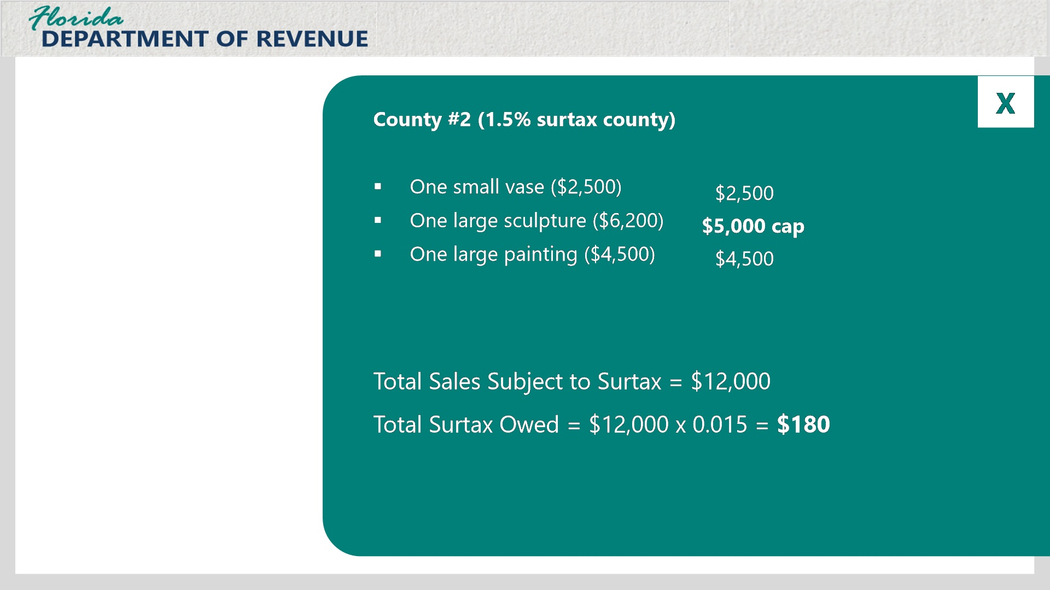

Transcript:
The second set of transactions in the 1.5% surtax county includes: one small vase for $2,500, one large sculpture for $6,200, and one large painting for $4,500

First, determine what items if any qualify for the cap. In this case, only the large sculpture for $6,200 qualifies. Add that amount to the other amounts of $2,500 and $4,500. The total comes to $12,000.
Multiply this amount by the surtax rate of 1.5% or 0.015. The total discretionary sales surtax owed is $180.
------------------------------------------
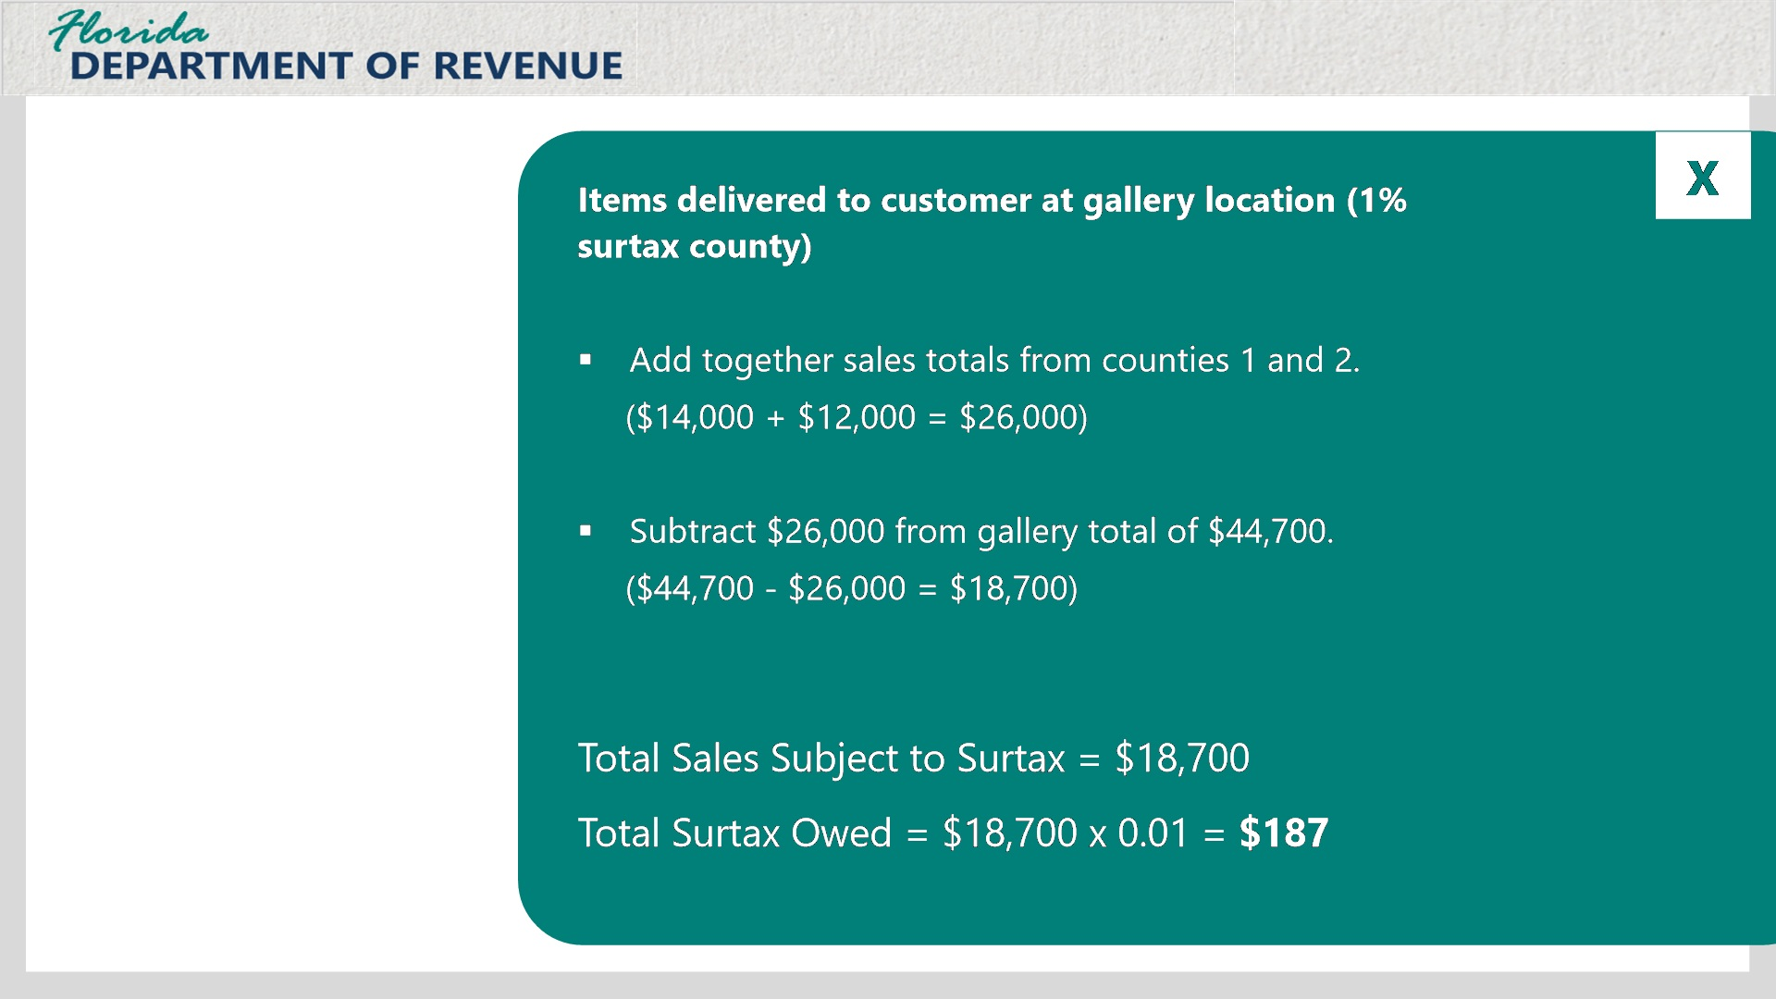

Transcript:
You also need to calculate the amount of discretionary sales surtax for the items sold at your location where the customer took delivery immediately from the gallery. For this example, none of the items sold at your location qualify for the cap.
To get the total sales from the gallery at the location, add together the sales totals from counties 1 and 2. This gives a total of $26,000. Then subtract this number from the overall sales total for all sales from the gallery of $44,700. The total sales subject to surtax equals $18,700.
To determine the surtax owed, multiply $18,700 by 1% or 0.01.
The total discretionary sales surtax owed for purchases from the gallery location is $187.
---------------------------------------
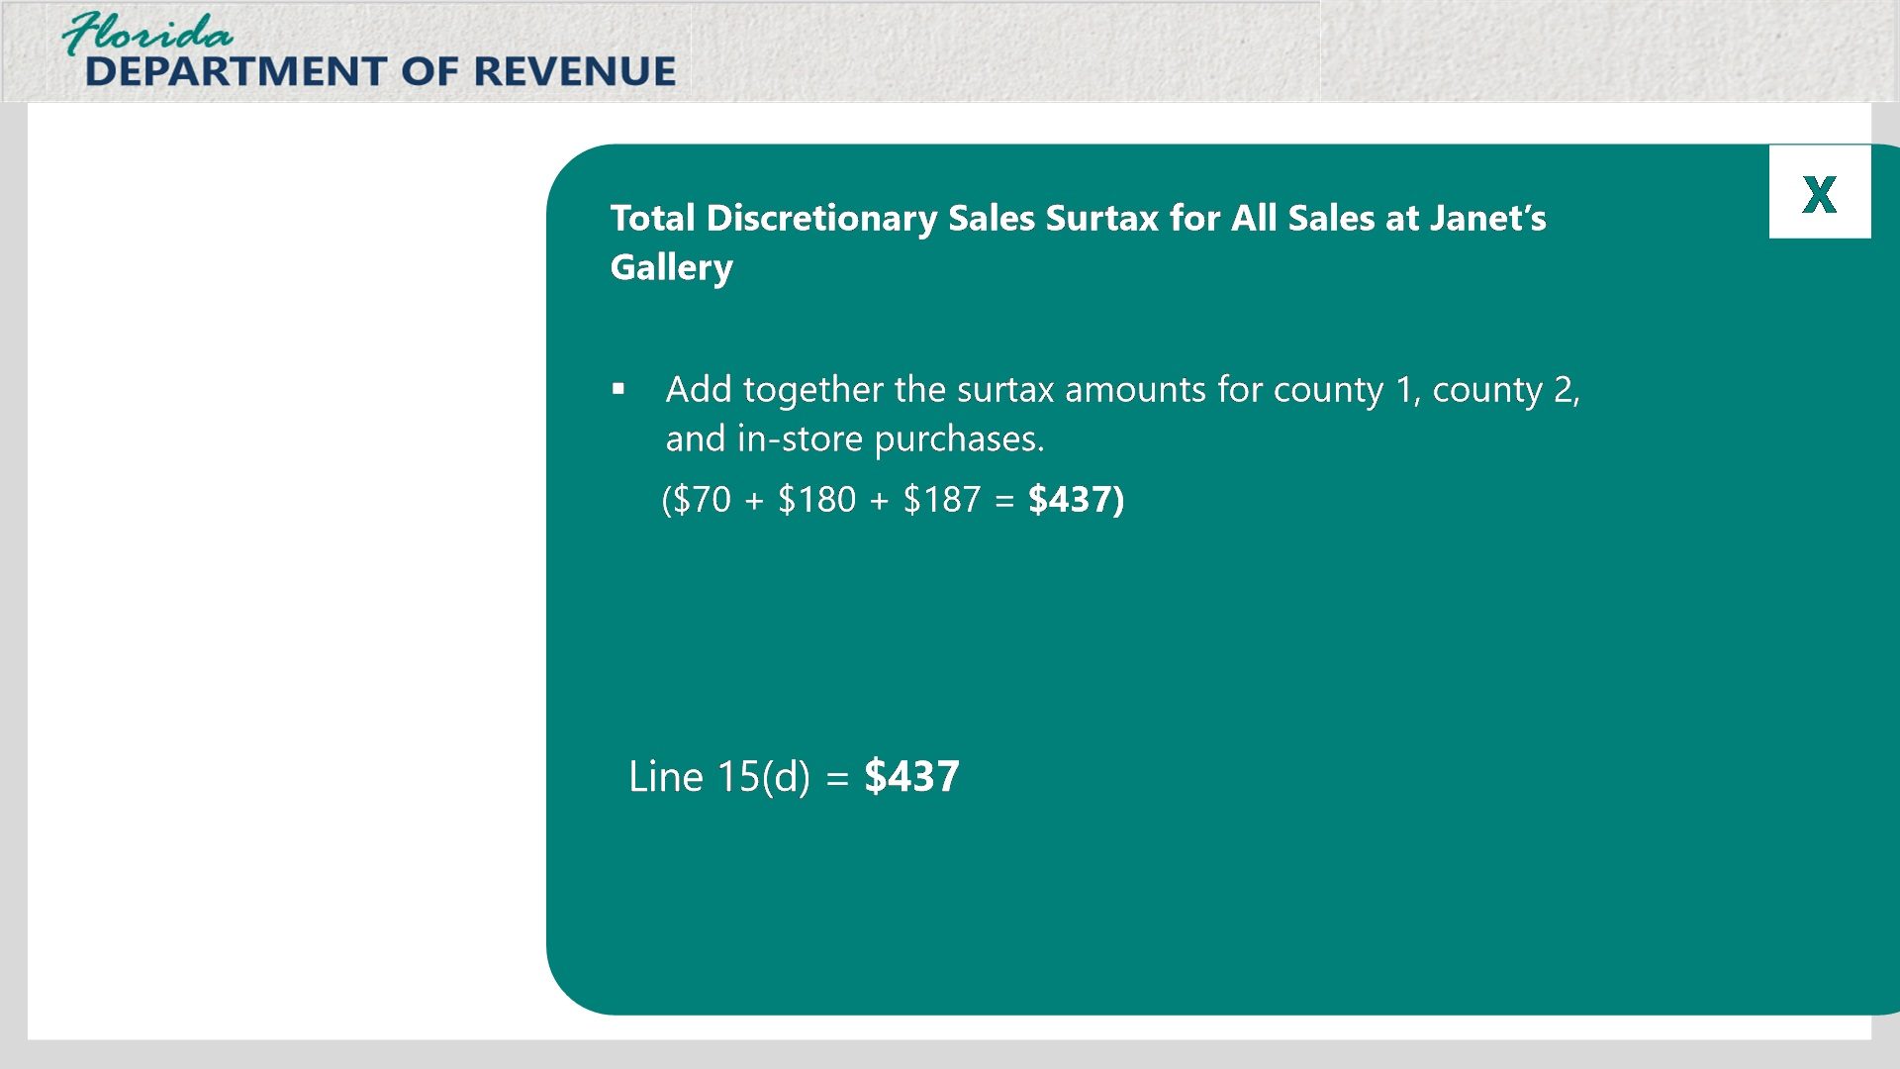

Transcript:
Finally, to calculate the total discretionary sales surtax collected by Janet’s Gallery, add all three discretionary sales surtax for the different counties together.
$70 + $180 + $187 = $437. Therefore, you would enter the total of $437 on Line 15(d) for your gallery.

3.16 Knowledge Check #3: Line 15(d)
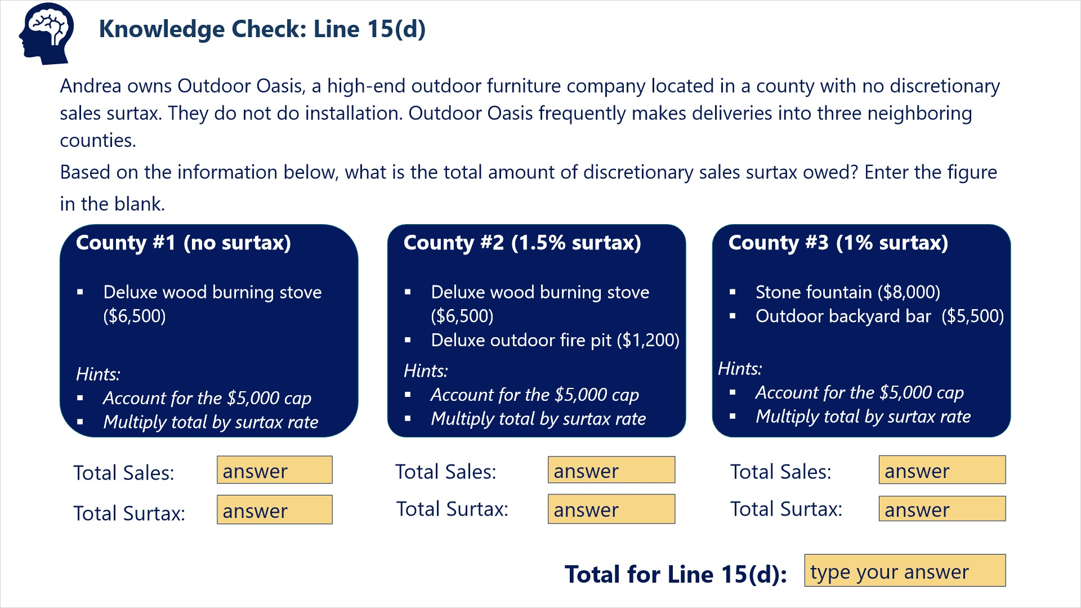
Transcript:
Question: Andrea owns Outdoor Oasis, a high-end outdoor furniture company located in a county with no discretionary sales surtax. They do not do installation. Outdoor Oasis frequently makes deliveries into three neighboring counties.
Based on the information below, what is the total amount of discretionary sales surtax owed? Enter the figure in the blank.
-----------------------------------------
County #1 has no surtax. Items include one deluxe wood burning stove for $6,500.
County #2 has a 1.5% surtax. Items include one deluxe wood burning stove for $6,500, and one deluxe outdoor fire pit for $1,200.
County #3 has a 1% surtax. Items include a stone fountain for $8,000, and an outdoor backyard bar for $5,500.
Hint: Account for the $5,000 cap and multiply the total by the surtax rate.
Correct Answer: $93 + $100 = $193

4. Calculating and Reporting Discretionary Sales Surtax (Form DR-15EZ)

4.1 Form DR-15EZ
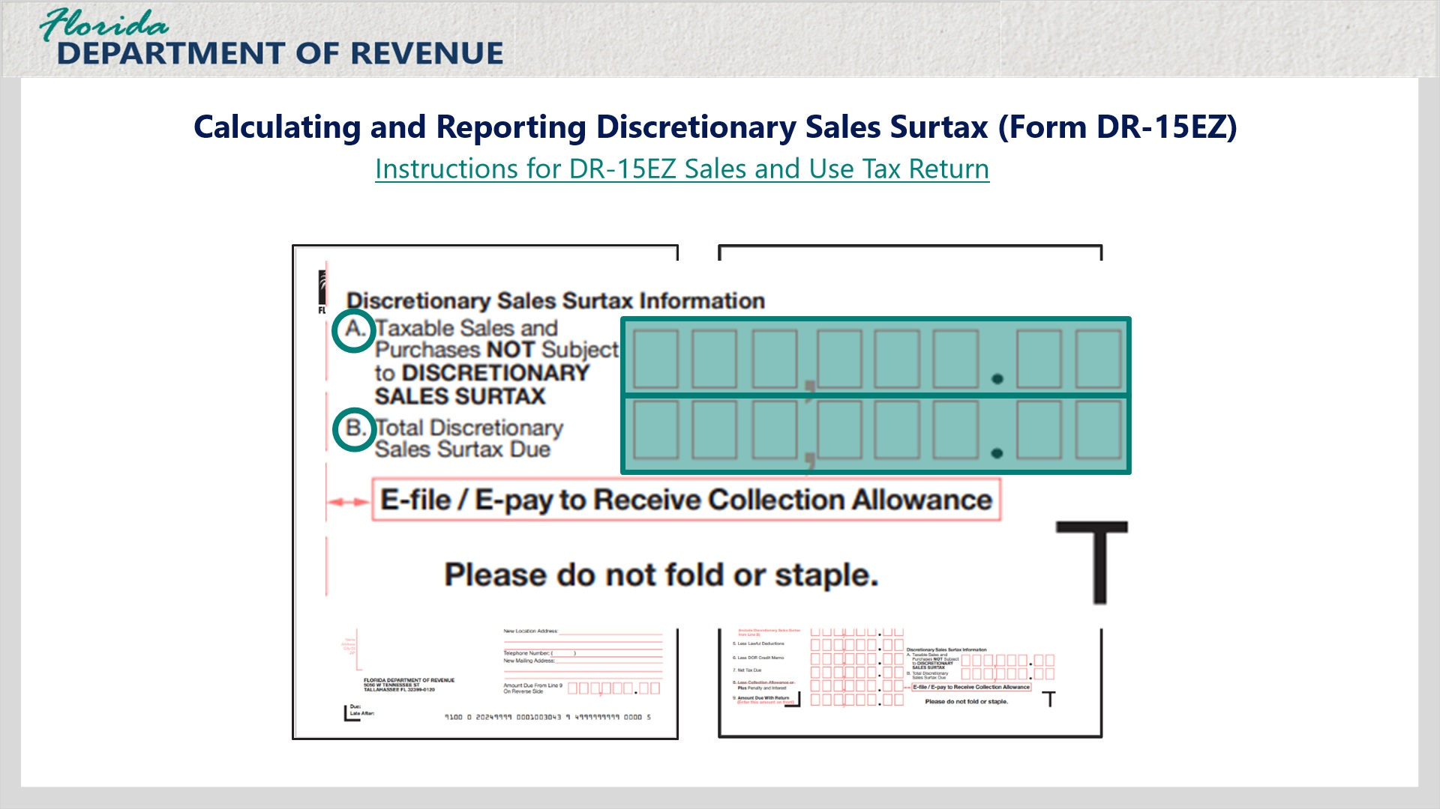
Transcript:
Now we’ll review how to calculate and report discretionary sales surtax using Form DR-15 EZ. As you may recall, there are some requirements for using this form. You may click on the link to review these to see if you are eligible to use this form for reporting purposes.
Dealers must report the following discretionary sales surtax information when using Form DR-15EZ.
First, they must enter the single sales amount of tangible personal property over $5,000.
When we reviewed the DR-15, recall that this information was entered on Line 15(a).
[Janet]: That’s right. I add together the amounts over $5,000 on single sales and enter them.
That’s correct. On the DR-15EZ, you enter them under the Discretionary Sales Surtax Information on Line A.
The other information you must enter in Line B is the Total Discretionary Sales Surtax Due.

4.2 Example: Calculating Line A
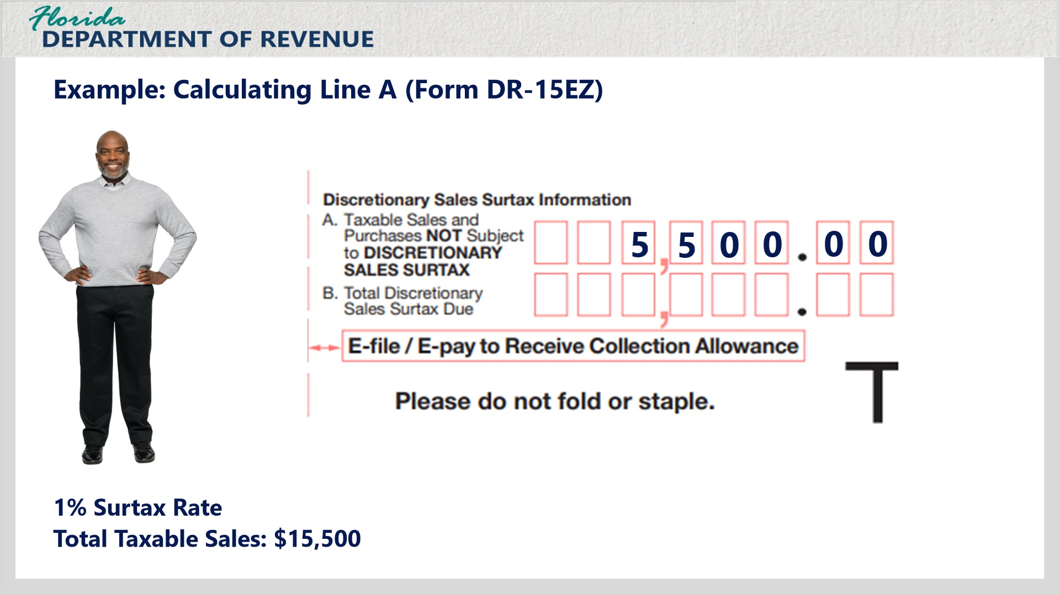
Transcript:
Here’s an example of calculating Line A.
A taxpayer is in a county with a 1% discretionary sales surtax rate. His total taxable sales are $15,500. He only sells two items.
The first item is $7,000. The second item is $8,500. To determine the total on Line A, determine the amounts in excess of $5,000 by subtracting $5,000 from each item. Then add the totals for each item together. The total should be entered on Line A of the DR-15EZ.

4.3 Knowledge Check: Line A
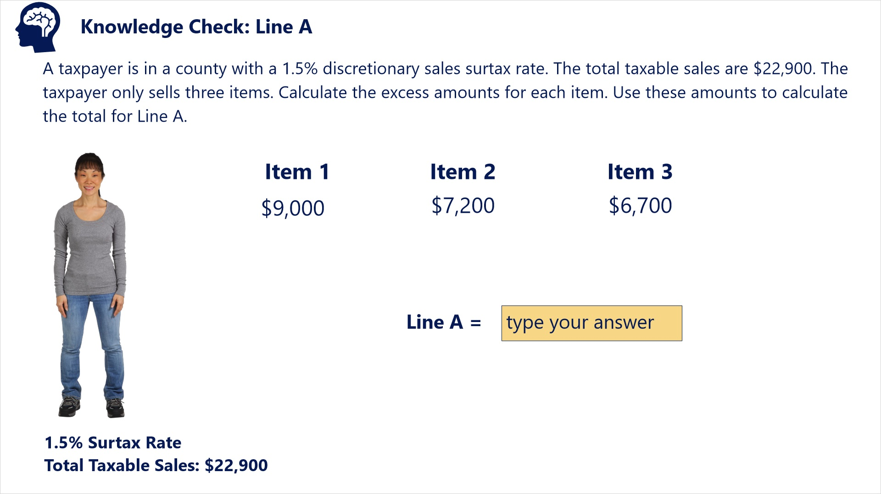
Transcript:
Question: A taxpayer is in a county with a 1.5% discretionary sales surtax rate. The total taxable sales are $22,900. The taxpayer only sells three items. Calculate the excess amounts for each item. Use these amounts to calculate the total for Line A.
Item 1 = $9,000
Item 2 = $7,200
Item 3 = $6,700
Correct Answer: Subtract $5,000 from each item. Then add these amounts to get the total for Line A.
$4,000 + $2,200 + $1,700 = $7,900

4.4 Example: Calculating Line B
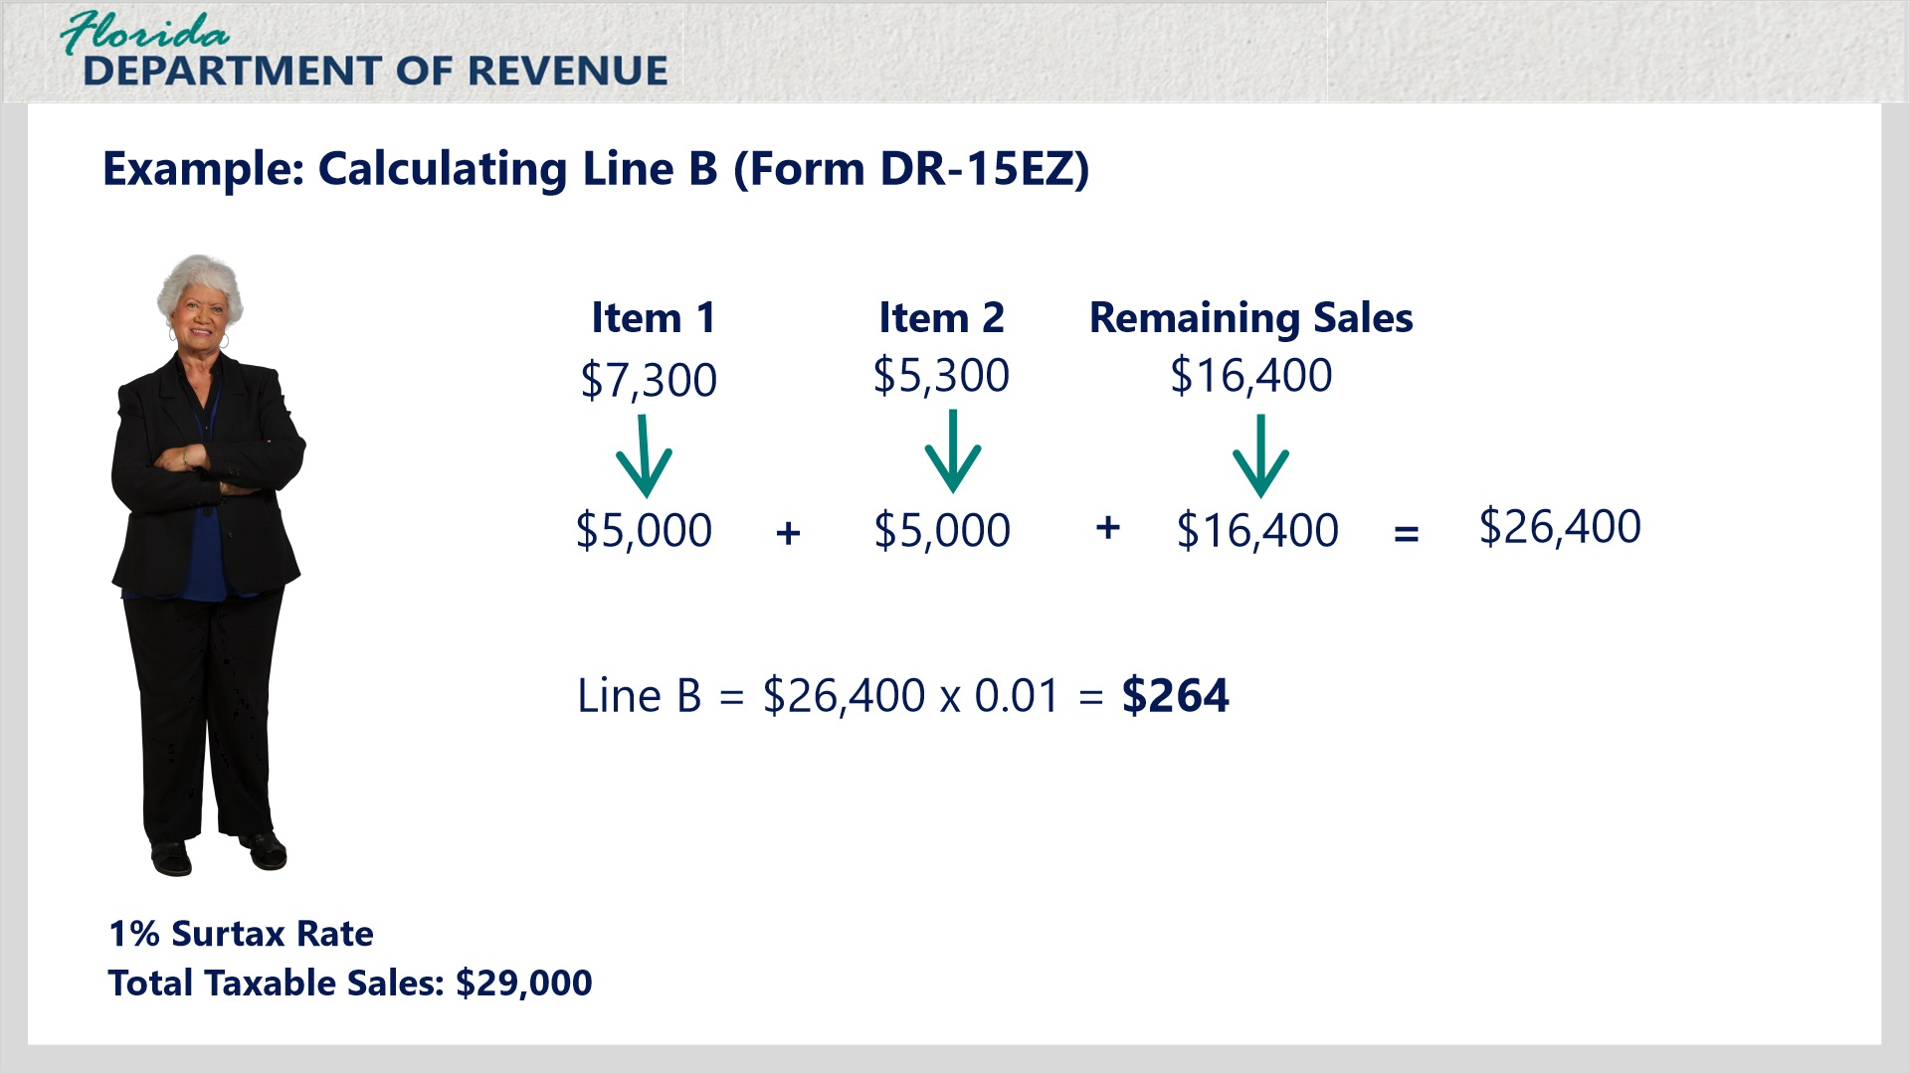
Transcript:
Let’s look at an example of calculating the total discretionary sales surtax owed in Line B.
A taxpayer is in a county with a 1% discretionary sales surtax rate. The total taxable sales reported is $29,000. Line 3 includes sales of one item for $7,300 and another for $5,300. The remaining sales of $16,400 did not contain any items where the cap was applied.
For the first two items, include only the amounts for each item up to the $5,000 cap in your calculations. Add these two amounts to the amount of remaining sales of $16,400. The total adds up to $26,400. Multiply this amount by the discretionary sales surtax rate of 1% or 0.01.
The total to enter on Line B is $264.

4.5 Knowledge Check: Line B
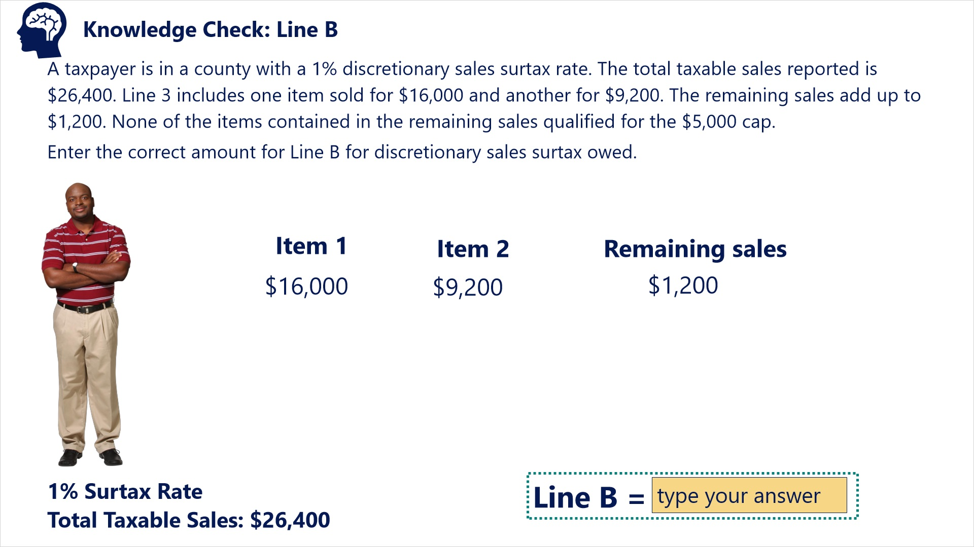

Transcript:
Question: A taxpayer is in a county with a 1% discretionary sales surtax rate. The total taxable sales reported is $26,400. Line 3 includes one item sold for $16,000 and another for $9,200. The remaining sales add up to $1,200. None of the items contained in the remaining sales qualified for the $5,000 cap.
Enter the correct amount for Line B for discretionary sales surtax owed.
Item 1 = $16,000
Item 2 = $9,200
Item 3 = $1,200
Correct Answer: Add together each amount accounting for the $5,000 cap. Multiply the total by the discretionary sales surtax rate of 1%.
($5,000 + $5,000 + $1,200) x 0.01 = $112

5. Summary

5.1 Summary
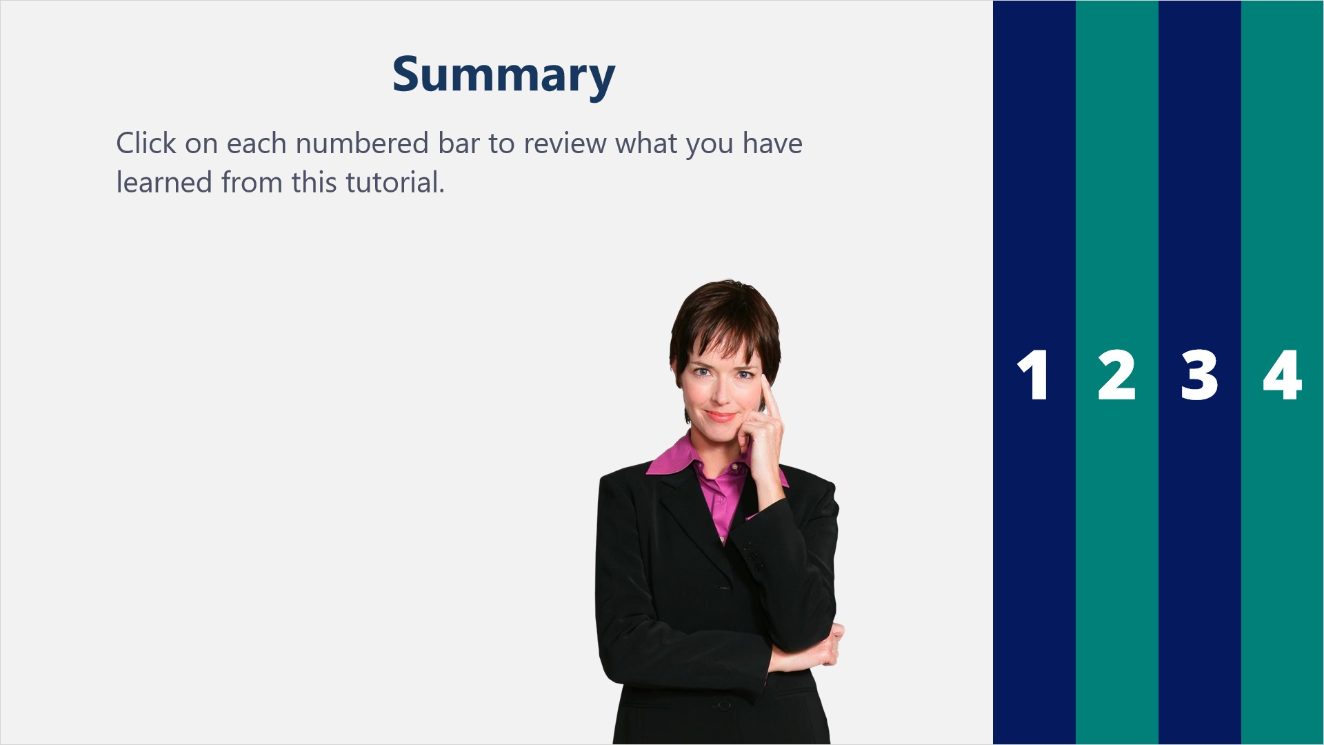
Transcript:
Click on each numbered bar to review what you have learned from this tutorial.
-----------------------------------------------------------------------------
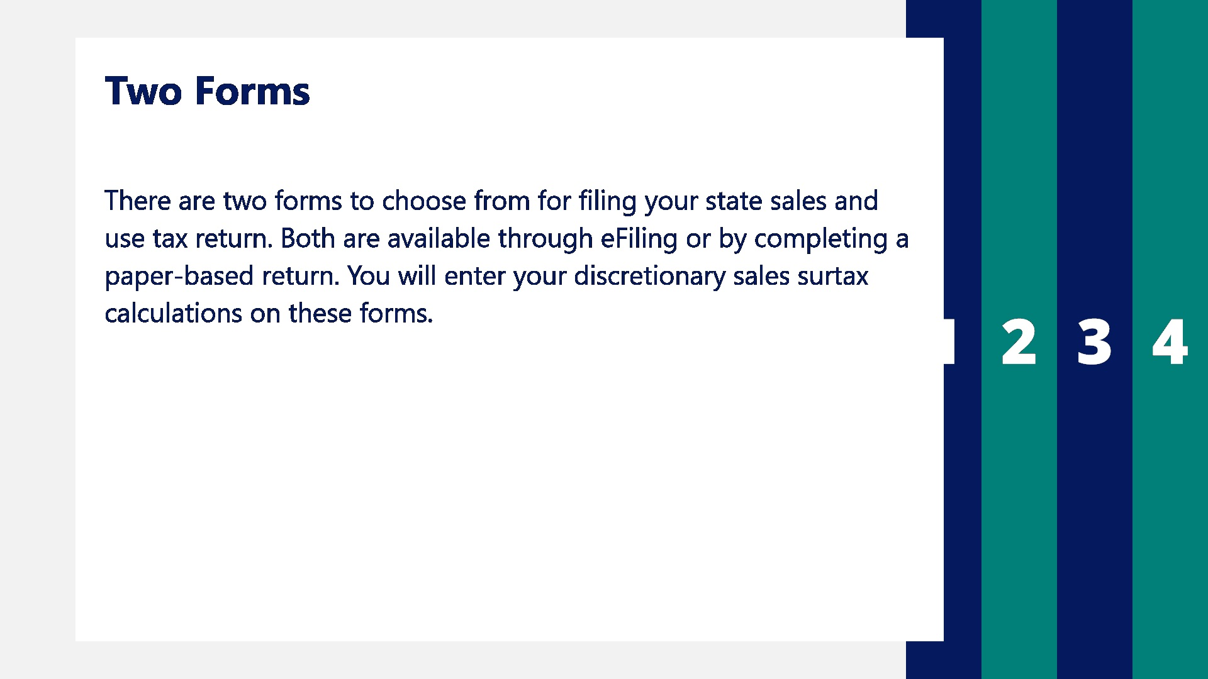

Transcript:
There are two forms to choose from for filing your state sales and use tax return. Both are available through e-Filing or by completing a paper-based return. You will enter your discretionary sales surtax calculations on these forms.
-----------------------------------------------

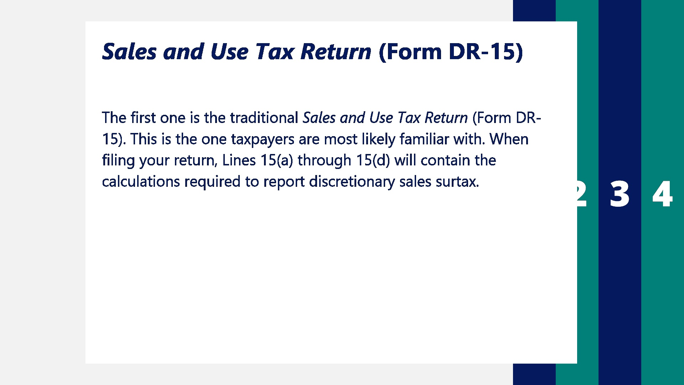
Transcript:
The first one is the traditional Sales and Use Tax Return (Form DR-15). This is the one taxpayers are most likely familiar with. When filing your return, Lines 15(a) through 15(d) will contain the calculations required to report discretionary sales surtax.
--------------------------------------------------------
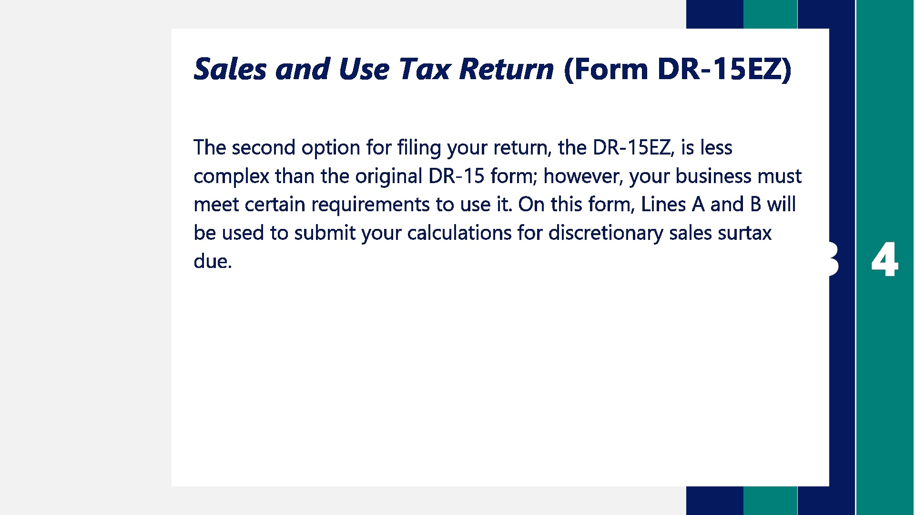

Transcript:
The second option for filing your return, the DR-15EZ, is less complex than the original DR-15 form; however, your business must meet certain requirements to use it. On this form, Lines A and B will be used to submit your calculations for discretionary sales surtax due.
------------------------------------------------------
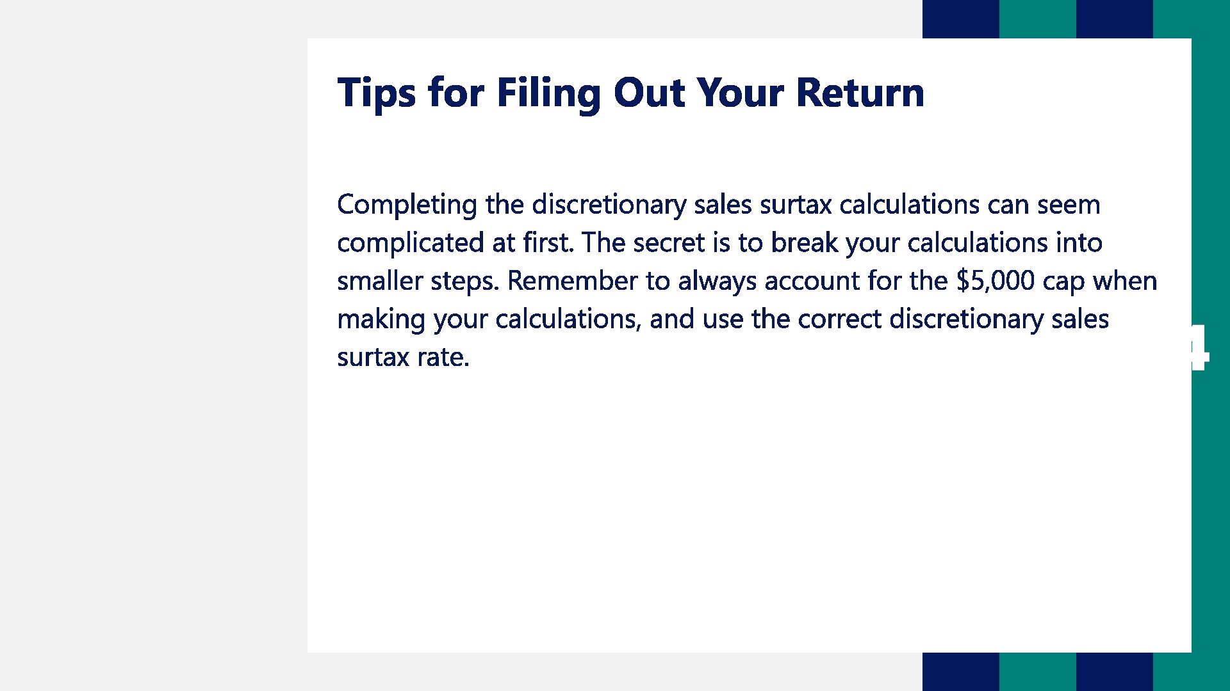

Transcript:
Completing the discretionary sales surtax calculations can seem complicated at first. The secret is to break your calculations into smaller steps. Remember to always account for the $5,000 cap when making your calculations and use the correct discretionary sales surtax rate.

6. Assessment

6.1 Quiz Instructions
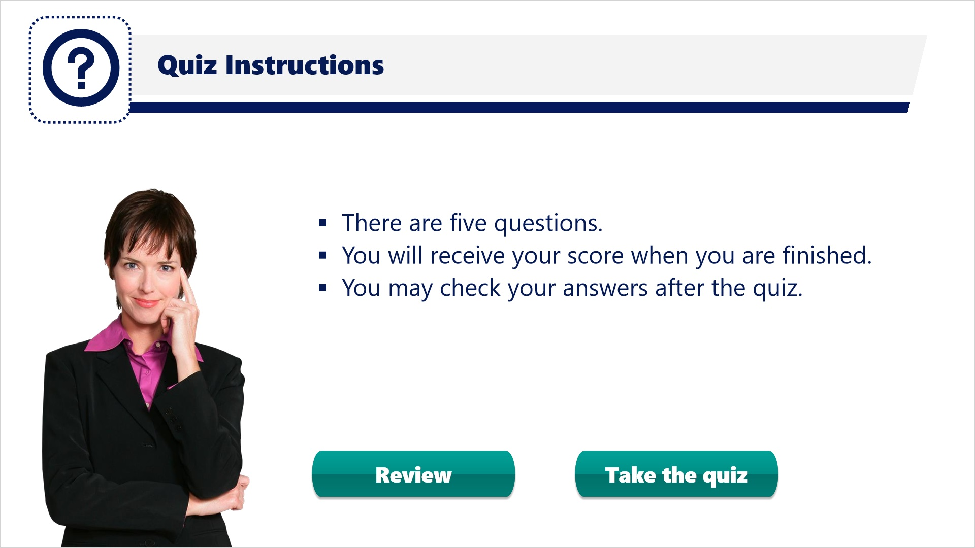
Transcript:
The following quiz items require you to use the information you learned in this tutorial. If you wish, you can review the material by clicking on the Review button before taking the quiz.
There are five questions. You will have the opportunity to check your answers after you have taken the quiz.
Remember, quiz slides are not narrated. Best of luck to you!

6.2 Quiz Question #1
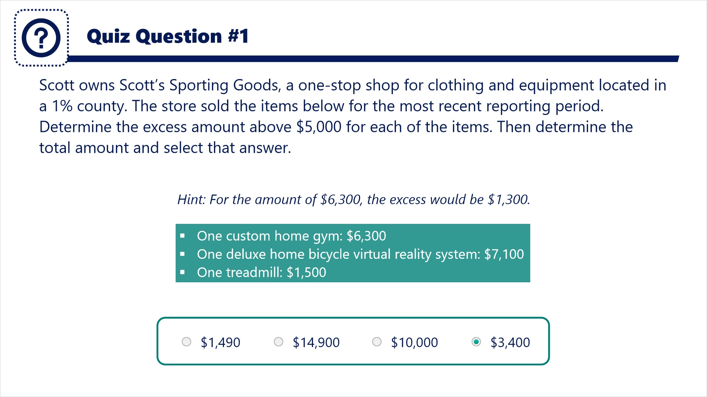
Transcript:
Question: Scott owns Scott’s Sporting Goods, a one-stop shop for clothing and equipment located in a 1% county. The store sold the items below for the most recent reporting period. Determine the excess amount above $5,000 for each of the items. Then determine the total amount and select that answer.
Hint: For the amount of $6,300, the excess would be $1,300.

Answers:
- $1,490
- $14,900
- $10,000
- $3,400
Correct Answer: $1,300 + $2,100 = $3,400

6.3 Quiz Question #2
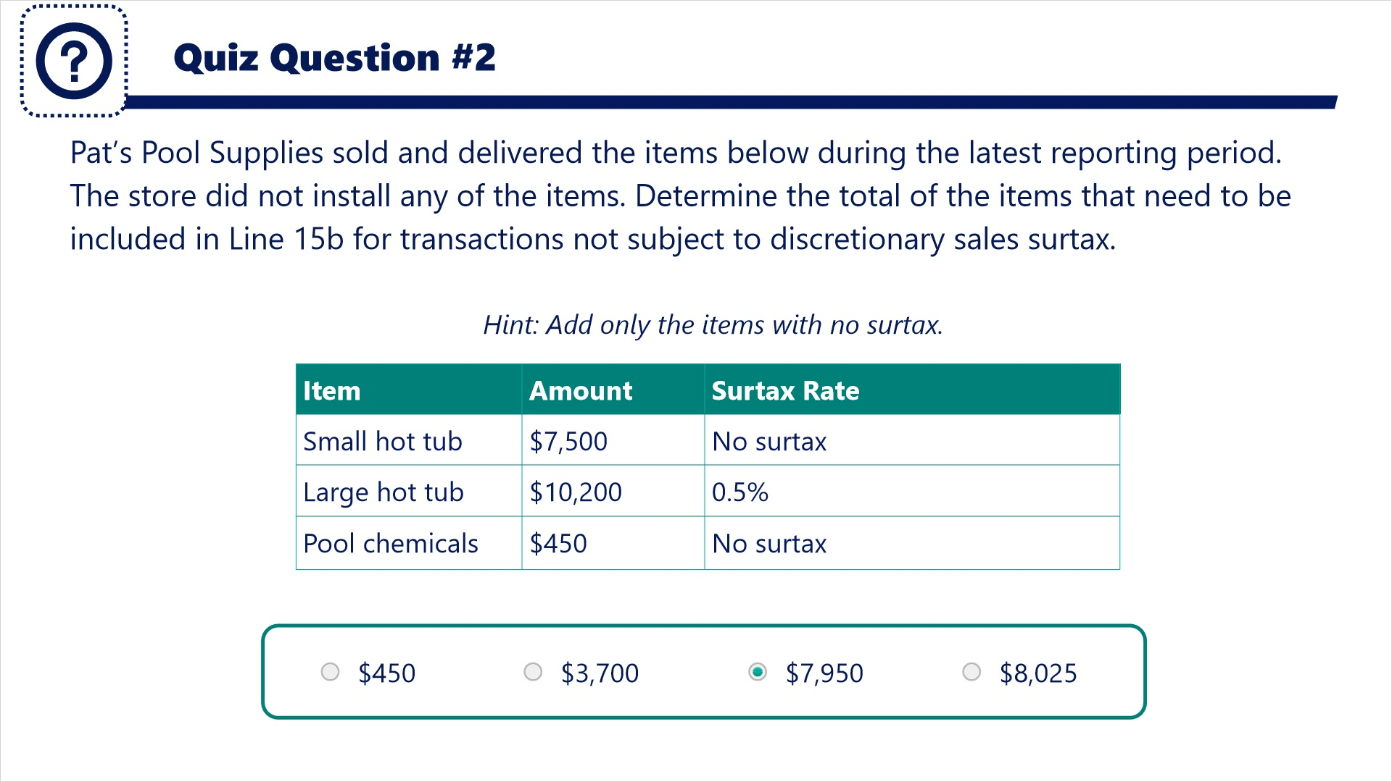
Transcript:
Question: Pat’s Pool Supplies sold and delivered the items below during the latest reporting period. The store did not install any of the items. Determine the total of the items that need to be included in Line 15b for transactions not subject to discretionary sales surtax.
Hint: Add only the items with no surtax.
- Small hot tub: $7,500 (no surtax)
- Large hot tub: $10,200 (0.5% surtax)
- Pool chemicals: $450 (no surtax)
Answers:
- $450
- $3,700
- $7,950
- $8,025
Correct Answer: Add together the two items that have no surtax.
$7,500 + 450 = $7,950

6.4 Quiz Question #3
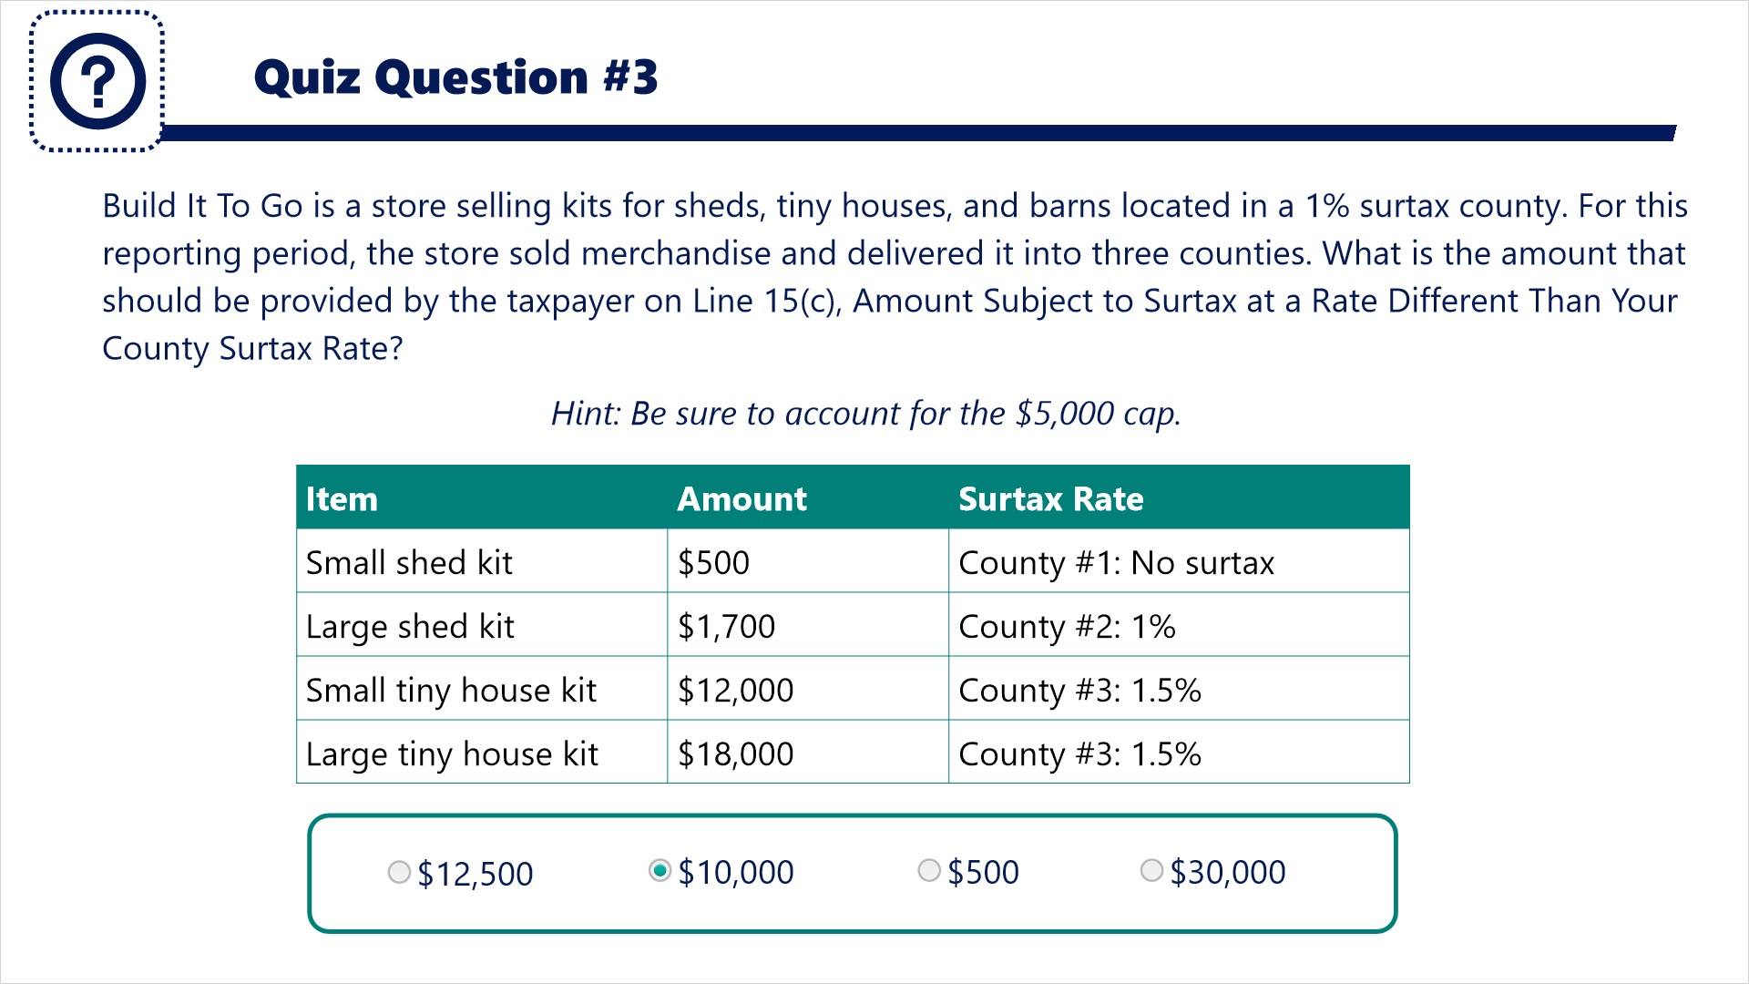

Transcript:
Question: Build It To Go is a store selling kits for sheds, tiny houses, and barns located in a 1% surtax county. For this reporting period, the store sold merchandise and delivered it into three counties. What is the amount that should be provided by the taxpayer on Line 15(c), Amount Subject to Surtax at a Rate Different Than Your County Surtax Rate?
Hint: Be sure to account for the $5,000 cap.
Items:
- County #1: Small shed kit for $500 (no surtax)
- County #2: Large shed kit for $1,700 (1% surtax)
- County #3: Small tiny house kit for $12,000 (1.5% surtax)
- County #3: Large tiny house kit for $18,000 (1.5% surtax)
Answers:
- $12,500
- $10,000
- $500
- $30,000
Correct Answer: Eliminate items for the county without a surtax. Eliminate items for the county with a 1% surtax. Add the remaining amounts together accounting for the $5,000 cap.
$5,000 + $5,000 = $10,000

6.5 Quiz Question #4
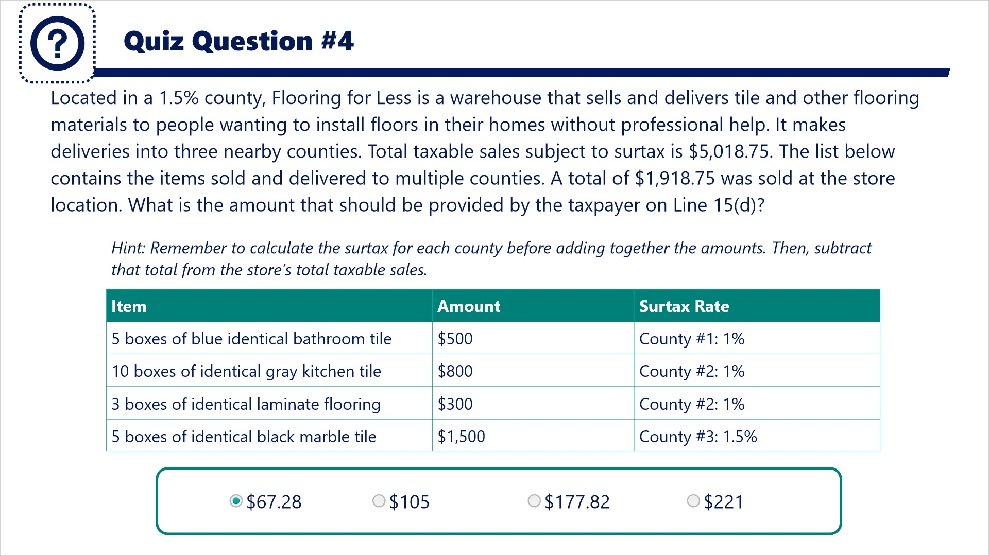
Transcript:
Question: Located in a 1.5% county, Flooring for Less is a warehouse that sells and delivers tile and other flooring materials to people wanting to install floors in their homes without professional help. It makes deliveries into three nearby counties. Total taxable sales subject to surtax is $5,018.75. The list below contains the items sold and delivered to multiple counties. A total of $1,918.75 was sold at the store location. What is the amount that should be provided by the taxpayer on Line 15(d)?
Hint: Remember to calculate the surtax for each county before adding together the amounts. Then, subtract that total from the store’s total taxable sales.
Items
- County #1 (1% surtax): 5 boxes of blue identical bathroom tile for $500
- County #2 (1% surtax): 10 boxes of identical gray kitchen tile for $800
- County #2 (1% surtax): 3 boxes of identical laminate flooring for $300
- County #3 (1.5% surtax): 5 boxes of identical black marble tile
Answers:
- $67.28
- $105
- $177.82
- #221
Correct Answer: Multiply each item’s total by its county surtax rate. Add these totals together. Multiple sales picked up in-store by 1.5%. Add both totals together.
$38.50 + $28.78 = $67.28

6.6 Quiz Question #5
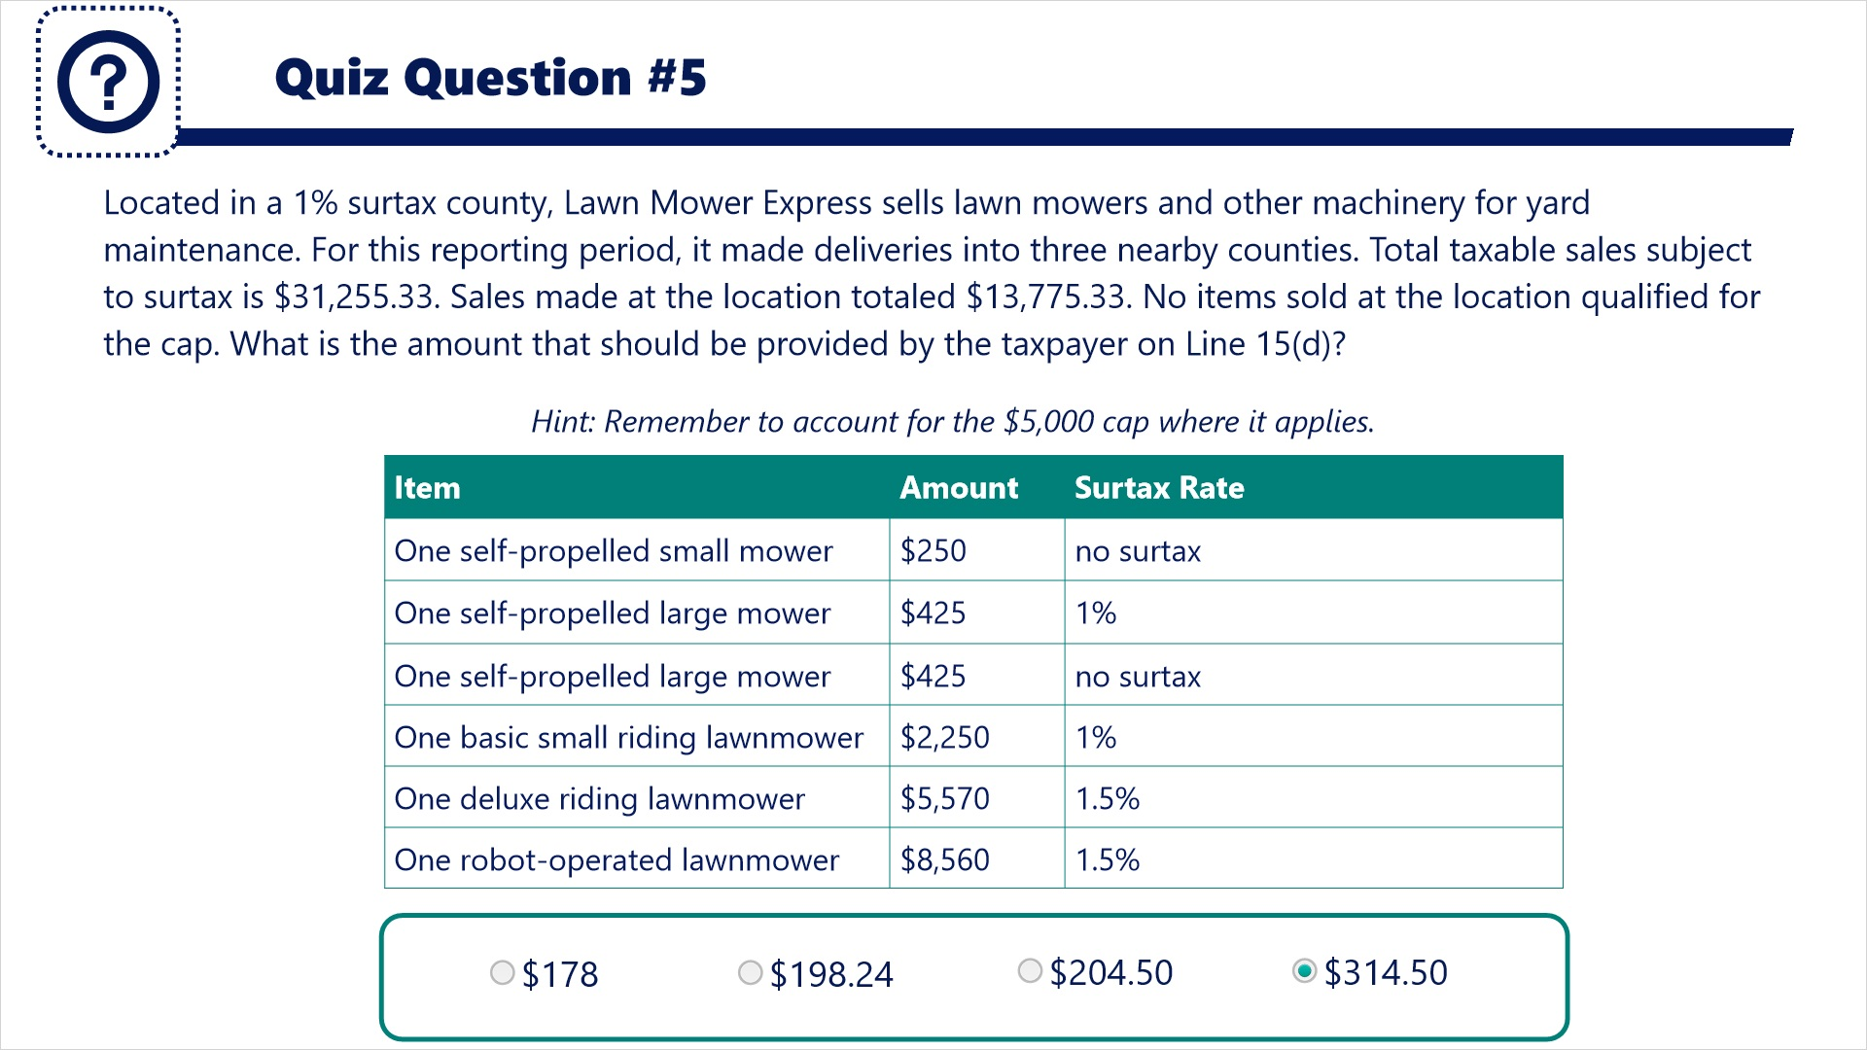
Transcript:
Question: Located in a 1% surtax county, Lawn Mower Express sells lawn mowers and other machinery for yard maintenance. For this reporting period, it made deliveries into three nearby counties. Total taxable sales subject to surtax is $31,255.33. Sales made at the location totaled $13,775.33. No items sold at the location qualified for the cap. What is the amount that should be provided by the taxpayer on Line 15(d)?
Hint: Remember to account for the $5,000 cap where it applies.
Items:
- One self-propelled small mower for $250 (no surtax)
- One self-propelled large mower for $425 (1% surtax)
- One self-propelled large mower for $425 (no surtax)
- One basic small riding lawnmower for $2,250 (1% surtax)
- One deluxe riding lawnmower for $5,570 (1.5% surtax)
- One robot-operated lawnmower for $8,560 (1.5% surtax)
Answers:
- $178
- $198.24
- $204.50
- $314.50
Correct Answer: Multiply each item’s total by its county surtax rate. Be sure to account for the $5,000 cap. Multiply the amount sold and picked up in-store by 1%. Add the two totals together.
$176.75 + $137.75 = $314.50

7. Conclusion

7.1 Tax Page and Social Media
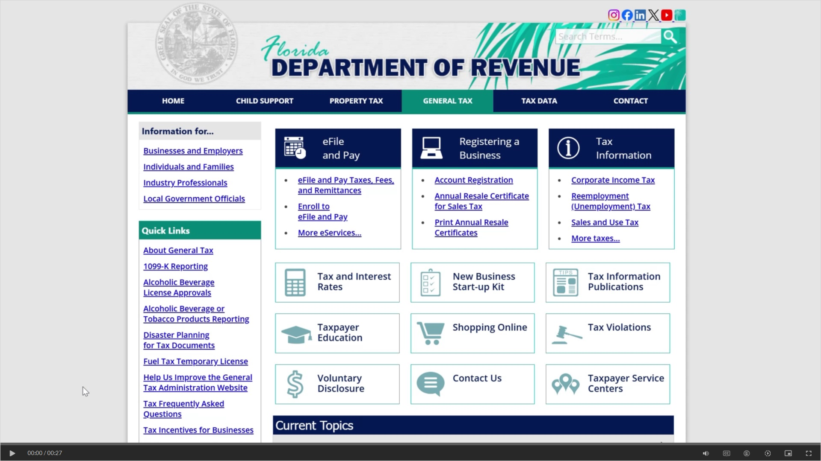
Transcript:
Visit floridarevenue.com/taxes for business resources such as forms, publications, and information on all tax types.
Check out our Taxpayer Education webpage for new business guides, tutorials, and other helpful tools.
And follow us on YouTube, X, Instagram, and LinkedIn using the icons at the top of our website to stay up to date on tax topics, alerts, and more.

7.2 Survey
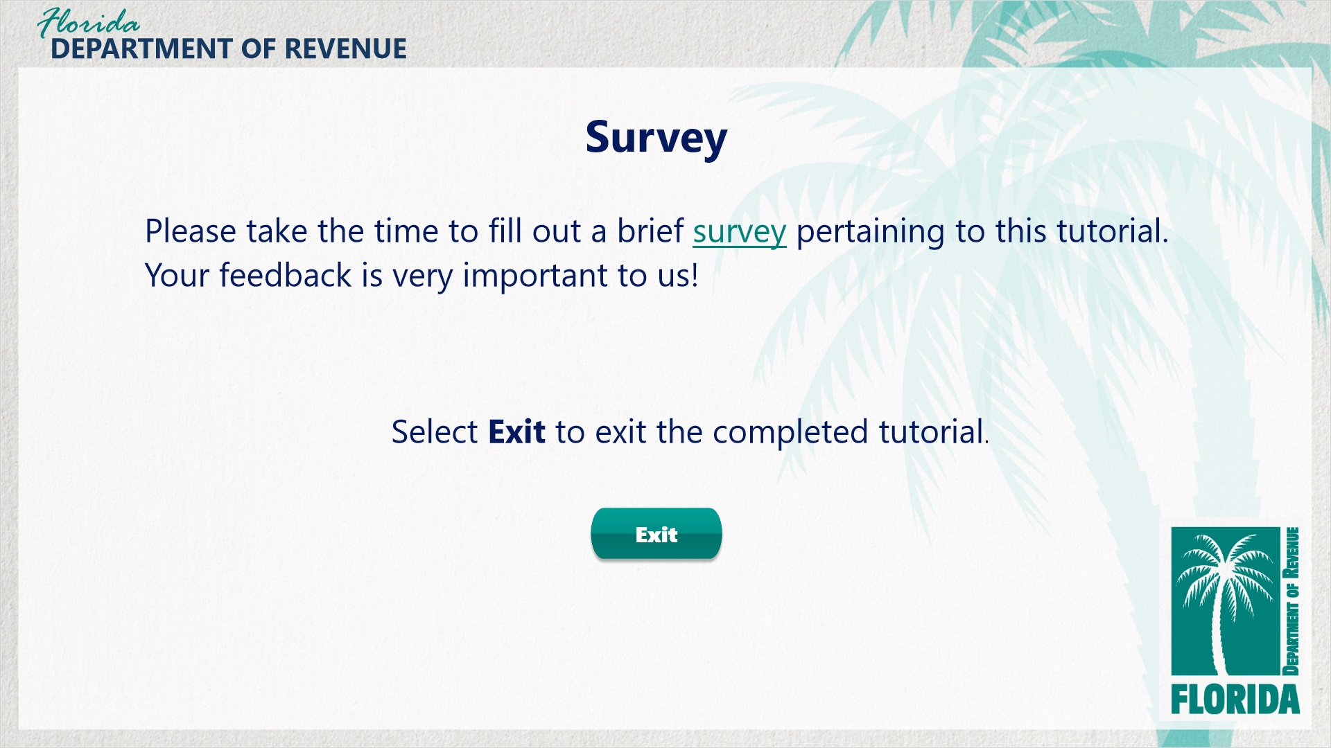
Transcript:
Thank you for completing Discretionary Sales Surtax: How to Calculate and Report.

Remember, there are a great deal of resources available to you by clicking on the Resources link in the upper-right corner of your screen. You can also find many other helpful resources at floridarevenue.com.

Please click on the survey link to take a short survey about the content and quality of this tutorial. The Department greatly appreciates your feedback and will use it to develop future tutorials.

To exit this tutorial, click on the Exit button.

