What to Expect From a Florida Tax Audit

1. Introduction

1.1 Welcome
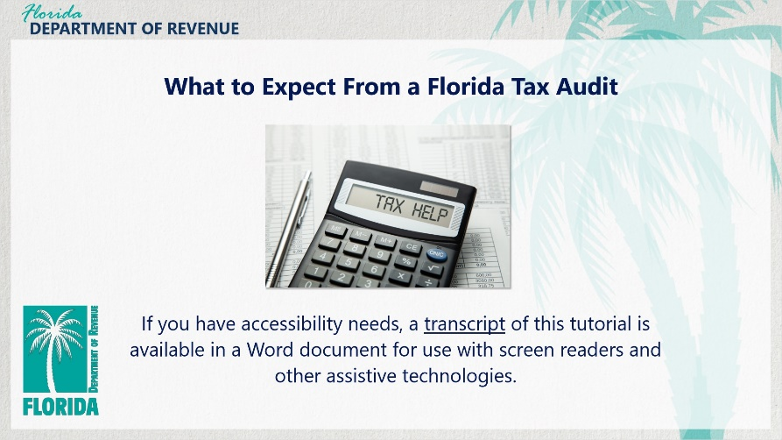
Transcript:
Welcome to What to Expect from a Florida Tax Audit.
If you have accessibility needs, a transcript of this tutorial is available in a Word document for use with screen readers and other assistive technologies.
In this tutorial, we discuss what taxpayers should expect during a tax audit by the Florida Department of Revenue.

1.2 Navigating This Tutorial
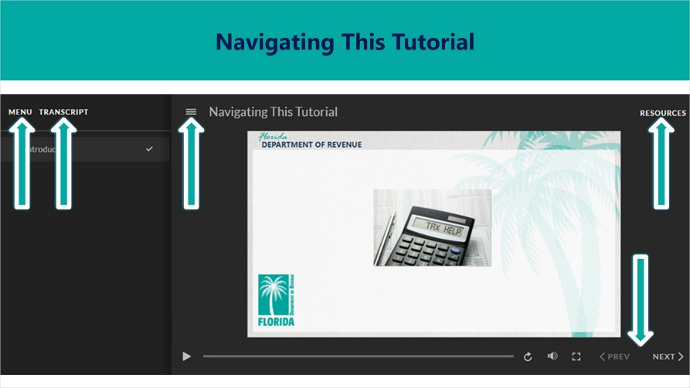
Transcript:
This tutorial will take approximately 15 minutes to complete. A transcript of the audio is available by clicking on the Transcript tab in the top-left corner of your screen. The following tabs and buttons are available to help you navigate through this tutorial.
Menu Tab
The Menu tab displays by default when the tutorial is viewed on a computer. It allows you to navigate through the tutorial by clicking on the topic name in the menu. When viewing this tutorial on a tablet or smartphone, the menu does not display by default and must be accessed using the menu symbol.
Resources Tab
The Resources tab is found to the right side of the top bar. When clicked, it displays a list of links to useful forms, documents, and webpages.
Previous and Next Buttons
The Previous and Next buttons are located at the bottom-right corner of your screen. These buttons allow you to move either back or forward.

1.3 Topics
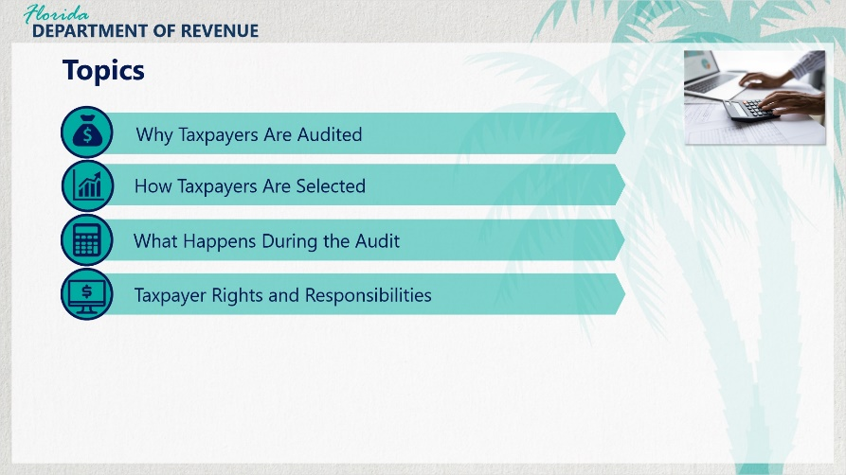
Transcript:
Topics for this tutorial include, why taxpayers are audited, how taxpayers are selected, what happens during the audit, and taxpayer rights and responsibilities.

2. Why Taxpayers Are Audited

2.1 Why Taxpayers Are Audited
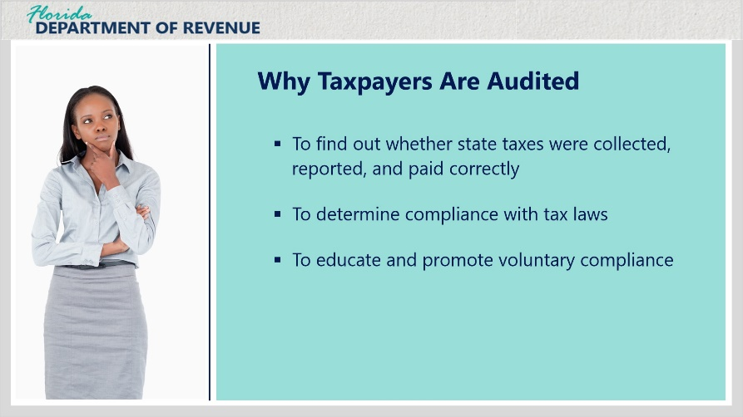
Transcript:
The Department of Revenue (Department) is dedicated to professional and efficient tax administration promoting the highest level of voluntary compliance, enhanced customer service, and fair and effective enforcement of Florida tax laws.
The goal of the Department is to ensure that all taxpayers doing business in Florida are registered, collecting, and paying the taxes they are obligated to pay. The Department audits businesses to find out whether state taxes were collected, reported, and paid correctly.
Registered and nonregistered taxpayers’ accounting records are reviewed to determine compliance with tax laws.
Audits can identify underpaid or overpaid taxes and can be educational and promote voluntary compliance.
Although tax audits are viewed by many strictly as an enforcement tool used only to find unpaid taxes, the Department uses audits to monitor and evaluate tax compliance.
Throughout the audit process, auditors educate taxpayers about future compliance.

3. How Taxpayers Are Selected

3.1 How Taxpayers Are Selected
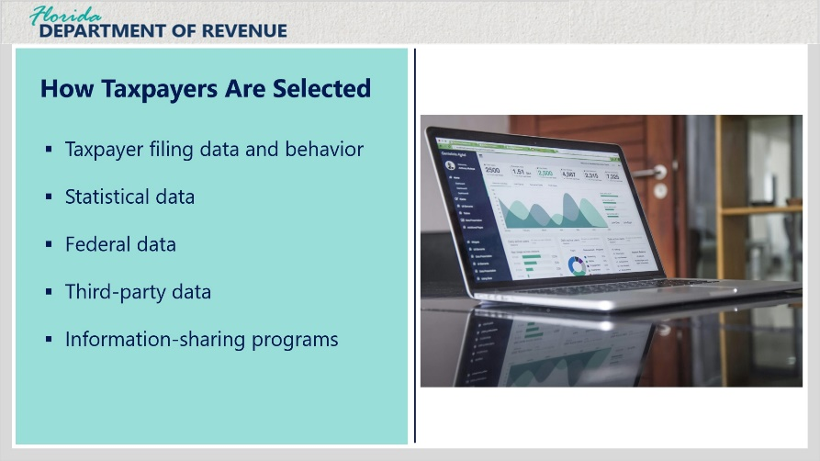
Transcript:
The Department considers multiple factors when identifying potential audit candidates. These factors include but are not limited to: taxpayer filing data and filing behavior; statistical data on business industry, size, and location; federal data; third-party data; information-sharing programs with other states and state agencies.
The vast majority of audit leads are selected through an automated process that uses flexible rules based on taxpayer data and reporting patterns.
Those selected outside of the automated process are based on specific analysis and/or third-party information.

3.2 Taxpayer Filing Data
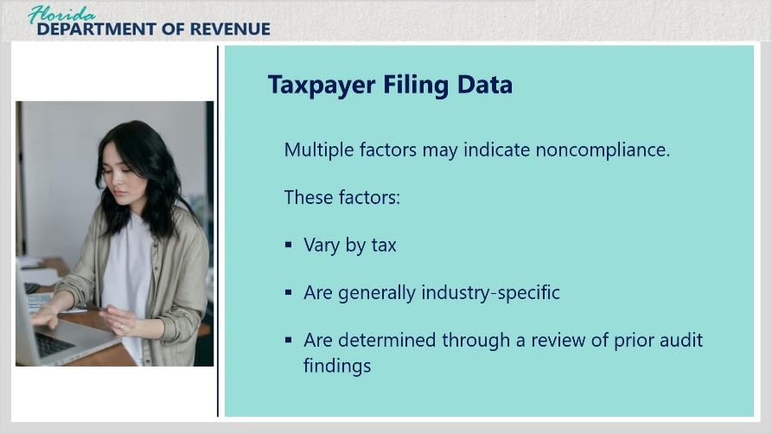
Transcript:
The Department has identified multiple factors within a businesses’ filing data that are a possible indicator of noncompliance.
These factors vary by tax, are generally industry-specific, and are determined through a review of prior audit findings.

3.3 Example 1
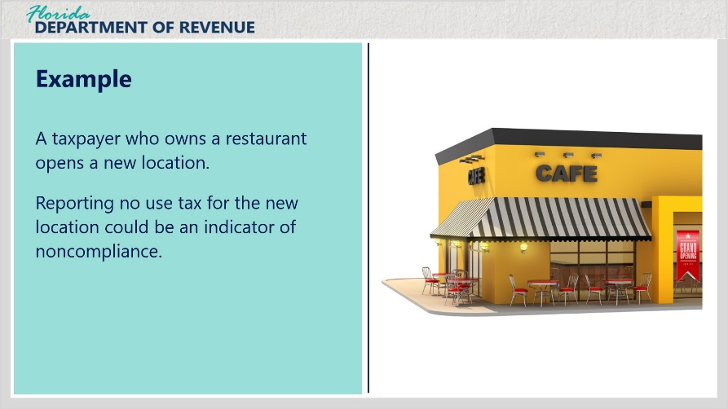
Transcript:
For example, for sales and use tax, if a taxpayer is in the food service industry and opens a new location, reporting no use tax for that new location could be an indicator of noncompliance because tables, chairs, other furnishings, and kitchen equipment may have been purchased without paying sales tax.
In this case, the business should report and pay use tax on these items.

3.4 Filing Data Research
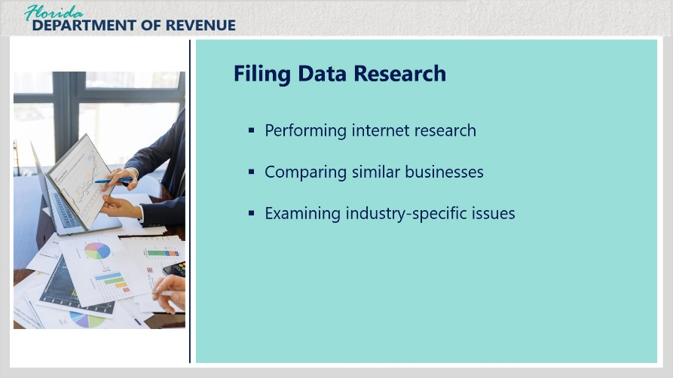
Transcript:
Some of the additional steps taken for audit selection are researching the business via the internet, comparing the business filing to other comparable businesses in the same geographic area, looking for specific issues that commonly arise in a particular industry.

3.5 Statistical Data
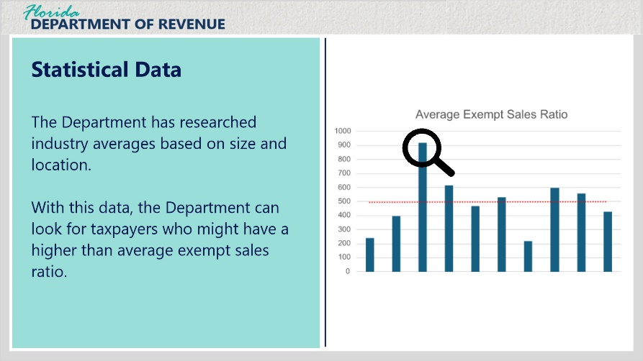
Transcript:
Similar to the indicators that have been identified in a taxpayer’s filing behavior, the Department has researched industry averages based on size and location.
One good example is an outlier exempt ratio calculation.
The Department has identified what the average exempt sales ratio - that is, the proportion of sales that are exempt from sales tax relative to total sales - is for businesses by industry and size.
The Department then looks for taxpayers who are filing exempt sales that are far greater than the state average for their industry and size.

3.6 IRS Information Sharing
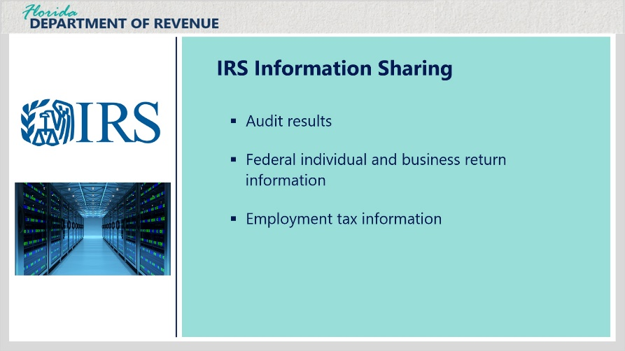
Transcript:
The IRS shares taxpayer information with federal, state, and municipal government agencies with the goal of improving overall compliance with tax laws. This information includes audit results, federal individual and business return information, and employment tax information.
The Department receives the federal reports and compares the information to what was filed by the taxpayer in Florida. Any reports with unexplained discrepancies may result in the creation of a lead.

3.7 Example 2
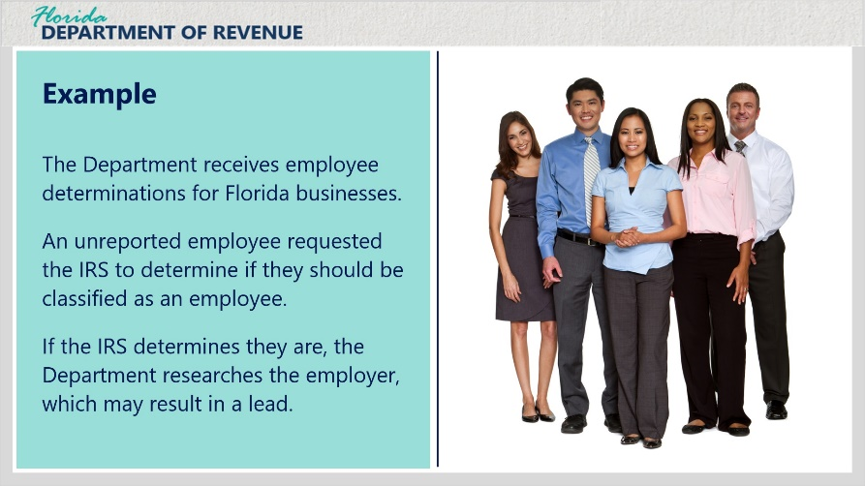
Transcript:
For reemployment tax, the Department receives employee determinations for Florida businesses.
In these cases, an employee was not reported by an employer and the employee requested a determination from the IRS as to whether they should be classified as an employee.
If the determination is that the claimant is truly an employee, the Department conducts research to see if the employer was reporting the employee to Florida. If not, the Department creates a lead.

3.8 Sharing Programs
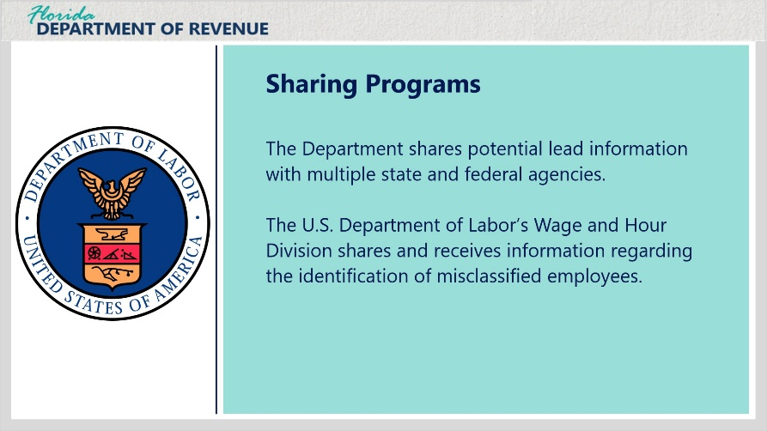
Transcript:
The Department has partnered with multiple state and federal agencies to share potential lead information.
Most recently, the Department has partnered with the U.S. Department of Labor’s Wage and Hour Division to receive and share information with regard to the identification of misclassified employees.

3.9 Example 3
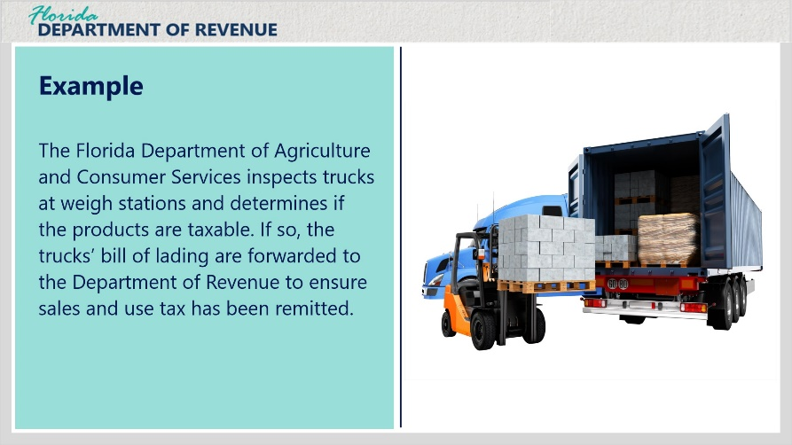
Transcript:
Another example of working with other state and federal agencies is the Department’s close collaboration with the Florida Department of Agriculture and Consumer Services.
Trucking companies are required to stop at Department of Agriculture weigh stations located throughout Florida.
During these stops, the Department of Agriculture inspects the trucks’ bills of lading to determine if the products being shipped are taxable.
If so, the bill of lading is scanned and forwarded to the Department of Revenue to verify that sales and use tax has been remitted on the product.

3.10 Third-Party Data
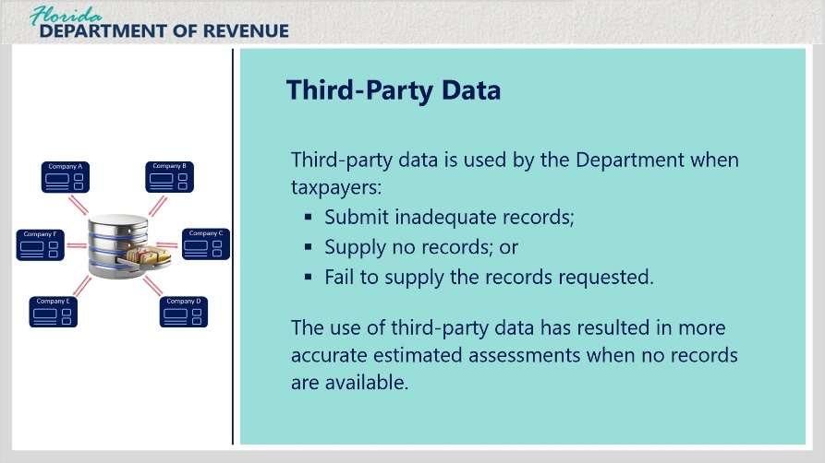
Transcript:
The Department also uses third-party data.
One of the major issues the Department faces is taxpayers who either have inadequate records, no records, or fail to supply the records requested.
The Department relies more on third-party data as a basis for assessment due to the lack of records.
The use of third-party data has also resulted in more accurate estimated assessments when no records are available.

4. What Happens During the Audit

4.1 Preparing For an Audit
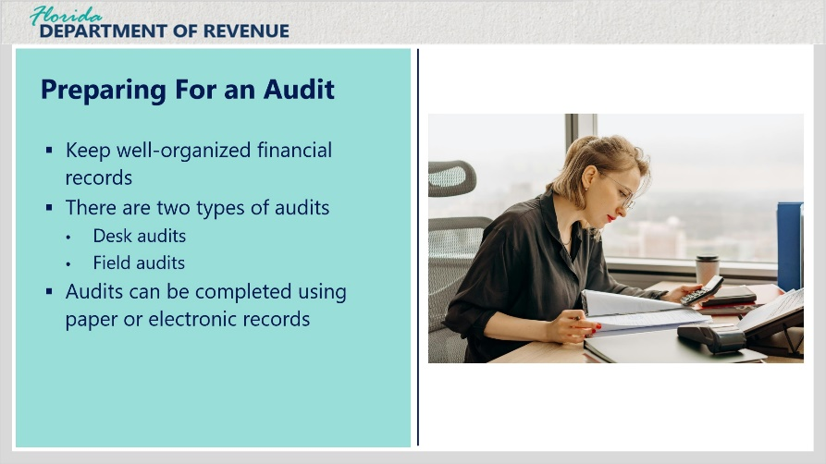
Transcript:
The most important thing you can do to prepare for an audit is to keep accurate, well-organized financial records.
These records are the best resource for confirming the accuracy of the returns you filed.
The Department conducts two types of audits: those done in Department offices (desk audits), and those done at your place of business (field audits).
Audits can be completed using paper or electronic records.
Generally, a major tax, such as sales and use tax, will be audited along with related taxes, such as local option taxes.

4.2 Beginning an Audit
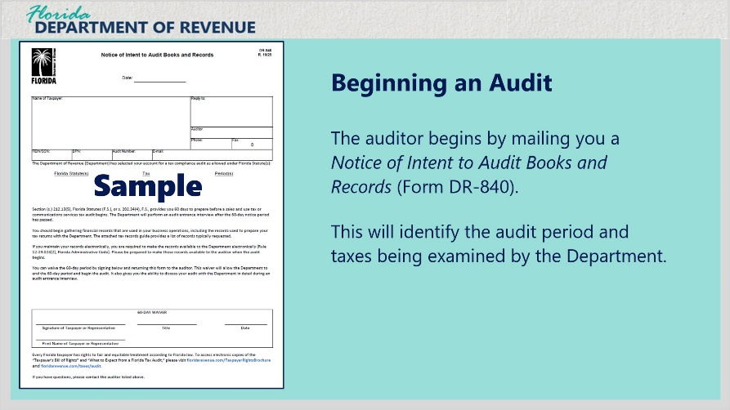
Transcript:
The auditor begins by mailing you a Notice of Intent to Audit Books and Records (Form DR-840).
This notice identifies the audit period and taxes to be examined.

4.3 Types of Records Reviewed
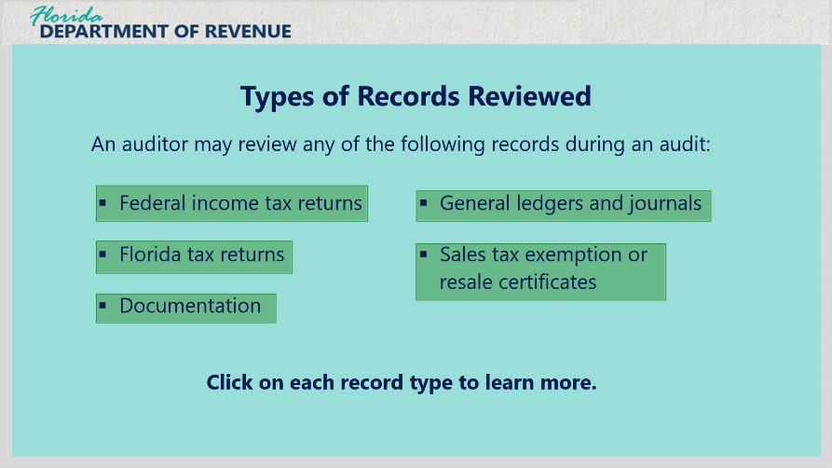
Transcript:
When the audit begins, the auditor may review a variety of records.
The types of records needed may include, but are not limited to the following: federal income tax returns, Florida tax returns, documentation, general ledgers and journals, and sales tax exemption or resale certificates
Click on each record type to learn more.

Federal Income Tax Return (Slide Layer)
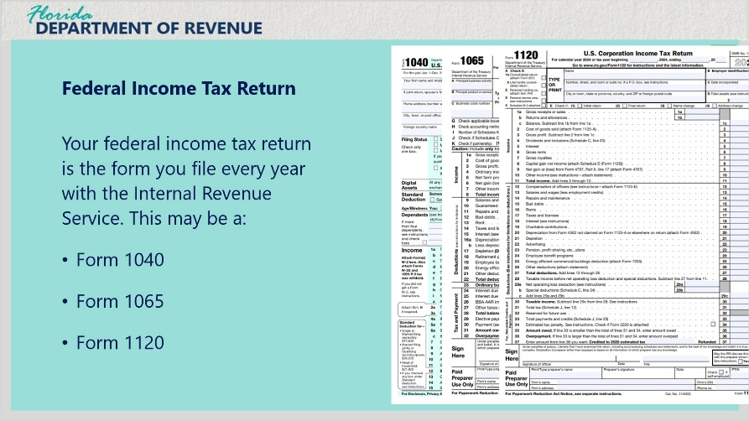
Transcript:
Federal Income Tax Return
Your federal income tax return is the form you file every year with the Internal Revenue Service. This may be a Form 1040, Form 1065, Form 1120.

Florida Tax Return (Slide Layer)
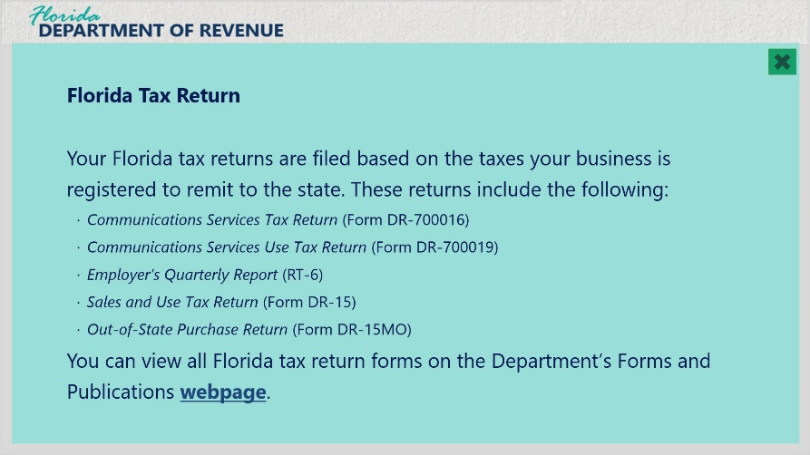
Transcript:
Florida Tax Return
Your Florida tax returns are filed based on the taxes your business is registered to remit to the state. These returns include the following: Communications Services Tax Return (Form DR-700016), Communications Services Use Tax Return (Form DR-700019), Employer’s Quarterly Report (RT-6), Sales and Use Tax Return (Form DR-15), and Out-of-State Purchase Return (Form DR-15MO).
You can view all Florida tax return forms on the Department’s Forms and Publications webpage (floridarevenue.com/forms).

Documentation (Slide Layer)
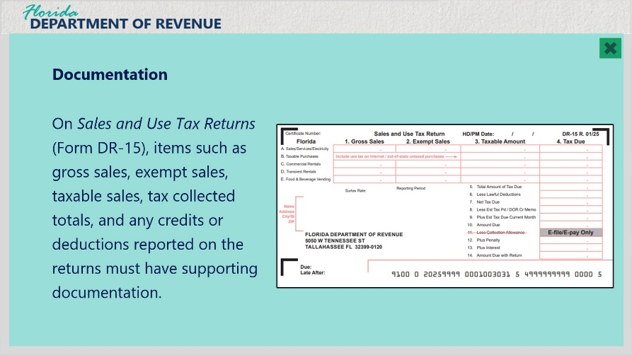
Transcript:
Documentation
Documentation is required to verify the amounts entered on the tax returns.
For example, on Sales and Use Tax Returns (Form DR-15), items such as gross sales, exempt sales, taxable sales, tax collected totals, and any credits or deductions reported on the returns must have supporting documentation.

General Ledgers and Journals (Slide Layer)
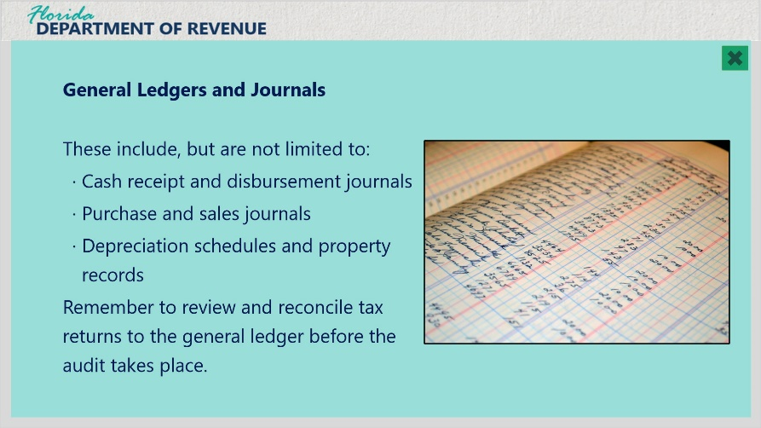
Transcript:
General Ledgers and Journals
General ledgers and journals include cash receipt and disbursement journals, purchase and sales journals, depreciation schedules and property records.
You should also review tax returns and reconcile them to the general ledger before the audit takes place.

Sales Tax Exemption or Resale Certificates (Slide Layer)
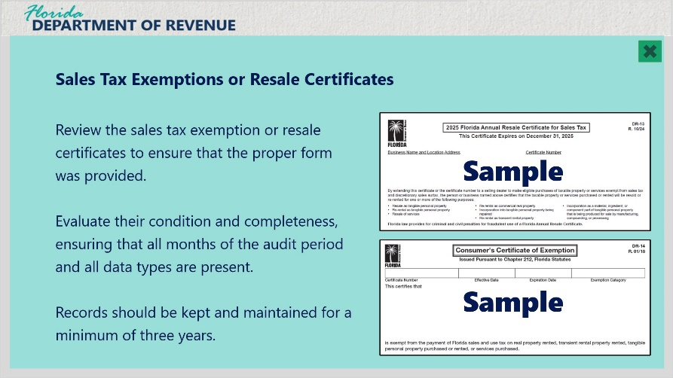
Transcript:
Sales Tax Exemption or Resale Certificates
Review the sales tax exemption or resale certificates to ensure that the proper form was provided. This is the time to go back to your customers and obtain valid certificates if you do not already have them. (Ideally, this would have been done at the time of the transaction to exempt the sale.)
Once you have compiled the records, you will need to evaluate their condition and completeness, ensuring that all months of the audit period and all data types are present.
Records should be kept and maintained for a minimum of three years. The Department may audit for periods longer than three years if you did not file or filed substantially incorrect returns.
If you fail to produce records, your tax liability will be estimated based on available information.

4.4 Communication With the Auditor
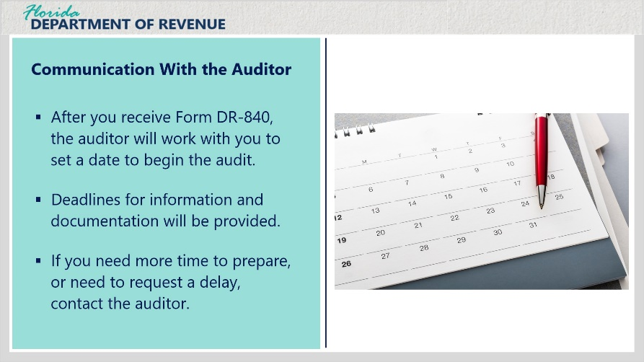
Transcript:
Throughout the audit process, communication is essential. After the Notice of Intent to Audit Books and Records (Form DR-840) is issued, the auditor will work with you to set a date to begin the audit.
The auditor will give you deadlines for providing information or documentation.
If you need additional time to prepare, or need to request a delay for other reasons, contact the auditor.
The auditor will make every reasonable effort to accommodate your requests.
We understand that an audit can be stressful. Please don’t hesitate to ask questions if something isn’t clear. We also recommend that you respond quickly to all letters, phone calls, and requests for information to keep the audit process flowing smoothly.

4.5 Power of Attorney
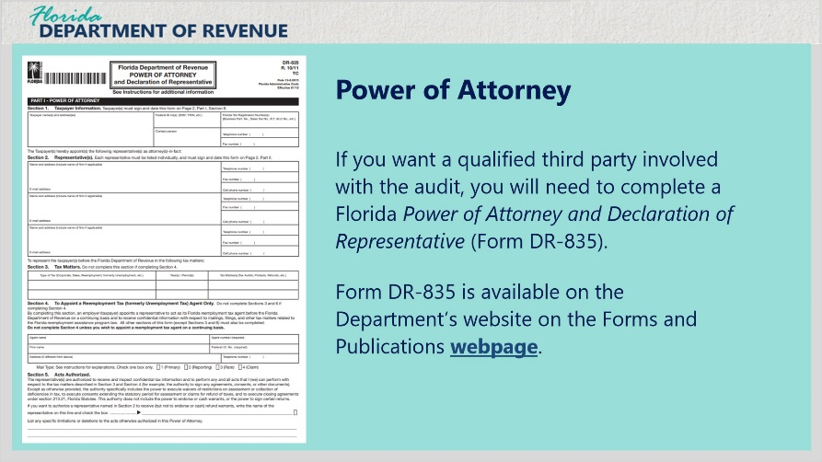
Transcript:
You get to decide if you want a qualified third party, such as your accountant or bookkeeper, involved in the audit. The auditor will interview you or your authorized representative.
You must complete a Florida Power of Attorney and Declaration of Representative (Form DR-835) if you want the Department’s auditor to discuss the audit with your authorized representative.
The Florida Power of Attorney and Declaration of Representative is available on the Forms and Publications webpage.

4.6 Requesting Technical Advice
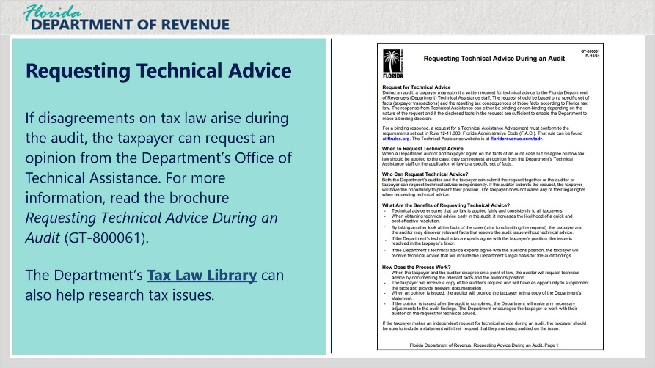
Transcript:
So, what happens when an auditor and a taxpayer agree on the facts of an audit case but disagree on how tax law should be applied to the case?
In this situation, the taxpayer can request an opinion on the application of law to a specific set of facts.
The Department’s Office of Technical Assistance will issue a Technical Assistance Advisement, which is binding on the Department.
For more information, read the brochure Requesting Technical Advice During an Audit (GT-800061).
The Department’s Tax Law Library can help you research the issue before requesting technical assistance.

5. Taxpayer Rights and Responsibilities

5.1 When an Audit is Completed
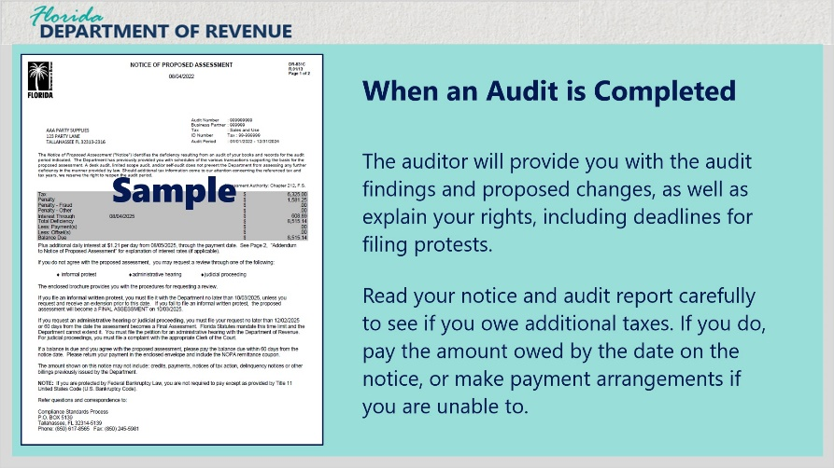
Transcript:
After the audit is complete, you may review the audit findings and proposed changes.
The auditor will give you a copy of the work papers and explain your rights, including deadlines for filing protests.
Read your notice and audit report carefully. If you owe additional taxes, these will explain the audit findings and proposed changes.
Pay the amount owed by the date on the notice or make payment arrangements if you can't pay the full amount.

5.2 Pay Online
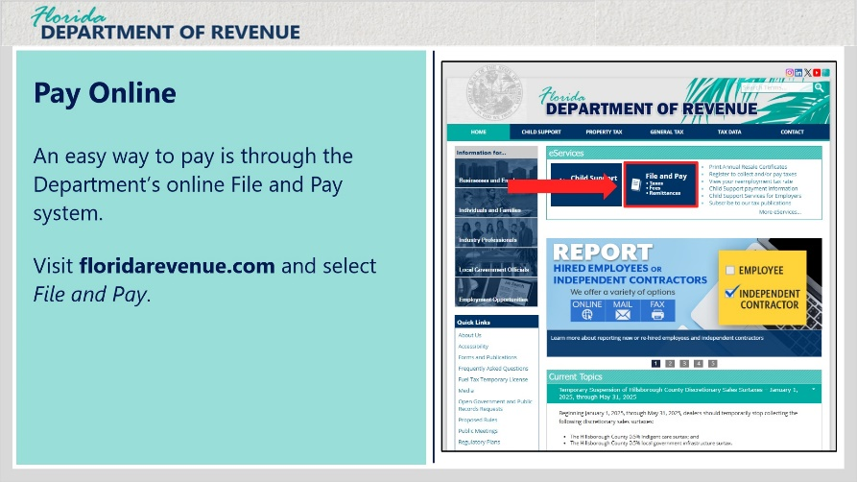
Transcript:
An easy way to pay is through the Department’s online File and Pay system.
Visit floridarevenue.com and select File and Pay.

5.3 How to Pay Your Assessment and Notice of Taxpayer Rights
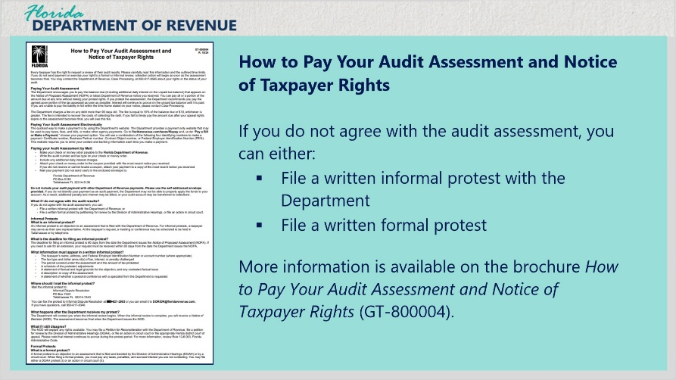
Transcript:
If you do not agree with the audit assessment, you can either file a written informal protest with the Department or file a written formal protest.
More information is available on the brochure How to Pay Your Audit Assessment and Notice of Taxpayer Rights (GT-800004).

5.4 Florida Taxpayer's Bill of Rights
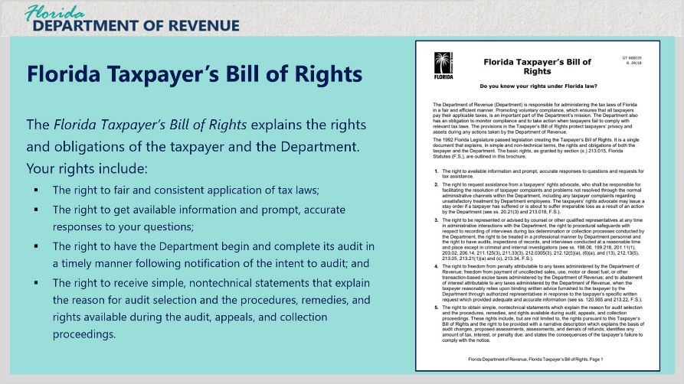
Transcript:
As mentioned before, the Department is dedicated to professional and efficient tax administration promoting the highest level of voluntary compliance, enhanced customer service, and fair and effective enforcement of Florida tax laws.
Every taxpayer has a set of fundamental rights, and the Department has an obligation to protect them.
The brochure Florida Taxpayer’s Bill of Rights (GT-800039) explains the rights and obligations of the taxpayer and the Department. Your rights include: the right to fair and consistent application of tax laws; the right to get available information and prompt, accurate responses to your questions; the right to have the Department begin and complete its audit in a timely manner following notification of the intent to audit; and the right to receive simple, nontechnical statements that explain the reason for audit selection and the procedures, remedies, and rights available during the audit, appeals, and collection proceedings.

6. Conclusion

6.1 Tax Page and Social Media
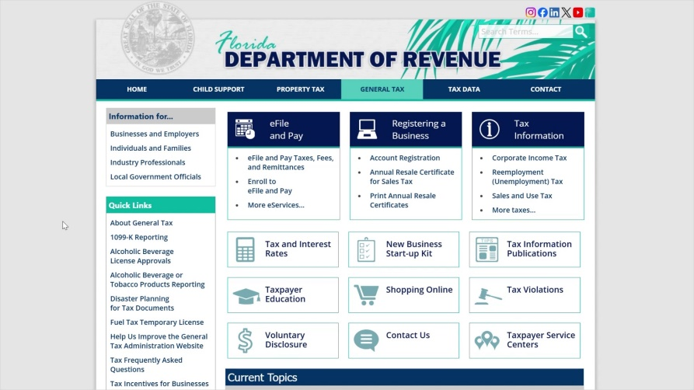
Transcript:
Visit floridarevenue.com/taxes for business resources such as forms, publications, and information on all tax types.
Check out our Taxpayer Education webpage for new business guides, tutorials, and other helpful tools.
And follow us on YouTube, X, Instagram, and LinkedIn using the icons at the top of our website to stay up to date on tax topics, alerts, and more.

6.2 Survey
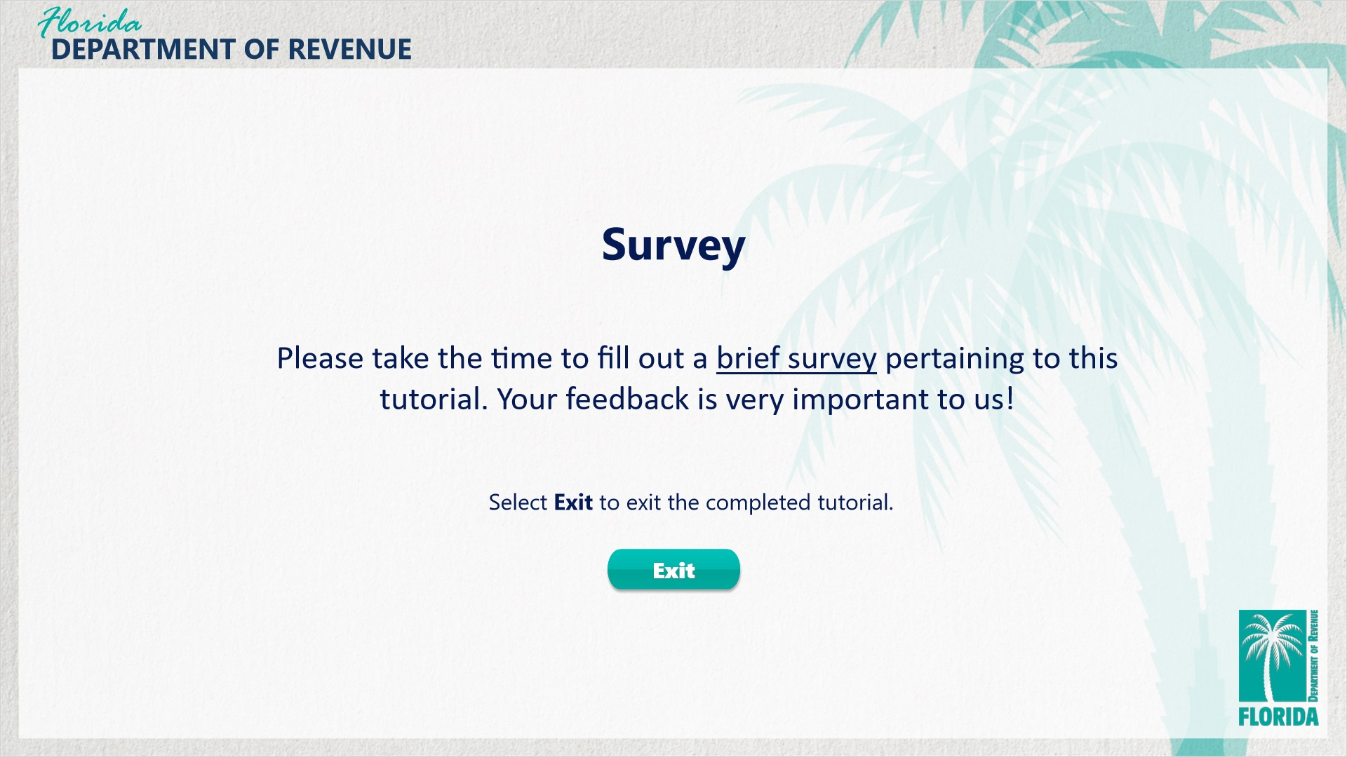
Transcript:
This concludes What to Expect from a Florida Tax Audit.
Please take the time to fill out a brief survey pertaining to this tutorial. Your feedback is very important to us.
To exit this tutorial, click on the Exit button.
Thank you.

